Game Design Document

Fill up the following document

1. Write the title of your project ?

Collect the Flowers

1. What is the goal of the game?

The player has to collect all the flowers from the park,you have 10 chances and you have to get 100 points to win.

1. Write a brief story of your game.

Ariana loves a flowers,one day she went to a park there was event.In

the event the person who has the most flowers wins a flower

Trophy.And there was a twist there was only 4 types of flower,but

Ariana was to small.So,the player have to help her by

collecting her the flowers.

1. Which are the playing characters of this game?

* Playing characters are the ones who respond to the user based on the input from the user.
* Basket is the playing character in the game.

|  |  |  |
| --- | --- | --- |
| Number | Character Name | What can this character do? |
| 1 | Basket | This character has to collect the flowers |

1. Which are the Non-Playing Characters of this game?

* Non-Playing characters are the ones that don't have an action or behavior when the user interacts with the game.
* Lily,Dahlia,Rose,Jasmine, are non-playing characters in the game.

|  |  |  |
| --- | --- | --- |
| Number | Character Name | What can this character do? |
| 1 | Lily | This character can fall randomly from top |
| 2 | Dahlia | This character can fall randomly from top |
| 3 | Rose | This character can fall randomly from top |
| 4 | Jasmine | This character can fall randomly from top |
| 5 | Boosters | This character can give more powers to the player |

Draw your imagination of this game. What does this game look like?

* Draw the game either on your computer or on paper.
* Add images of the game scenes to show each of the playing and non-playing characters at least once.

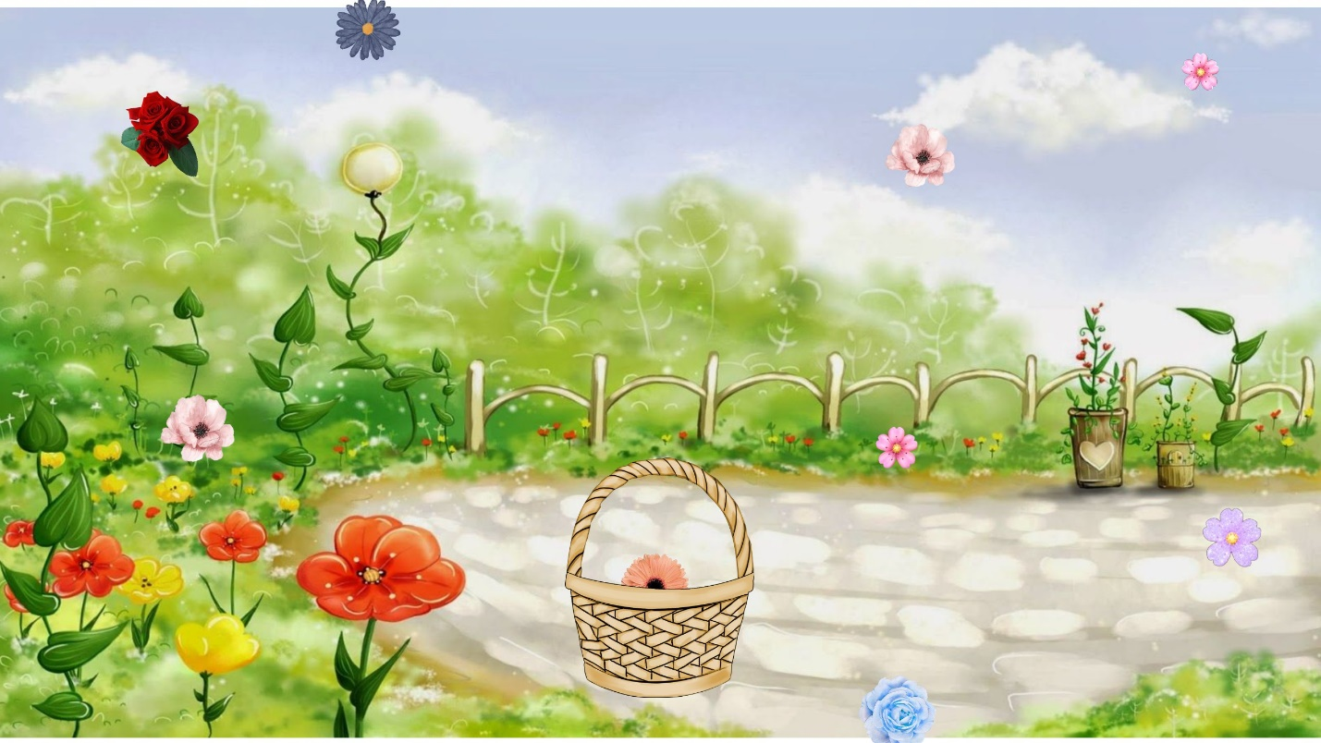

How do you plan to make your game engaging?

After collecting 50 points the game will become more and more faster

and the flowers will also starts to fall in the horizontal direction and there is some power up

boosters to make the player more fun and energetic .