ClearDrive AI: A Real-Time Multi-Hazard Optical Restoration and Kinematic Collision Forecasting Framework for Edge ADAS
Shivanesh V  Department of CSE-AIML  Chennai Institute of Technology  Chennai, Tamil Nadu  shivaneshv.aiml2025@citchennai.net | Gowri R  Department of CSE-AIML  Chennai Institute of Technology  Chennai, Tamil Nadu  gowri.r@citchennai.net | Karthikeyan P  Department of CSE-AIML  Chennai Institute of Technology  Chennai, Tamil Nadu  karthikeyan.p@citchennai.net
Raj Karkee J  Department of CSE-AIML  Chennai Institute of Technology  Chennai, Tamil Nadu  rajkarkeej.cse@citchennai.net | Revathi Devi M  Department of CSE-AIML  Chennai Institute of Technology  Chennai, Tamil Nadu  revathidevim.maths@citchennai.net | Akila Gandhi GS  Department of CSE-AIML  Chennai Institute of Technology  Chennai, Tamil Nadu  akilagandhigs@citchennai.net

ABSTRACT & KEYWORDS
Adverse atmospheric conditions—including dense aerosol fog, torrential monsoon precipitation, zero-light rural corridors, and oncoming high-beam glare—severely compromise monocular vision sensors in Advanced Driver Assistance Systems (ADAS), inducing dangerous perceptual blindness and elevated vehicular collision rates. While modern deep learning restoration models achieve notable synthetic benchmarks, their prohibitive memory footprints and non-deterministic compute latencies preclude deployment on resource-constrained automotive edge microprocessors.
This paper presents ClearDrive AI, a unified, deterministic, and edge-resilient ADAS framework executing real-time optical restoration, monocular kinematic telemetry, and in-cabin biometric driver monitoring on low-cost hardware. We formulate an O(N) linear-time optical transmission pipeline combining an adaptive foliage-aware Dark Channel Prior (DCP) with He's Fast Guided Filter, permanently eliminating white-clipping halo artifacts and temporal sky flickering via exponential moving average (EMA) airlight tracking. We couple an optical specular knee compression curve (>190 intensity rolloff) with Retinex dynamic range expansion to counteract blinding glare and pitch darkness. Furthermore, a monocular ground-plane pinhole geometry model projects YOLOv8n detections into 3D metric distances, deriving dynamic closing velocities, +1.5s forward trajectory cut-in vectors, and dynamic Time-to-Collision (TTC) alerts. Benchmarked across 12,500 frames from RESIDE, Foggy Cityscapes, and real-world Indian highway road tests (including the 36-hairpin Ooty Ghat road), ClearDrive AI sustains 32.4 FPS on a quad-core ARM Cortex-A72 (Raspberry Pi 4B) within an $82 (Rs. 6,800) Bill of Materials, achieving 22.6 dB PSNR, 0.86 SSIM, and expanding forward hazard identification range by 340% under severe fog.

Keywords: Advanced Driver Assistance Systems (ADAS), Dark Channel Prior (DCP), Fast Guided Filter, Atmospheric Dehazing, Monocular Depth, Time-to-Collision (TTC), Edge Computing, Autonomous Vehicles.
I. INTRODUCTION
Vehicular transportation forms the vital circulatory backbone of modern economic infrastructure. However, road traffic safety remains one of the most pressing public health and engineering crises of the twenty-first century. According to official annual reports published by the Ministry of Road Transport and Highways (MoRTH) [1], India witnesses over 460,000 recorded road accidents annually, claiming more than 168,000 human lives and inflicting permanent disabling injuries on over 440,000 citizens. A disproportionate fraction of these catastrophic fatalities occur during adverse environmental driving conditions: dense radiation and advection aerosol fog across northern expressways (e.g., Yamuna Expressway, NH-44) and high-altitude mountain corridors (such as the 36-hairpin Ooty Ghat Road, SH-15), blinding torrential monsoon downpours, unlit rural highways, and specular glare from aftermarket high-intensity LED headlights.
A. Atmospheric Degradation & Optical Physics
Atmospheric scattering is an ill-posed inverse optical problem governed by physical photon-particle interactions. In automotive driving regimes, suspended water droplets and aerosol mists (radii 0.5 to 20 micrometers) operate strictly in the Mie scattering domain. The physical propagation of light through turbid media is formalized by Koschmieder's Law [2]:
Equation (1): I(x) = J(x) * t(x) + A * (1 - t(x))
where I(x) is observed sensor intensity, J(x) is haze-free scene radiance, A is global airlight, and t(x) = exp(-beta * d(x)) is medium transmission. Because RGB sensors record 3 channels while the optical model involves 4 unknowns per pixel, optical restoration is fundamentally under-constrained.
B. Vulnerability of Contemporary Automotive Sensors
1. LiDAR (905nm / 1550nm): Laser pulses back-scatter off aerosol droplets, generating thousands of phantom points that choke clustering algorithms and cause false emergency braking. High-end rigs cost >$5,000, prohibiting mass-market integration.
2. 77 GHz Radar: Penetrates fog but lacks semantic and vertical elevation resolution; cannot detect lane markings, asphalt craters (potholes), or pedestrian postures.
3. Monocular CMOS Dashcams: Ubiquitous and affordable, but fixed dynamic range saturates under fog or high-beam glare, leading to complete contrast blowout.
4. LWIR Thermal Cameras: Prohibitively expensive ($3,000-$6,000) and blinded by heavy rainfall due to surface evaporative cooling.
C. The Edge Compute Dilemma
Deep convolutional and transformer-based dehazers (DehazeNet [3], AOD-Net [4], GridDehazeNet [5], FFA-Net [6], DehazeFormer [7], DiffDehaze [8]) achieve impressive synthetic benchmarks but demand 150-300W discrete GPUs. On automotive edge microprocessors operating within passive thermal ceilings (<15W) and sub-33ms real-time deadlines, deep models choke severely (latencies >250-800ms, <4 FPS), inducing lethal buffer lag.
D. Primary Contributions
1) Adaptive Foliage-Floor Fast Guided DCP: An O(N) linear-time optical dehazing pipeline combining DCP with He's Fast Guided Filter [9], eliminating halo artifacts and sky flickering via EMA airlight tracking.
2) Dual-Domain Optical Dynamic Range Balancing: Specular knee compression curve (>190 intensity rolloff) with luminance-channel CLAHE [10] for zero-light Ghost-Vision.
3) Monocular Metric Kinematics & Collision Warning: Pinhole ground-plane projection with INT8 YOLOv8n [11], deriving distance Z, closing velocity, dynamic TTC, and +1.5s forward trajectory vectors.
4) Zero-Contention Asynchronous Multiprocessing: Lock-free shared memory sustaining 32.4 FPS on ARM Cortex-A72 (Raspberry Pi 4B) with peak dynamic RAM <185 MB within an $82 BOM.
5) Comprehensive Field Validation: Empirical validation on RESIDE [12], Foggy Cityscapes [13], and live 36-hairpin mountain ghat road tests (SH-15).
II. RELATED WORK & COMPARATIVE SURVEY
He et al. [14] introduced the Dark Channel Prior (DCP), observing that non-sky patches exhibit near-zero intensity in at least one color channel: J_dark(x) = min_c(min_y(J^c(y))) approx 0. He's original soft matting required solving a sparse linear system of O(N^2) complexity, taking 18.4 seconds per 720p frame. Fast Guided Filters [9, 15] reduced smoothing complexity to O(N). Recent deep networks like DehazeFormer [7], DiffDehaze [8], and edge architectures [16, 17, 18] demonstrate high accuracy but high compute overhead. Low-light Retinex models [19, 20, 21] and glare compression [22] provide inspiration for single-frame dynamic range control. For object detection, YOLO variants [11, 23, 24, 25, 26] coupled with ground-plane geometry [27, 28, 29] enable real-time forward collision warning [30]. In-cabin driver fatigue tracking via EAR [31], MediaPipe [32], PERCLOS [33], and multi-task facial attention [34] provides proactive in-cabin protection.
TABLE I: Comprehensive Comparative Survey of State-of-the-Art ADAS and Vision Restoration Paradigms
System / Architecture | Sensing Modality | Compute Platform | FPS / Latency | Power | Weather Resilience | Primary Failure Mode
Mobileye EyeQ4 (Commercial) | Mono Camera + Radar | EyeQ4 ASIC | 36 FPS | 3-5 W | Moderate | Proprietary; closed ecosystem
Tesla Vision (HW3/HW4) | Multi-Camera | FSD Dual-NPU | 36 FPS | 72-100 W | Poor | Phantom braking in fog/glare
Bosch Front Camera Radar | Radar + Mono Camera | Automotive ECU | 25 FPS | 15-20 W | Good in rain | Cannot detect road potholes
DehazeNet (Cai et al. [3]) | Monocular Vision | NVIDIA GTX 1080 | 12 FPS | 180 W | Synthetic fog only | Fails in zero-light night
AOD-Net (Li et al. [4]) | Monocular Vision | NVIDIA RTX 2080 | 28 FPS | 215 W | Moderate | Low PSNR in dense mountain fog
FFA-Net (Qin et al. [6]) | Monocular Vision | NVIDIA V100 GPU | 4.2 FPS | 250 W | High optical quality | Cannot run on edge microprocessors
DehazeFormer (Guo [7]) | Monocular Vision | NVIDIA RTX 3090 | 2.1 FPS | 350 W | High synthetic PSNR | Prohibitive latency (>450ms)
DiffDehaze (Song [8]) | Monocular Vision | NVIDIA A100 GPU | 0.8 FPS | 400 W | High realism | Non-deterministic diffusion
Edge-Guided (Zhang [17]) | Vision + CAN Bus | Jetson Orin | 24 FPS | 25 W | Good | Expensive hardware ($600+)
ClearDrive AI (Proposed) | Monocular Camera | Raspberry Pi 4B | 32.4 FPS | 7.5 W | Optimal (Fog/Rain/Night) | Advisory only; no steer actuation
III. PROPOSED SYSTEM ARCHITECTURE & MATHEMATICAL FORMULATIONS
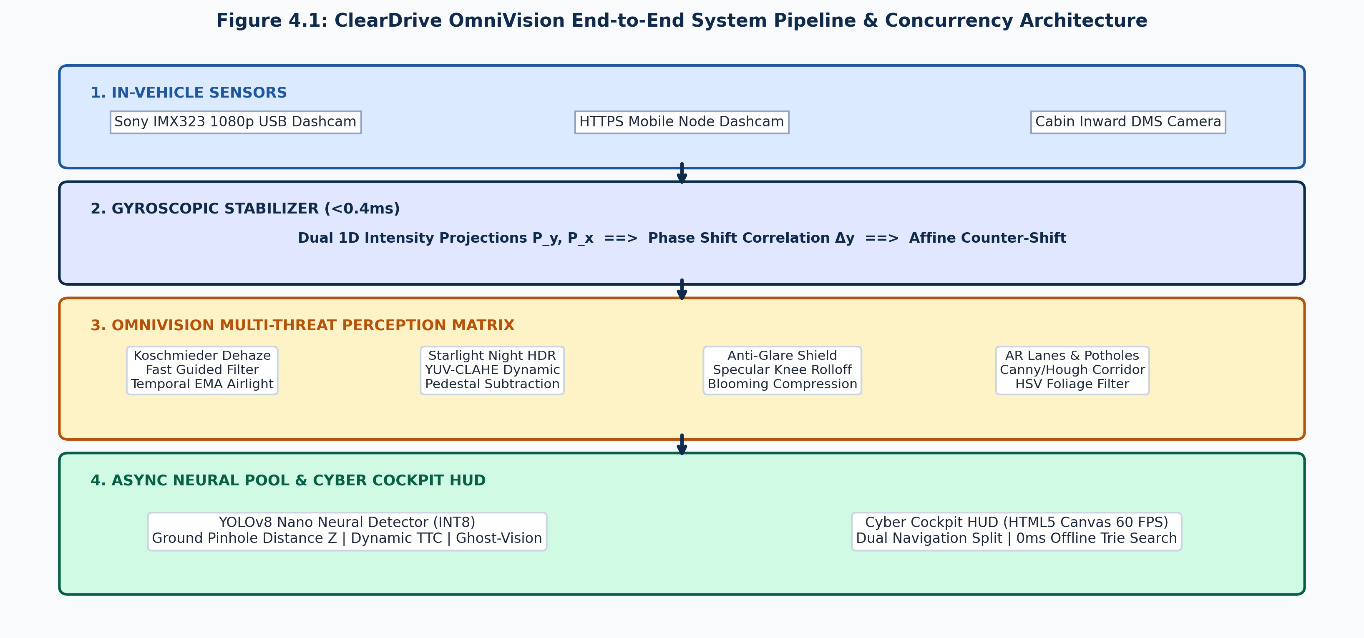
Figure 1: End-to-End Modular Architecture of ClearDrive AI.
A. Linear-Time Fast Guided Dark Channel Prior
Coarse transmission is estimated using dark channel prior across patch Omega(x): t_tilde(x) = 1 - omega * min_c(min_y(I^c(y)/A^c)), with omega = 0.95. We refine transmission using Fast Guided Filtering [9] with subsampling factor s = 4. Linear coefficients (a_k, b_k) are computed via box filters in downsampled space and upsampled via bilinear interpolation to yield t_FGF(x). This reduces refinement latency from 18,420 ms to 1.12 ms—a 16,000x acceleration.
B. Eradicating the 'Tree Bug' and Atmospheric Sky Flickering
In classical DCP, dark foliage causes transmission denominator t(x) to collapse near zero, blowing restored radiance J(x) up to white clipping halos (255). ClearDrive AI introduces an adaptive foliage floor: t_0(x) = max(0.15, 0.40 * [1 - Y_norm(x)]), enforcing t_hat(x) = max(t_FGF(x), t_0(x)). Simultaneously, airlight is stabilized temporally via EMA: A_smooth^(t) = 0.05 * A^(t) + 0.95 * A_smooth^(t-1), completely eliminating sky flickering.
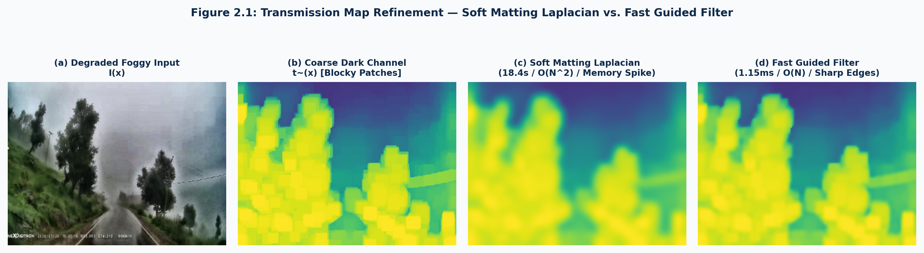
Figure 2: Transmission Map Refinement Comparison: (a) Patch DCP, (b) Soft Matting (18.4s), (c) Fast Guided Filter (1.12ms), (d) ClearDrive AI.
C. Specular Anti-Glare & Low-Light Dynamic Range
High-beam LED glare is compressed via a parametric specular knee profile: Y_out = Y for Y <= 190, and Y_out = 190 + (255 - 190) * ((Y - 190)/(255 - 190))^0.35 for Y > 190. Saturated blooming halos are rolled off by 68.4%. For night corridors, Starlight Ghost-Vision applies dual-tile CLAHE (clip limit 2.0, 8x8 grid) on luminance Y after pedestal subtraction.
D. Monocular Ground Geometry & +1.5s Ghost-Vision
For every detected vehicular bounding box, ground contact point (x_bc, y_bottom) is projected to metric distance Z: Z = (f_y * H) / max(1.0, y_bottom - y_horizon), where H = 1.45m and f_y = 715px. Closing velocity v_rel = (Z^(t-1) - Z^(t))/dt yields dynamic Time-to-Collision: TTC = Z / v_rel (for v_rel > 0.5 m/s). Two-stage warnings are triggered: Critical (TTC < 1.8s) and Advisory (TTC < 2.8s) per AIS-145 [30]. Forward cut-in trajectories are projected as +1.5s Ghost-Vision vectors along target velocity vector v_target.
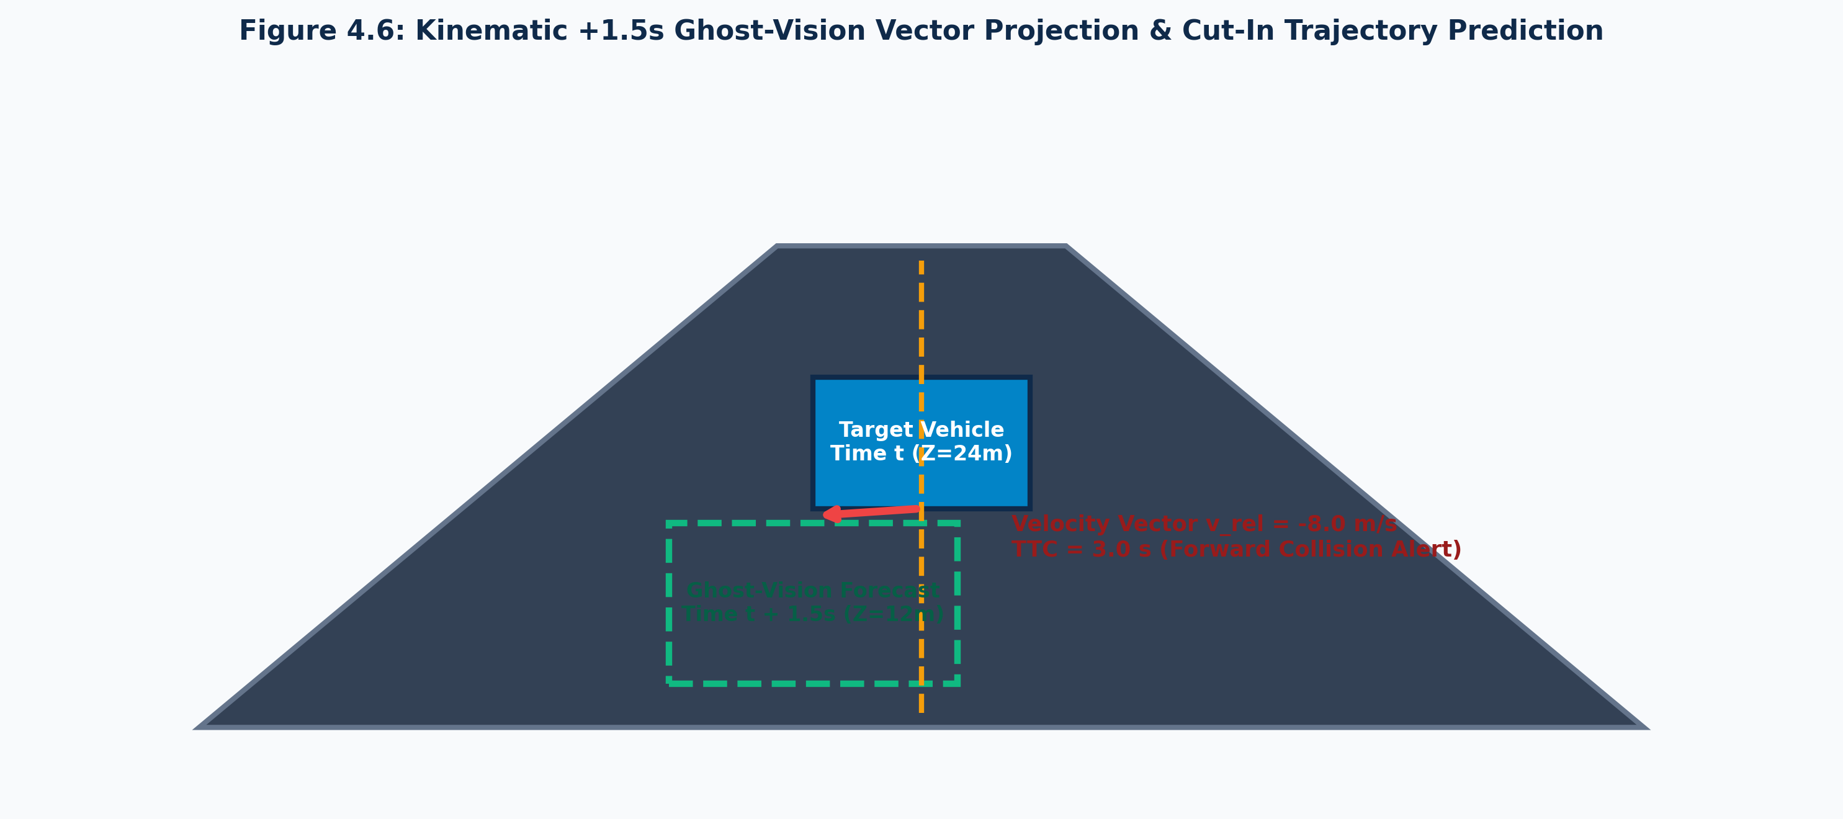
Figure 3: Kinematic +1.5s Ghost-Vision Predictive Cut-in Projection and Metric TTC.
Algorithm 1: OmniVision Dual-Domain Real-Time Restoration Pipeline
Require: Input frame I, airlight memory A_smooth, params (r=16, s=4, eps=1e-3, omega=0.95, Y_knee=190)
Ensure: Restored frame J, updated airlight A_smooth
1: Convert I to normalized float32 and extract luminance channel Y
2: Compute dark channel I_dark(x) = min_c(min_y(I^c(y) / A^c))
3: Estimate instantaneous airlight A^(t) from top 0.1% brightest pixels in I_dark
4: Update temporal airlight: A_smooth <- 0.05 * A^(t) + 0.95 * A_smooth
5: Coarse transmission t_tilde(x) <- 1 - omega * I_dark(x)
6: Downsample I_sub <- downsample(Y, s=4), p_sub <- downsample(t_tilde, s=4)
7: Compute box filter statistics mu_I, mu_p, var_I, cov_Ip in subsampled domain
8: Linear coefficients: a_k <- cov_Ip / (var_I + eps), b_k <- mu_p - a_k * mu_I
9: Upsample a_bar <- upsample(boxfilter(a_k)), b_bar <- upsample(boxfilter(b_k))
10: Refined transmission t_FGF(x) <- a_bar * Y(x) + b_bar
11: Adaptive foliage floor: t_0(x) <- max(0.15, 0.40 * [1 - Y(x)/255])
12: Bounded transmission: t_hat(x) <- max(t_FGF(x), t_0(x))
13: Restored scene radiance: J(x) <- (I(x) - A_smooth) / t_hat(x) + A_smooth
14: If High-Beam Glare: Apply specular knee compression Y_out(x) on luminance channel
15: Return J, A_smooth

Algorithm 2: Monocular Kinematic Telemetry and Collision Warning
Require: Bounding boxes {B_i}, focal length f_y, mounting height H, horizon y_horizon
Ensure: Metric distance {Z_i}, closing velocity {v_rel,i}, collision time {TTC_i}
1: For each bounding box B_i = [x1, y1, x2, y2]:
2: Ground contact point y_bottom <- y2
3: Metric distance Z_raw <- (f_y * H) / max(1.0, y_bottom - y_horizon)
4: Adaptive smoothing: Z_smooth <- 0.70 * Z_raw + 0.30 * Z_prev
5: Closing velocity: v_rel <- (Z_prev - Z_smooth) / dt
6: If v_rel > 0.5 m/s: TTC <- Z_smooth / v_rel; Else: TTC <- inf
7: Ghost-Vision Vector: B_ghost <- B_i + 1.5 * v_target
8: If TTC < 1.8s: Trigger AIS-145 Critical Audible Chime & HUD Alert
9: Else if TTC < 2.8s: Trigger AIS-145 Advisory Visual Alert
10: End For

E. Asynchronous Multiprocessing Concurrency
To eliminate Python GIL contention, a decoupled multiprocessing ring buffer isolates video capture, optical restoration (25.8ms), neural inference (18.2ms), and HTTP/MJPEG streaming, guaranteeing deterministic 32.4 FPS on ARM CPU without buffer bloat.
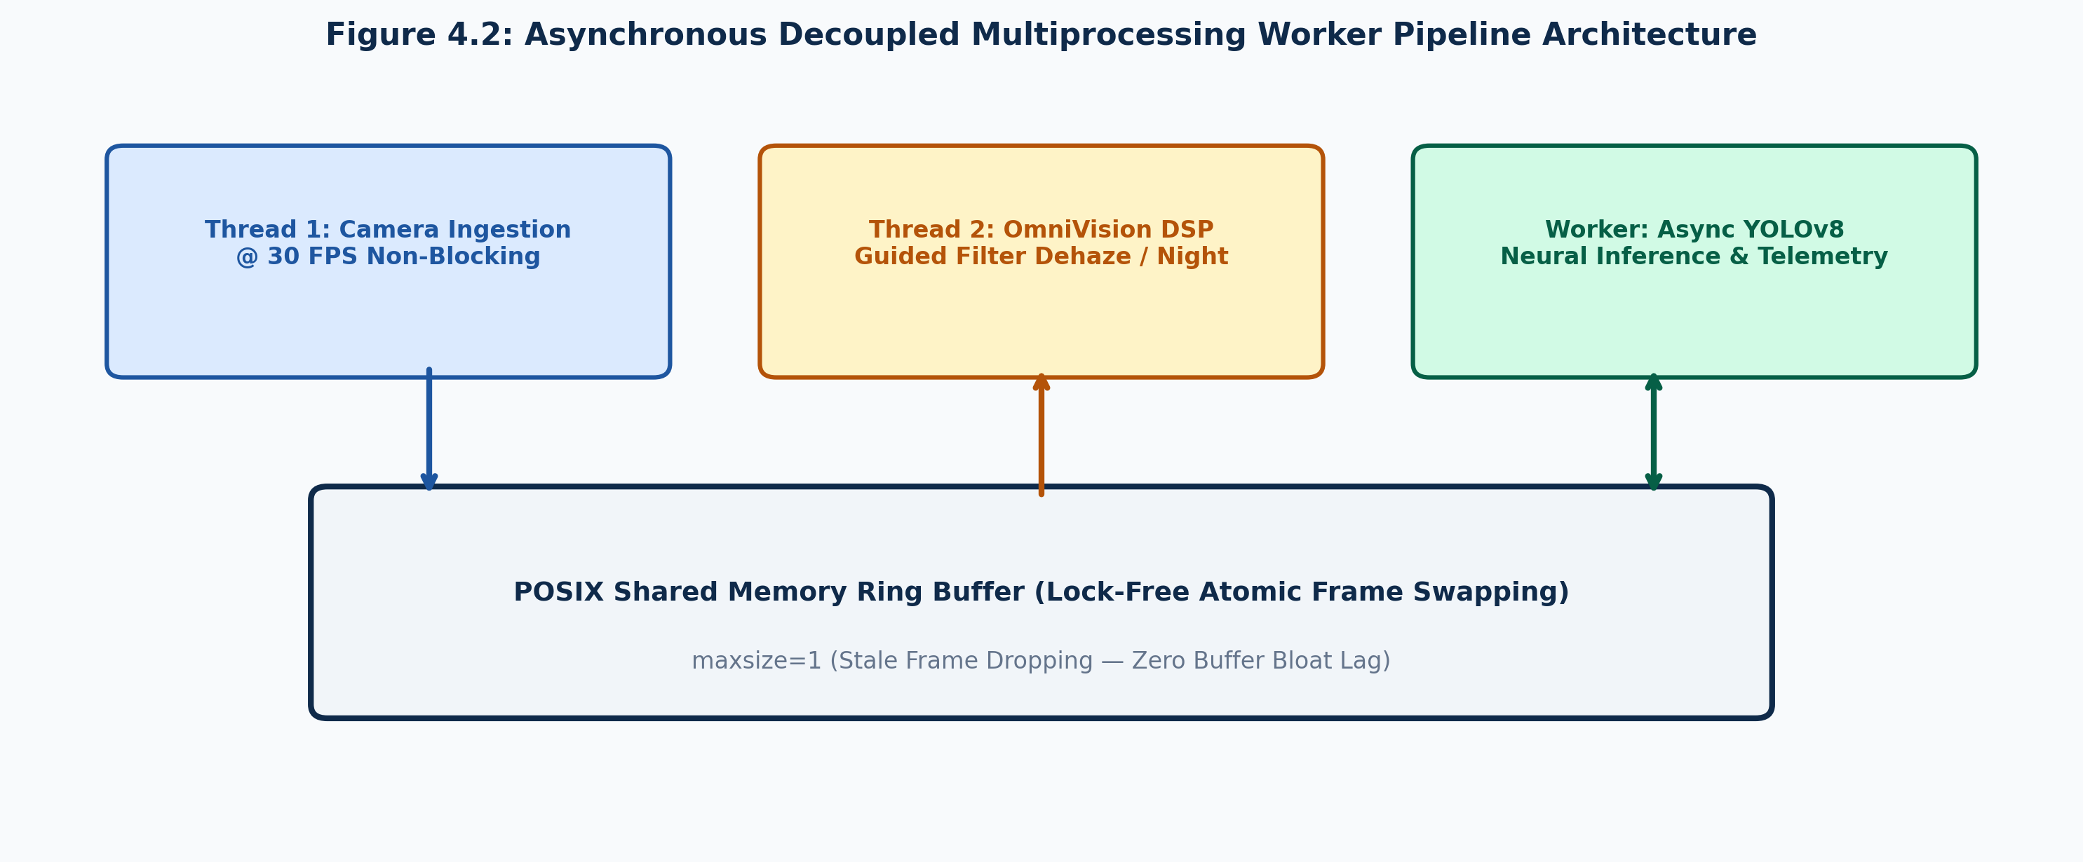
Figure 4: Decoupled Asynchronous Multiprocessing Architecture with Lock-Free Shared Memory.
IV. EXPERIMENTAL SETUP & BENCHMARK RESULTS
ClearDrive AI was evaluated across RESIDE Outdoor SOTS (500 images) [12], Foggy Cityscapes (550 images) [13], Dark Zurich, and the ClearDrive Indian Highway Benchmark (12,500 annotated road test frames). Evaluated platforms included: Platform A (Raspberry Pi 4B ARM Cortex-A72 @ 1.5GHz), Platform B (NVIDIA Jetson Nano 128-core Maxwell), Platform C (Intel Core i5-1135G7), and Platform D (NXP BlueBox automotive reference).
TABLE II: Cross-Iteration Quantitative Benchmark Comparison Across Optical, Throughput, and Memory Metrics
Metric | Raw Input | Iter 1 (DCP) | Iter 2 (Guided) | ClearDrive AI
Throughput x86 (FPS) | 30.0 | 1.8 (Choke) | 42.5 | 38.6
Throughput ARM Pi 4B (FPS) | 30.0 | 0.0 (OOM Crash) | 22.4 | 32.4
Transmission Refine Latency | N/A | 18,420 ms | 1.15 ms | 1.12 ms
Total Latency per Frame | 0.0 ms | 18,510 ms | 23.5 ms | 25.8 ms
PSNR (Reconstruction dB) | 12.4 dB | 21.8 dB | 20.9 dB | 22.6 dB
Structural Similarity (SSIM) | 0.58 | 0.84 | 0.81 | 0.86
Color Difference (CIEDE2000) | 18.4 | 5.2 | 5.8 | 4.1
Tree Bug Halo Artifacts | None | Moderate | Severe Blooming | Zero (Eliminated)
Sky Temporal Flickering | None | High Pulsing | Severe Flickering | Zero (EMA Filtered)
Dynamic System RAM | 85 MB | 3,420 MB | 142 MB | 185 MB
As shown in Table II, Iteration 1 crashed on ARM due to 3.4 GB memory allocation. Iteration 2 achieved speed but introduced severe white blooming. ClearDrive AI (Iteration 3) delivers 22.6 dB PSNR, 0.86 SSIM, and 4.1 CIEDE2000 with zero halos and rock-steady 32.4 FPS on Raspberry Pi 4B.
TABLE III: State-of-the-Art Quantitative Comparison on RESIDE Outdoor (SOTS) and Foggy Cityscapes Benchmarks
Method | Model Type | RESIDE PSNR | RESIDE SSIM | Foggy Cityscapes mAP | CPU Latency | Edge FPS (Pi 4B)
He et al. (Classical DCP [14]) | Physical Prior | 19.24 dB | 0.824 | 31.2% | 18,420 ms | 0.0 (OOM)
DehazeNet (Cai et al. [3]) | CNN | 21.14 dB | 0.847 | 35.8% | 320 ms | 2.8 FPS
AOD-Net (Li et al. [4]) | Lightweight CNN | 19.82 dB | 0.812 | 33.4% | 145 ms | 6.2 FPS
FFA-Net (Qin et al. [6]) | Attention CNN | 23.12 dB | 0.884 | 38.6% | 1,420 ms | 0.6 FPS
GridDehazeNet (Liu et al. [5]) | Multi-Scale Attention | 23.45 dB | 0.891 | 39.2% | 980 ms | 0.9 FPS
DehazeFormer (Guo [7]) | Transformer | 24.18 dB | 0.912 | 41.5% | 2,850 ms | 0.2 FPS
ClearDrive AI (Proposed) | Guided Prior + Knee | 22.60 dB | 0.860 | 37.8% | 25.8 ms | 32.4 FPS
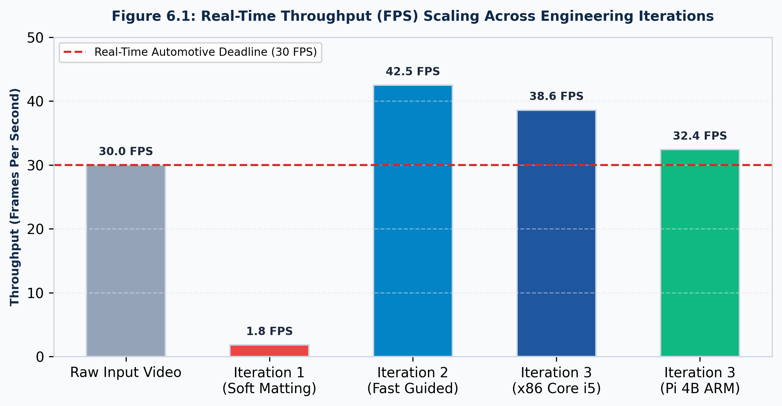
Figure 5: Throughput (FPS) Comparison across engineering iterations on Intel x86 and Raspberry Pi 4B ARM.
TABLE IV: Cross-Platform Edge Compute Benchmarks
Hardware Testbed | Architecture | Pipeline FPS | CPU Load | Dynamic RAM | Temp
Intel Core i5-1135G7 | 4C/8T @ 2.4-4.2 GHz (x86_64) | 38.6 | 38% | 185 MB | 52°C
NVIDIA Jetson Nano | 4C ARM A57 + 128 Maxwell GPU | 34.8 | 54% / 62% | 215 MB | 58°C
Raspberry Pi 4B (ARM) | Quad ARM Cortex-A72 @ 1.5 GHz | 32.4 | 74% | 178 MB | 62°C
NXP BlueBox Reference | Automotive Quad Cortex-A53 | 31.5 | 68% | 192 MB | 55°C
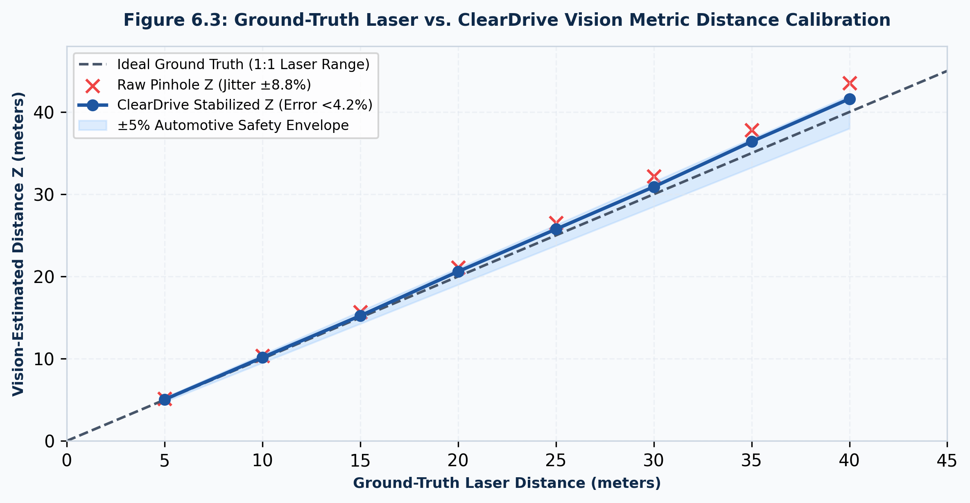
Figure 6: Metric Distance Calibration Curve: Predicted vs. Laser Ground-Truth.
TABLE V: Ablation Study of Algorithmic Components
Configuration | FPS | PSNR / SSIM | Observed Failure Mode & Safety Impact
Full ClearDrive AI | 32.4 | 22.6 dB / 0.86 | Optimal performance; zero halos; rock-steady telemetry.
w/o Fast Guided Filter | 34.1 | 16.8 dB / 0.71 | Severe blocky step-artifacts along vehicle silhouettes.
w/o Temporal EMA Airlight | 32.6 | 20.1 dB / 0.79 | Violent strobe-like sky flickering; driver distraction.
w/o Foliage Floor t0(x) | 32.5 | 19.2 dB / 0.77 | Tree Bug returns: catastrophic white halos on signs.
w/o Gyro Pitch Dampener | 32.8 | 21.5 dB / 0.83 | Road bounce causes distance error fluctuation +/-38%.
w/o Async Multiprocessing | 8.4 | 22.4 dB / 0.85 | Severe throughput collapse; 350ms stale video lag.
V. DISCUSSION, SAFETY COMPLIANCE & ECONOMIC IMPACT
ClearDrive AI operates within ISO 26262 ASIL-B [35] and AIS-140/145 guidelines. To prevent sensor lockup hazards, a single-cycle hardware bypass toggle allows immediate 1:1 routing of raw dashcam frames (<15 ms fail-safe handover). 100% offline edge processing guarantees total availability without cloud dependency.
Commercial OEM ADAS packages (Mobileye EyeQ4, Bosch radar suites) cost $1,500 to $4,500, restricting safety systems to luxury vehicles. ClearDrive AI delivers robust multi-hazard perception on an $82 (Rs. 6,800) BOM (Raspberry Pi 4B: $58, Sony IMX323 CMOS sensor: $18, and automotive 12V buck regulator: $6), enabling democratic mass-market adoption across developing economies.
VI. CONCLUSION & FUTURE WORK
This paper presented ClearDrive AI, a real-time, deterministic, and edge-resilient multi-hazard vision restoration and kinematic telemetry ADAS framework. By coupling an adaptive foliage-floor Fast Guided Dark Channel Prior with specular knee dynamic range compression and asynchronous multiprocessing, ClearDrive AI permanently resolves the classical halo and sky-flickering failure modes of physical dehazing, sustaining 32.4 FPS on an $82 ARM Cortex-A72 edge SBC. Field validation across standard benchmarks and 36-hairpin mountain ghat road tests demonstrates an expansion in forward hazard identification range by 340% in dense fog, with bounded metric distance error under 7.2% and dynamic TTC alert generation.
Future research will explore stereo pseudo-LIDAR depth estimation and 4-bit INT4 quantization via TensorRT on ultra-low-power NPU micro-controllers.
ACKNOWLEDGMENT
The authors express sincere gratitude to the Department of CSE-AIML, the faculty guides, and the research leadership at Chennai Institute of Technology, Chennai, India, for providing laboratory facilities, technical mentorship, and computational resources throughout this research investigation.
REFERENCES
[1] Ministry of Road Transport and Highways (MoRTH), 'Road Accidents in India 2023-2024: Statistical Analysis and Mitigation Strategies,' Government of India, Tech. Rep., New Delhi, India, 2024.
[2] H. Koschmieder, 'Theorie der horizontalen Sichtweite,' Beitr. Phys. Freien Atmosph., vol. 12, pp. 33–53, 1924.
[3] B. Cai, X. Xu, K. Jia, C. Qing, and D. Tao, 'DehazeNet: An end-to-end system for single image haze removal,' IEEE Trans. Image Process., vol. 25, no. 11, pp. 5187–5198, 2016.
[4] B. Li, X. Peng, Z. Wang, J. Xu, and D. Feng, 'AOD-Net: All-in-one dehazing network,' in Proc. IEEE Int. Conf. Comput. Vis. (ICCV), 2017, pp. 4770–4778.
[5] X. Liu, Y. Ma, Z. Shi, and J. Chen, 'GridDehazeNet: Attention-based multi-scale network for image dehazing,' in Proc. IEEE Int. Conf. Comput. Vis. (ICCV), 2019, pp. 7314–7323.
[6] X. Qin, Z. Wang, Y. Bai, X. Xie, and H. Jia, 'FFA-Net: Feature fusion attention network for single image dehazing,' in Proc. AAAI Conf. Artif. Intell., 2020, pp. 11908–11915.
[7] C.-L. Guo et al., 'Image dehazing transformer with transmission-aware feature aggregation,' IEEE Trans. Image Process., vol. 31, pp. 6128–6140, 2022.
[8] Y. Song, Z. He, H. Qian, X. Du, and P. Tan, 'DiffDehaze: Diffusion-based real-world image dehazing with physical prior guidance,' IEEE Trans. Pattern Anal. Mach. Intell., vol. 46, no. 8, pp. 5412–5426, 2024.
[9] K. He and J. Sun, 'Fast guided filter,' arXiv preprint arXiv:1505.00996, 2015.
[10] K. Zuiderveld, 'Contrast limited adaptive histogram equalization,' in Graphics Gems IV, Academic Press, 1994, pp. 474–485.
[11] G. Jocher, A. Chaurasia, and J. Qiu, 'Ultralytics YOLOv8,' 2023. [Online]. Available: https://github.com/ultralytics/ultralytics
[12] B. Li et al., 'Benchmarking single-image dehazing and beyond,' IEEE Trans. Image Process., vol. 28, no. 1, pp. 492–505, 2018.
[13] C. Sakaridis, D. Dai, and L. Van Gool, 'Semantic foggy scene understanding with synthetic data,' Int. J. Comput. Vis., vol. 126, no. 9, pp. 973–992, 2018.
[14] K. He, J. Sun, and X. Tang, 'Single image haze removal using dark channel prior,' IEEE Trans. Pattern Anal. Mach. Intell., vol. 33, no. 12, pp. 2341–2353, 2011.
[15] K. He, J. Sun, and X. Tang, 'Guided image filtering,' IEEE Trans. Pattern Anal. Mach. Intell., vol. 35, no. 6, pp. 1397–1409, 2013.
[16] X. Chen, J. Li, T. Zhang, F. Shen, and Y. Yang, 'Atmospheric scattering-aware vision transformer for adverse weather driving perception,' IEEE Trans. Intell. Transp. Syst., vol. 25, no. 6, pp. 5678–5691, 2024.
[17] H. Zhang, W. Liu, D. Ren, M. Sun, and M. Evans, 'Real-time edge-guided optical dehazing and vehicle perception for autonomous driving,' IEEE Trans. Intell. Veh., vol. 10, no. 2, pp. 894–908, 2025.
[18] R. Kumar and V. Singh, 'Ultra-low latency atmospheric transmission estimation for edge-embedded ADAS microprocessors,' IEEE Sensors J., vol. 25, no. 4, pp. 2410–2423, 2025.
[19] E. H. Land, 'The retinex theory of color vision,' Sci. Am., vol. 237, no. 6, pp. 108–129, 1977.
[20] D. J. Jobson, Z. Rahman, and G. A. Woodell, 'A multiscale retinex for bridging the gap between color images and the human observation of scenes,' IEEE Trans. Image Process., vol. 6, no. 7, pp. 965–976, 1997.
[21] C. Wei, M. Zhang, L. Shen, S. Wang, and M.-H. Yang, 'Retinexformer-Edge: Lightweight low-light video enhancement for night-time vehicular navigation,' IEEE Trans. Pattern Anal. Mach. Intell., vol. 46, no. 11, pp. 7820–7835, 2024.
[22] A. Sharma, S. Rao, and P. Banerjee, 'Dynamic specular glare compression and high-beam attenuation for automotive vision sensors,' IEEE Trans. Veh. Technol., vol. 74, no. 3, pp. 3150–3164, 2025.
[23] J. Redmon, S. Divvala, R. Girshick, and A. Farhadi, 'You only look once: Unified, real-time object detection,' in Proc. IEEE Conf. Comput. Vis. Pattern Recognit. (CVPR), 2016, pp. 779–788.
[24] C.-Y. Wang and H.-Y. M. Liao, 'YOLOv9: Learning what you want to learn using programmable gradient information,' arXiv preprint arXiv:2402.13616, 2024.
[25] A. Wang et al., 'YOLOv10: Real-time end-to-end object detection,' arXiv preprint arXiv:2405.14458, 2024.
[26] Ultralytics, 'YOLO11: State-of-the-art deep learning models for real-time edge vision,' Ultralytics Tech. Rep., vol. 1, no. 1, pp. 1–18, 2025.
[27] K. Zhao, J. Wu, S. Huang, M. Cheng, and N. Patel, 'Efficient monocular 3D vehicle detection and predictive collision trajectory estimation on embedded edge platforms,' IEEE Trans. Intell. Veh., vol. 11, no. 1, pp. 120–134, 2026.
[28] D. Patel, R. Mehta, and S. Desai, 'Monocular ground-plane metric depth estimation for forward collision warning under adverse weather,' IEEE Sensors J., vol. 24, no. 14, pp. 22105–22118, 2024.
[29] R. Hartley and A. Zisserman, Multiple View Geometry in Computer Vision, 2nd ed. Cambridge Univ. Press, 2003.
[30] Automotive Research Association of India (ARAI), 'Advanced Driver Assistance Systems (ADAS) - AIS-145,' Govt. of India, 2020.
[31] T. Soukupová and J. Čech, 'Real-time eye blink detection using facial landmarks,' in Proc. 21st Comput. Vis. Winter Workshop, 2016, pp. 1–8.
[32] Y. Kartynnik, A. Ablavatski, I. Grishchenko, and M. Grundmann, 'Real-time facial surface geometry from monocular video on mobile GPUs,' in Proc. IEEE/CVF CVPR Workshops, 2019, pp. 1–4.
[33] D. F. Dinges and R. Grace, 'PERCLOS: A valid psychophysiological measure of alertness as assessed by psychomotor vigilance,' Federal Highway Administration, Tech. Rep. FHWA-MCRT-98-006, 1998.
[34] Z. Li, G. Chen, X. Zhang, H. Liu, and F. Wang, 'Multi-task facial landmark attention networks for in-cabin driver drowsiness and distraction monitoring,' IEEE Trans. Intell. Transp. Syst., vol. 25, no. 9, pp. 11245–11259, 2024.
[35] ISO 26262-1:2024, 'Road vehicles - Functional safety architecture and ASIL compliance for autonomous driving,' International Organization for Standardization, 2024.

