**Mini Project Report on**



**Design a Breakout Ball Game**



**Submitted in partial fulfillment of the requirement for the award of the degree of**

**BACHELOR OF TECHNOLOGY**

**IN**

**COMPUTER SCIENCE & ENGINEERING**

**Submitted by:**

**Name: Shivang Mahendra**  **University Roll No: 2019103**

***Under the Mentorship of***

**Ms. Tanusha Mittal**

**Assistant Professor**



**Department of Computer Science and Engineering**

**Graphic Era (Deemed to be University)**

**Dehradun, Uttarakhand**

**January 2023**



**CANDIDATE’S DECLARATION**

I hereby certify that the work which is being presented in the project report entitled **“Design a Breakout Ball Game”** in partial fulfillment of the requirements for the award of the Degree of Bachelor of Technology in Computer Science and Engineeringof the Graphic Era (Deemed to be University), Dehradun shall be carried out by the under the mentorship of **Ms. Tanusha Mittal, Assistant Professor**, Department of Computer Science and Engineering, Graphic Era (Deemed to be University), Dehradun.

Name: Shivang Mahendra University Roll No: 2019103 **signature**

**Table of Contents**

| **Chapter No.** | **Description** | **Page No.** |
| --- | --- | --- |
| Chapter 1 | Introduction | 1-3 |
| Chapter 2 | Literature Survey | 4 |
| Chapter 3 | Methodology | 5-10 |
| Chapter 4 | Result and Discussion | 11-13 |
| Chapter 5 | Conclusion and Future Work | 14 |
|  | References | 15 |

**Chapter 1**

**Introduction**

# **Problem Statement**

This project is about ***Designing a Breakout Ball Game using Java*** for users to play and enjoy.

And also to understand the concepts of Java Swing and solve real world problems using Java.

* 1. **Breakout Ball Game**

Breakout Ball Game is a simple arcade video game. It was developed by Atari.Inc. It was released on 13th May, 1976. It was designed and implemented by Steve Wozniak, based on the concepts from Nolan Bushnell and Steve Bristow who were influenced by Pong, another arcade game by Atari.Inc.

In Breakout Ball Game, there are a number of obstacles or bricks on top of the screen

that covers almost one-third of the screen. The goal of the game is to destroy all the bricks with the help of a bouncing ball and slider (paddle) through which the ball bounces back. Player gets 5 points for destroying each brick.

When all the bricks are destroyed, the player wins the game.

When the player misses to bounce back the ball using slider or paddle and the ball goes out of the screen, the player loses the game.

Breakout Ball Game was a huge worldwide success and due to this it many programmer create many versions of it. It was among the top five highest grossing arcade video games of 1976 and in the top three highest grossing arcade video games of 1977 in Japan and United states.

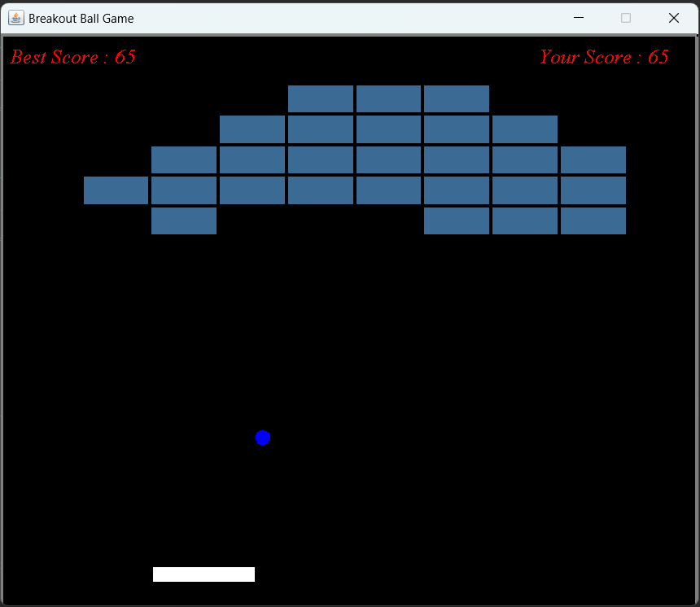

**Fig 1.1: Breakout Ball Game**

**1.3 Java and Java Swing**

Java is a simple programming language, which was created in 1995. It is owned by Oracle. It was developed by James Gosling. It is class-based, object-oriented, programming language. Java code is platform independent i.e. it can run on all platforms.

The main features of Java:

* Object-Oriented Programming Language
* Secure
* Portable
* High Performance
* Platform independent
* Dynamic flexibility
* Simple

Java Swing is a Java Foundation Classes (JFC) library. It is built on the foundation of the Abstract Window Toolkit (AWT). It was introduced in 1997 to Java Foundation Classes (JFC). It is a set of APIs that provides the graphical user Interface (GUI) for Java programs. It was created to address the limitations present in the AWT. The two major key features of Java Swing are:

* Lightweight Components
* A Pluggable Look and Feel

**Chapter 2**

**Literature Survey**

The Breakout Ball Game was designed by Steve Wozniak, based on the concepts of Nolan Bushnell and Steve Bristow, who were influenced by another Atari.Inc. game called Pong. This game was a huge success and an entire genre of clones spawnned after its release in May, 1972. Many versions of the game were released by different developers worldwide.

The first step is to create a slider or paddle and a ball. The slider should be able to move on the screen and should be able to remain in the screen even if the arrow keys are pressed for too long. The length of slider should decreases as the level increases of the game. And the code should be able to detect if the ball collides with the paddle and tiles and bounce back destroying the tile.

The next step is to create rows of tiles or bricks that are to be destroyed in order to win the game. The tiles should be created keeping in mind the spaces to be left from the sides and the top and such that the tiles are in the upper part of the screen. And the number of tiles should depend upon the level of game i.e. upon the difficulty of the game.

Java should be fast enough for almost all of the games but due to lack of expertise and due to lack of game development frameworks, programmers don’t consider Java as a programming language for games. In terms of machine speed, Java is faster than C++. A properly written Java code doesn’t suffer from gigahertz pauses. It requires active memory management but less than what is required by C/C++.

Game programmers use Java because Java supports multithreading and socket. Multithreading uses less memory and uses the most what is obtainable from mainframe. Sockets help in building multiplayer games. And also Java runs on virtual machine, thus the game is easier to distribute.

In the game, we have to use a timer to create a game cycle. And we don’t work with angles, instead we work with directions top, bottom, left, right.

**Chapter 3**

**Methodology**

In the game, there is a slider whose length depends upon the level the player is playing, one ball, and the total number of tiles depends on the level on which the player is playing using graphics class in java. I have used the timer class to create a cycle. The game consists of 3 java files:

* Main.java
* Game.java
* tiles.java
  1. **Designing Game Window**

I created a project named “BreakoutBallGame” in eclipse IDE. And in that project I have created a package called “Game” and three classes in that package. The three classes are: *Main.java, Game.java, tiles.java.*

In the main method, I have created an object reference jf of JFrame. And with the help of jf I have designed the game window. Also I have created an object of Game class to run the breakout ball game.

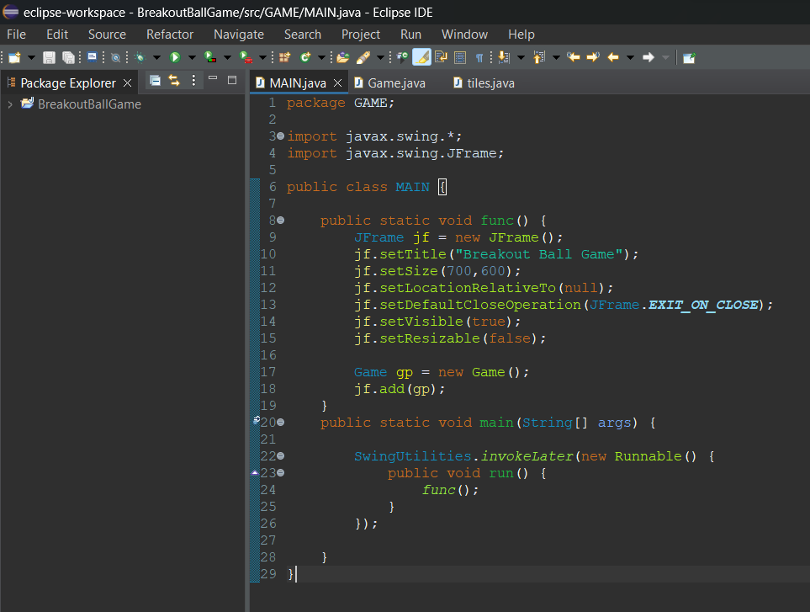

**Fig 3.1: Main class**

* 1. **Designing Game**

I have created a class named Game which inherits (extends) JPanel. This class is the panel where the game will work. I am using the timer class to create a class and setting speed of the ball. I have created a constructor with no parameter to initialize Timer object and. I am using public method paint () to draw background, border, slider whose length decreases as the level increases and ball and to display instructions and messages.

It also implements KeyListner and ActionListener to move slider left and right, to restart game when enter key is pressed and to pause and continue game when ESC key is pressed.

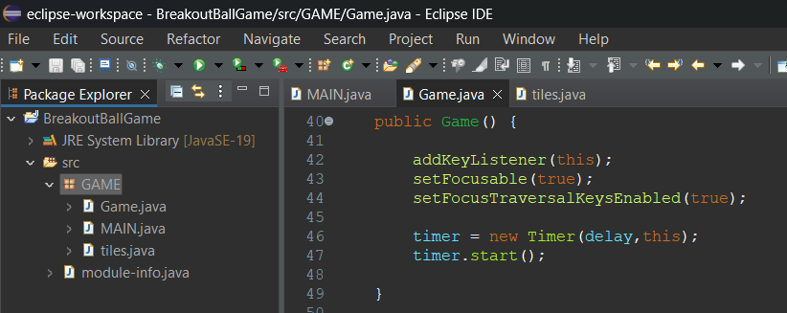

**Fig 3.2: Game() Constructor**

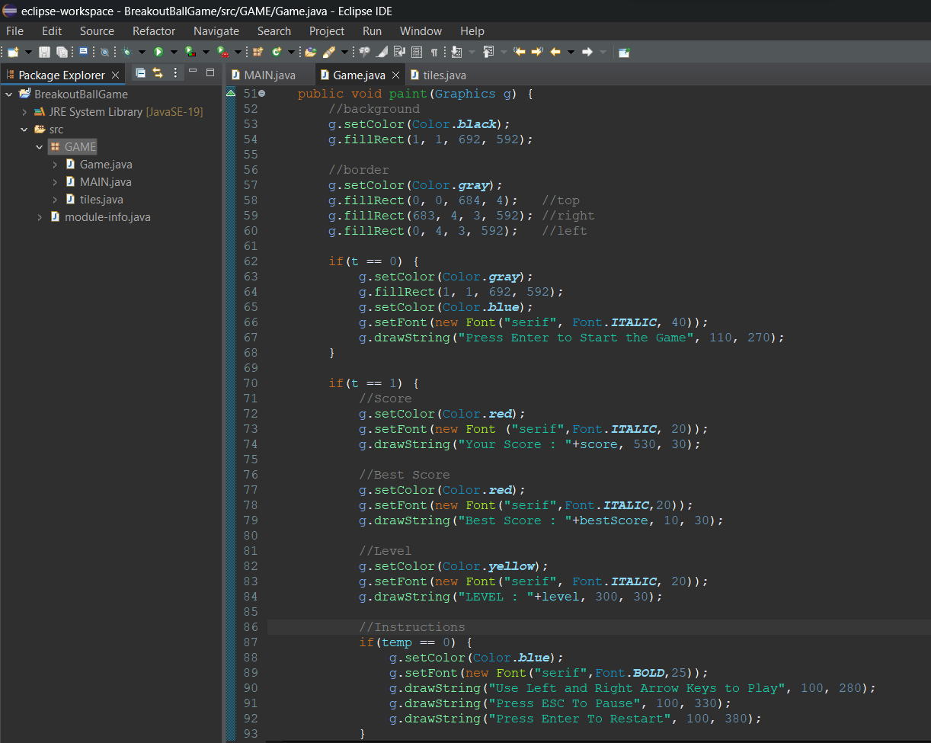

**Fig 3.3(a): paint() method**

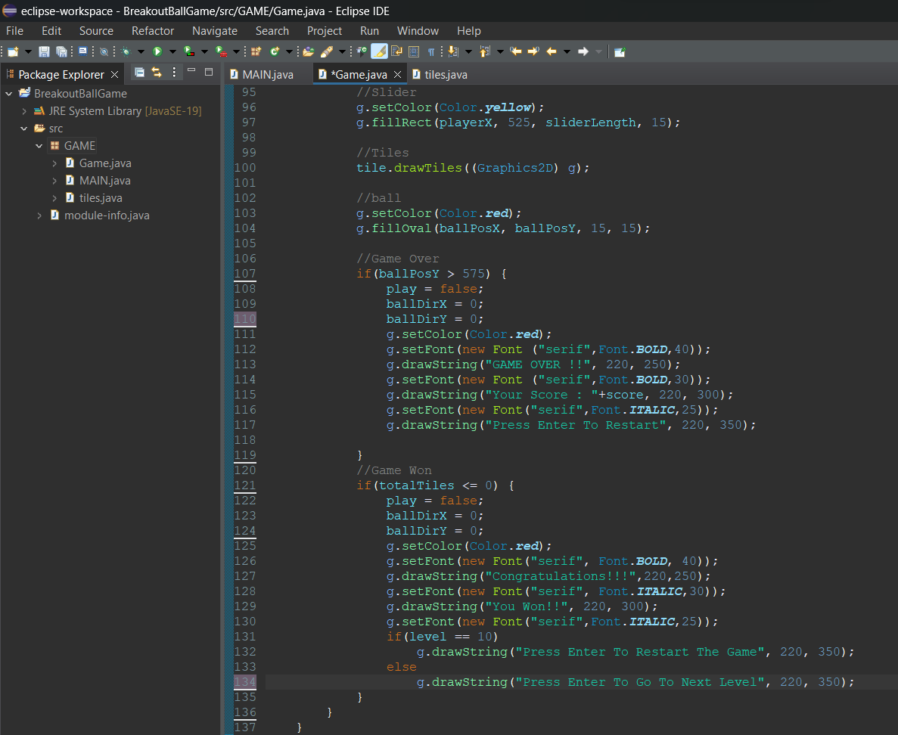

**Fig 3.3(b): paint() method**

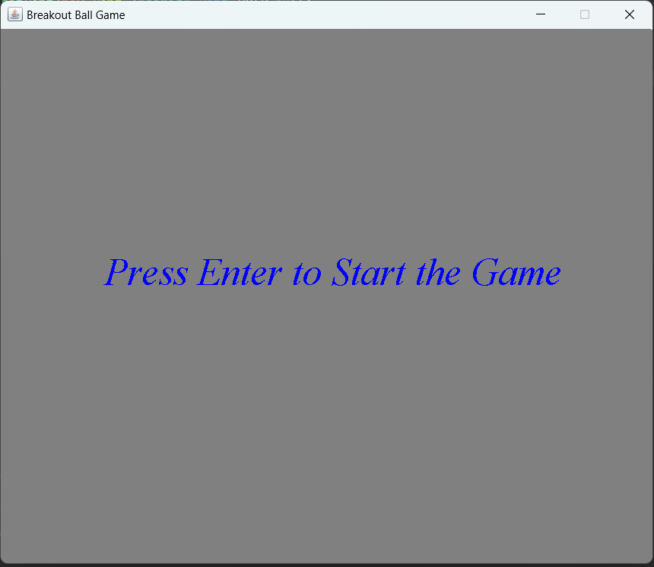

**Fig 3.4(a): Output of paint() method**

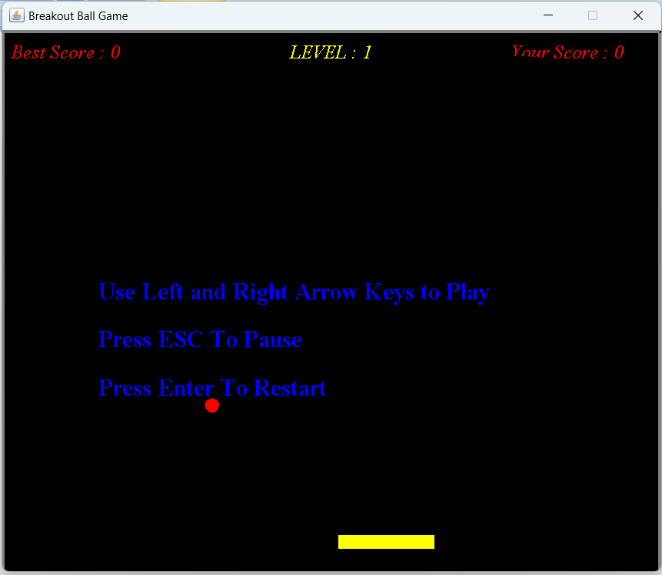

**Fig 3.4(b): Output of paint() method**

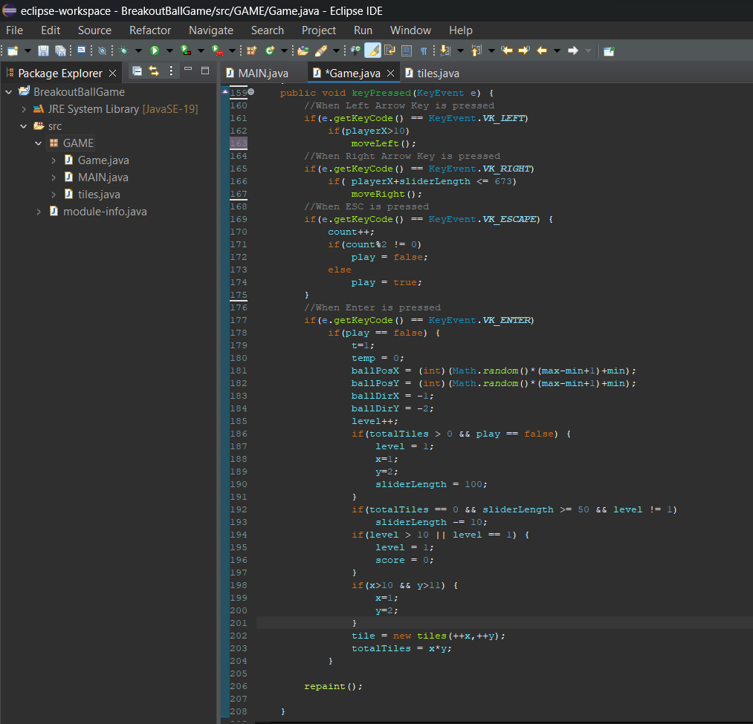

**Fig 3.5: keyPressed method**

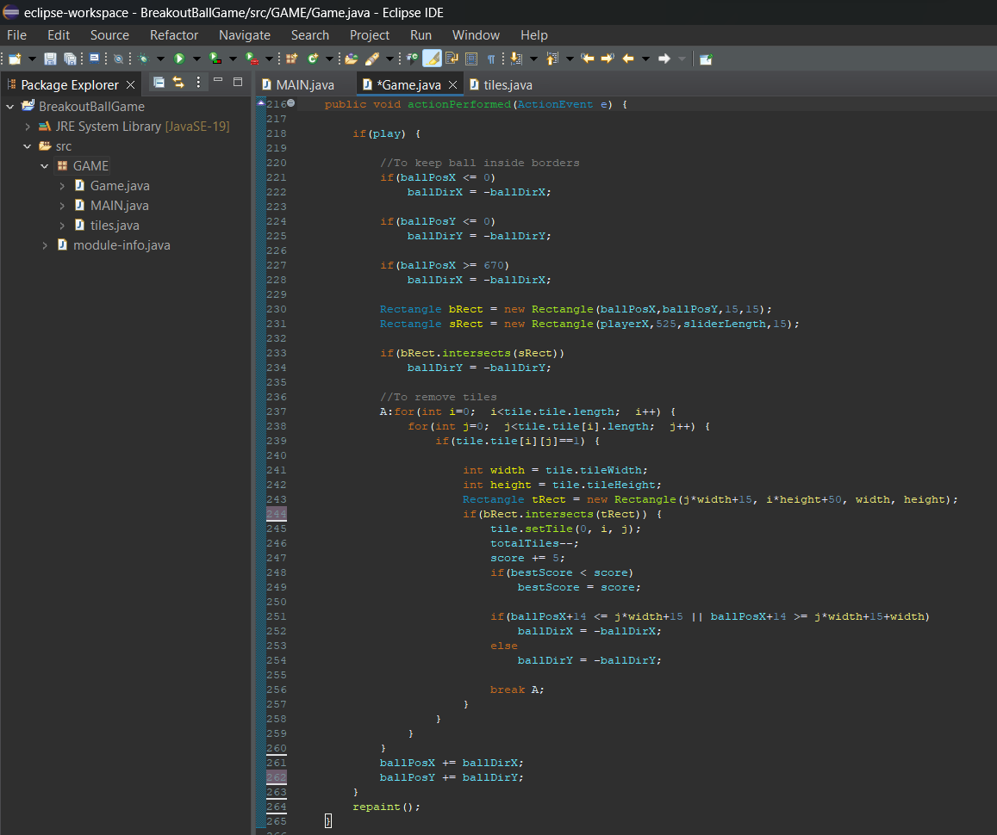

**Fig 3.6: actionPerformed method**

* 1. **Designing tiles**

I have created this tiles class to generate tiles which the player needs to destroy to win the game. I have invoked the drawTiles() method in the above paint() method to draw the tiles on the screen which are to be destroyed to win and the number of tiles depends upon the level player is playing.

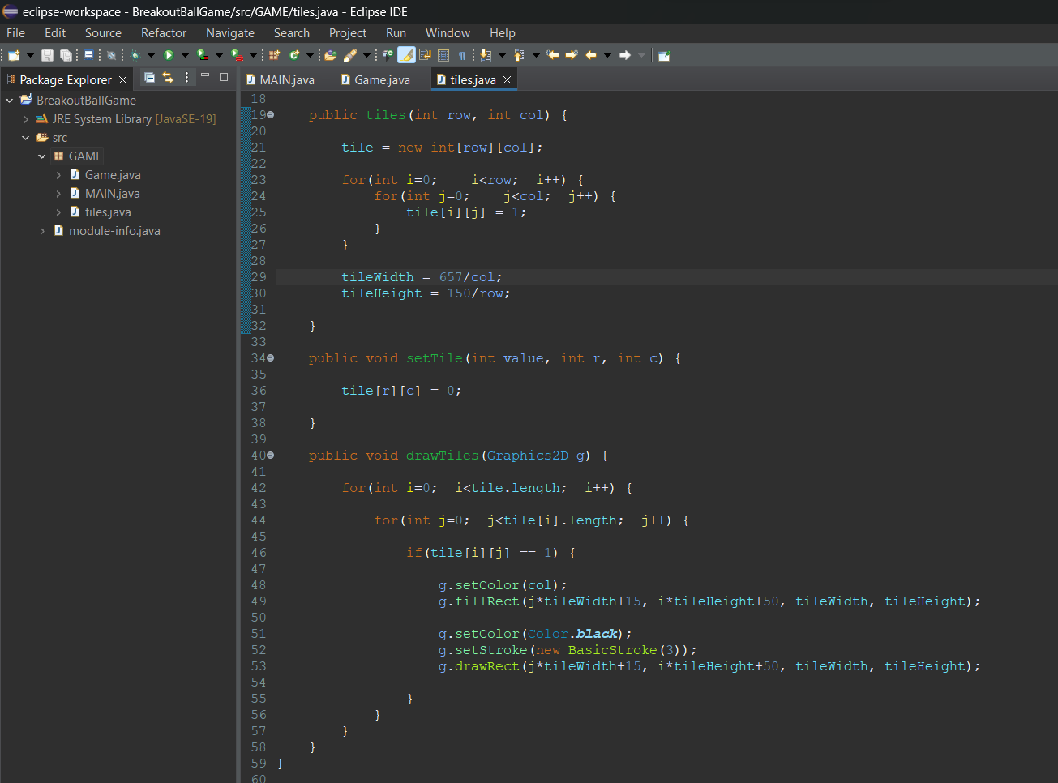

**Fig 3.7: tiles class**

**Chapter 4**

**Result and Discussion**

With the help of the above explained methodology the designing of a breakout ball game was successfully completed and the designed Breakout Ball Game does work perfectly. The images below show the final output of the above methodology (code).

For the final source code of Breakout Ball Game [CLICK HERE](https://drive.google.com/drive/folders/1xo32zngUuaMIrsvk8ex8uU-mpZwN9AHQ?usp=sharing)

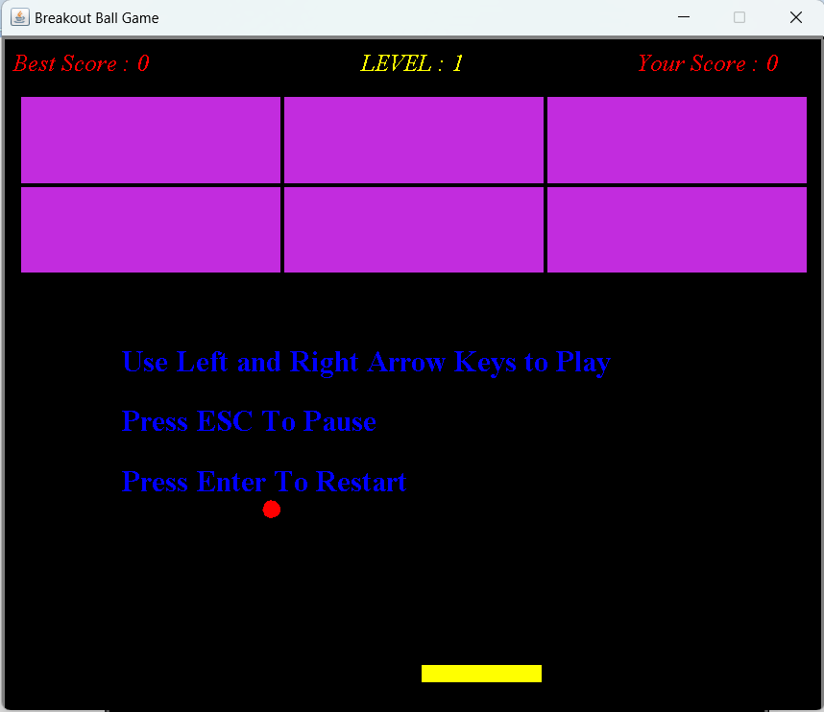

**Fig 4.1: Output of the above methodology**

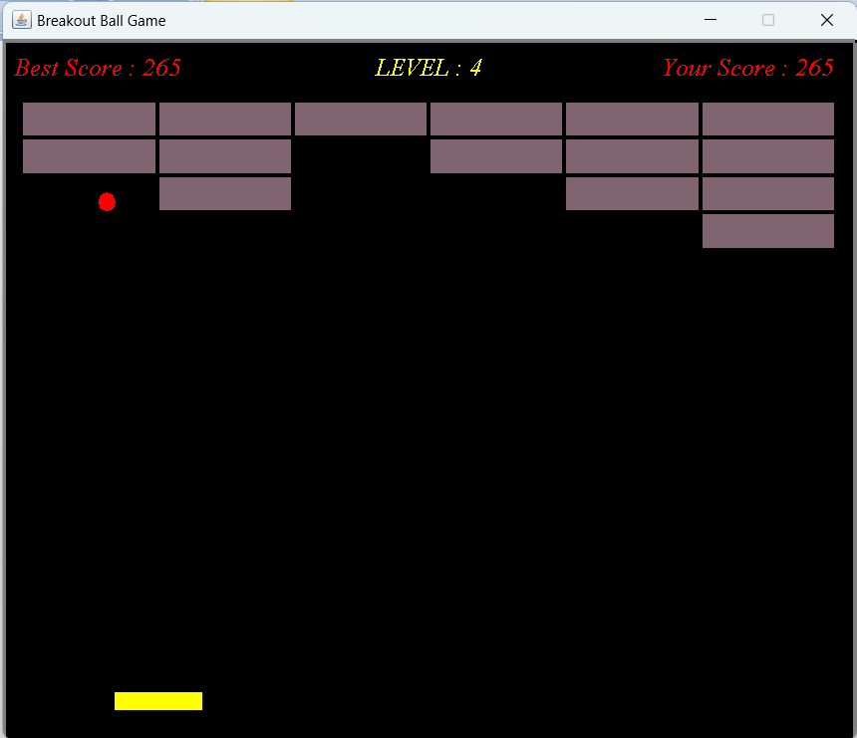

**Fig 4.2: Output when playing game**

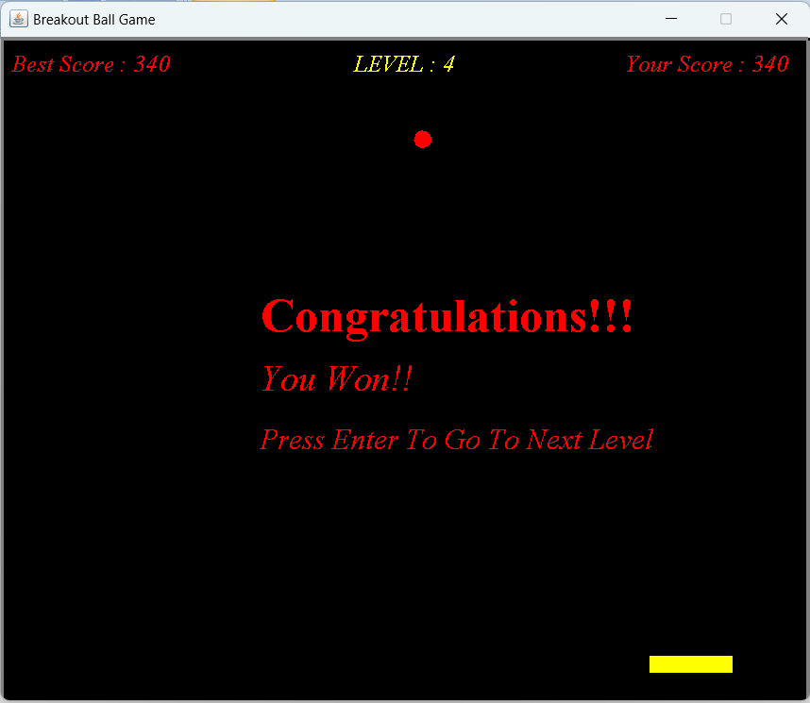

**Fig 4.3: Output when player wins**

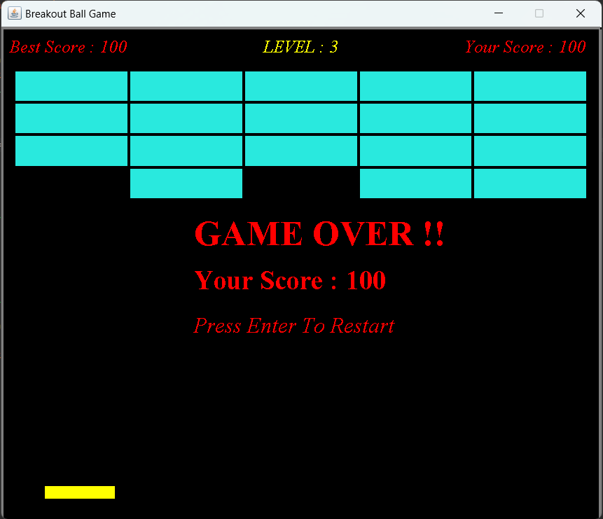

**Fig 4.4: Output when player loses**

**Chapter 5**

**Conclusion and Future Work**

**5.1 Conclusion**

With the help of above mentioned methodology and as shown in the results the project on *Designing a Breakout Ball Game* was successfully accomplished using Java.

**5.2 Future Work**

The above project on *Designing a Breakout Ball Game* can be improved by adding new things and making it more interactive and attractive. So that it attracts more users and is more enjoyable and challenging. Some ideas for future improvement are:

* To add sound effects, such as when player wins or loses, when the ball destroys a brick or it bounces of the slider.
* To add different value points tiles, i.e. the player gets different number of points when different colour tiles are destroyed i.e. different colour tiles carry different points.
* To increase the speed of the ball and with each increasing level and making its movements more random i.e. its direction after bouncing is unknown.
* To introduce different modes in the game so that different players can play according to their capabilities and the game could attract more audience.

**References**

[1] Tata McGraw Hill Education Private Limited, “Java: The Complete Reference, Seventh Edition” by Herbert Schildt.

[2] Javapoint website accessed to understand the concepts of JFrame

<https://www.javatpoint.com/java-jframe>

[3] Javapoint website accessed to get a deep understanding of concepts of java Swing <https://www.javatpoint.com/java-swing>

[4] Wikipedia website accessed for about and history of Breakout Ball Game <https://en.wikipedia.org/wiki/Breakout_(video_game)>

[5] Javapoint website accessed to understand the concepts of Graphics and Graphics 2D in Java

<https://www.javatpoint.com/Graphics-in-swing>

[6] To get idea of how to Design a fully working Breakout Ball Game

<https://www.crio.do/projects/java-breakout-game/>