**Mini Project Report on**



**QuizUp – A Quiz Application**



**Submitted in partial fulfilment of the requirement for the award of the degree of**

**BACHELOR OF TECHNOLOGY**

**IN**

**COMPUTER SCIENCE & ENGINEERING**

**Submitted by:**

**Shivang Mahendra**  **University Roll No. 2019103**

***Under the Mentorship of***

**Ms. Tanusha Mittal**

**Assistant Professor**



**Department of Computer Science and Engineering**

**Graphic Era (Deemed to be University)**

**Dehradun, Uttarakhand**

**July-2023**



**CANDIDATE’S DECLARATION**

I hereby certify that the work which is being presented in the project report entitled **“QuizUp – A Quiz Application”** in partial fulfillment of the requirements for the award of the Degree of Bachelor of Technology in Computer Science and Engineeringof the Graphic Era (Deemed to be University), Dehradun shall be carried out by the under the mentorship of **Ms. Tanusha Mittal, Assistant Professor**, Department of Computer Science and Engineering, Graphic Era (Deemed to be University), Dehradun.

Shivang Mahendra University Roll No.: - 2019103

**Table of Contents**

|  |  |  |
| --- | --- | --- |
| **Chapter No.** | **Description** | **Page No.** |
| Chapter 1 | Introduction | 1-3 |
| Chapter 2 | Literature Survey | **4-6** |
| Chapter 3 | Methodology | **7-10** |
| Chapter 4 | Result and Discussion | **11-13** |
| Chapter 5 | Conclusion and Future Work | **14** |
|  | References | **15** |

**Chapter 1**

**Introduction**

* 1. **Problem Statement**

This project is about Designing a Quiz Application where a user can give answers to given questions and get results and correct output.

And also to understand concepts of Java and how to work on android studio and interact with database in an application.

* 1. **QuizUp – A Quiz Application**

QuizUp is a quiz application in which there are many quiz based on different topics such as Sports, Current Affairs, Science, General Knowledge, etc. which are update date wise. And users can login or sign up in the application using their email ids and can play/access all the quizzes. Users get points/credit score for each correct answer and at the end of the quiz, users can see correct answers for each question along with the total points they scored in the quiz. For each correct answer users get +10 points and there is no negative marking. Each question is a multiple choice question having 4 options each and user is supposed to select the correct answer from the given options. It contains different questions that are stored in the database and can be updated and also new quizzes can be added to the application by adding it to the database. This application tests the basic knowledge of the user and user can access his/her account from anywhere and any device using his email id and password.

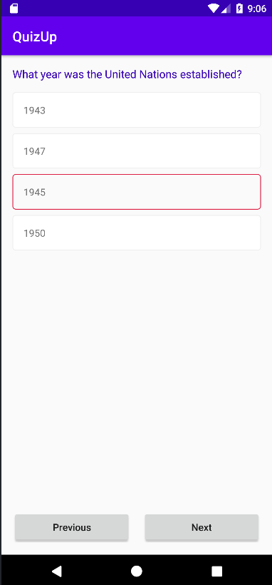

**Fig 1.1: QuizUp – A Quiz Application**

* 1. **Java and Android Studio**

Java is a simple programming language which was introduced in 1995 and is constantly being upgraded. It is currently owned by Oracle. It was developed by James Gosling. It is completely object-oriented, class-based programming language. Java code is platform independent as well as portable language i.e.it can run on all platforms and without any modifications.

The main features of Java:

* Object-Oriented Programming Language
* Secure
* Portable
* High Performance
* Platform Independent
* Dynamic Flexibility

Android Studio is an official IDE (Integrated Development Environment) for Android app development. It has many features that help in writing easy codes and making interactive applications and is based on powerful code editor and developer tools from IntelliJ IDEA. It also provides fast and filled with features emulator to try and test applications on. And also features to run application on physical devices as well. It has built in support for Google Cloud Platform, and multiple APK support and also integrated firebase which helps in easy database access.

Firebase is a set of cloud based development tools (such as FirebaseAuth for authentication, Firestore that is a nosql database, etc.) that helps mobile app developers build, deploy and make their apps scalable.

**Chapter 2**

**Literature Survey**

Nowadays, most of the people have smartphones and tablets, which support many applications(apps). Therefore, I decided to make a good use of this feature of mobile phones to create interactive, interesting and knowledge gaining application QuizUp which is a quiz application consisting of various different quizzes on various topics. It will help many to gain knowledge and spend their time learning whenever and wherever they want.

Especially after the Covid-19 outbreak, education system are adapting to online modes for teaching and conducting exams and tests, these Quiz applications help teachers and students in conducting and attempting tests and exams. Teachers can update questions with options and correct answers and students can attempt these quizzes and at end can get their results at the same time after submitting the quiz.

1. **Popular Quiz Applications**
2. **Infuse Learning**

It is a web-based teacher-to-student Virtual Learner Response System that helps teachers by ask questions to students and allow them to respond to questions through their smart phones, ipads, tables and laptops. It was a breakthrough virtual learner that helped teachers and students a lot. It was great Student-Response System that works with any internet connected device. It even allows students to answer questions by creating drawings or diagrams.

1. **Quiz Socket**

It is used to create real-time multiple-choice quizzes that can accessed across multiple devices having internet connection. It is fully web based. It is a tool developed to enable teachers to quickly create quizzes and asses students based on it. It is also a free student response system. It is the easiest tool because of its simplicity. It is very easy to asses students in a very simple and quick way. There is no username or password to enter the quiz so students can take part without having an account.

1. **Kahoot**

Like other free student response systems, Kahoot also gives several options to develop quizzes. The main tool is that here teachers can impose time limit on each question. Students are awarded points for correct answers and how fast they answer.

A scoreboard is shown on teacher’s screen and can be shared with students and it also shows students rankings. To attempt the quiz students do not require to have an account, they can access the quiz using a pin provided by teacher/quiz creator.

1. **Verso**

It differs a little bit from previously discussed tools as it is based on collaboration principle and rest are more oriented to reinforce contents already explained. In this tool students cannot see the progress of other students until they have posted their own. The posted responses are anonymous i.e. one cannot know who posted which one.

1. **Socrative**

This app is similar to previous one but has more innovations. There are 3 ways to release the quiz:

* + - * + Student Paced – Immediate Feedback: - Here the student has to answer the question as they come and after each question they get explanations for the question.
        + Student Paced – Student Navigation: - Here students can answer questions in any order and can also skip question and submit the after completing the activity.
        + Teacher Paced: - Teachers can control the flow of questions. They send one question at a time and can visualize answers.

1. **Poll Everywhere**

This is a free response tool that is used to create polls. It has broader use as many different types of polls can be created using this such as polls for conference, medicine purposes, etc. It is a voting system which supports web-voting and also SMS text-voting.

**Chapter 3**

**Methodology**

In this application there are various windows that are designed such as introduction, login, registration, question and options, profile, and result window. The user can login using his/her mail id and a password. The user can logout whenever the want to through their profile window. The users can attempt a quiz and after completing it they can see the result.

**3.1 Designing Introduction, Login and Registration Window**

The introduction window tells about the QuizUp application and there is a button which takes us to the login window to enter the application.

The login window asks you to enter your mail id and application password and a “Login” button to enter the application and if user does not have an account it takes there is a text that takes you to the registration/sign up window to create an account for the application.

The registration/sign up window asks you to enter your mail id with which you want to create an account and enter a password and re-enter password to confirm and a “Sign Up” button to create an account and enter application. It also has a text that asks you if you already have an account and takes you to login window on clicking on it.

And if the user has already logged in once and then closes application and re-opens it, then user directly enters the application and reaches the main window. The user is not asked to login again.

|  |  |
| --- | --- |
| **Fig 3.1 : Introduction Window** | **Fig 3.2 : Login Window** |

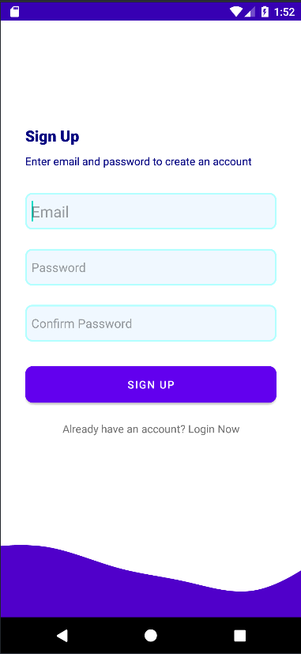

**Fig 3.3 Sign Up Window**

**3.2 Designing Main Window and Profile Window**

It consists of various quizzes titled according to dates that are available in the database and a calendar with which we can open a quiz of that date. It also has a drawer that shows various options such as profile, follow us and rate us. The drawer profile option takes us to profile activity and users can log out from there.

Profile Window shows users which Id they have used to log in and then it also has a button which users can use to log out of their current profile.

|  |  |
| --- | --- |
| **Fig 3.4: Main Window** | **Fig 3.5: Profile Window** |

**3.3 Designing Question Window and Result Window**

The Question Window consists of question that quiz contains and its 4 options. It also has some buttons such as previous to go to previous question, next to go to next question and submit button at last question to submit the quiz. Users can choose any option and can go to next question.

After submitting the quiz, result window pops up and the total score is shown along with the questions and correct answers of the questions asked in the quiz.

|  |  |
| --- | --- |
| **Fig 3.6: Question Window** | **Fig 3.7: Result Window** |

**Chapter 4**

**Result and Discussion**

With the help of the above explained methodology, the designing of the **“QuizUp – A Quiz Application”** is successfully completed and the QuizUp application works perfectly fine and is tested. The images below show the results of the above methodology.

To view the complete code of the QuizUp Application [CLICK HERE](https://drive.google.com/drive/folders/1LhQ-Nwz4E10Ub-M_HlEDJeiGZ8VUD6CW?usp=drive_link).

|  |  |
| --- | --- |
| **Fig 4.1: Output of above methodology** | **Fig 4.2: Logging In the Application** |

|  |  |
| --- | --- |
| **Fig 4.3: Creating a new account** | **Fig 4.4: Selecting a Quiz** |

|  |  |
| --- | --- |
| **Fig 4.5: Attempting a Quiz** | **Fig 4.6: Viewing Result after Submitting** |

|  |  |
| --- | --- |
| **Fig 4.7: Selecting a Quiz through Calendar** | **Fig 4.8: Going to profile window to log out** |

**Chapter 5**

**Conclusion and Future Work**

**5.1 Conclusion**

With the help of the above explained methodology and as shown in the results section,

the project of Designing a QuizUp Application is successful accomplished using Java, Android Studio and Firebase.

**5.2 Future Work**

This project of designing a QuizUp Application can be further improved by adding more features and making it more attractive and interacting with users. Some of the ideas for further improvement of the project are: -

* Adding more features for users to login with such as phone number, meta id, Instagram, or twitter id.
* By adding a feature that allows users to create their own private and public quizzes. This way users can play with their friends and family members and can also organize quiz competitions.
* By adding different user profile options such as view past attempted quizzes and score in those quizzes.
* By organizing quizzes according to difficulty levels such as easy, medium and hard and questions asked in a quiz depends on it.
* By using a pin or a password to attempt some particular quizzes so that only selected members can participate in a private quiz.

**References**

[1] Tata McGraw Hill Education Private Limited, “Java: The Complete Reference, Seventh Edition” by Herbert Schildt.

[2] Android Studio Documentation to learn about android studio and its features

<https://developer.android.com/docs>

[3] Firebase documentation to understand its features and implement it

[Firebase Documentation](https://firebase.google.com/docs?gad=1&gclid=CjwKCAjwtuOlBhBREiwA7agf1iuJETcrX9e9axUU5Sf7dZ5REfshZbfA2zAwR5dq1_xvry6PANfrJxoCaj4QAvD_BwE&gclsrc=aw.ds)

[4]<https://riunet.upv.es/bitstream/handle/10251/66300/2015%20INTED%20Aandres_B.pdf?sequ>

To learn more about past Quiz applications and their methods.