|  |
| --- |
| **Application Screenshot**  **VirtualLocked.com** |

Version history:

|  |  |
| --- | --- |
| Author | Shivang Dhasmana |
| Purpose | Screenshot |
| Date | 12/08/1996 |
| Version | 1.0 |

Contents

1. Main Menu Screenshot 3

2. Display All files 4

3. Add Files: 5

4. Search Files 6

# Main Menu Screenshot

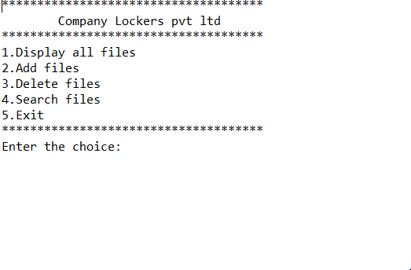

# Display All files

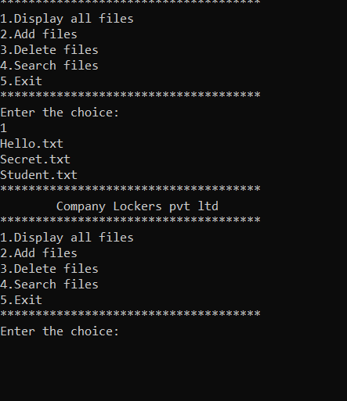

# Add Files:

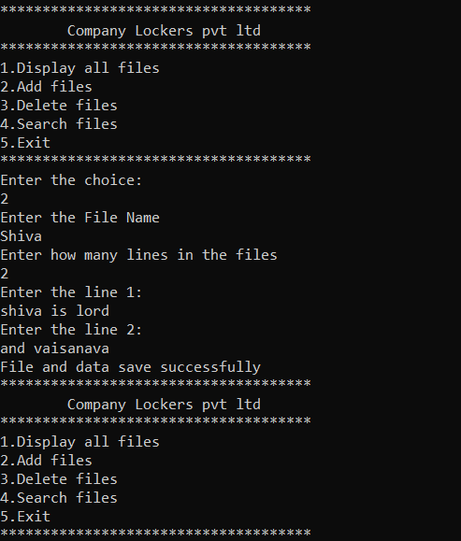

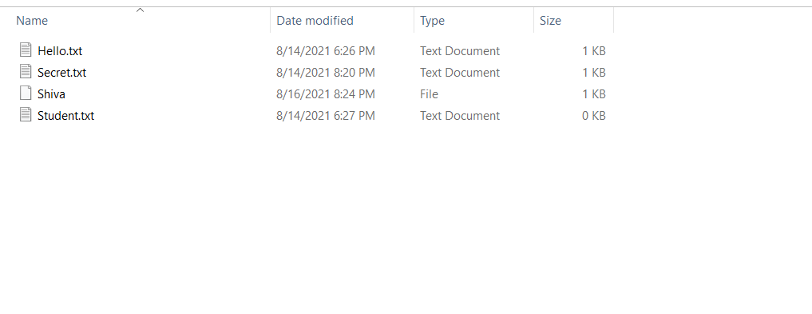

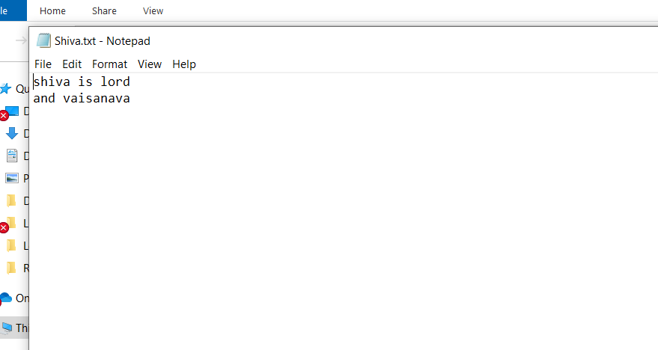

# Search Files

