**package** com.phone;

**class** PhoneWithBuilderPattern {

**private** String screenType;//Amoled or IPS LCD

**private** String os;//Android or iOS or windows

**private** **int** ram;//in GB

**private** String processor;

**private** **int** battery;//in mAh

**private** **double** screenSize;

**private** **int** storage;//in GB

**public** PhoneWithBuilderPattern setScreenType(String screenType) {

**this**.screenType = screenType;

**return** **this**;

}

**public** PhoneWithBuilderPattern setOs(String os) {

**this**.os = os;

**return** **this**;

}

**public** PhoneWithBuilderPattern setRam(**int** ram) {

**this**.ram = ram;

**return** **this**;

}

**public** PhoneWithBuilderPattern setProcessor(String processor) {

**this**.processor = processor;

**return** **this**;

}

**public** PhoneWithBuilderPattern setBattery(**int** battery) {

**this**.battery = battery;

**return** **this**;

}

**public** PhoneWithBuilderPattern setScreenSize(**double** screenSize) {

**this**.screenSize = screenSize;

**return** **this**;

}

**public** PhoneWithBuilderPattern setStorage(**int** storage) {

**this**.storage = storage;

**return** **this**;

}

**public** Phone getDetailsOfPhone() {

**return** **new** Phone(screenType, os, ram, processor, battery, screenSize, storage);

}

}

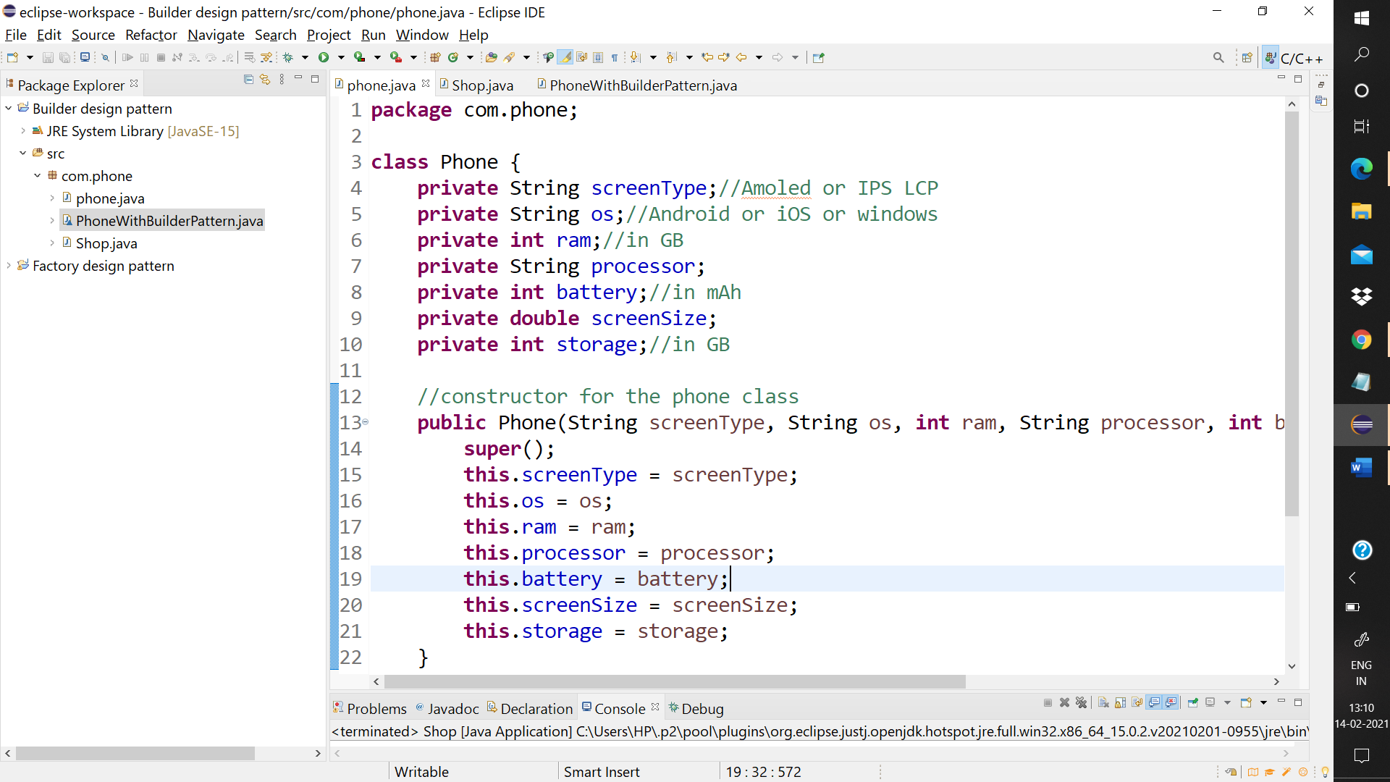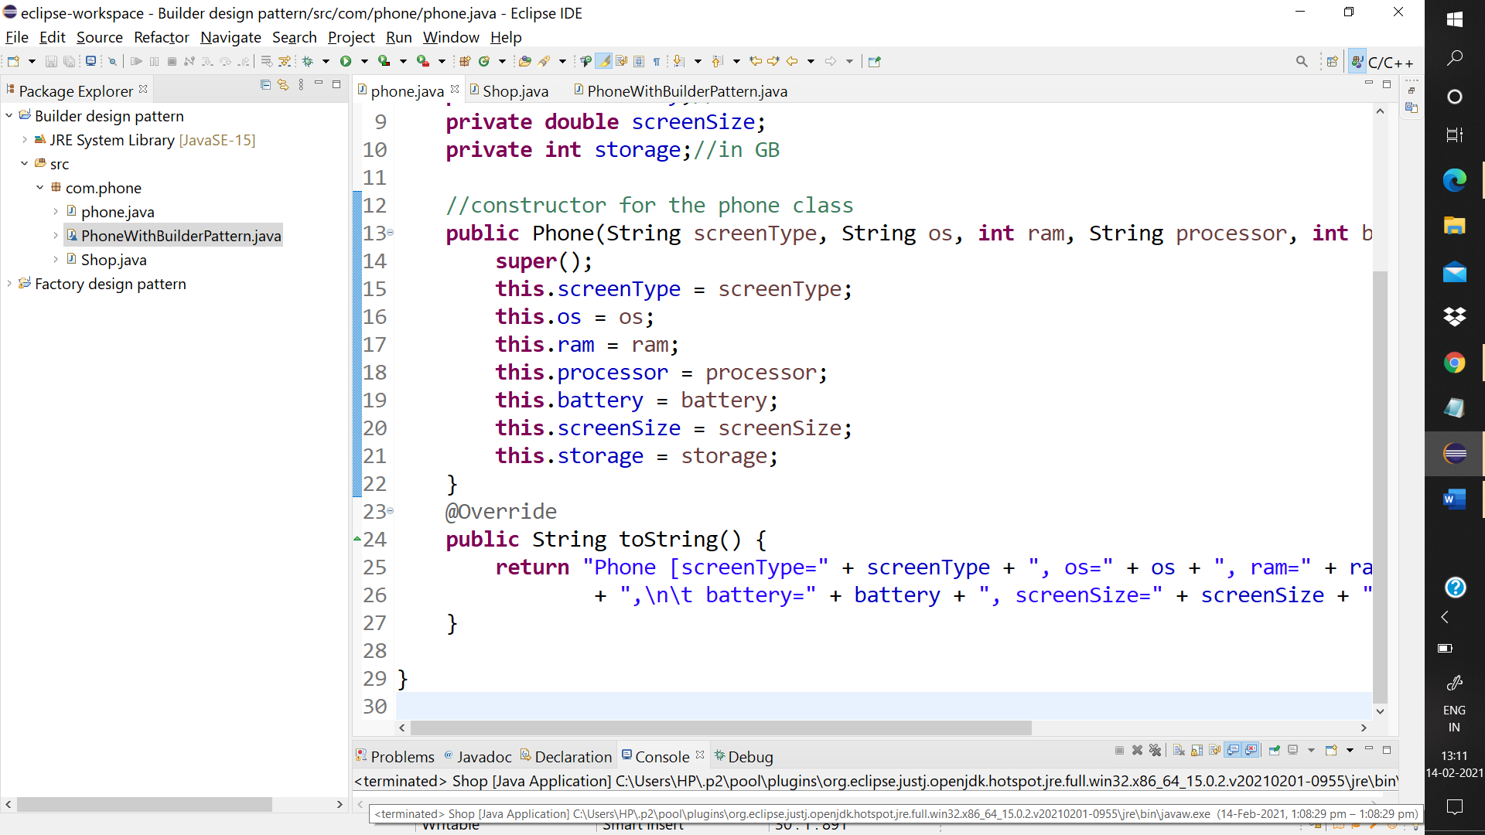

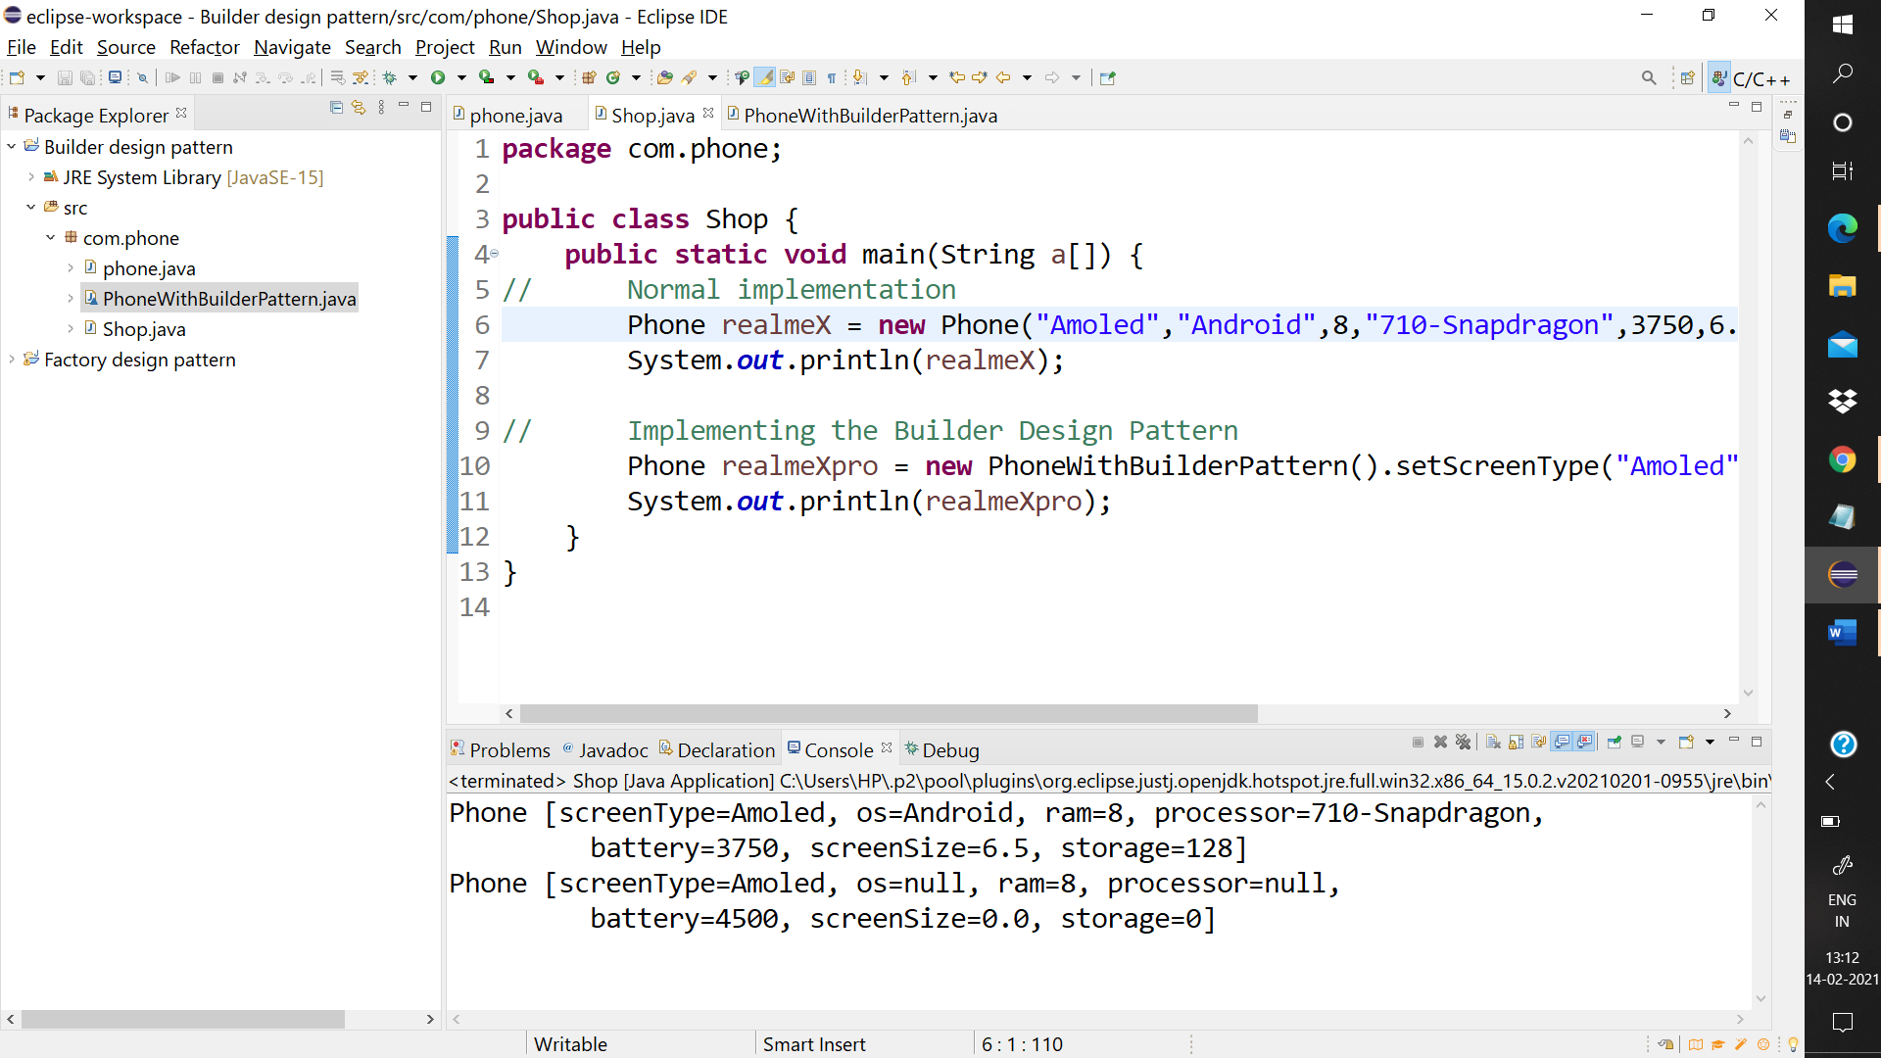

The first is the normal implementation

While the one at the bottom is through the design pattern where there is no need to set all the parameters as well as there is no need to remember their order of parameters in the function call.

