## **AI Driven Gift-Recommender**

## **Project Report**

## **Introduction**

## Gifting is a timeless way to express appreciation, love, and celebration. However, choosing the perfect gift can often be overwhelming, especially when you're unsure about the recipient's interests or the occasion's tone. The **AI-Driven Gift Recommender** addresses this issue by providing intelligent and personalized gift suggestions using AI and Natural Language Processing.

## This chatbot allows users to describe the person or the occasion in natural language, and instantly receive thoughtful gift ideas powered by OpenRouter’s GPT-based API. It enhances the gift-giving experience by combining creativity with technology in a clean, responsive web interface.

## **Problem Statement**

## Despite the abundance of gift guides and e-commerce platforms, users face these common issues:

## **Indecisiveness** due to too many choices and lack of direction.

## **Generic suggestions** that aren't personalized for the individual or event.

## **Time constraints** preventing detailed research.

## **Low confidence** in selecting a meaningful and appreciated gift.

**Solution: AI-Driven Gift Recommender**

To effectively address the challenges of indecision, lack of personalization, time constraints, and uncertainty in gift selection, we have developed the **AI-Driven Gift Recommender Chatbot**. This intelligent solution transforms the traditional gift selection process by offering personalized, context-aware recommendations through a simple and user-friendly interface.

Instead of relying on generalized gift guides or spending extensive time browsing online platforms, users can input a brief description of the recipient or occasion. Based on this input, the chatbot delivers thoughtful and tailored gift suggestions within seconds.

**Key Features and How They Address the Problem**

**1. Personalized Recommendations**

The chatbot utilizes the OpenRouter API powered by advanced GPT-based language models to interpret user input and generate highly relevant gift suggestions. This eliminates the issue of generic recommendations by providing ideas that are specific to the described person or event.

**Example:**  
**Input:** “A gift for my friend who just became a mother and enjoys photography.”  
**Output:** “A baby memory book with sections for photos, or a diaper bag that includes compartments for a camera.”

**2. Time Efficiency**

The chatbot offers near-instant responses, helping users save time that would otherwise be spent researching or browsing through product listings. This is especially beneficial for individuals with busy schedules or for those needing last-minute gift ideas.

**3. Intuitive, Conversational Interface**

Designed with a clean interface using HTML, Bootstrap, and JavaScript (frontend), and powered by Node.js and Express (backend), the chatbot allows users to interact in natural language. This conversational approach makes the experience more engaging and eliminates the need for complex forms or product filters.

**4. Web-Based Accessibility**

As a browser-based application, the chatbot can be accessed from any device with an internet connection. This ensures maximum flexibility and convenience for users, whether at home or on the go.

**5. Secure and Lightweight Design**

The backend is securely built using Node.js and Express, with environment variables managed through the dotenv package to protect API credentials. No user authentication or personal data collection is required, ensuring a seamless and privacy-conscious user experience.

**Technical Workflow Summary**

1. **User Input:** The user provides a description of the recipient or occasion.
2. **API Request:** The backend sends this input to the OpenRouter AI API.
3. **AI Processing:** The AI model interprets the message and generates a relevant gift suggestion.
4. **Response Output:** The chatbot displays the suggestion on the user interface.

### **Technologies Used**

| **Layer** | **Technologies Used** |
| --- | --- |
| **Frontend** | HTML, Bootstrap 4.5, JavaScript |
| **Backend** | Node.js, Express.js |
| **AI Model** | OpenRouter API (GPT-3.5-Turbo) |
| **Packages** | dotenv, axios |
| **Hosting** | Localhost / Cloud Compatible |

### **ScreenShot:**

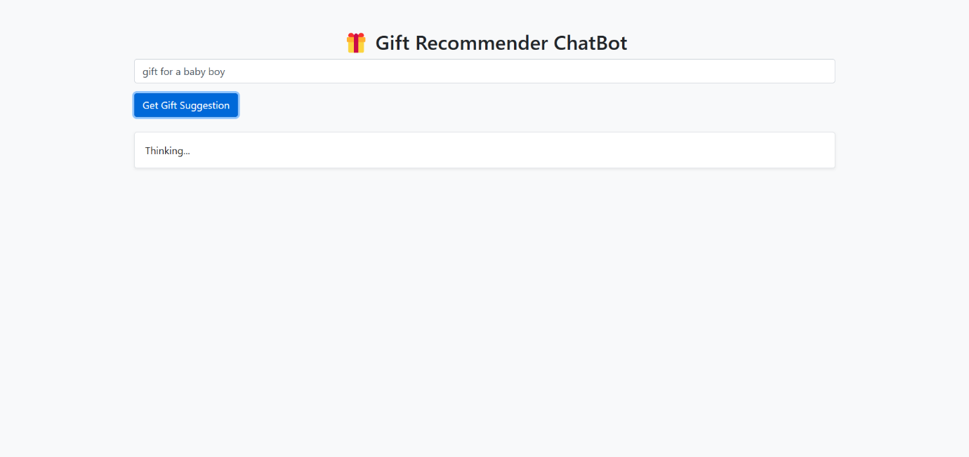

## 

## **Technical Implementation**

**System Architecture**

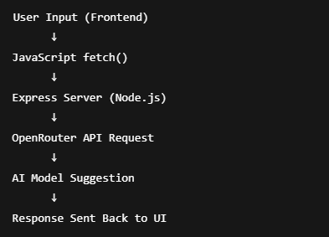

**Directory Structure**

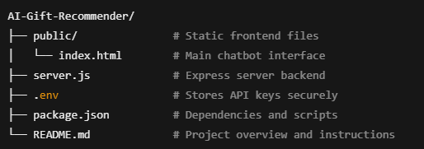

### **Key Components**

**Frontend Code (index.html)**

* Input box captures user queries.
* Button triggers the sendMessage() function.
* Response area displays AI-generated gift suggestions dynamically.
* Uses Bootstrap for clean styling and responsiveness.

**Backend Code (server.js)**

* Node.js server with Express handles POST requests to /ask.
* Sends user input to OpenRouter API.
* Receives the AI response and returns it to the frontend.
* Uses Axios for external API communication.
* .env handles API key confidentiality.

**Sample Workflow**

1. **User Input**:  
   *"Looking for a gift for my mom who loves gardening and just retired."*
2. **AI Response**:  
   *"How about a personalized gardening tool set with her name engraved? You could also consider a subscription to a gardening magazine or a relaxing hammock for her backyard."*

## **Results and Impact**

**Current Benefits:**

* Eases decision-making for confused or last-minute shoppers.
* Offers thoughtful, creative, and occasion-specific gift ideas.
* Can be used by anyone with minimal tech skills.

**Future Enhancements:**

* Add **budget filtering**.
* Integrate with **e-commerce APIs** to link products directly.
* Include **user history** to refine future suggestions.
* Deploy to platforms like **WhatsApp**, **Facebook Messenger**, or as a **mobile app**.

## **Conclusion**

The **AI-Driven Gift Recommender** is an intelligent assistant designed to make gift selection smarter, faster, and more personal. By combining the power of conversational AI with a lightweight and responsive web interface, it simplifies one of life’s most frequent yet challenging tasks—finding the perfect gift.

This project also serves as a practical demonstration of how real-world applications can be enhanced using AI, making everyday tasks more convenient and enjoyable.

SS