Continuous Assessment - 1
Problem Statement:
- Environmental Issue Reporting:
Citizens face difficulties in reporting problems such as illegal dumping, air pollution, water pollution, overflowing garbage, and poor sanitation to the appropriate authorities.
- Household Waste Management:
People struggle to properly segregate, dispose of, and manage household waste, leading to increased landfill waste and environmental pollution.
- Water Conservation & Leakage Management:
Individuals and communities often lack effective ways to identify, report, and reduce water wastage caused by leaks, overflowing tanks, inefficient usage, and damaged infrastructure.
- Air Pollution Awareness & Monitoring:
People have limited awareness of the air quality around them and find it difficult to understand pollution levels, major pollution sources, and appropriate actions to reduce exposure.
- Community Recycling & Reuse:
People often do not know where to recycle or responsibly dispose of items such as e-waste, plastic, batteries, clothing, and other reusable materials, resulting in recyclable waste being sent to landfills.

Reasoning for Choosing Environmental Issue Reporting:
I chose Environmental Issue Reporting because citizens frequently encounter issues such as illegal dumping, overflowing garbage, and pollution but often lack a simple way to report them to the right authorities. The problem has a direct impact on community cleanliness and sustainability. It also offers clear user pain points and good scope for research and designing a user-centered digital solution.

Primary Research:
- Selected Problem Statement:
Environmental Issue Reporting System
- Students often notice environmental problems around the college campus, such as garbage, overflowing dustbins, pollution, water wastage, and other unhygienic conditions. Sometimes students also come across injured or harmed animals on roads but do not know whom to contact for help.
- The main problem is that there is no simple and convenient way for students to report these issues with proper location and evidence. Our idea is to create a platform where students can report an issue by adding a photo, location, and short description.

- Target Users:
- Our target users are college students. Students spend a lot of time on campus and regularly move through different areas, so they can easily notice environmental problems.
- They can also come across situations such as injured animals on roads or waste being dumped in public areas. Their experiences can help us understand what problems they face and what kind of reporting system they would actually use.

- Research Location:
- The research was conducted within the college campus. We interacted with students in different common areas of the campus and discussed the environmental problems they have noticed.
- The purpose was to understand their experiences and how they currently deal with such problems.

- Interview Questions:
We asked students the following questions:
- What environmental problems do you usually notice around the college campus?
- Have you ever seen an injured or harmed animal on a road? What did you do?
- How do you usually report an environmental problem?
- What problems do you face while reporting such issues?
- What stops you from reporting an issue when you notice it?
- What information should be included in an environmental complaint?
- Would a photo and exact location make reporting easier for you? Why?
- What features would make you use an environmental reporting system?
- User Responses:
- Most students said that they have noticed problems like garbage, overflowing dustbins and improper waste disposal around the campus.
- Some students said that they usually do not report these problems because they are not sure whom they should contact. Because of this, they often ignore the issue and continue with their work.
- One important concern was injured or harmed animals. Students mentioned that they have seen animals on roads that appeared injured, but they were not sure which person or organization could help them.
- Students also felt that taking a photograph would make the complaint more clear. They said that adding the exact location would make it easier for the concerned person to find the problem.
- Overall, students preferred a system that is quick and easy to use. They also felt that knowing the status of their complaint would make them more interested in using such a platform.

- Observations:
- During the interactions, we noticed that students were aware of environmental problems but did not always take action.
- The main reason seemed to be the lack of a simple reporting process. Students often did not know where to report an issue or whether their complaint would actually be considered.
- We also observed that location can be important while reporting a problem. A photo along with the exact location can give the responsible person a much better understanding of the situation.
- In the case of injured animals, quick reporting can be especially important because the animal may need immediate help.

- Pain Points:
- The first major pain point is that students do not have one common place to report different environmental issues.
- Another problem is that students are often unsure about whom to contact. This can discourage them from reporting the problem at all.
- Students may also find the existing reporting process inconvenient or time-consuming. Because of this, smaller issues are often ignored.
- There is also a lack of proper location and evidence in normal complaints. Without a photo or exact location, it can be difficult to understand the actual problem.
- Students also do not always know what happens after they report an issue. They would prefer to see whether their complaint is being reviewed or resolved.

- Key Insights:
- Many students notice problems but avoid reporting them because they don't know whom to contact or the process feels inconvenient.
- Students feel that adding a photo and location would help authorities understand the problem and reach the exact place quickly.
- Students may come across injured or harmed animals on roads but often don't know where to seek help. A dedicated option for reporting such cases could make the response faster.
- Students want to know what happens after they submit a report. Without any status update or feedback, they may feel that their complaint has been ignored.
- Students prefer a quick reporting process that does not require too many steps. A simple form with only necessary information could make them more comfortable reporting issues when they notice them.
- The seriousness of an issue can affect how students respond to it. Issues such as injured animals or situations that may cause immediate harm may need a faster response than regular environmental complaints.
- Students are more likely to report issues when they feel their report can lead to actual action. Knowing that the report will reach the right person or department can encourage them to participate.

- Photographic Evidence:

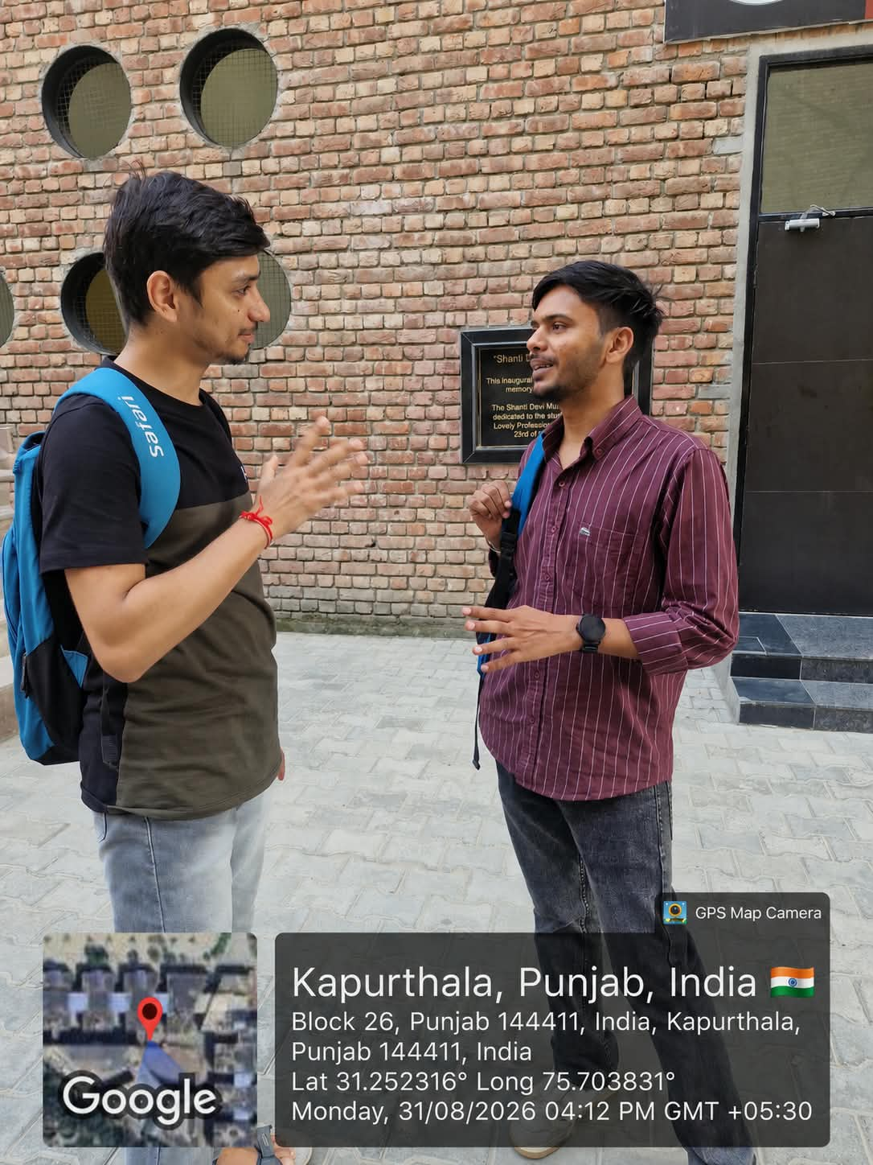
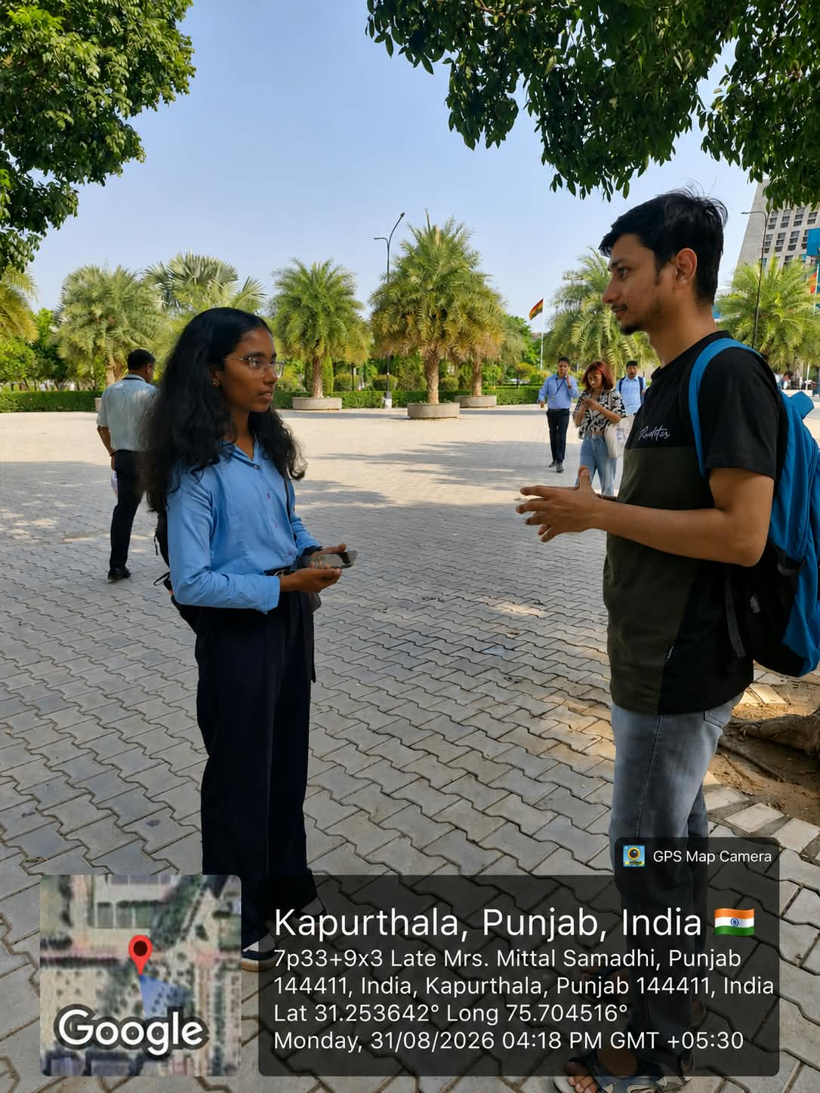
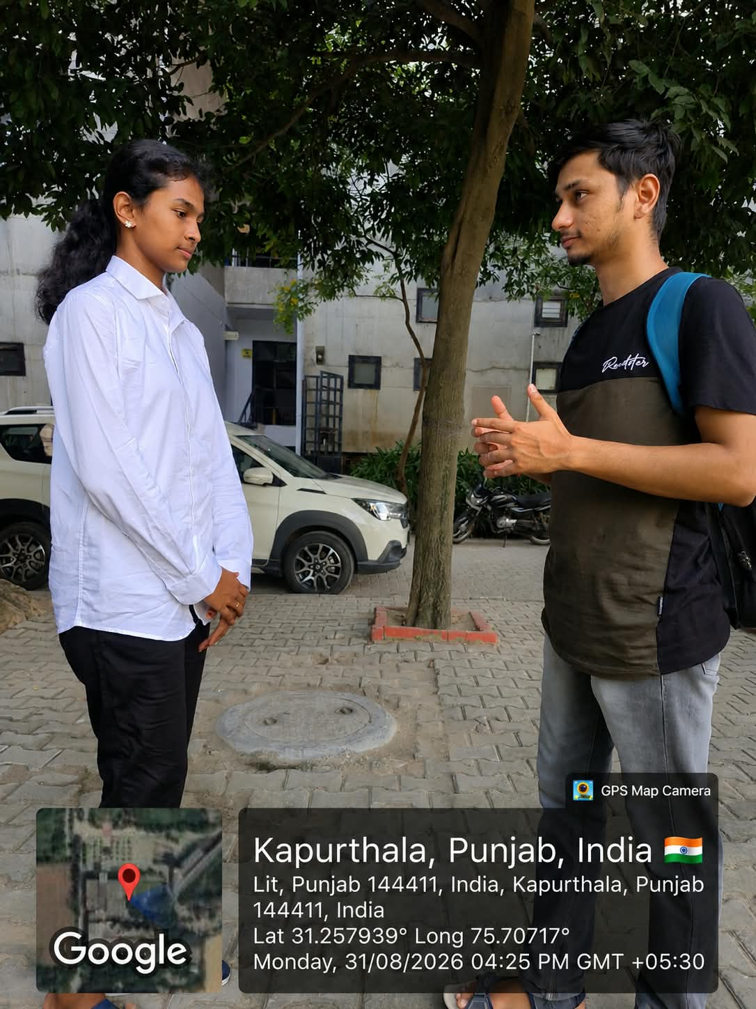
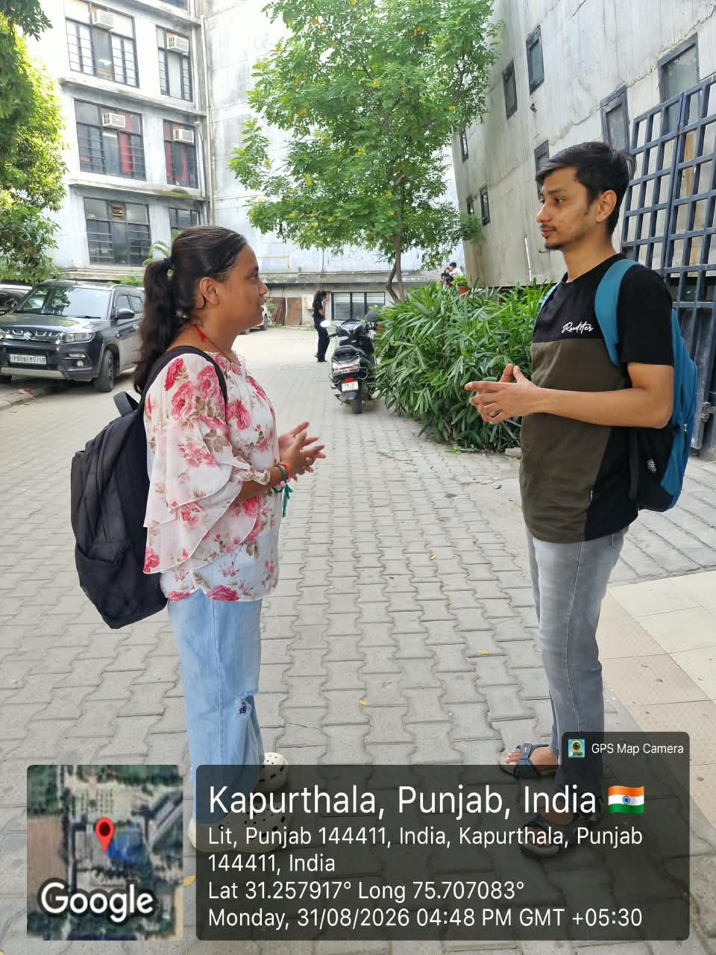
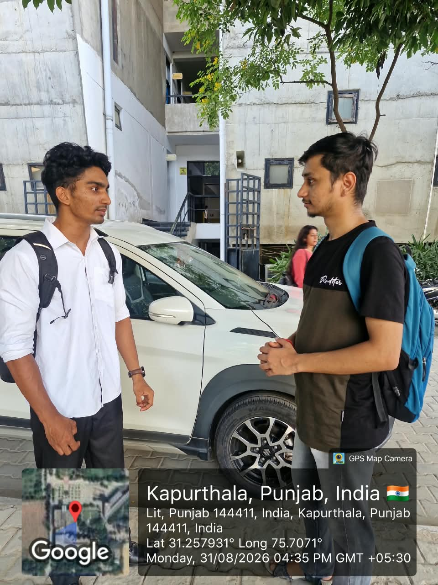

Secondary Research:
- Competitive Analysis:
Platform | Main Purpose | Useful Features | Limitation / Opportunity
Swachhata-MoHUA | Civic cleanliness and sanitation reporting | Photo, location, categories, authority assignment, status updates, reopening complaints | Mainly designed for city-level civic complaints rather than campus-specific issues. (Google Play)
Snap Send Solve | Reporting local community problems | Photo upload, automatic/manual location, issue category, authority routing, status updates | Broad community focus; not specifically designed around student/campus reporting. (Snap Send Solve Help Centre)
SeeClickFix | Civic issue reporting and tracking | Location-based reports, issue descriptions, media and tracking | Focuses on general municipal/community issues rather than a focused campus environment.
SARRP India | Animal rescue reporting | Injured/animal distress reports, photos, precise location and quick response | Focuses specifically on animal rescue and does not cover other environmental issues. (Google Play)
- Key Findings from Competitive Analysis
Existing platforms show that photo + exact location + issue category can make reporting easier and more useful for authorities. Platforms such as Swachhata-MoHUA and Snap Send Solve also show the importance of giving users feedback about what happens after a complaint is submitted.
However, there is a gap between these systems and our target users. Most are designed for general citizens, cities, or specific organisations, rather than college students reporting problems within their campus.
- Design Opportunity
Our proposed system can combine the useful features of these platforms into a simple campus-focused environmental reporting system. Students could report issues such as garbage, pollution, water problems, greenery issues and injured/harmed animals, while providing a photo, location and short description. The system can also show the report status so students know whether action has been taken.

- Literature Review:
- Crowdsourcing and Citizen Participation (2023): Bastardo, Pavão and Rocha reviewed 29 studies on crowdsourcing technologies in smart cities. Their review found that participatory reporting and sensing are being used for areas such as infrastructure maintenance and environmental monitoring. The study also identified limited evidence about the effectiveness of many existing solutions.
Relevance: This supports the idea of involving students in reporting environmental problems around their campus.
- Mobile Civic Reporting (2013): Santos, Rodrigues and Oliveira proposed a web and mobile system for reporting non-emergency urban problems. The system uses a location-based environment and allows users to attach multimedia information to reports.
Relevance: This supports using location and photos as important information when reporting environmental issues.
- Campus Safety Reporting (2017): Huang et al. studied mobile crowdsourcing for campus safety reporting. Their experiments showed that location context influenced people's reporting decisions, and they developed a location-based nudge mechanism to influence reporting behaviour.
Relevance: Since our target users are college students, this research supports making reporting location-aware and relevant to the campus environment.
- Pro-social Behaviour in Crowdsourcing (2019)
Komninos studied a mobile crowdsourcing system used for monitoring beach conditions. The study found that participation was strongly influenced by altruistic motives and that openly sharing collected information could provide benefits to users and public bodies.
Relevance: This suggests that students may participate in environmental reporting when they can see that their contributions provide a benefit to the wider campus community.

- Survey Images:
