

Name: Shivang Chaurasia
Section: 4O2336

Roll No: 16

Registration No: 12316885

Heuristic Evaluation
Income Tax Department of India — e-Filing Website

Introduction
This report evaluates the user interface of the Income Tax Department of India’s e-Filing website using ten usability heuristics and related UI/UX principles. The observations are based on the supplied screenshots of the website, including its homepage and quick links, navigation menus, quick access services, login and registration flows, contact information, downloads page, and Tax Genie help widget. Each section describes the principle, the observed interface, a potential usability problem, and a practical solution.

1. Visibility of System Status
Principle: The system should keep users informed about what is happening through timely and understandable feedback.
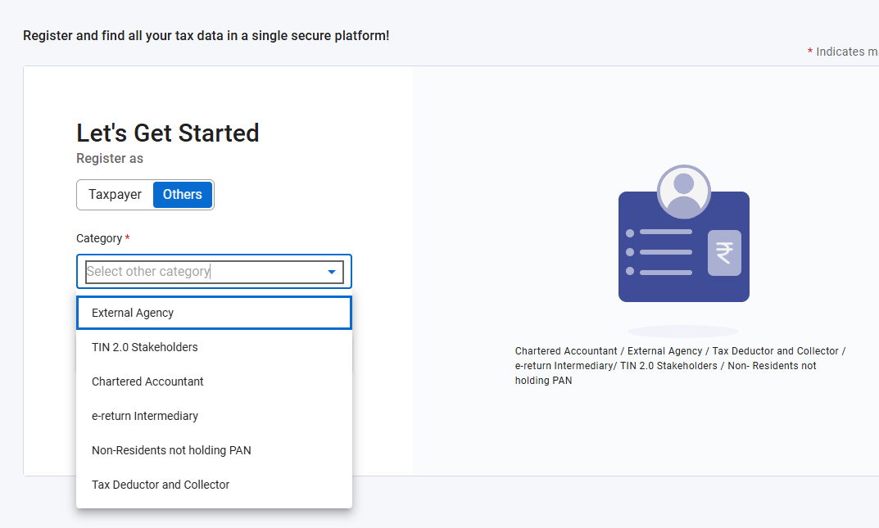
Registration flow showing the four steps: Get Started, Fill Details, Verify Details, and Secure Your Account.
Problem: The registration screen shows the sequence of steps, but the supplied screenshots only show the initial stage. The current progress and the information needed to complete later stages are not visible in these images, so users may be unsure how much work remains once they begin.
Solution: Keep the step indicator visible throughout registration, clearly mark the current and completed steps, and display confirmation messages after successful validation or submission.

2. Recognition Rather Than Recall
Principle: Make options and relevant information visible so users do not have to remember details from previous screens.
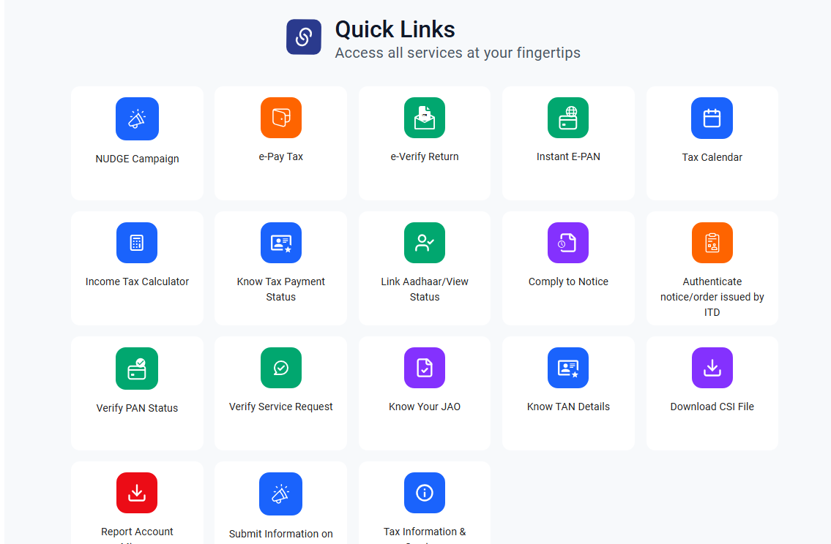
Quick Links section displaying frequently used services as labelled cards.
Problem: The Quick Links cards make many services visible, which supports recognition. However, the range of services is large, and some labels may require users to understand tax-specific terminology before choosing the correct option.
Solution: Keep clear labels and familiar icons, add short explanatory descriptions for less familiar services, and group related links into categories so users can recognize the correct task quickly.

3. User Control and Freedom
Principle: Users should be able to go back, cancel, or exit an action without losing control of the process.
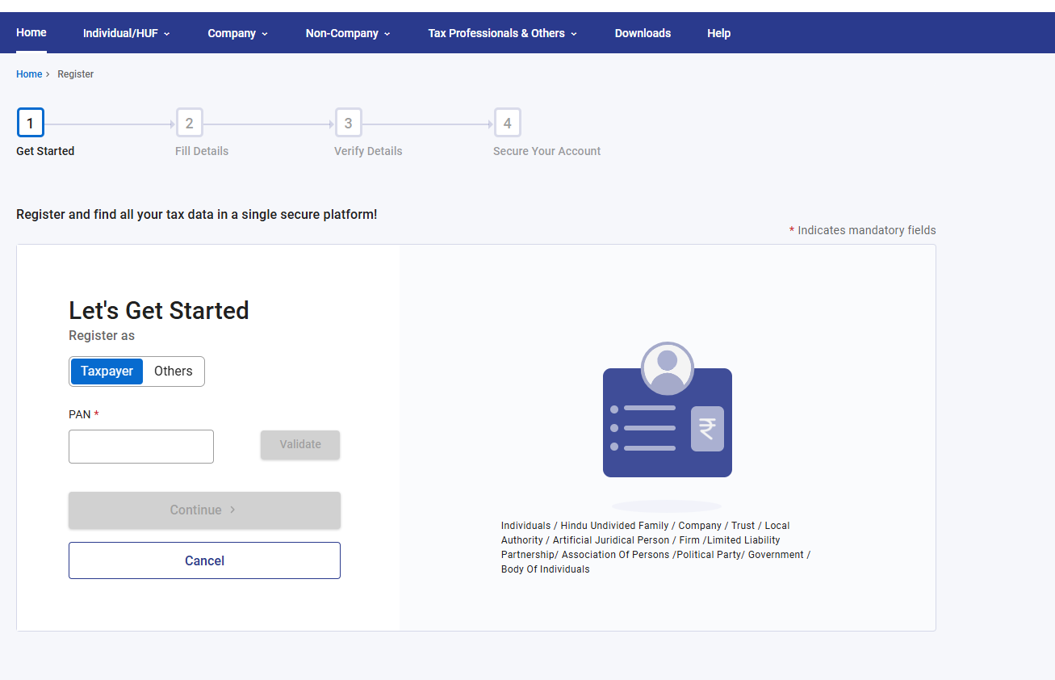
Registration form with Continue and Cancel controls.
Problem: The registration screen provides a Cancel button, but the screenshot does not show whether entered information is saved if the user leaves the process. Users may hesitate to cancel or navigate away if they are unsure whether their progress will be retained.
Solution: Explain what happens when Cancel is selected, offer a clear Back action on subsequent steps, and provide Save and Exit or resume-later functionality where appropriate.

4. Match Between System and the Real World
Principle: Use familiar language and explain specialist terminology in ways that match users’ understanding.
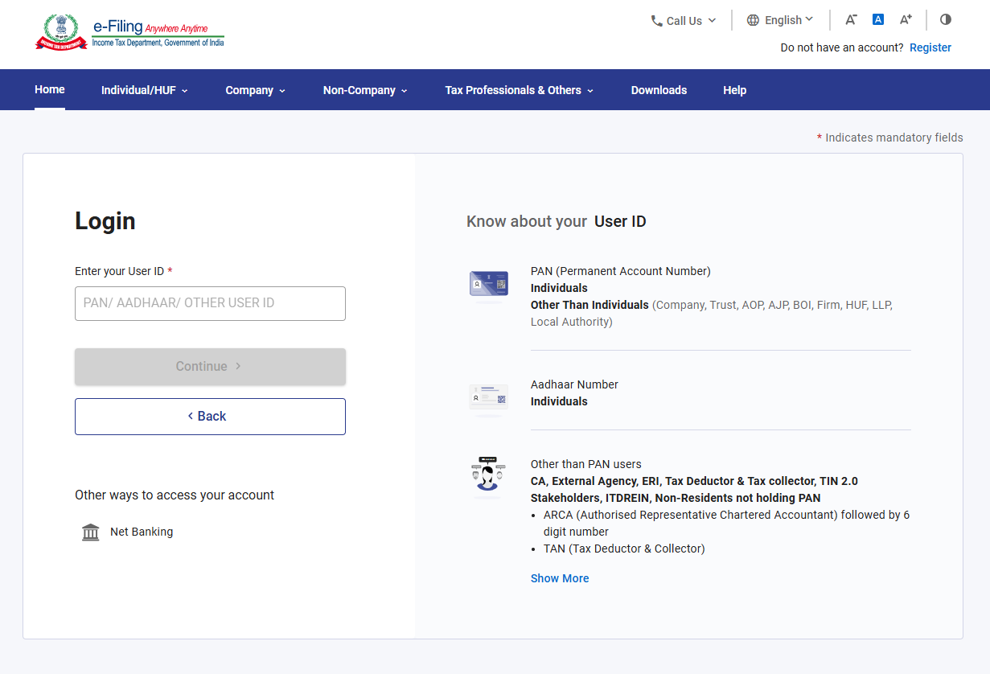
Registration category dropdown containing options such as External Agency, TIN 2.0 Stakeholders, and e-return Intermediary.
Problem: The category dropdown includes specialist terms such as “TIN 2.0 Stakeholders” and “e-return Intermediary.” Users unfamiliar with tax administration may not know which category applies to them.
Solution: Add short plain-language explanations beside specialist categories and provide examples of who should select each option. Keep official category names but support them with understandable descriptions.

5. Error Prevention
Principle: Design the interface to prevent errors before they happen.
Registration screen requiring the user to enter a PAN and validate it before continuing.
Problem: The form marks PAN as mandatory and provides a Validate button, but the screenshot does not show the validation rules or an example of the expected format. Users may enter information incorrectly before learning what is required.
Solution: Show the expected format and concise instructions next to the field, validate the input before submission, and explain how to correct an invalid entry. Keep Continue disabled until required information is valid.

6. Consistency and Standards
Principle: Use consistent labels, layouts, visual styles, and interaction patterns across the website.
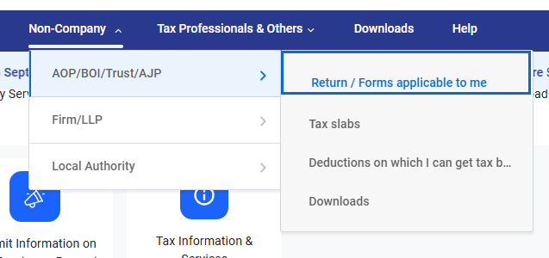
Quick Access Services presented in a grid of similarly styled cards.
Problem: The Quick Links and Quick Access Services screens both present service shortcuts, but the screenshot set shows different card layouts and visual treatments across sections. Users may need to re-learn how to scan or interact with shortcuts when moving between areas.
Solution: Use a consistent card structure, icon treatment, spacing, heading style, and hover/focus behavior for comparable service shortcuts. Preserve visual differences only when they communicate a meaningful difference in function.

7. Flexibility and Efficiency of Use
Principle: Help both new and experienced users complete frequent tasks efficiently.
Quick Links provide direct access to services including e-Pay Tax, e-Verify Return, Tax Calendar, and Income Tax Calculator.
Problem: The Quick Links area offers shortcuts, but the number of cards means a user may still need to scan a large grid to locate a particular service. The screenshot does not show a way to personalize or prioritize frequently used links.
Solution: Keep the most frequently used services near the top, provide a clear search or filtering option for services, and consider allowing users to pin commonly used tasks where the product supports personalization.

8. Aesthetic and Minimalist Design
Principle: Keep the interface focused by giving priority to relevant information and reducing unnecessary visual complexity.
Quick Access Services grid with many service cards and explanatory text.
Problem: The page presents many service cards in a dense grid. Although the cards are separated clearly, the quantity of choices and text can make it harder for users to quickly scan the services most relevant to them.
Solution: Group services by task or user need, prioritize common actions, and shorten card descriptions while retaining essential context. Use whitespace and clear section headings to improve scanning.

9. Help Users Recognize, Diagnose and Recover from Errors
Principle: Error messages should explain what happened and provide a clear path to recovery.
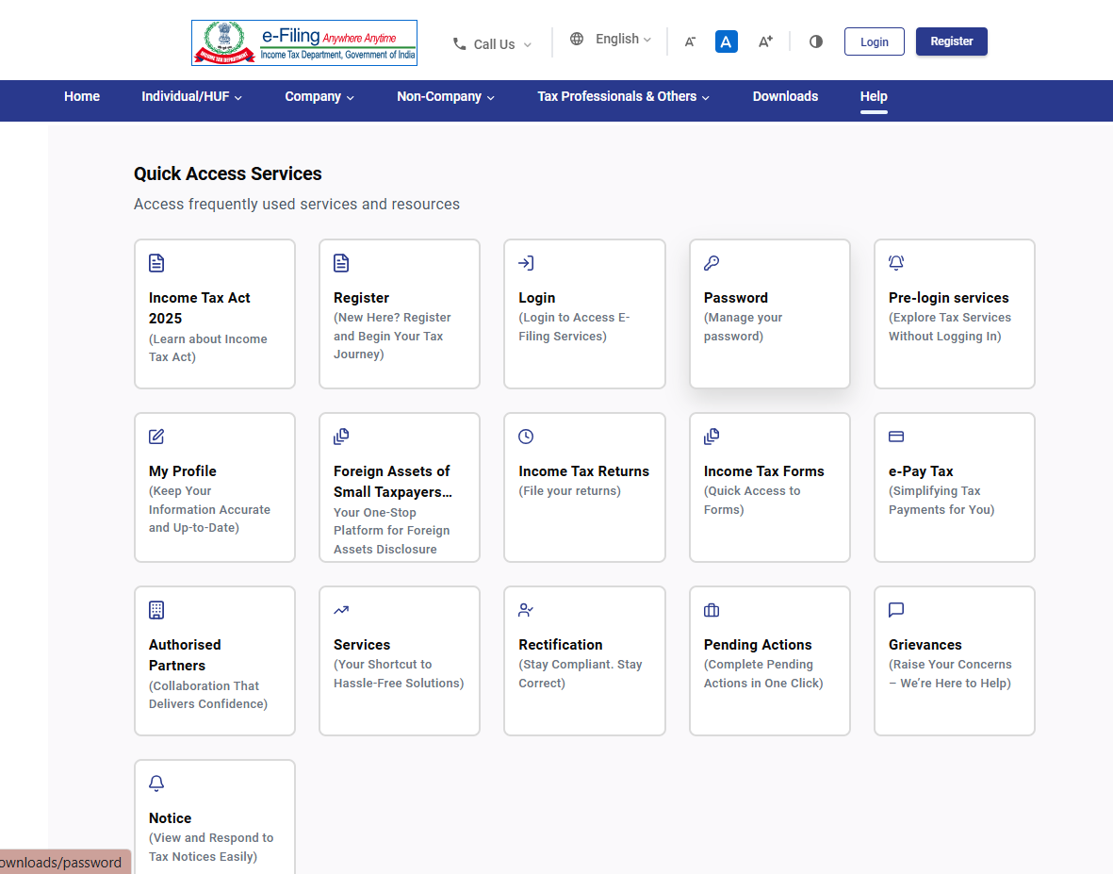
Login screen with a User ID field and a disabled Continue button before input is provided.
Problem: The Continue button is disabled until a User ID is entered. The screen explains the types of User ID accepted on the right, but a first-time user may not immediately understand why Continue is disabled or what to enter if their ID is not accepted.
Solution: Place a short hint directly beneath the User ID field, explain the accepted formats, and provide a specific inline error if the entered ID is invalid. Keep the disabled state visually clear and pair it with instructions for enabling the action.

10. Help and Documentation
Principle: Make assistance easy to find and relevant to the task the user is trying to complete.
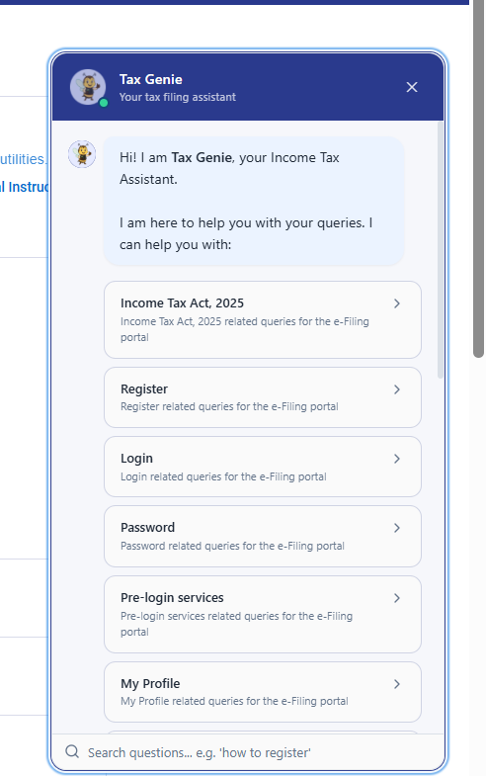
Tax Genie assistant offering topic shortcuts and a search field for help questions.
Problem: The Tax Genie widget provides help topics and a search field, but users working on a specific task may still need to leave that task or explain their issue in general terms to find relevant guidance.
Solution: Provide contextual help links beside complex form fields and actions, make common topics such as registration, login, returns, and refunds easy to find, and ensure the assistant offers a clear route to official support when it cannot resolve a query.

Conclusion
The supplied screenshots show several helpful design features, including a clearly structured top navigation, service cards, a multi-step registration indicator, visible Cancel and Back controls in relevant flows, contact information, and an embedded help assistant. The recommendations in this evaluation focus on improving clarity, reducing the effort required to find services, making specialist terminology easier to understand, and ensuring that users receive useful guidance while completing important tax-related tasks. A full usability test with users and inspection of interactive states would be needed to confirm the severity of each potential issue.

