

Continuous Assessment - II

Name: Riya
Section: 4O2336
Roll No: 15
Registration No: 12316877

Heuristic Evaluation
Selected Payment Application
1. Visibility of System Status: Keep users informed about what is happening through clear, timely feedback.
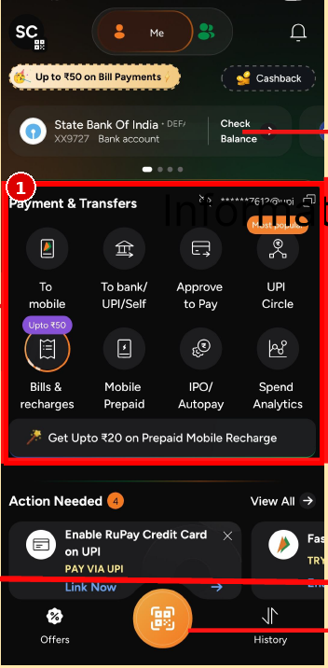
Problem: The Payment & Transfers section presents many actions together, but the interface gives limited feedback about which transfer method is currently selected or what will happen after tapping an option. The action labels are visible, but the resulting state is not previewed.
Solution: Add short contextual feedback after a transfer option is selected, such as the selected method, expected next step, and transaction status. Use clear states such as Processing, Successful, Failed, or Awaiting approval.

2. Recognition Rather Than Recall: Show options and information so users do not have to remember things.
Problem: The Payment & Transfers area uses several icon-only or icon-dominant actions such as To mobile, To bank/UPI/Self, Approve to Pay, UPI Circle, Bills & recharges, Mobile Prepaid, IPO/Autopay, and Spend Analytics. Users may need to interpret several icons and remember what each represents.
Solution: Use clearer text labels with consistent icon-plus-label treatment and add brief supporting descriptions for less familiar actions. Keep the most common actions visually prominent.

3. User Control and Freedom: Allow users to undo, cancel, go back, or exit unwanted actions easily.
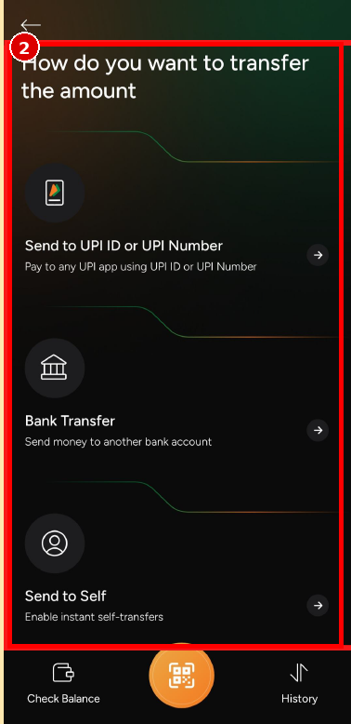
Problem: The transfer-selection screen provides a back arrow, but once a user enters a transfer route, there is no visible cancel or escape action within the individual options. The user has to rely mainly on the top-level back navigation.
Solution: Provide a clear Cancel or Back action at each important step of the transfer flow. For sensitive actions, also allow users to review and cancel before the transaction is finally submitted.

4. Match Between System and the Real World: Use familiar words, concepts, and representations that users understand.
Problem: The transfer screen mixes terms such as UPI ID, UPI Number, Bank Transfer, and Self Transfer. These are understandable, but the distinction between the three destinations could be made clearer for users who are not familiar with UPI terminology.
Solution: Use plain-language descriptions alongside financial terms, for example, 'Send to another person using UPI', 'Send money to a bank account', and 'Move money between your own accounts'.

5. Error Prevention: Design the interface to prevent problems before they occur.
Problem: The home screen exposes several high-impact payment actions in a compact grid. Similar-looking icons and multiple transfer-related options increase the possibility of choosing the wrong action before the user reaches a confirmation step.
Solution: Add clear confirmation and review steps for consequential actions. Distinguish similar transfer options with stronger labels and show the recipient/account details before final submission.

6. Consistency and Standards: Keep terminology, visual language, and interaction patterns consistent throughout the interface.
Problem: The home screen combines different visual treatments: dark circular action icons, promotional cards, pill-shaped controls, and a large orange central scan button. The hierarchy between primary actions and promotional content is not always consistent.
Solution: Use a consistent component system for action tiles, cards, labels, and buttons. Reserve stronger visual emphasis for primary tasks and use a consistent hierarchy across the home and transaction screens.

7. Flexibility and Efficiency of Use: Provide shortcuts and efficient ways for both new and experienced users.
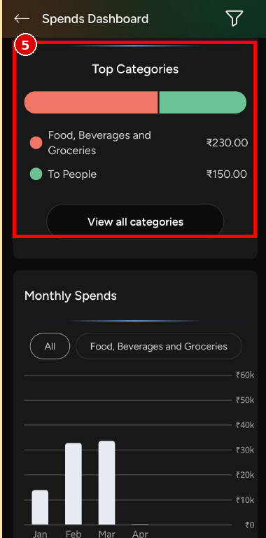
Problem: The Spends Dashboard provides category information and filters, but users must open the dashboard and interact with filters to explore their spending. There is no immediately visible shortcut for the most common spending views or time periods.
Solution: Add quick filters such as This Month, Last Month, Food, Bills, and Transfers. Provide one-tap access to frequently used spending views while keeping the detailed dashboard available.

8. Aesthetic and Minimalist Design: Keep the interface focused and avoid unnecessary information or destinations.
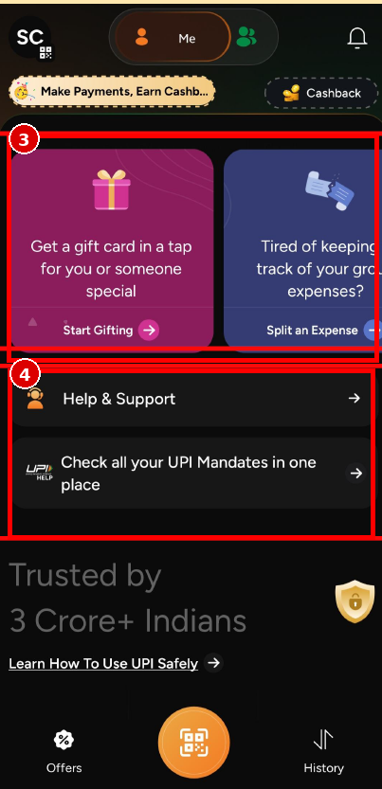
Problem: The lower part of the home screen contains promotional cards, Help & Support, UPI Mandates, a trust statement, and a safety-learning link in close succession. These elements compete for attention with the core payment experience.
Solution: Reduce the number of competing promotional and informational blocks on the primary screen. Prioritize essential payment tasks first and move secondary educational or promotional content lower in the hierarchy.

9. Help Users Recognize, Diagnose and Recover from Errors: Give clear error messages and explain what happened and how the user can recover.
Problem: The screenshots show action-heavy payment areas, but there is little visible inline guidance explaining what happens if a transfer, UPI payment, or approval fails. Users may need to leave the current flow to understand the next step.
Solution: Provide contextual error messages beside the affected transaction with a clear reason and recovery action, such as 'Payment failed — Try again', 'Bank unavailable — Use UPI instead', or 'Approval expired — Request again'.

10. Help and Documentation: Provide easy-to-find help or guidance when users need assistance.
Problem: Help & Support is available on the home screen, but it is presented as a separate destination rather than contextual help attached to individual payment actions. Users dealing with a specific payment issue may have to search for assistance.
Solution: Add contextual Help links or tooltips within transfer, UPI, mandate, and payment screens. Keep the existing Help & Support destination, but surface relevant guidance at the point where users need it.

