YUVAINTERN DATA SCIENCE INTERNSHIP · WEEK 4
Predicting Malignant Breast Tumours from Cell-Nucleus Measurements
Machine Learning Model Development and Evaluation — a leakage-safe, nested-validation study
Author: Shiv Date: September 2026 Dataset: Breast Cancer Wisconsin (Diagnostic), UCI
Companion code: week4_ml_pipeline.py (reproduces every number and figure in this report; seed 42)

Executive summary
The question. Can a simple, explainable model tell malignant from benign breast masses using 30 numeric measurements of cell nuclei — and, just as important, how far can we trust the accuracy figure it reports?
The answer. Yes, with a caveat about certainty. A regularised logistic regression was selected from five candidates by nested cross-validation (ROC-AUC 0.994 ± 0.004 across five outer folds). On a 114-patient test set opened exactly once it scored 98.2% accuracy, 100% precision and 95.2% recall: 2 malignant patients were missed and 0 benign patients were flagged. Because 114 patients is a small sample, the exact 95% confidence interval for recall runs from 83.8% to 99.4%; the cross-validated accuracy of 97.4% is the more reliable expectation.
Table 1. Headline results for all five candidates. The final model is highlighted; the dummy row is the do-nothing baseline.
Model | Nested-CV ROC-AUC | Test accuracy | Test recall | Test ROC-AUC | Train − CV accuracy gap
Dummy (class prior) | 0.500 ± 0.000 | 63.2% | 0.0% | 0.500 | —
Logistic Regression | 0.994 ± 0.004 | 98.2% | 95.2% | 0.998 | 0.7 pp
Decision Tree | 0.948 ± 0.028 | 91.2% | 78.6% | 0.969 | 3.7 pp
Random Forest | 0.988 ± 0.007 | 97.4% | 92.9% | 0.994 | 3.1 pp
SVM (RBF) | 0.995 ± 0.006 | 96.5% | 90.5% | 0.996 | 1.8 pp

Four findings that go beyond the headline number:
- The top two models are statistically tied, so simplicity broke the tie. SVM reached nested-CV AUC 0.9948 against 0.9936 for logistic regression — a difference of 0.0012, smaller than one standard error (0.0025). Logistic regression also gave the best-calibrated probabilities (Brier 0.019 vs 0.025 for the SVM). The random forest (0.988) and decision tree (0.948) were clearly behind, and the tree overfits.
- Correlation hurts explanation, not prediction. 21 of 435 feature pairs have |r| > 0.9 and the variance inflation factor reaches 3,806. Dropping 10 features left cross-validated AUC unchanged (0.9956 → 0.9935, inside the ±0.005 noise), but without regularisation the coefficients of radius, perimeter and area flipped sign in 32–45% of bootstrap resamples; the tuned L2 model never flipped.
- Duplicates would have silently flattered the score. The data contain none, so I measured the risk by injecting copies. With 30% duplicated rows split naively, an unpruned tree's accuracy rose by 2.6 percentage points and a random forest's by 1.8; at 50% duplication the apparent advantage of logistic regression over the tree shrank from 5.3 to 1.5 points. This pipeline splits before any transformation, so it is immune.
- The costliest error can be traded off explicitly. Moving the threshold from 0.50 to 0.40 (the F2-optimal point, chosen on out-of-fold training data only) recovered one of the two missed cancers for one false alarm with no loss of test accuracy; pushing to 0.16 for ≥ 98% recall buys more sensitivity at a steep price in false alarms (Section 6.4). Separately, a human-review band of P(malignant) between 0.2 and 0.8 contains only 7.7% of patients but 63.6% of all cross-validated errors.
RECOMMENDATION
Use the model as decision support (triage or second reader), not as an autonomous diagnosis. Its remaining errors sit where the disease is genuinely ambiguous in these features (Section 7), so the next gains will come from external validation, a human-review band and richer inputs — not from a fancier algorithm (Section 8).

How this report maps to the evaluation criteria
Evaluation criterion | Where it is addressed
Soundness of the model development process | Sections 2–4: audit, leakage-safe split, pipelines, nested cross-validation, one-standard-error selection rule
Clarity and detail of the documentation | Numbered sections, a decision table linking each finding to a modelling choice (Table 7), code in Section 4 and Appendix A
Effectiveness of visualisations | 11 figures, each followed by a “what to notice” paragraph; confusion matrices, ROC and PR curves in Section 5
Insightfulness of evaluation and discussion of improvements | Sections 6–8: over/under-fitting diagnosis, confidence intervals, collinearity experiment, threshold trade-off, error analysis, prioritised roadmap
Completion within 30–35 hours | Appendix B: effort breakdown

1. Problem framing and success criteria

1.1 What is being predicted, and why the two errors are not equal
In a fine-needle aspiration, a few cells are drawn from a breast mass and imaged; software outlines each cell nucleus and measures its shape. The task is to classify the sample as malignant or benign from those measurements. The two possible mistakes have very different consequences: a missed malignancy (false negative) can delay treatment, whereas a false alarm (false positive) usually triggers further tests. This asymmetry drives the choice of metrics below and the threshold analysis in Section 6.4.
A SILENT TRAP IN THE DATA
scikit-learn stores this dataset with 0 = malignant and 1 = benign — the reverse of what most people assume. Left uncorrected, “recall” would silently measure benign cases. I recode the label so that malignant = 1 (the positive class) and verify the counts: 212 malignant and 357 benign.

1.2 Metrics and success criteria — fixed before modelling
Table 2. Metrics used in this report and why each one is there.
Metric | Plain-English meaning | Role
Accuracy | Share of all patients classified correctly | Headline only — misleading here: always answering “benign” scores 63.2%
Recall (sensitivity) | Share of malignant patients that are caught | Primary safety metric
Precision | Share of “malignant” alarms that are real | Controls the false-alarm burden
F1 | Harmonic mean of precision and recall | Single summary of the two
ROC-AUC | Probability that a random malignant case is scored above a random benign one | Threshold-free; used for tuning and model selection
PR-AUC (average precision) | Area under the precision–recall curve | More sensitive to the positive class when classes are unbalanced
MCC | Correlation between predicted and true labels, using all four confusion-matrix cells | Robust single-number cross-check
Brier score | Mean squared error of the predicted probability (lower is better) | Can the probabilities be trusted?

Success criteria, set in advance: (1) nested-CV ROC-AUC ≥ 0.98; (2) at one operating point, cross-validated recall ≥ 95% and precision ≥ 90%; (3) no material overfitting — training accuracy no more than 3 percentage points above cross-validated accuracy; (4) a wide margin over the majority-class baseline. Section 5.6 scores every model against them.

1.3 Workflow at a glance
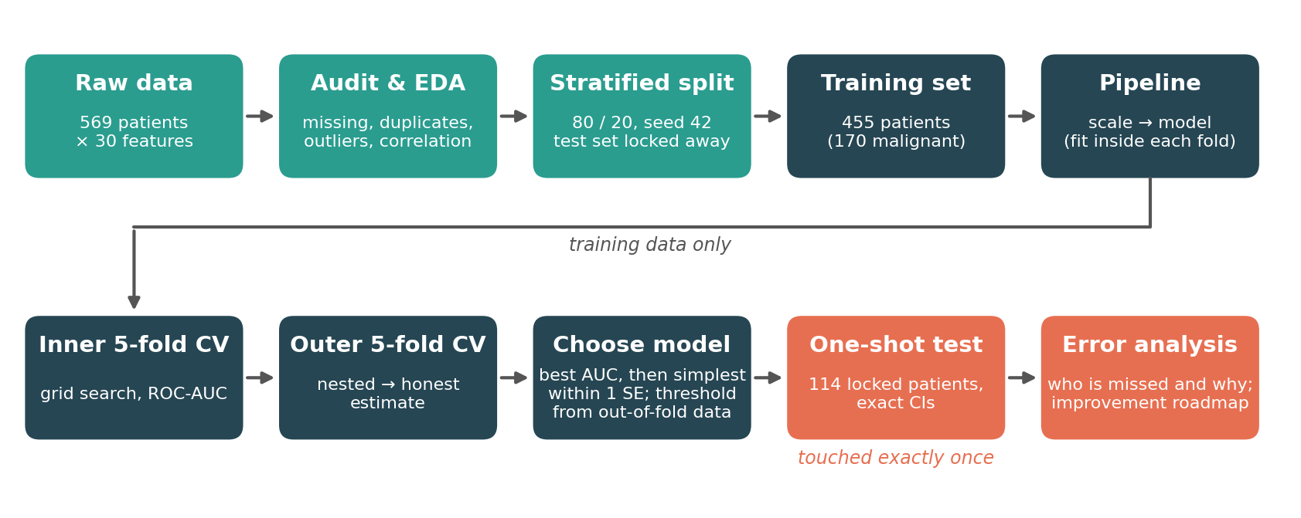
Figure 1. End-to-end workflow. The test set is separated at the start and used once; every fitted step (scaling, tuning, threshold choice) sees training data only.
The order matters more than any single technique: split first, fit everything on the training portion only, and touch the test set once. Each later section is one box in this diagram.

2. Data acquisition and audit

2.1 Source and structure
The Breast Cancer Wisconsin (Diagnostic) dataset was created by W. N. Street, W. H. Wolberg and O. L. Mangasarian at the University of Wisconsin and is hosted in the UCI Machine Learning Repository; a copy ships with scikit-learn, which is how it is loaded here so that the analysis reproduces exactly and offline. Each row is one patient's sample. Ten geometric properties of the cell nuclei were measured on the digitised image and each is summarised three ways — the mean, the standard error (variability across nuclei) and the worst value (mean of the three largest) — giving 10 × 3 = 30 numeric features for 569 patients. The label is the diagnosis later confirmed by pathology.
Table 3. The ten base measurements (each appears as mean, error and worst).
Measurement | What it captures
Radius, perimeter, area | Size of the nucleus (three views of the same idea — geometrically linked)
Texture | Variation in grey-scale intensity inside the nucleus
Smoothness | Local variation in radius lengths around the outline
Compactness | Perimeter² / area − 1: how far from a compact circle
Concavity, concave points | Severity and number of indentations in the outline
Symmetry | Left–right symmetry of the nucleus
Fractal dimension | “Coastline” roughness of the boundary

2.2 Data-quality audit
Table 4. Audit results and the decision each one triggered.
Check | Finding | Decision and rationale
Missing values | 0 of 17,070 cells | No imputation needed. For deployment I would add a median imputer inside the pipeline so it is fitted fold-wise.
Data types | All numeric (float64) | No encoding needed; scaling only.
Exact duplicates | 0 rows | Nothing to drop. Section 3.3 measures what duplicates would have cost.
Near-duplicates | Closest pair of patients is 1.01 standardised units apart | No hidden copies (for example the same patient re-measured).
Suspicious zeros | Six concavity-based columns contain zeros — the same 13 patients in all six; all benign | Genuine measurements (nuclei with no concave regions), not missing-value codes. Kept — and informative: none of these patients is malignant.
Class balance | 357 benign / 212 malignant (37.3% malignant) | Mild imbalance: stratified splits and folds, no resampling, and metrics beyond accuracy.
Outliers (1.5 × IQR) | 608 cells (3.6%); 171 patients (30.1%) have at least one; 53.8% of malignant vs 16.0% of benign patients | Not removed. Outliers are mostly malignant (66.7% of outlier rows), i.e. signal. Deleting them would remove about 114 of 212 malignant patients but only 57 of 357 benign ones.
Skewness | 22 of 30 features have |skew| > 1 (largest: area error, 5.45) | Standardise for scale-sensitive models; a Yeo–Johnson transform is tested as an ablation (Section 6.3).

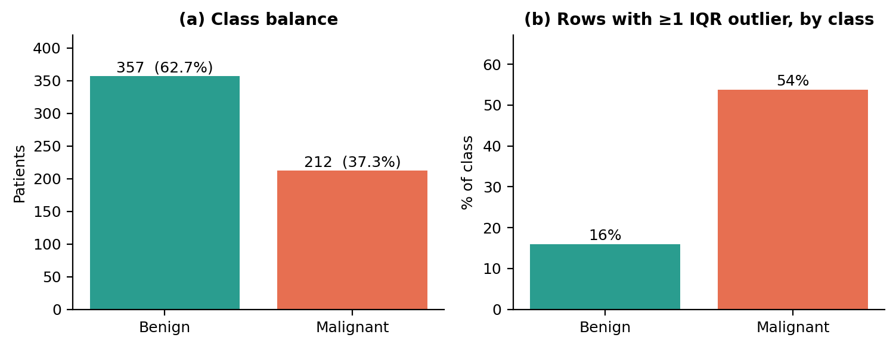
Figure 2. Class balance (a) and the share of patients with at least one statistical outlier, by class (b).
What to notice. Panel (b) is the reason no outliers were deleted: a malignant patient is 3.4 times as likely as a benign one to contain an extreme value. In this dataset, “unusual” is largely a synonym for “malignant”; a routine outlier-removal step would have quietly removed the very cases the model exists to catch.

3. Exploratory analysis that shapes the model

3.1 Which measurements carry signal?
Because 22 features are skewed, I compared the classes with the non-parametric Mann–Whitney U test (the same testing logic as Week 3) and, more usefully for modelling, with the univariate AUC: how well a single feature ranks malignant above benign. 26 of 30 features differ significantly after a Bonferroni correction (α = 0.05/30), with p-values as small as 2.6e-80. But significance is cheap with 569 rows; the AUC shows how large the separation is.
Table 5. The eight most discriminative single features.
Feature | Median (benign) | Median (malignant) | Ratio | Univariate AUC | Mann–Whitney p
worst perimeter | 86.9 | 138 | 1.59× | 0.975 | 2.6e-80
worst radius | 13.3 | 20.6 | 1.54× | 0.970 | 1.1e-78
worst area | 547 | 1303 | 2.38× | 0.970 | 1.8e-78
worst concave points | 0.0743 | 0.182 | 2.45× | 0.967 | 1.9e-77
mean concave points | 0.0234 | 0.0863 | 3.68× | 0.964 | 1.0e-76
mean perimeter | 78.2 | 114 | 1.46× | 0.947 | 3.6e-71
mean area | 458 | 932 | 2.03× | 0.938 | 1.5e-68
mean concavity | 0.0371 | 0.151 | 4.08× | 0.938 | 2.2e-68

11 features exceed a univariate AUC of 0.9, so this is an “easy” problem where I expect a ceiling around 97–99% accuracy; the interesting questions concern the borderline tail, not the bulk. At the other end, four features barely separate the classes (symmetry error 0.56, smoothness error 0.53, mean fractal dimension 0.52, texture error 0.51). They are kept: L2 regularisation shrinks their influence, and Section 6.3 tests whether aggressive selection would help.
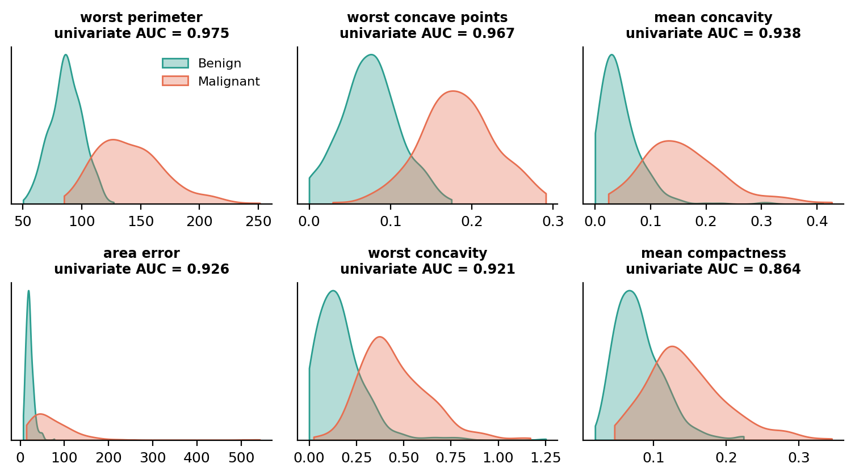
Figure 3. Class-conditional distributions of the six strongest non-redundant features (chosen greedily so that no two have |r| ≥ 0.9). Univariate AUC in each title.
What to notice. Malignant nuclei are larger and more indented, but every panel shows an overlap zone. No single feature is a clean decision rule; the model has to combine them, and its errors will concentrate in those overlaps (Section 7).

3.2 Multicollinearity
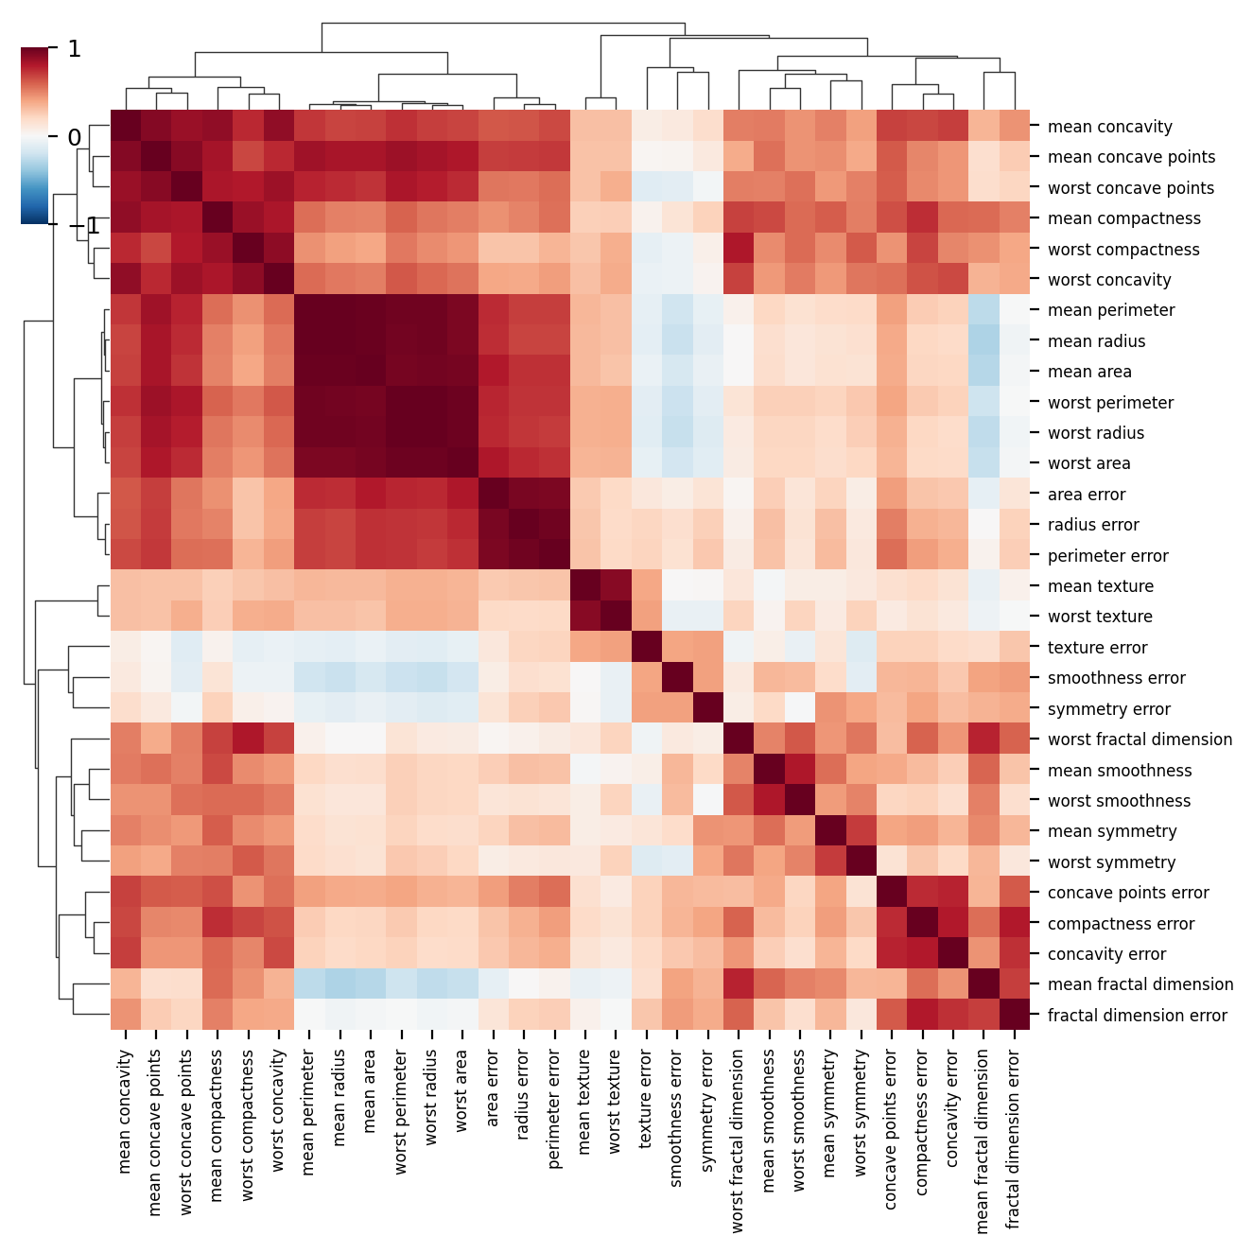
Figure 4. Correlation matrix, clustered so that similar features sit together. The dark red block is the “size” family.
Radius, perimeter and area describe the same physical quantity (for a circle, perimeter = 2πr and area = πr²), so they are almost perfectly correlated — mean radius vs mean perimeter has r = 0.998. Overall 21 of 435 pairs exceed |r| = 0.9 and 15 exceed 0.95. The variance inflation factor (VIF) tells the same story: 23 of 30 features have VIF > 10, 6 exceed 100 and the maximum is 3,806 (mean radius). Pruning one member of every pair above 0.9 (a label-free rule) leaves 20 features with maximum VIF 32.3; 9 still exceed 10 because VIF also detects dependence on combinations of features.
Predictions to test later (rather than assume): collinearity should (a) barely change predictive accuracy, (b) make unregularised coefficients unstable, and (c) be tamed by L2 regularisation. Section 6.3 runs these experiments.

3.3 Duplicates: no copies exist, so I measured what copies would do
This dataset has no exact or near-duplicate rows, so there is nothing to remove. But duplicates are the classic route by which test-set information leaks into training, and feedback on Week 1 asked for deeper analysis of their impact. So I injected them deliberately. For duplication rates from 0% to 50%, I copied randomly chosen rows into the table and compared two protocols over 20 random seeds and four models: naive (random 80/20 split of the inflated table, so copies of one patient can land on both sides) and clean (deduplicate, then split).
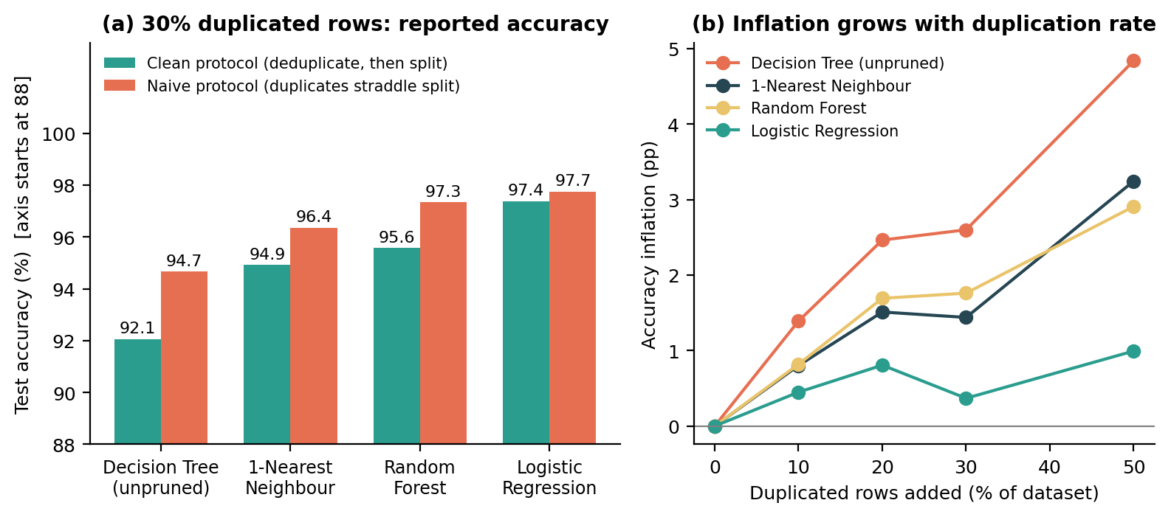
Figure 5. Effect of duplicated rows on reported test accuracy. (a) Accuracy at 30% duplication under the clean and naive protocols (y-axis starts at 88). (b) Inflation in percentage points as the duplication rate grows.
Table 6. Accuracy inflation (naive minus clean, percentage points) by duplication rate; mean of 20 seeds.
Model | 10% | 20% | 30% | 50% | Clean accuracy
Decision Tree (unpruned) | +1.4 | +2.5 | +2.6 | +4.8 | 92.1%
1-Nearest Neighbour | +0.8 | +1.5 | +1.4 | +3.2 | 94.9%
Random Forest | +0.8 | +1.7 | +1.8 | +2.9 | 95.6%
Logistic Regression | +0.4 | +0.8 | +0.4 | +1.0 | 97.4%

Three lessons.
- Inflation tracks memorisation capacity. The unpruned tree and 1-nearest-neighbour, which can memorise individual rows, gain the most; logistic regression, which cannot, gains the least.
- Duplicates compress differences between models. At 50% duplication, logistic regression looks only 1.5 points better than the tree, against a true gap of 5.3. A team comparing models on a leaky table could wrongly conclude that model choice does not matter — or pick a flexible model for the wrong reason.
- The effect here is moderate because the problem is easy and accuracy is already high. I would expect larger inflation on noisier problems, where memorising individual rows earns more; that is a hypothesis, not something measured here.
Duplicates also silently up-weight the copied patients in the loss function and distort correlation estimates. The defence is procedural: deduplicate first, then split, then fit anything.

3.4 From findings to decisions
Table 7. Every EDA finding and the modelling decision it produced.
Finding | Consequence for the pipeline
No missing values, no duplicates | No imputer or deduplication step; the leakage-safe split order is still enforced
37.3% malignant | Stratified split and folds; report recall, PR-AUC and MCC, not accuracy alone
30.1% of patients have an outlier, mostly malignant | Keep all rows; rely on scaling and regularisation instead of clipping
22 skewed features | Test a Yeo–Johnson transform as an ablation
Size-block collinearity (VIF up to 3,806) | L2 regularisation; compare with a pruned feature set; check coefficient stability
11 features with univariate AUC > 0.9 | Expect simple models to do very well; include a tree, forest and SVM to check that extra flexibility is not needed
Four almost-useless features | Let regularisation handle them; test top-10 selection inside cross-validation

4. Modelling approach

4.1 Protocol: split first, fit on training data only
The data are split once, stratified, into 455 training and 114 test patients (170 and 42 malignant respectively; seed 42). The test set is not looked at again until the final evaluation. Scaling lives inside a scikit-learn Pipeline, so during cross-validation the scaler is fitted on the training folds only — fitting it on all the data first would leak the held-out fold's mean and variance.
raw = load_breast_cancer(as_frame=True)
X = raw.frame[raw.feature_names]
y = 1 - raw.frame["target"] # recode: malignant = 1 (positive class)

Xtr, Xte, ytr, yte = train_test_split(
X, y, test_size=0.20, stratify=y, random_state=42) # 455 / 114; test locked

# scaler is fitted on training folds only (inside the pipeline)
lr_pipe = Pipeline([("scale", StandardScaler()),
("clf", LogisticRegression(solver="liblinear",
max_iter=5000))])

4.2 Candidate algorithms and why each is included
Table 8. Candidates, their role in the comparison and the hyper-parameters searched.
Model | Why it is in the comparison | Search grid (combinations)
Dummy (class prior) | The floor: always predict the majority class. Anything built must beat it by a wide margin. | None
Logistic Regression (L1/L2) | Primary candidate. Linear, convex (one optimum), outputs probabilities, and its coefficients explain each feature's push. Regularisation is the standard remedy for correlated inputs. | penalty {L1, L2} × C in 13 log-spaced values, 10⁻³ to 10³ (26)
Decision Tree | Fully transparent rules; deliberately included as the high-variance foil to demonstrate over-fitting. | depth {2,3,4,5,6,8,none} × min leaf {1,3,5,10} × criterion {gini, entropy} (56)
Random Forest | Averages many de-correlated trees to reduce variance; strong tabular baseline. Tests whether non-linearity or interactions matter. | depth {none, 6} × min leaf {1, 3} × max features {√p, 30%}; 200 trees (8)
SVM (RBF) | Smooth non-linear boundary; a second opinion on whether the classes are linearly separable. | C {0.1, 1, 10, 100} × gamma {scale, 0.003, 0.01, 0.03} (16)

Clustering (for example k-means) was not used: labels are available, so supervised learning answers the question directly. Clustering would only be relevant for discovering unlabelled sub-types.

4.3 Tuning, nested cross-validation and the selection rule
If hyper-parameters are tuned with cross-validation and the same cross-validation score is then reported, the number is optimistic: the winner is the configuration that got lucky on those folds. Nested cross-validation wraps the entire tuning procedure in an outer loop, so each outer fold is scored on data the tuning never saw. The outer scores therefore estimate how well the whole procedure — including tuning — generalises. Inner loops (5-fold) tune on ROC-AUC, which is threshold-free; the decision threshold is handled separately in Section 6.4.
grid = {"clf__penalty": ["l1", "l2"], "clf__C": np.logspace(-3, 3, 13)}
inner = StratifiedKFold(5, shuffle=True, random_state=43)
outer = StratifiedKFold(5, shuffle=True, random_state=42)

search = GridSearchCV(lr_pipe, grid, cv=inner, scoring="roc_auc")
metrics = ["accuracy", "precision", "recall", "f1", "roc_auc"]
nested = cross_validate(search, Xtr, ytr, cv=outer, scoring=metrics)
final = search.fit(Xtr, ytr).best_estimator_ # refit on all 455 training rows

Selection rule (one-standard-error rule). Pick the model with the highest mean nested AUC; where other models are within one standard error of it, choose the simplest (order: logistic regression, tree, SVM, forest). The choice is made on cross-validation only, never on test-set scores. Caveat: the five outer folds are not independent, so the standard error is approximate.

5. Results

5.1 Cross-validated performance (the number to trust)
Table 9. Nested cross-validation on the 455 training patients: mean ± standard deviation over five outer folds (percent, except AUC).
Model | Accuracy | Precision | Recall | F1 | ROC-AUC
Dummy (class prior) | 62.6 ± 0.0 | 0.0 ± 0.0 | 0.0 ± 0.0 | 0.0 ± 0.0 | 0.500 ± 0.000
Logistic Regression | 97.4 ± 1.3 | 99.4 ± 1.3 | 93.5 ± 3.8 | 96.3 ± 1.8 | 0.994 ± 0.004
Decision Tree | 92.1 ± 2.8 | 90.4 ± 3.1 | 88.2 ± 6.6 | 89.2 ± 3.9 | 0.948 ± 0.028
Random Forest | 95.6 ± 2.2 | 95.3 ± 3.6 | 92.9 ± 4.9 | 94.0 ± 3.0 | 0.988 ± 0.007
SVM (RBF) | 97.1 ± 1.0 | 98.3 ± 2.6 | 94.1 ± 3.6 | 96.1 ± 1.4 | 0.995 ± 0.006

Logistic regression and the SVM lead on every metric and are close to indistinguishable; the tree is both worse and much less stable (AUC standard deviation 0.028 against 0.004). The dummy model's 62.6% accuracy with zero recall is the reminder of why accuracy alone is not enough: it is right most of the time and useless.

5.2 Held-out test performance (one look)
Table 10. Test set of 114 patients (42 malignant), decision threshold 0.5.
Model | Acc. | Prec. | Recall | F1 | AUC | PR-AUC | MCC | Brier | Missed | False alarms
Dummy (class prior) | 63.2% | 0% | 0.0% | 0.000 | 0.500 | 0.368 | 0.000 | 0.233 | 42 | 0
Logistic Regression | 98.2% | 100% | 95.2% | 0.976 | 0.998 | 0.997 | 0.963 | 0.019 | 2 | 0
Decision Tree | 91.2% | 97% | 78.6% | 0.868 | 0.969 | 0.953 | 0.814 | 0.063 | 9 | 1
Random Forest | 97.4% | 100% | 92.9% | 0.963 | 0.994 | 0.991 | 0.944 | 0.032 | 3 | 0
SVM (RBF) | 96.5% | 100% | 90.5% | 0.950 | 0.996 | 0.995 | 0.926 | 0.025 | 4 | 0

Table 11. Hyper-parameters selected by the inner search on the full training set.
Model | Selected settings | Inner-CV AUC
Logistic Regression | C = 0.316, penalty = l2 | 0.9956
Decision Tree | criterion = gini, max_depth = 5, min_samples_leaf = 10 | 0.9737
Random Forest | max_depth = 6, max_features = 0.3, min_samples_leaf = 3 | 0.9871
SVM (RBF) | C = 100, gamma = 0.003 | 0.9947

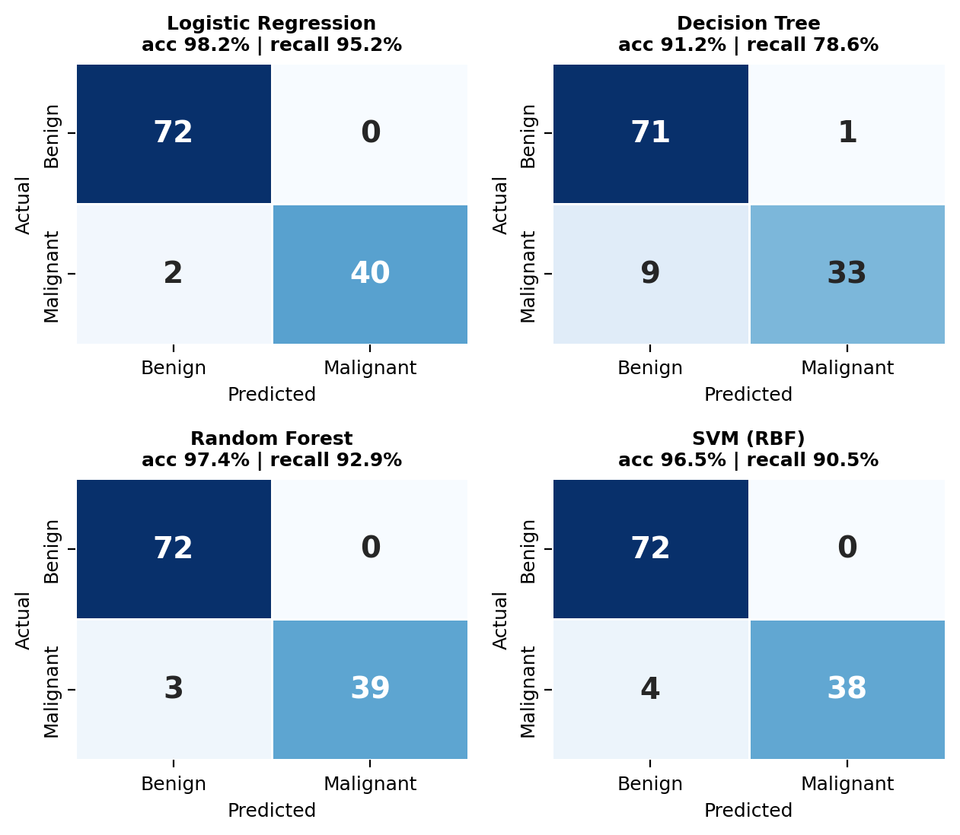
Figure 6. Confusion matrices on the test set for the four real candidates (rows: actual class; columns: predicted class).
What to notice. Three of four models raise no false alarms at all; they differ in how many malignant patients they miss (2, 3, 4 and 9 for logistic regression, forest, SVM and tree). The tree's 9 misses (recall 78.6%) is the practical cost of its instability. These are small counts, so read the differences among the top three as tendencies, not verdicts (Section 6.2).

5.3 ROC and precision–recall curves
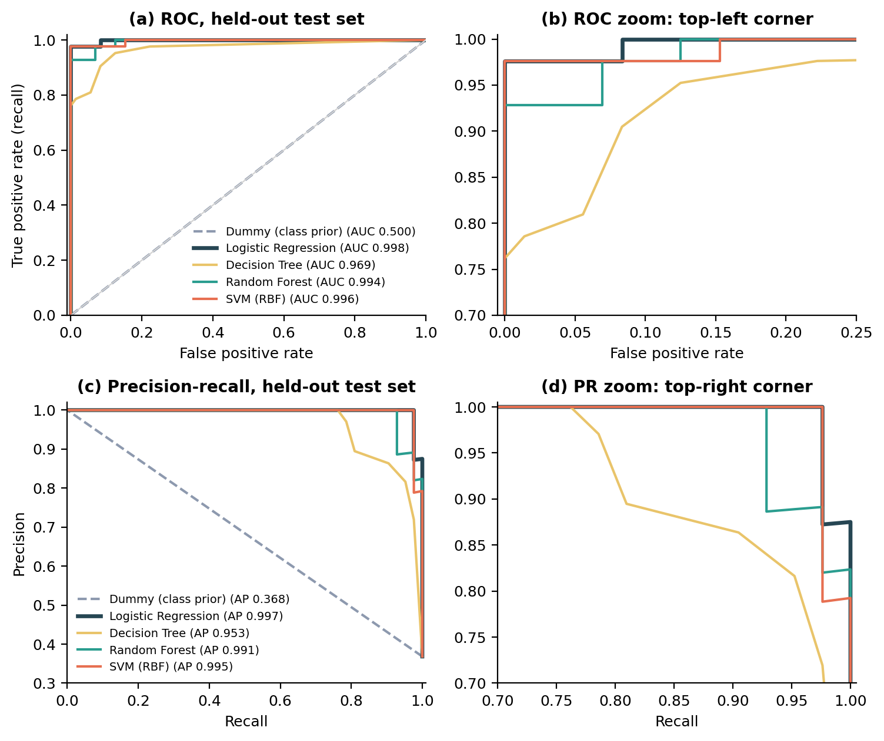
Figure 7. ROC and precision–recall curves on the test set. Panels (b) and (d) zoom into the corners where the models actually differ.
What to notice. On the full ROC (a) the four real models are hard to tell apart — a sign that the problem is easy — so the zoom (b) is needed. The decision tree's curve is a coarse staircase because a depth-limited tree produces only a handful of distinct probabilities. The precision–recall view (c, d) is the stricter test under class imbalance: logistic regression keeps precision at 1.0 for longest before dropping (average precision 0.997), while the tree's precision decays early (0.953).

5.4 Why the model was not chosen by test score
The test set ranks logistic regression first, but the margin over the SVM and forest is one or two patients — one patient is 0.9 points of accuracy and 2.4 points of recall. Choosing among near-tied models by test score would spend the test set's independence on noise. It is also worth noting that the test AUC (0.998) is higher than the nested-CV AUC (0.994 ± 0.004): this split turned out to be a favourable draw, so expect closer to 97.4% accuracy in future, not 98.2%. A ten-fold out-of-fold check on all 569 patients gives 98.1% accuracy and AUC 0.995, consistent with that view.

5.5 Scorecard against the success criteria
Table 12. Criteria (1) and (3) for every model; criterion (2) is evaluated for the final model in Section 6.4.
Model | (1) Nested AUC ≥ 0.98 | (3) Train − CV gap ≤ 3 pp | (4) Beats baseline (MCC)
Logistic Regression | ✓ 0.994 | ✓ 0.7 pp | ✓ 0.96
SVM (RBF) | ✓ 0.995 | ✓ 1.8 pp | ✓ 0.93
Random Forest | ✓ 0.988 | ✗ 3.1 pp | ✓ 0.94
Decision Tree | ✗ 0.948 | ✗ 3.7 pp | ✓ 0.81

6. Going deeper: is the model right for the right reasons?

6.1 Over-fitting and under-fitting
Table 13. Training, cross-validated and test accuracy, and what the gap says.
Model | Train | Nested CV | Test | Train − CV | Diagnosis
Dummy (class prior) | 62.6% | 62.6% | 63.2% | 0.0 pp | Under-fits completely: learns nothing
Logistic Regression | 98.0% | 97.4% | 98.2% | 0.7 pp | Well fitted; low variance
SVM (RBF) | 98.9% | 97.1% | 96.5% | 1.8 pp | Well fitted; slight variance
Random Forest | 98.7% | 95.6% | 97.4% | 3.1 pp | Moderate variance despite averaging
Decision Tree | 95.8% | 92.1% | 91.2% | 3.7 pp | Over-fits: high variance, worst CV and test scores

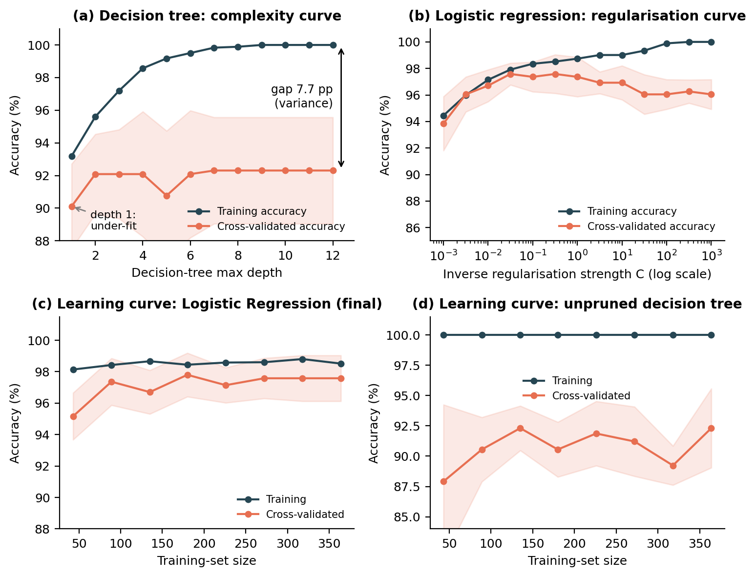
Figure 8. Bias–variance diagnostics on the training data. (a) Decision tree complexity curve. (b) Logistic regression regularisation curve. (c) Learning curve of the final model. (d) Learning curve of an unpruned tree. Bands show ±1 standard deviation across folds.
(a) Tree. Training accuracy climbs from 93.2% (a single split) to 100% by depth 9, while cross-validated accuracy plateaus near 92%. Extra depth does not make the CV score fall; it makes the gap grow to 7.7 points — over-fitting shows up as memorisation, not as a collapse. A depth-1 stump under-fits.
(b) Logistic regression. With very strong regularisation (small C) both curves are low — under-fitting. Cross-validated accuracy peaks around C ≈ 0.032 (97.6%); beyond C ≈ 30 the training score approaches 100% while the CV score drifts down — over-fitting from too little regularisation. The tuned C = 0.32 sits on the plateau.
(c–d) Learning curves. The final model's training and CV curves converge with a gap of about 0.9 point and flatten after roughly 180 training rows: low variance, and more rows of the same kind will help little. The remaining ~2.6% error is bias or genuine ambiguity in the features. The unpruned tree keeps 100% training accuracy at every size with a 7.7-point gap: classic high variance. The implication is that better inputs, not more data or a bigger model, are the lever (Section 8).

6.2 How certain are the test numbers?
Table 14. Exact (Clopper–Pearson) 95% confidence intervals for the final model on the 114 test patients.
Metric | Count | Point estimate | 95% confidence interval
Accuracy | 112 / 114 | 98.2% | 93.8% – 99.8%
Recall (sensitivity) | 40 / 42 | 95.2% | 83.8% – 99.4%
Precision | 40 / 40 | 100.0% | 91.2% – 100.0%
Specificity | 72 / 72 | 100.0% | 95.0% – 100.0%

The bootstrap 95% interval for the test AUC is 0.992 – 1.000. (For proportions that hit 100% a percentile bootstrap collapses to a single point, which is why exact binomial intervals are used.) Two practical consequences: a perfect-looking 100% precision is compatible with a true value as low as 91%, and the one-to-two-patient differences between the top three models are well inside the noise. Report intervals, not points.

6.3 Multicollinearity in practice: prediction versus interpretation
Section 3.2 predicted that collinearity would leave accuracy intact but wreck coefficient interpretation. Two experiments test that.
for _ in range(200):
i = rng.randint(0, len(Xtr), len(Xtr)) # bootstrap resample
Z = StandardScaler().fit_transform(Xtr.iloc[i])
yb = ytr.iloc[i]
weak = LogisticRegression(C=1e3, max_iter=50000).fit(Z, yb) # ~unregularised
tuned = LogisticRegression(solver="liblinear", penalty="l2",
C=0.316).fit(Z, yb) # tuned L2

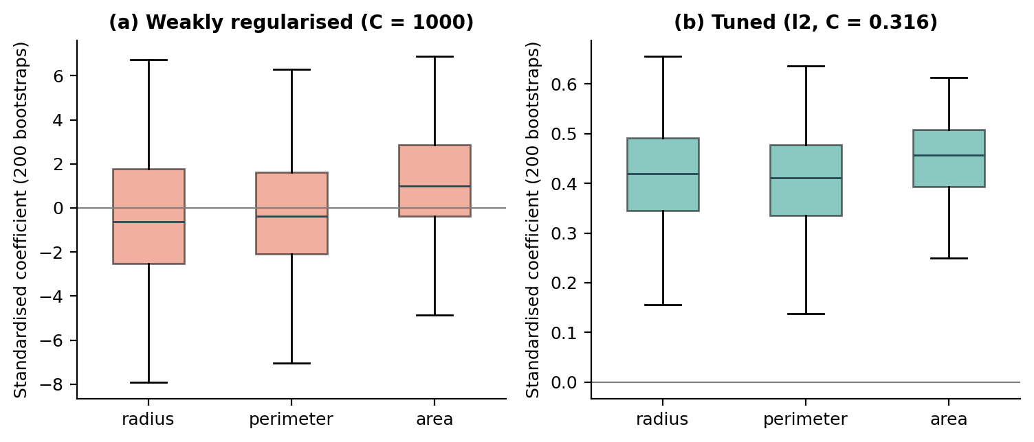
Figure 9. Bootstrap distribution (200 resamples) of the standardised coefficients of the three size features. Note the different y-axis scales.
What to notice. With weak regularisation the three coefficients swing across roughly ±7, have medians of -0.62, -0.37, 1.01 (mixed signs, which would wrongly suggest that a larger radius is protective) and change sign in 41%, 45%, 32% of resamples. The tuned L2 model gives all three the same modest positive weight (0.42, 0.41, 0.46), with a standard deviation of about 0.11 and no sign flips: L2 shares credit across correlated features instead of arbitrarily loading one. Individual coefficients of correlated features should be read as a group — “size” — never one by one.
Table 15. Feature-set ablation for the tuned logistic regression: 5-fold × 3-repeat cross-validation on the training data (mean ± SD; selection happens inside each fold).
Feature set | ROC-AUC | Recall | Accuracy
All 30 features (baseline) | 0.9956 ± 0.0051 | 95.3 ± 3.5% | 97.6 ± 1.5%
Correlation-pruned (|r| ≤ 0.9) → 20 features | 0.9935 ± 0.0060 | 94.9 ± 3.8% | 97.4 ± 1.5%
'Mean' block only → 10 features | 0.9847 ± 0.0084 | 88.4 ± 3.8% | 93.9 ± 2.1%
Top-10 by ANOVA F (selected inside each fold) | 0.9852 ± 0.0106 | 90.2 ± 6.0% | 93.7 ± 2.5%
All 30 + Yeo-Johnson power transform | 0.9954 ± 0.0042 | 95.7 ± 2.2% | 97.1 ± 1.6%

Findings. (i) Dropping 10 correlated features costs nothing measurable (AUC 0.9956 vs 0.9935, SD about 0.005) — prediction is robust to collinearity. (ii) The ten “mean” features alone lose 6.9 points of recall, so the “worst” block (extreme nuclei) carries information the averages hide. (iii) Aggressive selection to the ten top features hurts (recall 90.2%). (iv) The Yeo–Johnson transform adds nothing (AUC 0.9954), so the simpler pipeline stays. Caveat: C was tuned on all 30 features, which slightly favours the baseline row.

6.4 Choosing the decision threshold
A probability model does not have to classify at 0.5. Because a missed cancer costs more than a false alarm, I examined the trade-off using out-of-fold predictions on the training data only and then applied each candidate threshold to the test set once.
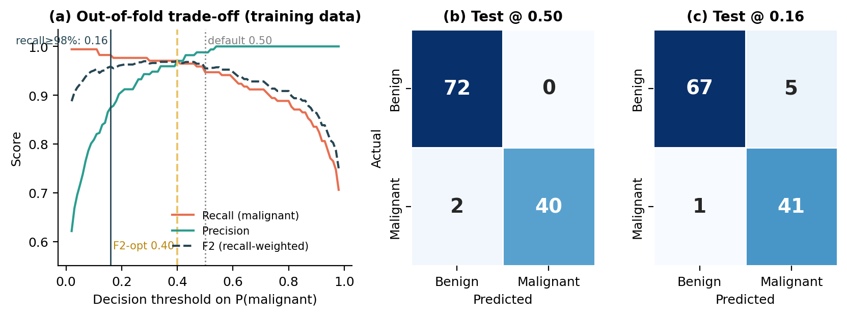
Figure 10. (a) Out-of-fold recall, precision and F2 versus threshold; the dashed line marks the F2-optimal threshold. (b, c) Test-set confusion matrices at 0.50 and at 0.16, the highest threshold keeping cross-validated recall at or above 98%.
Table 16. Four operating points. Thresholds are chosen on training out-of-fold data; test columns are one-shot.
Operating point | Threshold | CV recall | CV precision | Test missed | Test false alarms | Test recall | Test precision
Default | 0.50 | 94.7% | 98.8% | 2 | 0 | 95.2% | 100.0%
F2-optimal | 0.40 | 97.1% | 97.1% | 1 | 1 | 97.6% | 97.6%
Recall ≥ 95% | 0.49 | 95.9% | 98.8% | 2 | 0 | 95.2% | 100.0%
Recall ≥ 98% | 0.16 | 98.2% | 87.4% | 1 | 5 | 97.6% | 89.1%

Success criterion (2) — recall ≥ 95% and precision ≥ 90% at one operating point — is met by the F2-optimal and recall ≥ 95% settings on cross-validated data. The default 0.5 threshold gives cross-validated recall of 94.7%, just short of 95%. Moving to 0.16 raises cross-validated recall to 98.2% but cuts precision to 87.4%.
The price of each extra catch. On the 455 training patients, going from 0.5 to 0.16 catches 6 more malignant patients at the cost of 22 more false alarms — about 3.7 false alarms per additional cancer found. On the test set the move recovers 1 malignant patient(s) for 5 extra false alarms. The F2-optimal threshold of 0.40 is the best compromise here: cross-validated recall and precision are both 97.1%, and on the test set it recovers one of the two misses for a single false alarm (accuracy unchanged at 98.2%). Whether pushing further is worth it depends on the relative cost of the two errors, which is a clinical decision, not a statistical one; the analysis simply makes the exchange rate explicit. These test counts are tiny, so they illustrate rather than prove.

7. Error analysis: who is missed, and why?
To study errors with more cases than the test set offers, I generated ten-fold out-of-fold predictions for all 569 patients. The model makes 11 errors: 9 false negatives (missed malignancies) and 2 false positives. To compare error groups on one axis I built a severity score: the mean standardised value of the six key, non-redundant features (worst perimeter, worst concave points, mean concavity, area error, worst concavity, mean compactness).
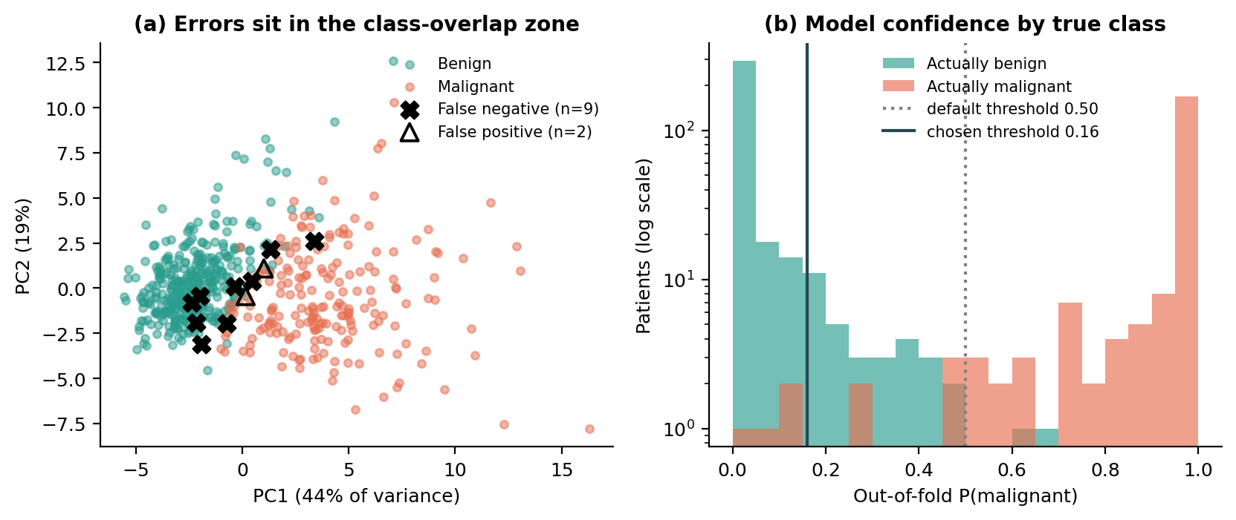
Figure 11. (a) The first two principal components (63% of variance) with misclassified patients marked. (b) Out-of-fold predicted probability by true class (log scale).
Table 17. Error groups from ten-fold out-of-fold predictions on all 569 patients.
Group | Patients | Mean predicted P(malignant) | Mean severity score
True negative (benign, correct) | 355 | 0.04 | -0.53
False positive (benign, flagged) | 2 | 0.65 | +0.08
False negative (malignant, missed) | 9 | 0.26 | -0.11
True positive (malignant, caught) | 203 | 0.96 | +0.93

What the errors reveal.
- Misses look benign. The missed malignancies have a mean severity of -0.11, much closer to true negatives (-0.53) than to caught malignancies (+0.93). In panel (a) they sit inside the benign cloud. These tumours are not being mishandled by the algorithm; on these measurements they are genuinely benign-looking.
- Most errors are uncertain, a few are not. 7 of 11 errors have predicted probability between 0.2 and 0.8. 2 are confidently wrong (probability ≤ 0.1 for a malignant case or ≥ 0.9 for a benign one) — these could be rescued only by accepting many more false alarms.
- Errors can be isolated. The 44 patients (7.7%) with probability between 0.2 and 0.8 contain 7 of 11 errors (63.6%); accuracy outside that band is 99.2%. Widening the band to 0.1–0.9 covers 80 patients (14.1%) and 9 errors (81.8%), with 99.6% accuracy outside. A model that abstains and refers such cases to a pathologist would remove most of its own mistakes.
- Test-set errors (threshold 0.5): patient index 73 (Malignant, predicted probability 0.11); patient index 205 (Malignant, predicted probability 0.48). One is a near coin-flip that any threshold at or below 0.48 would catch; the other, at 0.11, is missed at every threshold considered here.

7.1 Sources of error and what would reduce each
Table 18. Potential sources of error, the evidence for each in this study, and mitigations.
Source | Evidence here | Mitigation
Genuine class overlap | Distributions overlap in every panel of Figure 2; misses have benign-like severity; SVM and forest do not beat the linear model | Richer inputs (image-level features, clinical variables). A better algorithm will not fix this.
Small sample | Test intervals are wide (recall 84%–99%); a single patient moves accuracy 0.9 points | More data, repeated nested CV, external validation
Class imbalance and threshold | 37.3% malignant; the default 0.5 threshold gives cross-validated recall of only 94.7% | Cost-based threshold (Section 6.4); class weights as an experiment
Model variance | Tree gap 3.7 pp; forest 3.1 pp | Regularised or ensembled models; keep the tree only as an explanation aid
Measurement noise | “Worst” features are order statistics of a segmentation output and are sensitive to segmentation quality | Standardise imaging and segmentation; test robustness to perturbation
Dataset shift | One institution, one imaging pipeline, older data | External and temporal validation before any real use

8. Improvement roadmap
Ordered by expected value per unit of effort, using the evidence from Sections 6 and 7.
# | Improvement | Why (evidence) | How to verify
1 | External validation on a different institution's data | One source, 569 rows; wide intervals; possible dataset shift | Report performance with exact intervals on data never used for design
2 | Add a human-review band (0.2 < P < 0.8) | 44 patients (7.7%) hold 7 of 11 errors; 99.2% accuracy outside | Measure reviewer workload against errors avoided
3 | Cost-based decision threshold | Each extra catch costs about 3.7 false alarms | Agree a cost ratio with clinicians; pick the threshold by expected cost
4 | Richer inputs (deep image features, clinical variables) | Misses look benign on nucleus-shape features; learning curve has flattened | Add in a nested-CV comparison; keep only if the gain exceeds the SE
5 | Probability calibration and a reliability diagram | Brier 0.019 is already good but rests on 114 patients | Platt or isotonic calibration inside CV; check on external data
6 | Ratio and interaction features (worst ÷ mean) | The worst block adds information beyond the means | Nested CV; expect a small gain
7 | Repeated nested CV (5 × 5) | Only five outer folds, so the standard error is rough | Compare model differences with paired tests on repeated folds
8 | Boosting or stacking | Forest and SVM did not beat the linear model, so expected gain is low and n = 569 invites over-fitting | Try only after item 4 changes the feature set

9. Limitations and responsible use
- Not a clinical validation. This is a coursework model on a public research dataset and must not inform real diagnoses.
- Prevalence changes precision. This sample is 37% malignant; screening populations are far lower. Precision (positive predictive value) depends on prevalence, so the 100% precision reported here does not transfer.
- Single source. Features come from one imaging and segmentation pipeline; other scanners or protocols may shift the distributions.
- No demographic variables. Performance could not be checked across age or other groups, so fairness is unknown.
- Approximate uncertainty. Standard errors from five non-independent folds and bootstrap intervals on 114 patients are rough guides.
WHY PREVALENCE MATTERS — A WORKED EXAMPLE
Take the model's test sensitivity (95.2%) and the lower end of the specificity interval (95.0%), and suppose 5% of screened patients are malignant. Then the share of alarms that are real cancers (positive predictive value) is about 50% — one in two alarms would be a false alarm — even though precision on this 37%-malignant test set was 100%.

10. Conclusion
A regularised logistic regression separates malignant from benign samples with about 97.4% cross-validated accuracy and AUC 0.994, and it did so while staying interpretable, well calibrated and stable. Stronger-looking alternatives did not beat it beyond noise, which is itself informative: the classes are close to linearly separable, and what remains is ambiguity in the measurements.
The more transferable results are about method. Nested cross-validation and a locked test set keep the headline number honest; the duplicate experiment shows how easily a leaky protocol flatters flexible models; the collinearity experiment separates what correlation does to prediction (little) from what it does to explanation (a lot); and the threshold and error analyses turn “98.2% accurate” into a decision about which mistakes to accept and where a human should look. What I would do differently next time: validate externally before tuning further, agree the cost ratio between the two errors at the start, and treat feature quality as the main lever.

Appendix A. Reproducibility
Item | Value
Random seed | 42 (split, folds, models); inner-CV seed 43; threshold-CV seed 44
Environment | Python 3.12.3; scikit-learn 1.8.0; pandas 3.0.2; NumPy 2.4.4
Run time | About 3 minutes on a single CPU core
Files | week4_ml_pipeline.py regenerates every figure and number; results.json holds all reported metrics
Leakage controls | Split before fitting; scaling and feature selection inside pipelines; thresholds chosen on out-of-fold training data; test set used once

Key code: threshold selection and the duplicate-leakage experiment
cv3 = StratifiedKFold(5, shuffle=True, random_state=44)
oof = cross_val_predict(clone(final), Xtr, ytr, cv=cv3,
method="predict_proba")[:, 1]
grid = np.linspace(0.02, 0.98, 97)
recall = [recall_score(ytr, oof >= t) for t in grid]
# highest threshold that keeps out-of-fold recall >= 98%
chosen = max(t for t, r in zip(grid, recall) if r >= 0.98)

# duplicate-leakage experiment (seed s, duplication rate `rate`)
idx = rng.choice(len(X), int(rate * len(X)), replace=False)
X_dup = pd.concat([X, X.iloc[idx]], ignore_index=True)
y_dup = pd.concat([y, y.iloc[idx]], ignore_index=True)
# naive: copies of one patient can land in train AND test
naive = train_test_split(X_dup, y_dup, test_size=0.2,
stratify=y_dup, random_state=s)
# clean: deduplicated data, then split
clean = train_test_split(X, y, test_size=0.2, stratify=y, random_state=s)

Appendix B. Effort breakdown
Table 19. Indicative allocation of effort against the 30–35 hour guideline.
Phase | Hours
Problem framing, reading, metric and criteria selection | 3
Data audit and EDA, including the duplicate and collinearity experiments | 7
Pipelines, hyper-parameter tuning and nested cross-validation | 7
Evaluation: curves, threshold, uncertainty, error analysis | 7
Figures, writing and review | 8
Total | 32

