Practical-1

AIM: Installation of VS Code. Implement Linear Search and Binary Search using array data structure.

* Program

#include<bits/stdc++.h>

using namespace std;

//using iterative function

int linearSearch(int Arr[], int n, int key){

for(int i=0; i<n; i++){

if(Arr[i] == key){

return i;

}

}

return -1;

}

//Using recursive function

int linearSearch(int Arr[], int n, int key, int i){

if(i>n){

return -1;

}

else if(Arr[i] == key){

return i;

}

else if(Arr[i] != key){

return linearSearch(Arr, n, key, ++i);

}

}

void linearSearchSelected(){

int n;

int key;

cout << "Enter number of elements : ";

cin >> n;

int Arr[n];

for(int i=0; i < n; i++){

cout << "Enter " << i+1 << " element : ";

cin >> Arr[i];

}

cout << "Enter element you want to find : ";

cin >> key;

int result = linearSearch(Arr, n, key);

if(result == -1){

cout << "Element does not found in array." << endl;

}

else{

cout << "Element founded on index number " << result << endl;

}

}

//Using iterative function

int binarySearch(int Arr[], int n, int key){

int l = 0;

int h = n-1;

int mid = 0;

while(l<=h){

mid = (l+h)/2;

if(Arr[mid] == key){

return mid;

}

else if(Arr[mid] < key){

l = mid+1;

}

else if(Arr[mid] > key){

h = mid-1;

}

}

return -1;

}

//Using recursive function

int binarySearch(int Arr[], int n, int key, int l, int h){

int mid = (l+h)/2;

if(l>h){

return -1;

}

else if(Arr[mid] == key){

return mid;

}

else if(Arr[mid] < key){

return binarySearch(Arr, n, key, mid+1, h);

}

else if(Arr[mid] > key){

return binarySearch(Arr, n, key, l, mid-1);

}

}

void binarySearchSelected(){

int n;

int key;

cout << "Enter number of elements : ";

cin >> n;

int Arr[n];

cout << "Enter array in sorted form " << endl << endl;

for(int i=0; i < n; i++){

cout << "Enter element A[" << i << "] : " ;

cin >> Arr[i];

cout << endl;

}

cout << "Enter element you want to find : ";

cin >> key;

int result = binarySearch(Arr, n, key, 0, n-1); //Using iterative function or recursive function

if(result == -1){

cout << "Element does not found in array." << endl;

}

else{

cout << "Element founded on index number " << result << endl;

}

}

int main(){

int choice = 0;

cout << "This program is developed by 22CE097_ShivangPatel" << endl << endl;

cout << "1. Linear Search " << endl;

cout << "2. Binary Search " << endl;

cout << "Select searching method : ";

cin >> choice;

switch (choice)

{

case 1:

linearSearchSelected();

break;

case 2:

binarySearchSelected();

break;

default:

cout << "Select either 1 or 2";

main();

break;

}

}

Output

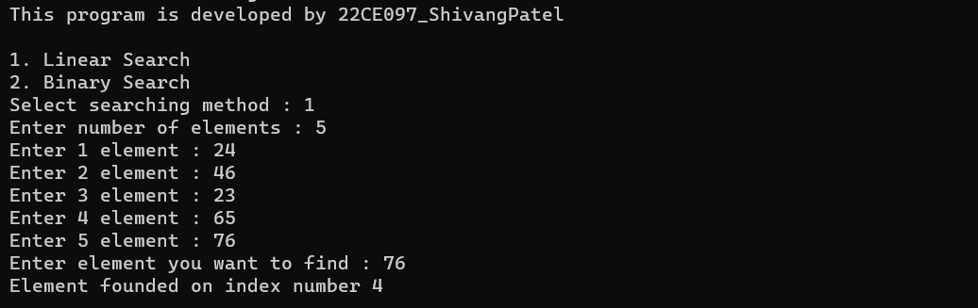

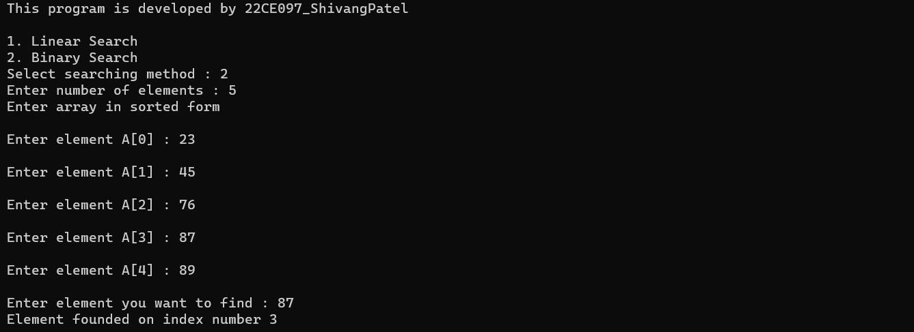

* Conclusion

_______________ ________________ __________

Student Signature Faculty Signature Marks