Practical – 10

AIM: Implement stack using array Implement a program to implement a Stack using Array. Your task is to use the class as shown in the comments in the code editor and complete the functions push () and pop () to implement a stack.

* Program

#include<bits/stdc++.h>

using namespace std;

int Stack[10], top=-1, n=10;

void push(int x);

int pop();

void display();

int main(){

int choice;

// cout << "Enter total number of elements : ";

// cin >> n;

// Stack = new int[n];

do{

cout << "1. Push" << endl;

cout << "2. Pop" << endl;

cout << "3. Display" << endl;

cout << "4. exit" << endl;

cout << "Select the operation : ";

cin >> choice;

switch (choice)

{

case 1:

int x;

cout << "Enter element you want to add : ";

cin >> x;

push(x);

display();

break;

case 2:

int y;

y = pop();

cout << "Retrived element : " << y << endl;

display();

break;

case 3:

display();

break;

case 4:

choice = 4;

break;

default:

cout << "Please Select Valid number " << endl;

break;

}

}while(choice!=4);

//delete Stack;

}

void push(int x){

if(top == n-1)

cout << "Stack overflow" << endl;

else{

top++;

Stack[top] = x;

}

}

int pop(){

if(top == -1){

cout << "Stack underflow" << endl;

return -1;

}

else{

int a = Stack[top];

top--;

return a;

}

}

void display(){

int x;

if(top == -1){

cout << "Stack is empty" << endl << endl;

}

cout << endl << endl << "Elements in stack : ";

for(int i=top; i>=0; i--){

cout << Stack[i] << " ";

}

cout << endl << endl << endl;

}

* Output

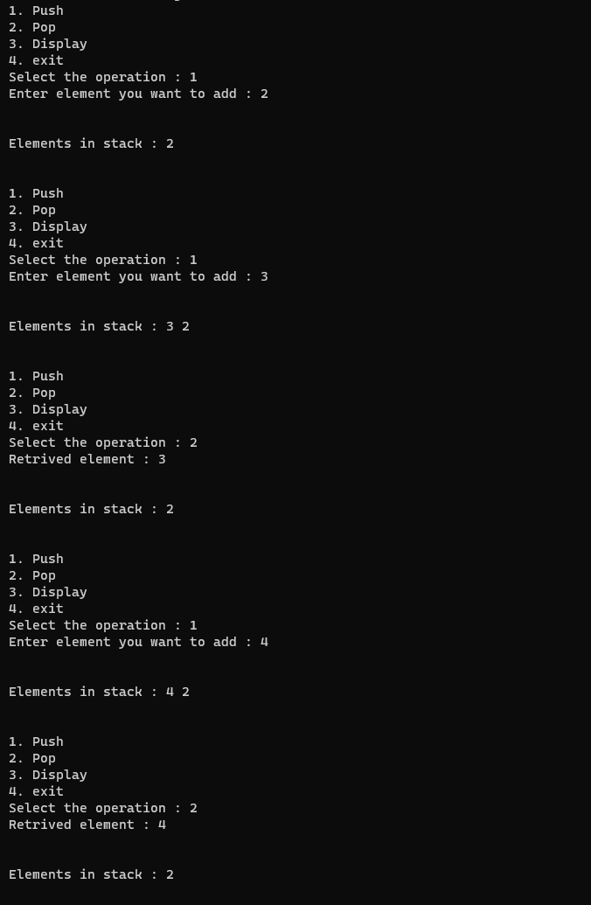

_______________ ________________ __________

Student Signature Faculty Signature Marks