Practical – 12

AIM: Implement Stack using Linked List You have a linked list and you have to implement the functionalities push and pop of stack using this given linked list. Your task is to use the class as shown in the comments in the code editor and complete the functions push () and pop () to implement a stack.

* Program

#include<bits/stdc++.h>

using namespace std;

struct node{

int info;

struct node * link;

};

struct node* First = NULL;

void push(int x);

struct node* Create(int n);

int pop();

void display();

int main(){

int choice;

do{

cout << "1. Push" << endl;

cout << "2. Pop" << endl;

cout << "3. Display" << endl;

cout << "4. Exit" << endl;

cout << "Select operation : ";

cin >> choice;

switch (choice)

{

case 1:

int x;

cout << "Enter a element you want to add : ";

cin >> x;

push(x);

//Display();

break;

case 2:

int y;

y = pop();

if(y != 0)

cout << y << endl;

break;

case 3:

display();

break;

default:

cout << "Select a valid number" << endl;

break;

}

}while(choice!=4);

return 0;

}

struct node* Create(int x){

struct node* temp;

temp = (struct node*)malloc(sizeof(struct node*));

temp->info = x;

temp->link = NULL;

return temp;

}

void push(int x){

struct node* temp = Create(x);

if(First == NULL){

First = temp;

}

else{

temp->link = First;

First = temp;

}

}

int pop(){

int x;

if(First==NULL){

cout << "Stack is underflow" << endl;

return 0;

}

x = First->info;

First = First->link;

return x;

}

void display(){

struct node* temp1 = First;

cout << endl << "Elemets : ";

while(temp1!=NULL){

cout << temp1->info << " ";

temp1=temp1->link;

}

cout << endl << endl;

}

* Output

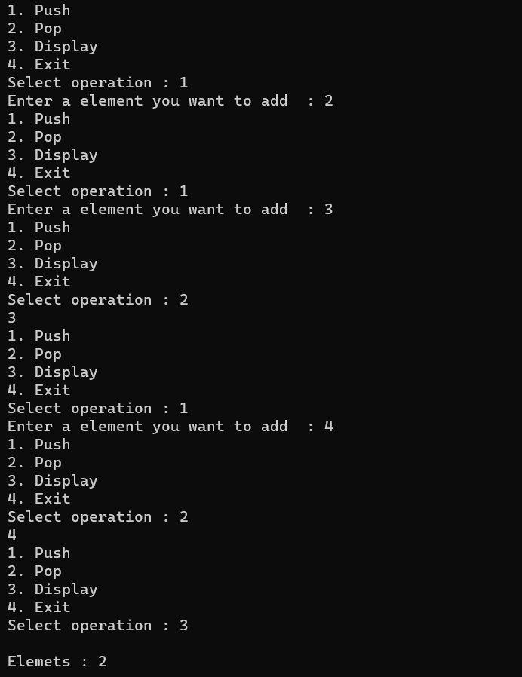

_______________ ________________ __________

Student Signature Faculty Signature Marks