Practical – 18

AIM: Binary Tree Postorder Traversal Given the root of a binary tree, return the postorder traversal of its nodes' values.

* Program

class Solution {

public:

vector<int> preorderTraversal(TreeNode* root) {

if(root){

postorderTraversal(root->left);

postorderTraversal(root->right);

a.push_back(root->val);

}

return a;

}

};

* Output

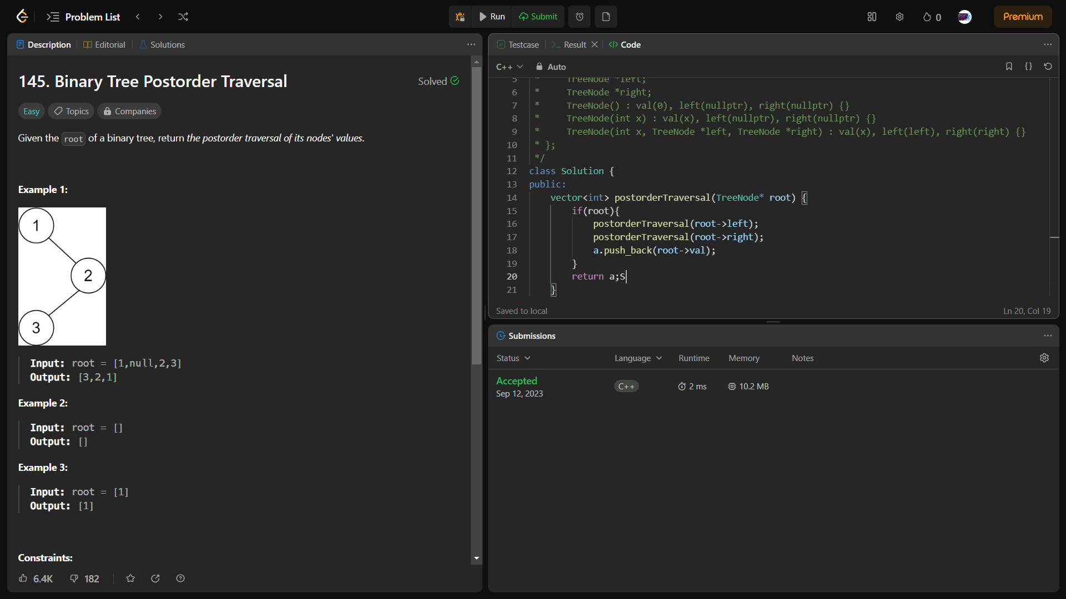

_______________ ________________ __________

Student Signature Faculty Signature Marks