Practical – 20

AIM: Maximum Depth of Binary Tree Given the root of a binary tree, return its maximum depth. A binary tree's maximum depth is the number of nodes along the longest path from the root node down to the farthest leaf node.

* Program

class Solution {

public:

int maxDepth(TreeNode* root) {

if(root == NULL)

return 0;

else{

int lheight = maxDepth(root->left);

int rheight = maxDepth(root->right);

if(lheight > rheight)

return (lheight+1);

else

return (rheight+1);

}

}

};

* Output

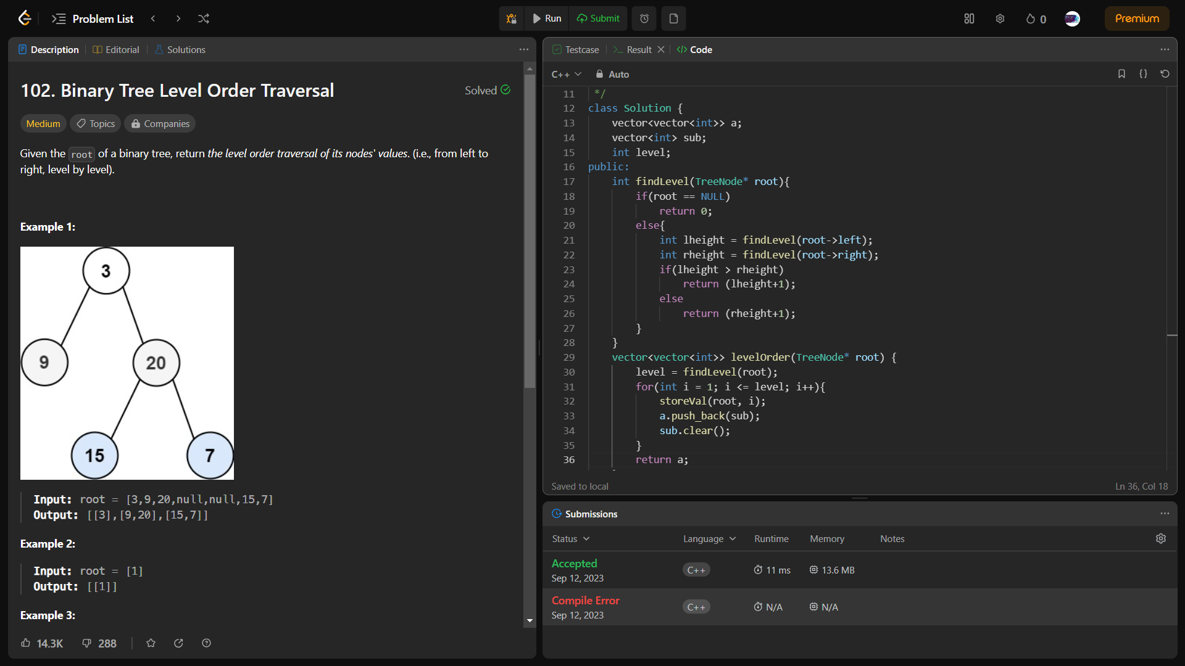

_______________ ________________ __________

Student Signature Faculty Signature Marks