Practical – 25

AIM: Search in a Binary Tree You are given the root of a binary search tree(BST) and an integer value. Find the node in the BST that node’s value equals value and return the subtree rooted with that node. If such a node does not exist, return null. Example 1: 0,4 1,2,4 9

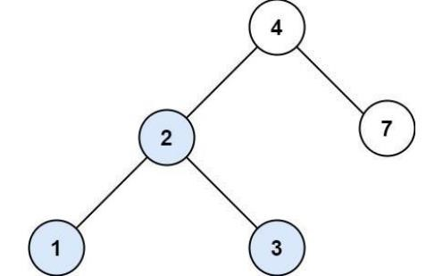

* Program

TreeNode* searchBST(TreeNode* root, int val) {

while(root!=NULL && root->val != val)

{

if(root->val > val)

root = root->left;

else

root =root->right;

}

return root;

}

* Output

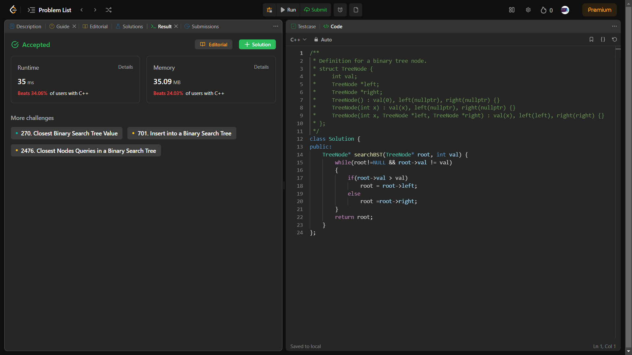

_______________ ________________ __________

Student Signature Faculty Signature Marks