Practical – 26

AIM: DFS of Graph You are given a connected undirected graph. Perform a Depth First Traversal of the graph. Note: Use a recursive approach to find the DFS traversal of the graph starting from the 0th vertex from left to right according to the graph.

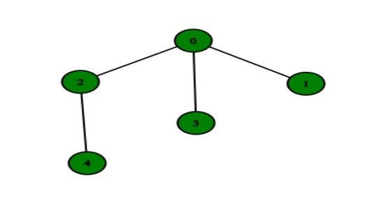

* Program

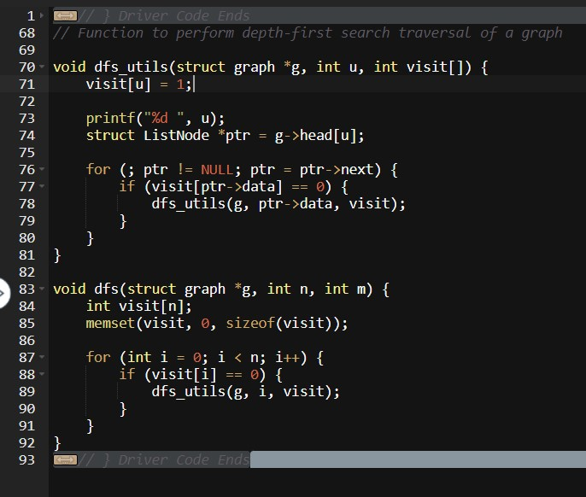

* Output

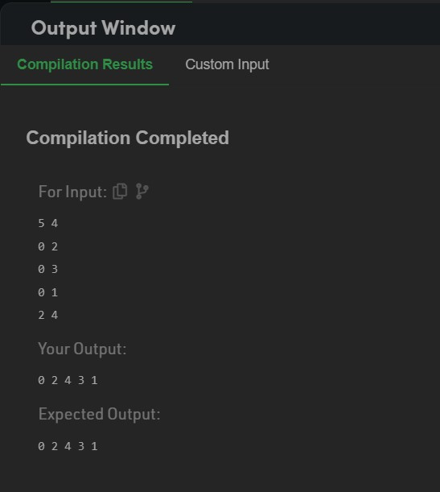

_______________ ________________ __________

Student Signature Faculty Signature Marks