Practical-3

AIM: Implement Sorting Algorithm(s).

(a) Bubble Sort

(b) Selection Sort

(c) Insertion Sort

* Program

#include<bits/stdc++.h>

using namespace std;

void bubbleSort(vector<int> vec, int x){

int exch;

int last = x-1;

cout << "Enter elements : ";

for(int i=1; i<=x; i++){

exch = 0;

for(int j=0; j<last; j++){

if(vec[j] > vec[j+1]){

swap(vec[j], vec[j+1]);

exch++;

}

}

if(exch==0)

break;

else

last--;

}

for(int i = 0; i < vec.size(); i++){

cout << vec[i] << " ";

}

}

void selectionSort(vector<int> vec, int n){

int exch, min_index;

for(int i=0; i < n-1; i++){

min_index=i;

for(int j=i+1; j < n; j++){

if(vec[min_index] > vec[j]){

min_index = j;

}

}

if(min_index != i)

swap(vec[i], vec[min_index]);

}

for(int i=0; i < n; i++){

cout << vec[i] << " ";

}

}

void insertionSort(vector<int> vec, int n){

int key, j;

for(int i=0; i<n; i++){

key = vec[i];

j = i - 1;

while(j>=0 && vec[j] > key){

vec[j+1] = vec[j];

j--;

}

vec[j+1] = key;

}

cout << "After Sorting the vector the elemets are : ";

for(int i=0; i<n; i++){

cout << vec[i] << " ";

}

}

int main(){

cout << "This program is developed by 22CE097_ShivangPatel" << endl;

int x, a;

cout << "Enter number of element : ";

cin >> x;

vector<int> vec;

for(int i=0;i<x;i++){

cout << "Enter Element Array [" << i << "] : ";

cin >> a;

vec.push_back(a);

}

int choice;

cout << "1. Bubble Sort" << endl;

cout << "2. Selecting Sort" << endl;

cout << "3. Insertion Sort" << endl;

cout << "Select number of selection of sorting method : ";

cin >> choice;

switch (choice)

{

case 1:

bubbleSort(vec, x); break;

case 2:

selectionSort(vec, x); break;

case 3:

insertionSort(vec, x); break;

default:

break;

}

return 0;

}

Output

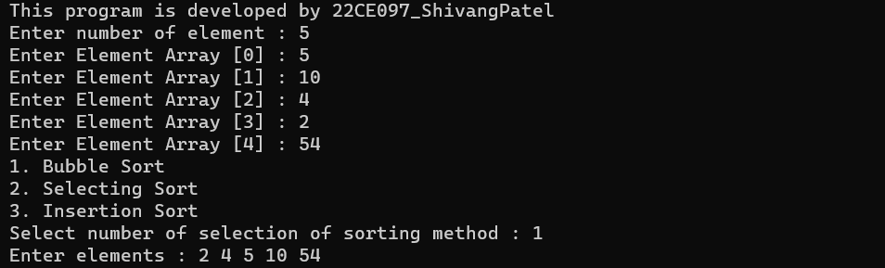

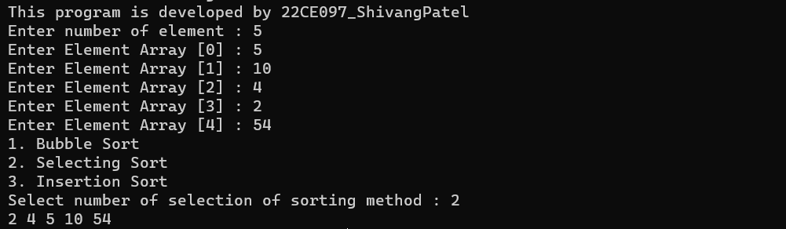

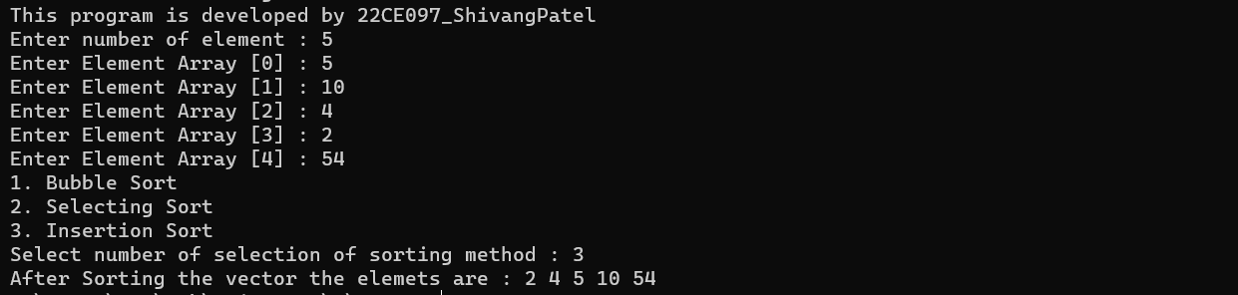

* Conclusion

_______________ ________________ __________

Student Signature Faculty Signature Marks