Practical-7

AIM: Reverse Linked List

Given the head of a singly linked list, reverse the list, and return the reversed list.

Input: head = [1,2,3,4,5]

Output: [5,4,3,2,1]

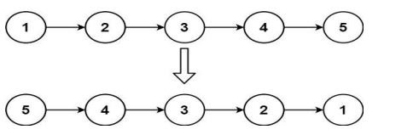

* Program and Output

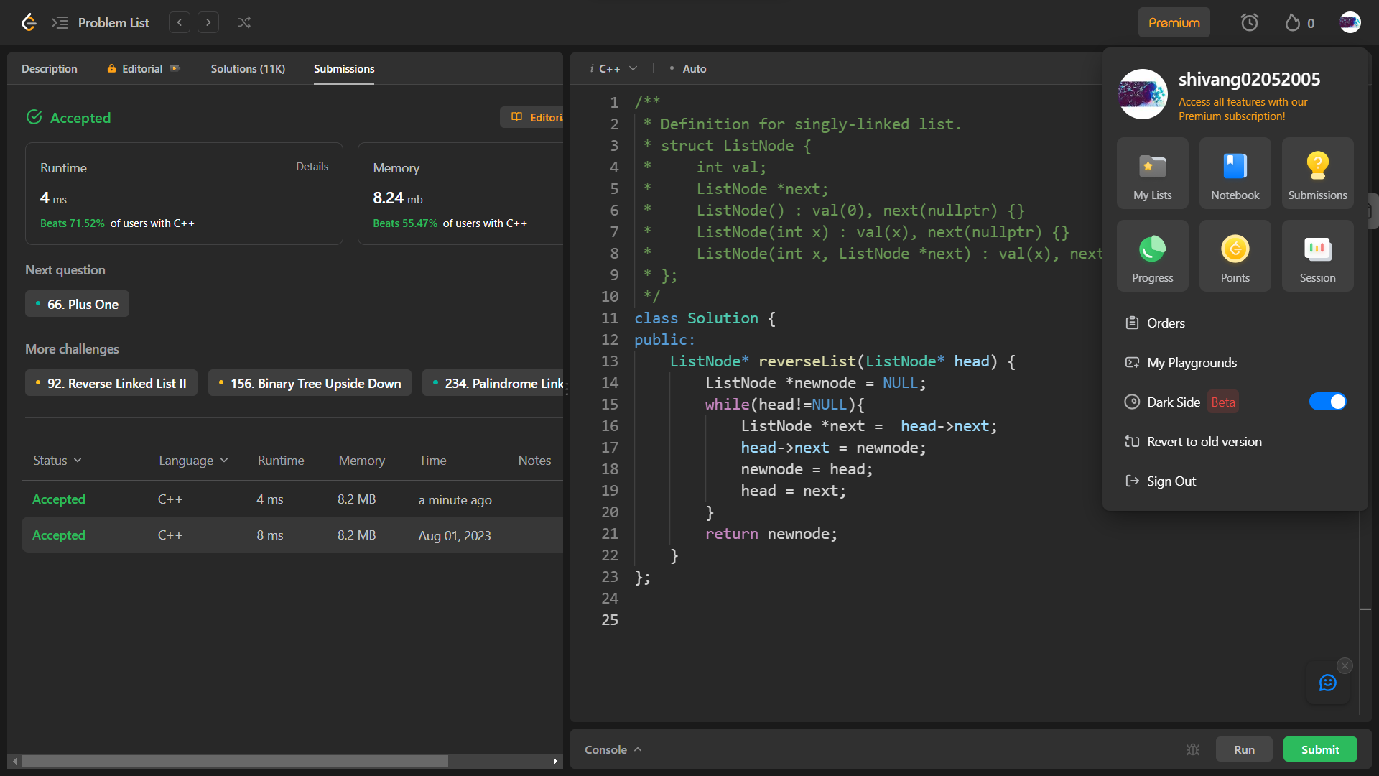

_______________ ________________ __________

Student Signature Faculty Signature Marks