Practical - 8

AIM: Middle of the Linked List Given the head of a singly linked list, return the middle node of the linked list. If there are two middle nodes, return the second middle node.

Example 1: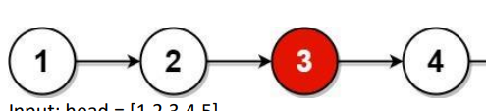

Input: head = [1,2,3,4,5]

Output: [3,4,5]

Explanation: The middle node of the list is node 3.

* Program and Output

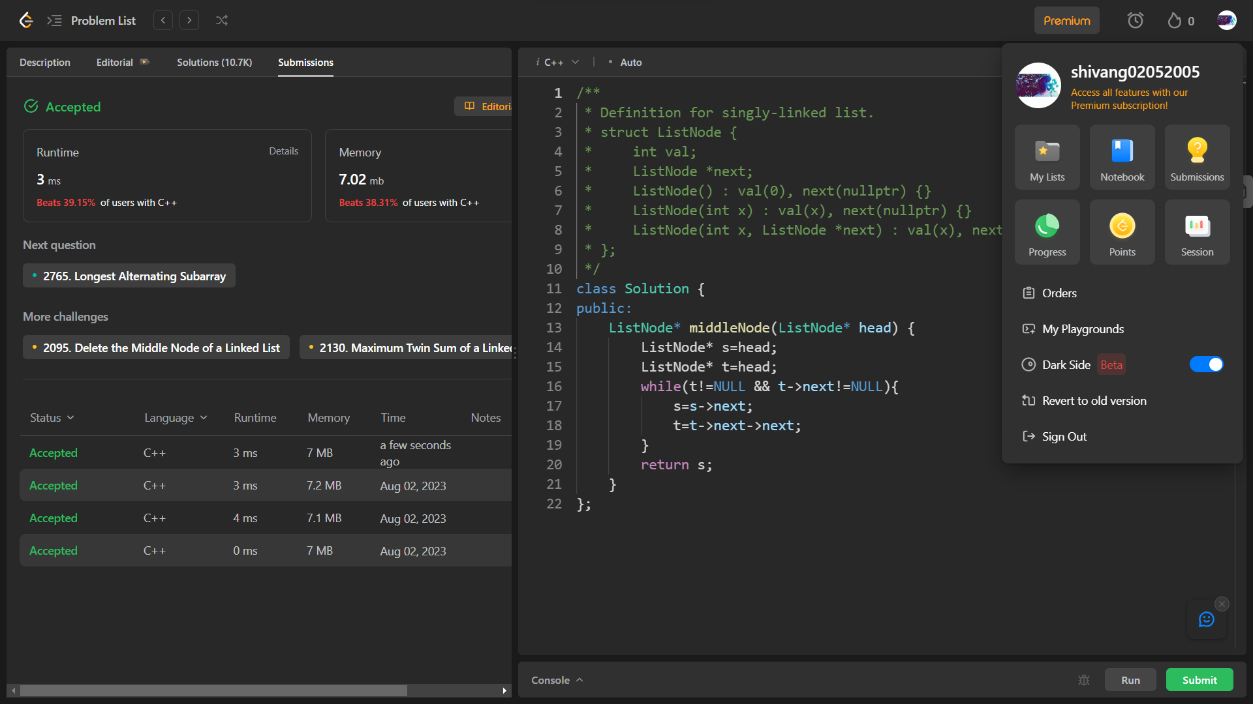

_______________ ________________ __________

Student Signature Faculty Signature Marks