Practical - 9

AIM: Merge Two Sorted Lists You are given the heads of two sorted linked lists list1 and list2. Merge the two lists in a one sorted list. The list should be made by splicing together the nodes of the first two lists. Return the head of the merged linked list.

Example 1:

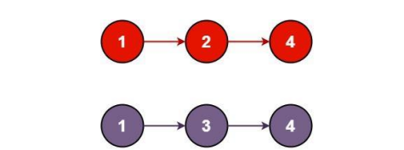

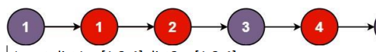

Input: list1 = [1,2,4], list2 = [1,3,4]

Output: [1,1,2,3,4,4]

* Program and Output

_______________ ________________ __________

Student Signature Faculty Signature Marks