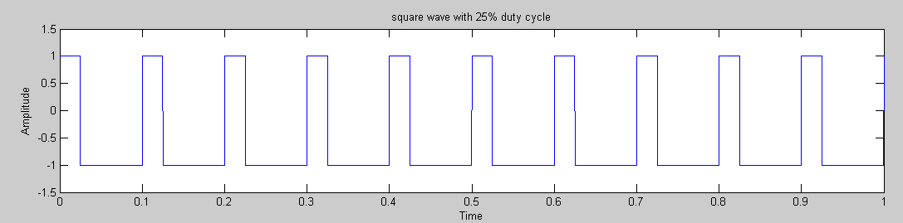

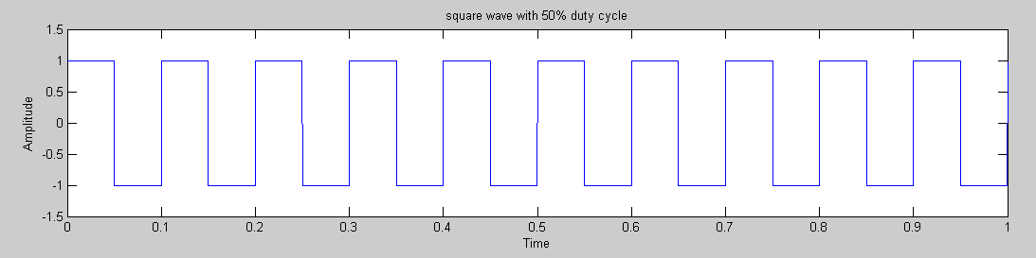

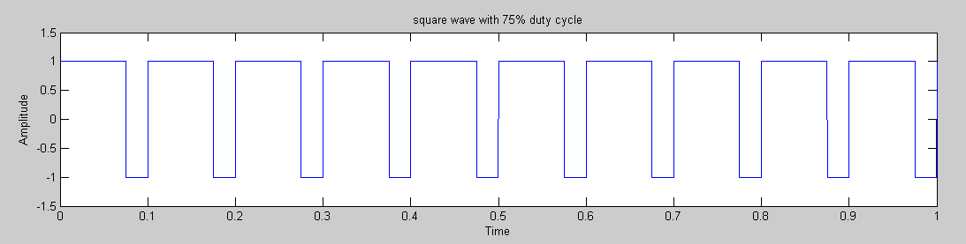

%1(a) Programm to generate square wave using MATLAB
%1(b) Programm to generate square wave with different duty cycles

f=input('Enter the frequency (in Hz) : ');
iv = input('Enter initial value : ');
fv = input('Enter final value : ');
i=input('Enter time interval : ');

t = iv:i:fv;

d1=input('Enter the duty cycle : ');
y = square(2*pi*f*t,d1);
subplot(311);
plot(t,y)
title('square wave with 25% duty cycle');
xlabel('Time');
ylabel('Amplitude');
axis([iv fv -1.5 1.5]);

d2=input('Enter the duty cycle : ');
y2 = square(2*pi*f*t,d2);
subplot(312);
plot(t,y2)
title('square wave with 50% duty cycle');
xlabel('Time');
ylabel('Amplitude');
axis([iv fv -1.5 1.5]);

d3=input('Enter the duty cycle : ');
y3 = square(2*pi*f*t,d3);
subplot(313);
plot(t,y3)
title('square wave with 75% duty cycle');
xlabel('Time');
ylabel('Amplitude');
axis([iv fv -1.5 1.5]);

