JAVA ASSIGNMENT 1
Q1. Write a program to replace a substring inside a string with other string ?

import java.util.Scanner;
public class String_replace {
public static void main(String[] args) {
Scanner sc = new Scanner(System.in);
System.out.println("Enter your main string: \n");
String s1= sc.nextLine();
System.out.println("Enter the substring to be changed: \n");
String s2 = sc.nextLine();
System.out.println("Enter the substring to be changed with:\n");
String s3=sc.nextLine();
if(s1.contains(s2))
System.out.println(s1.replace(s2,s3));
else
System.out.println("substring not present. ");
}
}
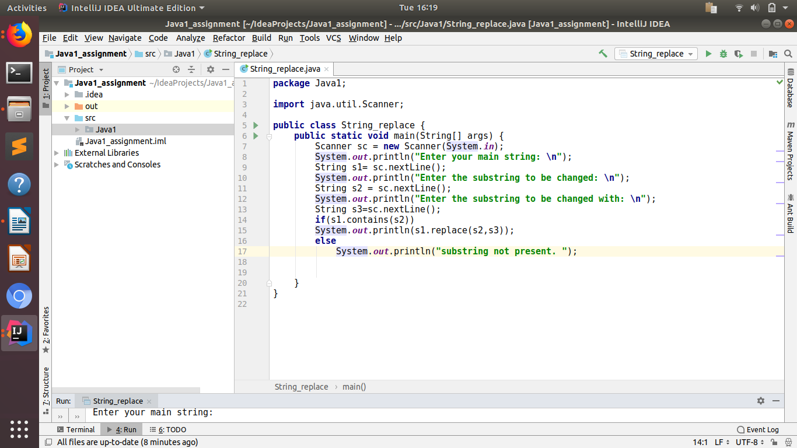

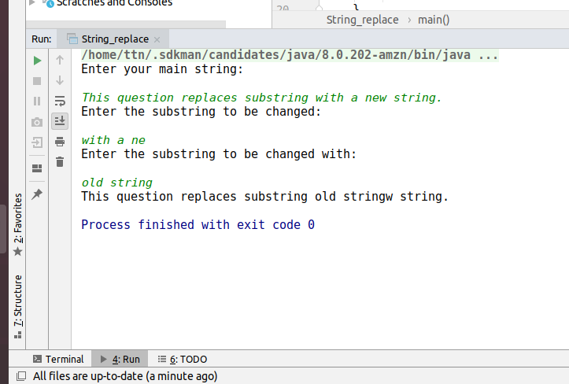

Q2. Write a program to find the number of occurrences of the duplicate words in a string and print them ?
package Java1;
import java.util.Scanner;
public class Duplicate_string {
public static void main(String[] args) {
Scanner sc = new Scanner(System.in);
System.out.println("enter the string: \n");
String s1= sc.nextLine();
int count=1;
String[] word = s1.split(" ");
for(int i=0; i< word.length;i++)
{
for(int j= i+1; j<word.length;j++)
{
if(word[i].equals(word[j]))
{
count+=1;
word[j]= "0";
}
}
if(word[i]!="0" && count>1) {
System.out.println("Duplicate word: " + word[i] + " and count is : " + count);
}
count=1;
}
}
}
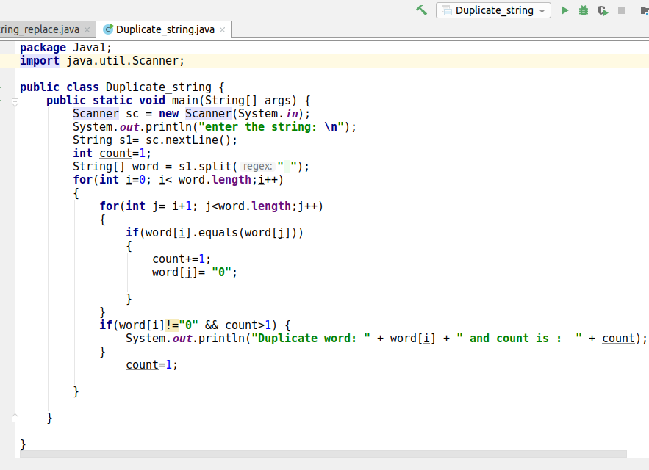
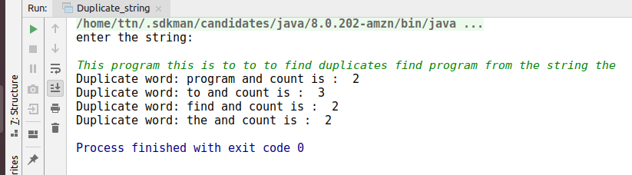

Q3. Write a program to find the number of occurrences of a character in a string without using loop?

package Java1;
import java.util.Scanner;
public class Char_occurence {
public static void main(String[] args) {
Scanner sc= new Scanner(System.in);
System.out.println("Enter the string");
String s1= sc.nextLine().toLowerCase();
System.out.println("Enter the character to be searched for occurence");
char a= sc.next().toLowerCase().charAt(0);
int occurence= s1.length()- s1.replaceAll( String.valueOf(a), "").length();
System.out.println(occurence);
}
}

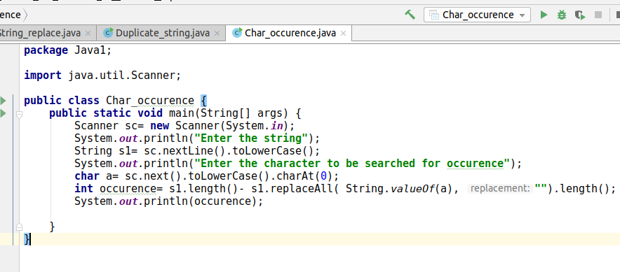
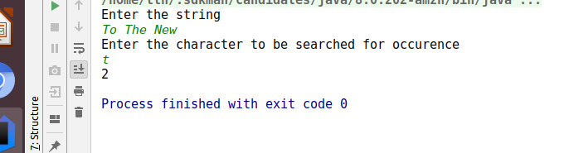

Q4. Calculate the number & Percentage Of Lowercase Letters,Uppercase Letters, Digits And Other Special Characters In A String

package Java1;
import java.util.Scanner;
public class Char_percentage {
public static void main(String[] args) {
int uppercase =0;
int lowercase =0;
int digit =0;
int space=0;
int special_char =0;
Scanner sc=new Scanner(System.in);
System.out.println("enter the string:");
String s1= sc.nextLine();
int str_length= s1.length();
for(int i=0; i<str_length;i++)
{
char c= s1.charAt(i);
if(Character.isUpperCase(c))
{
uppercase++;
}
else if(Character.isLowerCase(c))
{
lowercase++;
}
else if(Character.isDigit(c))
{
digit++;
}
else if(Character.isSpaceChar(c)){
space++;
}
else
{
special_char++;
}
}
System.out.println(str_length);
double upper_percent= (uppercase*100)/str_length;
double lower_percent= (lowercase*100)/str_length;
double digit_percent= (digit*100)/str_length;
double space_percent = (space*100)/str_length;
double specialChar_percent= (special_char*100)/str_length;
System.out.println("Total number of uppercase letters are "+uppercase+" and their percentage is "
+upper_percent+"%");
System.out.println("Total number of uppercase letters are "+lowercase+" and their percentage is "
+lower_percent+"%");
System.out.println("Total number of uppercase letters are "+digit+" and their percentage is "
+digit_percent+"%");
System.out.println("Total number of uppercase letters are "+space+" and their percentage is "
+space_percent+"%");
System.out.println("Total number of uppercase letters are "+special_char+" and their percentage is "
+specialChar_percent+"%");
}
}
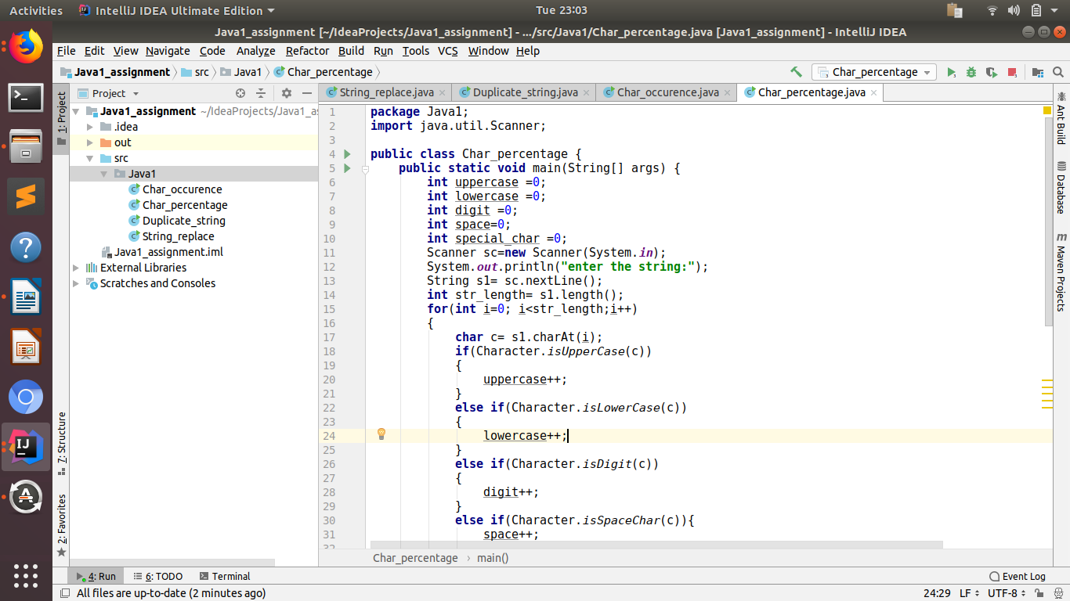

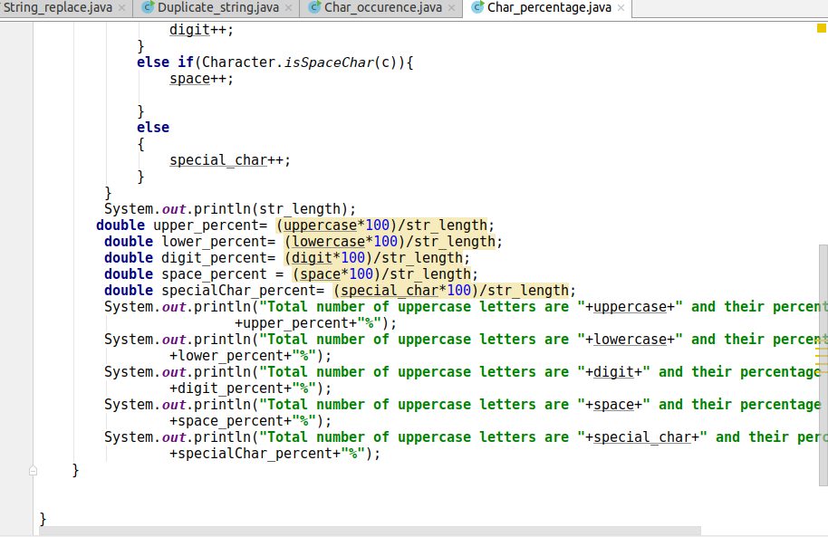

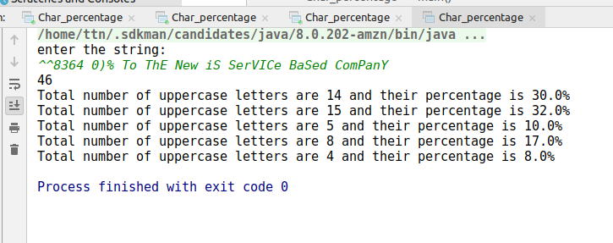

Q5. Find common elements between two arrays.

package Java1;
import java.util.Scanner;
public class Array_common {
public static void main(String[] args) {
Scanner sc =new Scanner(System.in);
System.out.println("enter the size of array 1");
int size1= sc.nextInt();
int [] array1= new int[size1];
System.out.println("enter array1 elements: ");
for(int i=0;i<array1.length;i++)
{
array1[i]= sc.nextInt();
}
for(int i=0;i<array1.length;i++)
{
System.out.println("array1 elements: "+array1[i]);
}
System.out.println("enter the size of array 2:");
int size2= sc.nextInt();
int [] array2= new int[size2];
System.out.println("enter array2 elements: ");
for(int i=0;i<array2.length;i++)
{
array2[i]= sc.nextInt();
}
for(int i=0;i<array2.length;i++)
{
System.out.println("array2 elements: "+array2[i]);
}
System.out.println("common elements are: ");
for (int i = 0; i < array1.length; i++) {
for (int j = 0; j < array2.length; j++) {
if (array1[i] == array2[j])
break;
}
System.out.print(array1[i]+" ");
}
}
}

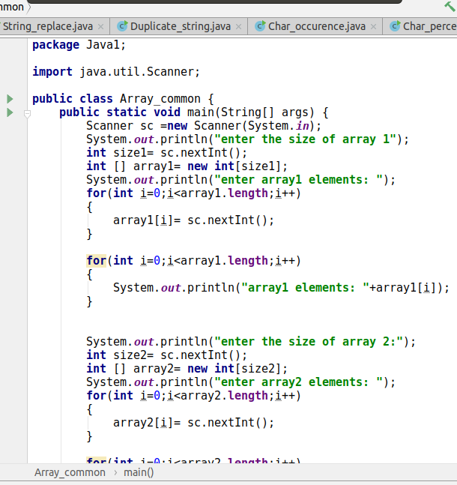

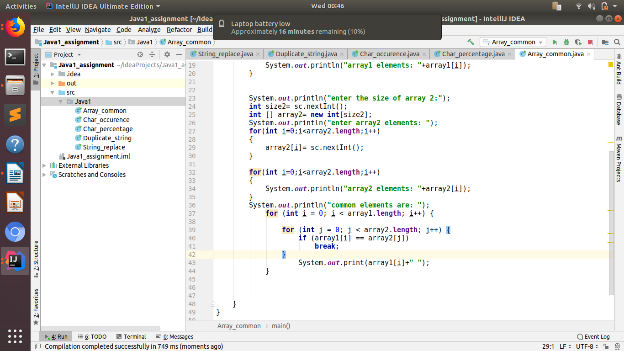

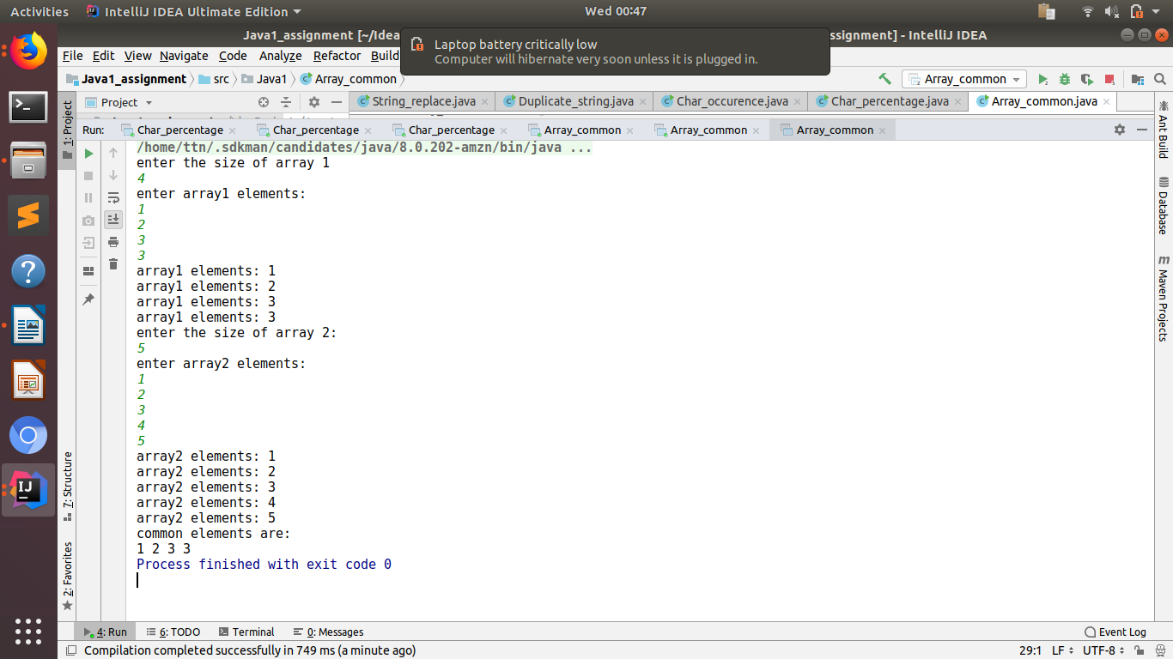

Q6 a. There is an array with every element repeated twice except one. Find that element

package Java1;
import java.util.Scanner;
public class Question6 {
public static void main(String[] args) {
int size;
System.out.println("enter size of array: ");
Scanner sc=new Scanner(System.in);
size=sc.nextInt();
int[] array= new int[size];
System.out.println("enter array1 elements: ");
for(int i=0;i<size;i++)
{
array[i]= sc.nextInt();
}
for(int i=0;i<array.length;i++)
{
System.out.println("array1 elements: "+array[i]);
}
int count=array[0];
for(int i=1; i<size;i++)
{
count=count^array[i];
}
System.out.println("element occurring once : " +count);
}
}
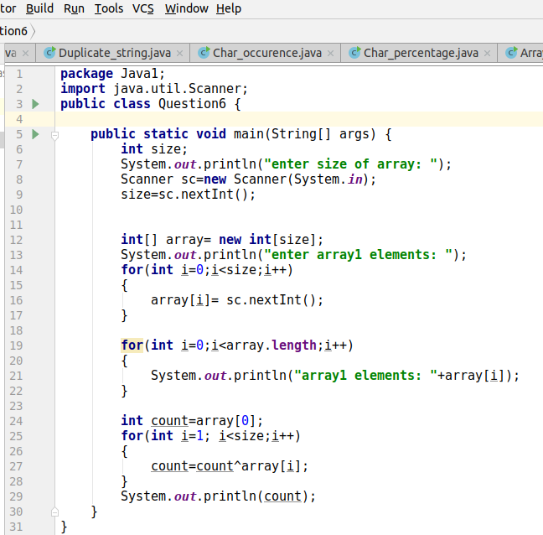

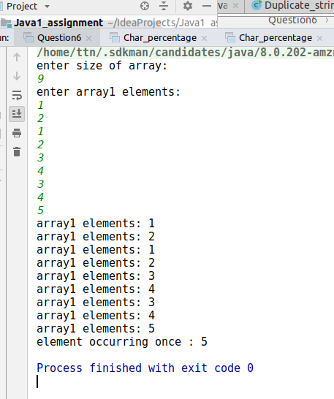

Ques6b.

package Java1;
import java.util.Arrays;
public class Question6b {
public static void main(String[] args) {
int[] arr = {1,3,4,2,3,4,1,2,9,12,9};
Arrays.sort(arr);
for (int i=0; i<arr.length;i++)
{
System.out.println(arr[i]);
}
for (int i=0;i<arr.length;i+=2)
{
if(i==arr.length-1)
{
System.out.println("missing element : "+arr[i]);
break;
}
if(arr[i]==arr[i+1])
{
continue;
}
else {
System.out.println(arr[i]);
break;
}
}
}
}

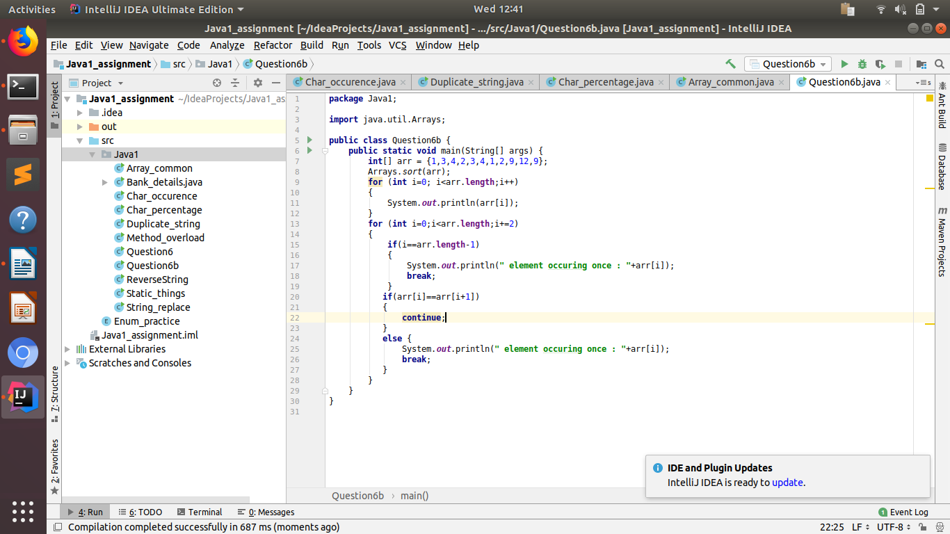

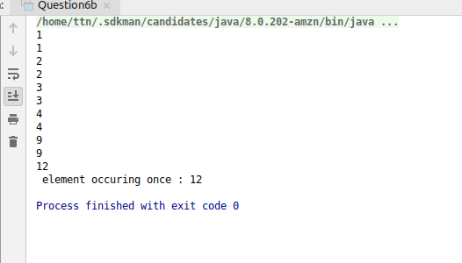

Q7. Write a program to print your Firstname,LastName & age using static block,static method & static variable respectively

package Java1;
public class Static_things {
static String firstname="shivangi";
static String lastname ="j";
static int age =23;
static void display()
{
System.out.println("Using static method: ");
firstname="shivi";
System.out.println("Firstname is: " +firstname+ ", Lastname is: " +lastname+ ", Age is: " +
age);
}
static
{
// used to initialize data members
System.out.println("using static block: ");
lastname="jain";
System.out.println("Firstname is: " +firstname+ ", Lastname is: " +lastname+ ", Age is: " +
age);
}
public static void main(String[] args) {
System.out.println("using static variables: ");
System.out.println("Firstname is: " +firstname+ ", Lastname is: " +lastname+ ", Age is: " +
age);
Static_things.display();
}
}
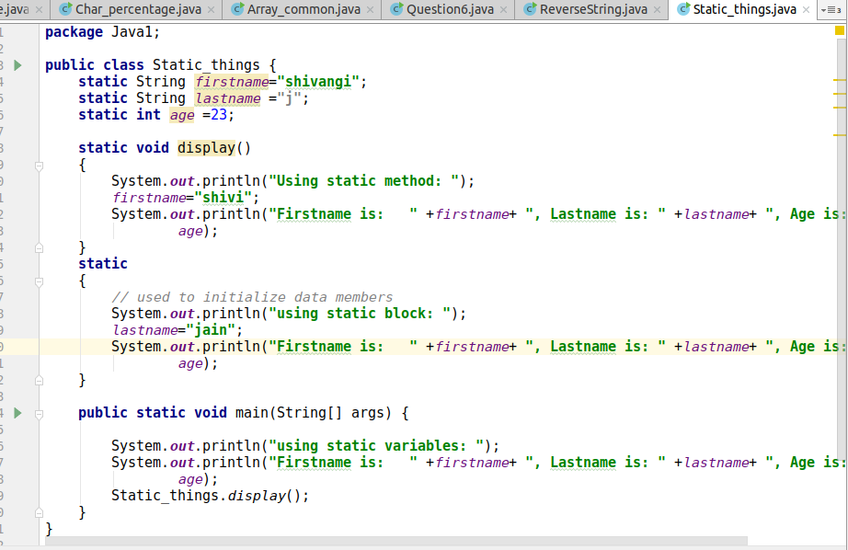

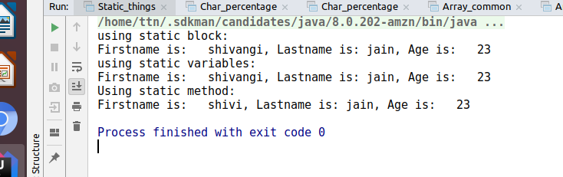

Q8. Write a program to reverse a string and remove character from index 4 to index 9 from the reversed string using String Buffer

package Java1;
import java.util.Scanner;
public class ReverseString {
public static void main(String[] args) {
Scanner sc= new Scanner(System.in);
System.out.println("enter the string to be reversed: ");
String s1= sc.nextLine();
StringBuffer string1= new StringBuffer(s1);
System.out.println("Reversed string : "+string1.reverse());
System.out.println("Deleted string : "+string1.delete(4,9));
}
}
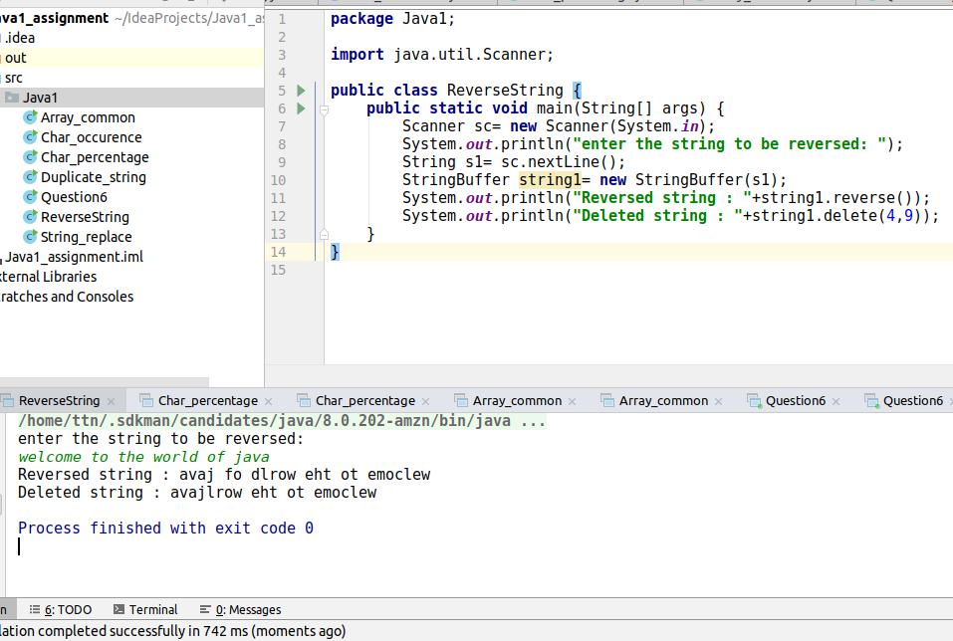

Q10.Write a single program for following operation using overloading
A) Adding 2 integer number
B) Adding 2 double
C) multiplying 2 float
D) multiplying 2 int
E) concate 2 string
F) Concate 3 String

package Java1;
public class Method_overload {
int add(int a, int b){
return a+b;
}
double add(double a, double b)
{
return a+b;
}
int product(int a, int b)
{
return a*b;
}
float product(float a, float b)
{
return a*b;
}
String concatenation(String s1, String s2)
{
return s1+s2;
}
String concatenation(String s1, String s2, String s3)
{
return s1+s2+s3;
}
public static void main(String[] args) {
Method_overload m= new Method_overload();
System.out.println("sum of integers: "+ m.add(10,20));
System.out.println("sum of double: "+ m.add(10.1, 19.7));
System.out.println("product of integers: "+ m.product(33,67));
System.out.println("product of float: "+ m.product(10.88f,195.8f));
System.out.println("concatenation of two strings: "+ m.concatenation("To","the"));
System.out.println("concatenation of three strings: "+ m.concatenation("To","the","new"));
}
}

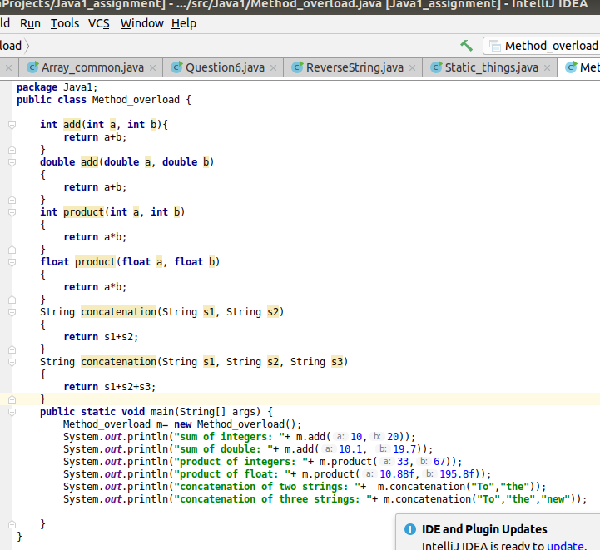

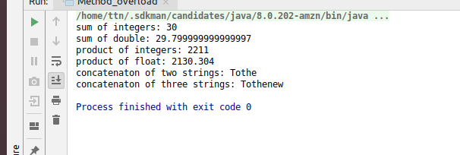

Q11.Create 3 sub class of bank SBI,BOI,ICICI all 4 should have method called getDetails which provide there specific details like rateofinterest etc,print details of every banks.

package Java1;
abstract class Bank {
int no_of_branches;
double rate;
abstract void getDetails();
}
class SBI extends Bank {
SBI() {
no_of_branches = 10;
rate = 12.2;
}
@Override
void getDetails() {
System.out.println("SBI no of branches: "+no_of_branches);
System.out.println("rate : "+rate);
}
}
class BOI extends Bank {
BOI() {
no_of_branches = 18;
rate = 10.6;
}
@Override
void getDetails() {
System.out.println("BOI no of branches: "+no_of_branches);
System.out.println("rate : "+ rate);
}
}
class ICICI extends Bank {
ICICI() {
no_of_branches = 35;
rate = 2.9;
}
@Override
void getDetails() {
System.out.println("ICICI no of branches: "+no_of_branches);
System.out.println("rate: "+rate);
}
}
public class Bank_details{
public static void main(String[] args) {
SBI s=new SBI();
s.getDetails();
BOI b=new BOI();
b.getDetails();
ICICI i=new ICICI();
i.getDetails();
}
}



