**Java Module Exam**

Q1 : Write a Java program to create a new array list, add some elements (string) and print out the collection by using for-each loop. (10 Marks)

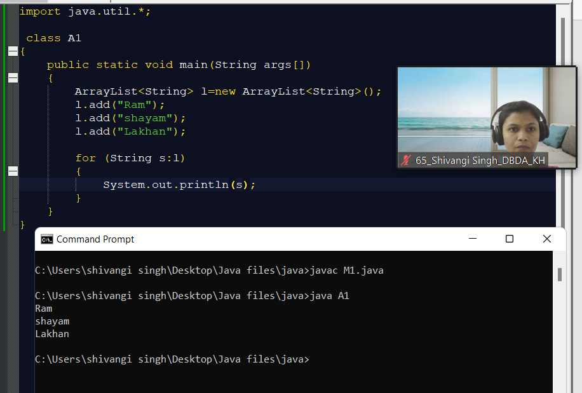

**CODE:-**

import java.util.*;

class A1

{

public static void main(String args[])

{

ArrayList<String> l=new ArrayList<String>();

l.add("Ram");

l.add("shayam");

l.add("Lakhan");

for (String s:l)

{

System.out.println(s);

}

}

}

Q2 : Develop a class BankAccount having following data members : (10 Marks)

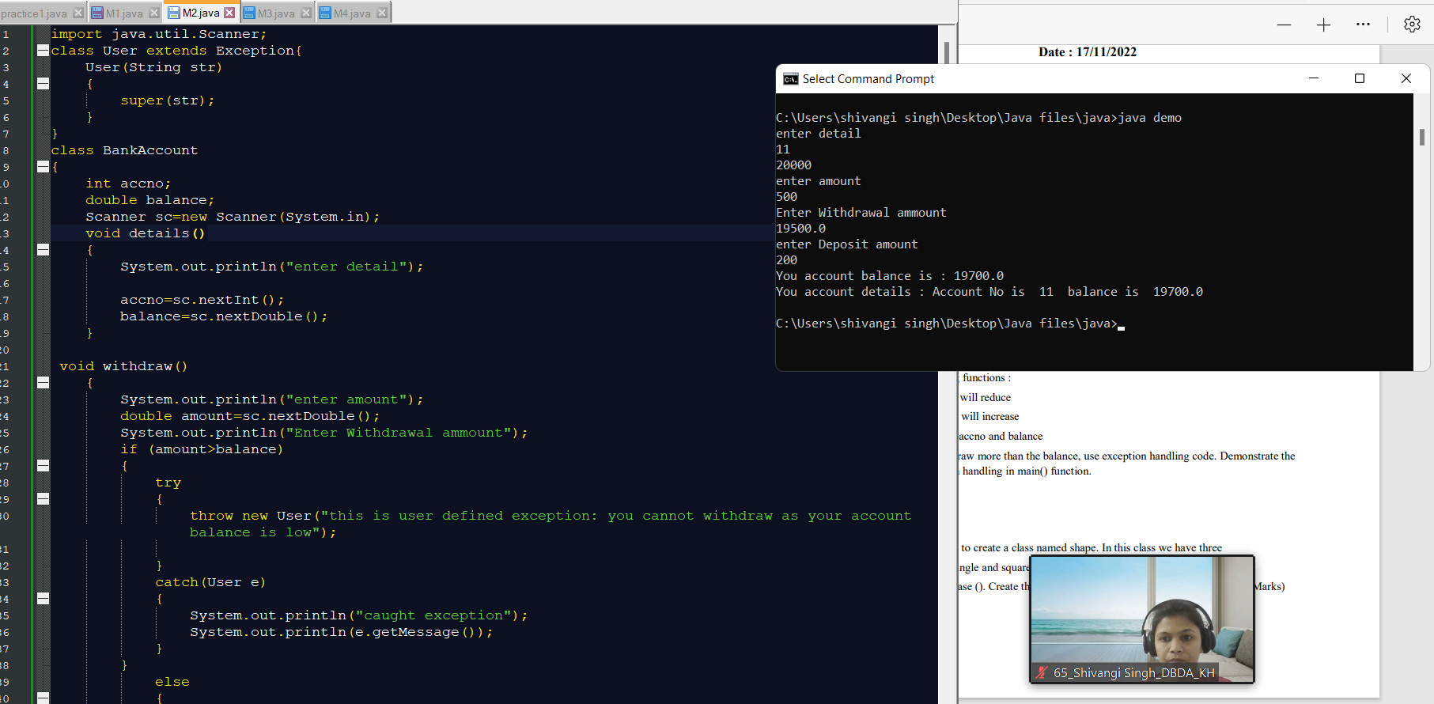

**CODE:-**

import java.util.Scanner;

class User extends Exception{

User(String str)

{

super(str);

}

}

class BankAccount

{

int accno;

double balance;

Scanner sc=new Scanner(System.in);

void details()

{

System.out.println("enter detail");

accno=sc.nextInt();

balance=sc.nextDouble();

}

void withdraw()

{

System.out.println("enter amount");

double amount=sc.nextDouble();

System.out.println("Enter Withdrawal ammount");

if (amount>balance)

{

try

{

throw new User("this is user defined exception: you cannot withdraw as your account balance is low");

}

catch(User e)

{

System.out.println("caught exception");

System.out.println(e.getMessage());

}

}

else

{

balance=balance-amount;

System.out.println(balance);

}

}

void deposit()

{

System.out.println("enter Deposit amount");

double deposit=sc.nextDouble();

balance=balance+deposit;

System.out.println("You account balance is : " +balance);

}

void show1()

{

System.out.println("You account details : " +"Account No is " +accno +" balance is " +balance);

}

}

class demo

{

public static void main(String args[])

{

BankAccount n= new BankAccount();

//Scanner sc=new Scanner(System.in);

//n.balance();

n.details();

n.withdraw();

n.deposit();

n.show1();

}

}

Q3 : Write a program to create a class named shape. In this class we have three sub classes circle, triangle and square, each class has two member function named draw () and erase (). Create these using Runtime Polymorphism concepts. (10 Marks)

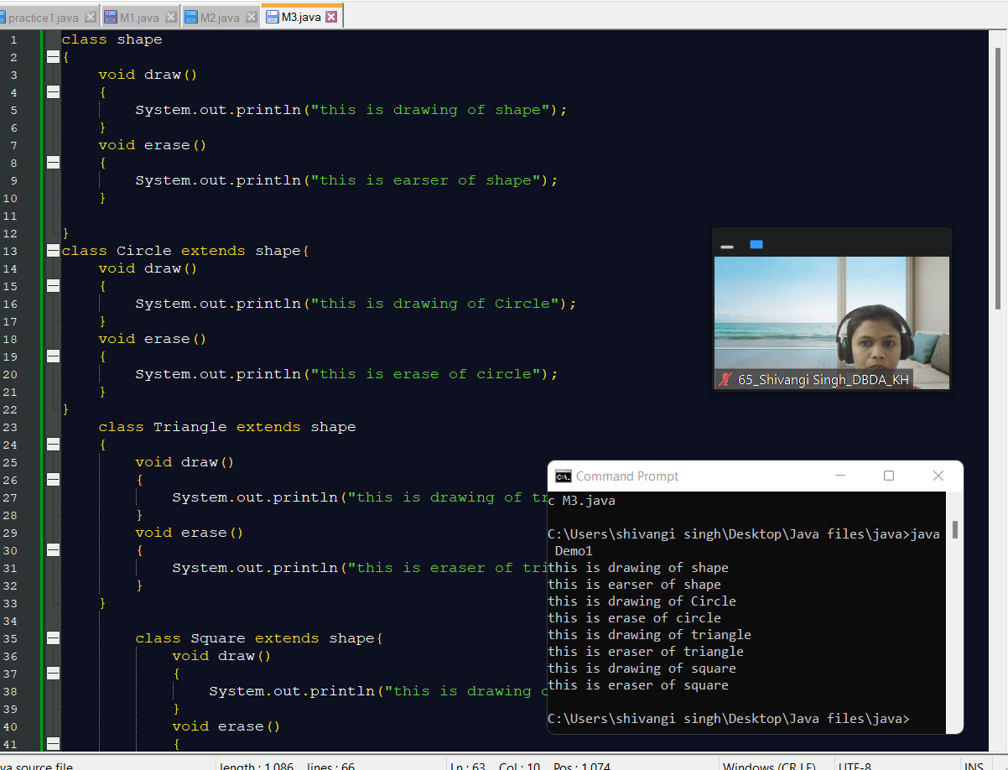

**CODE:-**

class shape

{

void draw()

{

System.out.println("this is drawing of shape");

}

void erase()

{

System.out.println("this is earser of shape");

}

}

class Circle extends shape{

void draw()

{

System.out.println("this is drawing of Circle");

}

void erase()

{

System.out.println("this is erase of circle");

}

}

class Triangle extends shape

{

void draw()

{

System.out.println("this is drawing of triangle");

}

void erase()

{

System.out.println("this is eraser of triangle");

}

}

class Square extends shape{

void draw()

{

System.out.println("this is drawing of square");

}

void erase()

{

System.out.println("this is eraser of square");

}

}

class Demo1

{

public static void main(String args[])

{

shape s=new shape();

Circle c=new Circle();

Triangle t=new Triangle();

Square sq=new Square();

s.draw();

s.erase();

c.draw();

c.erase();

t.draw();

t.erase();

sq.draw();

sq.erase();

}

}

Q4 : Constructor chaining (10 Marks)

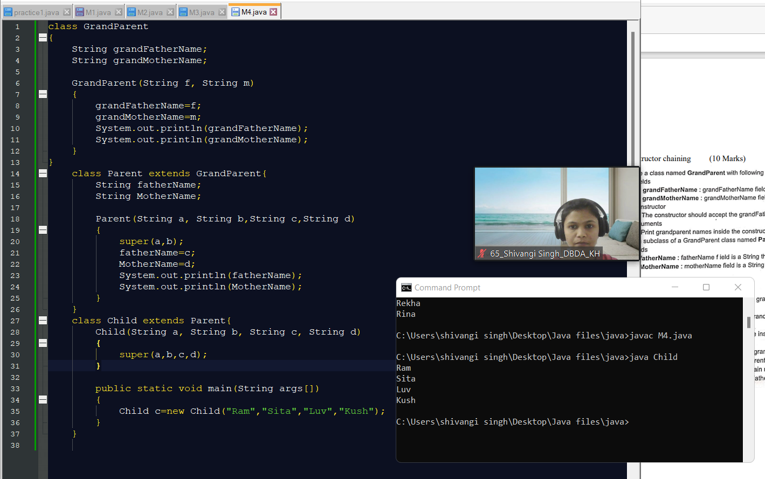

**CODE:-**

class GrandParent

{

String grandFatherName;

String grandMotherName;

GrandParent(String f, String m)

{

grandFatherName=f;

grandMotherName=m;

System.out.println(grandFatherName);

System.out.println(grandMotherName);

}

}

class Parent extends GrandParent{

String fatherName;

String MotherName;

Parent(String a, String b,String c,String d)

{

super(a,b);

fatherName=c;

MotherName=d;

System.out.println(fatherName);

System.out.println(MotherName);

}

}

class Child extends Parent{

Child(String a, String b, String c, String d)

{

super(a,b,c,d);

}

public static void main(String args[])

{

Child c=new Child("Ram","Sita","Luv","Kush");

}

}