Ques1. Git Setup https://confluence.atlassian.com/bitbucket/set-up-git-744723531.html
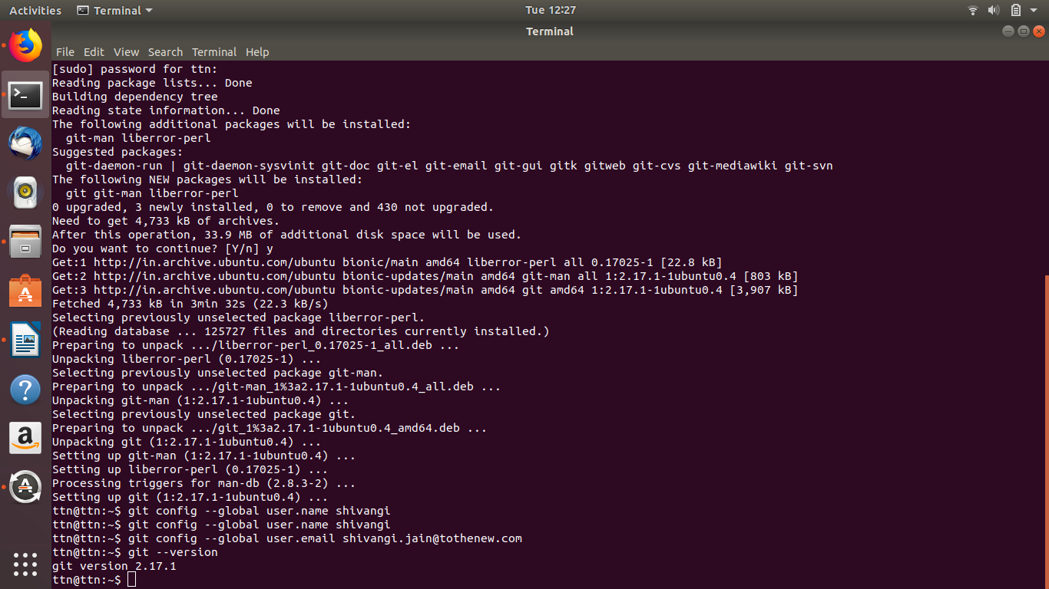

Ques 2. Initialize a Git Repository
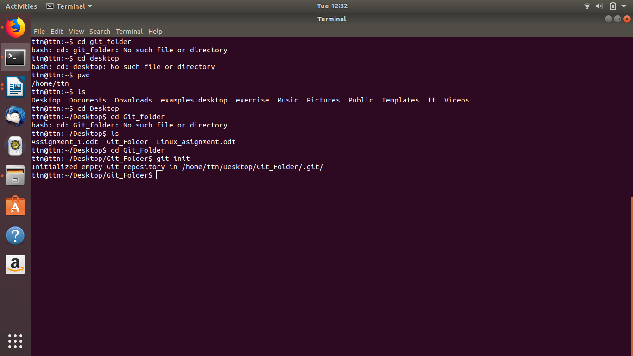

Ques 3. Add files to the repository
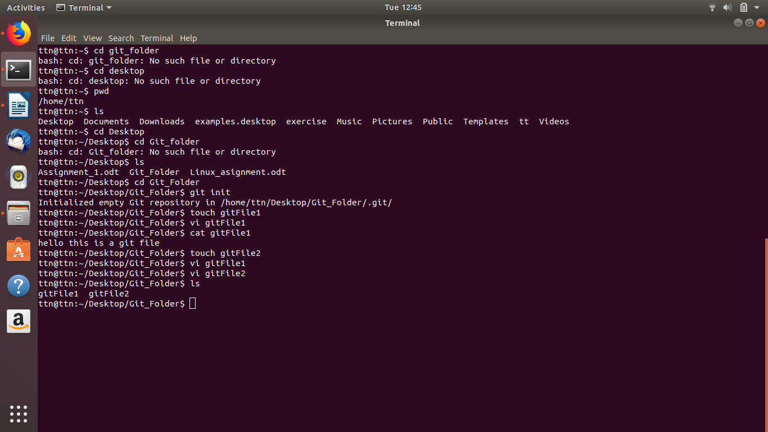

Ques 4. Unstage 1 file
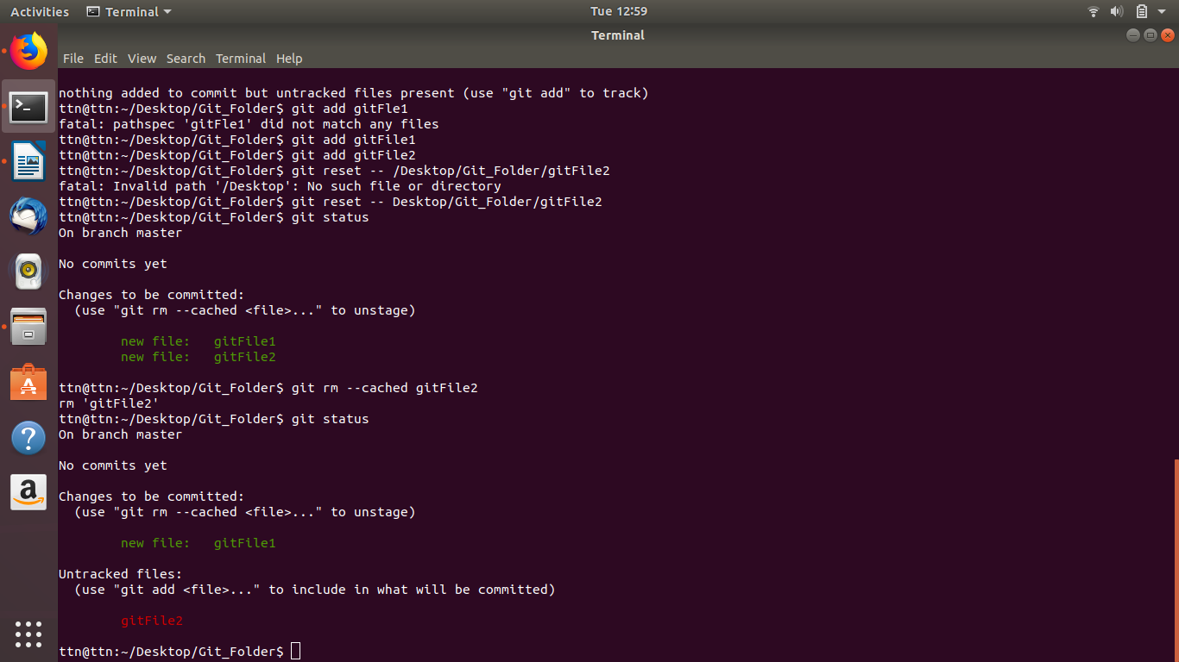

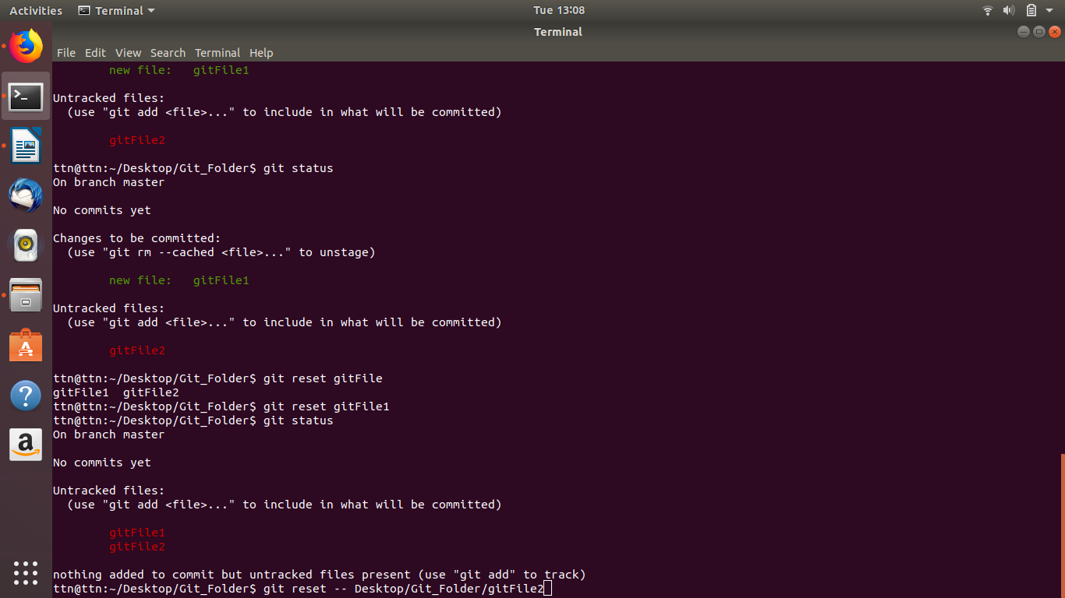

Ques. Commit the file

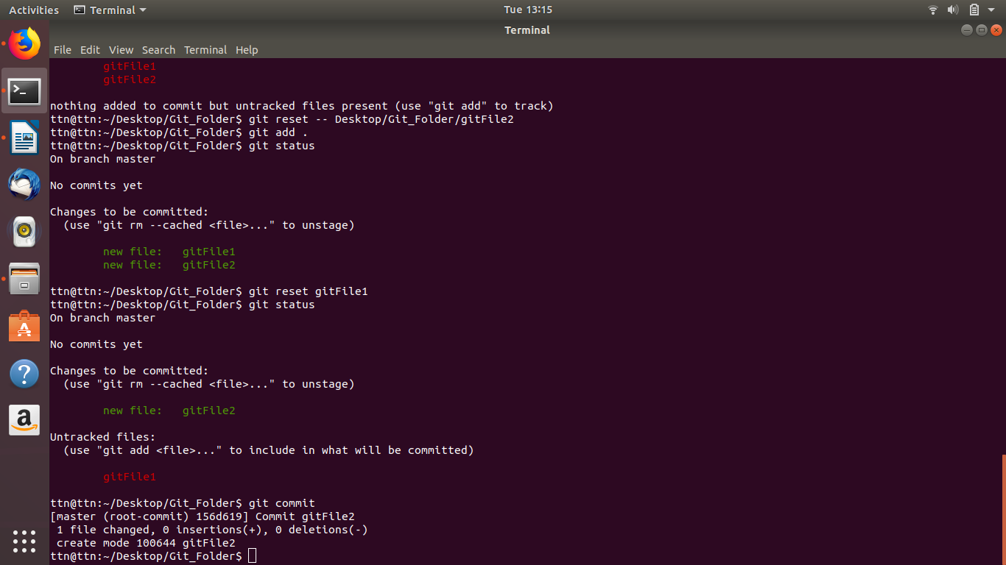
Ques 6. Add a remote

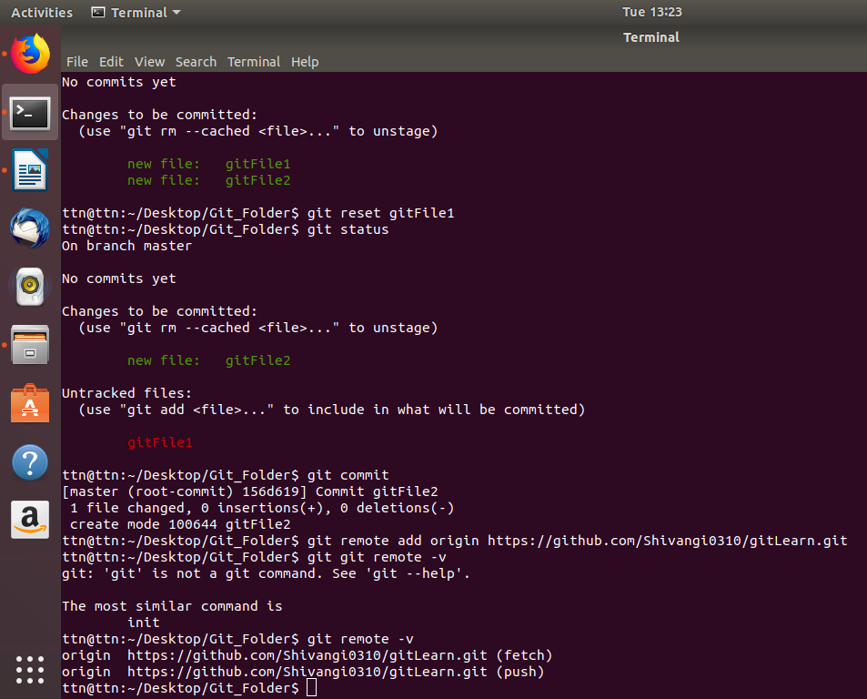

Ques 7. Undo changes to a particular file

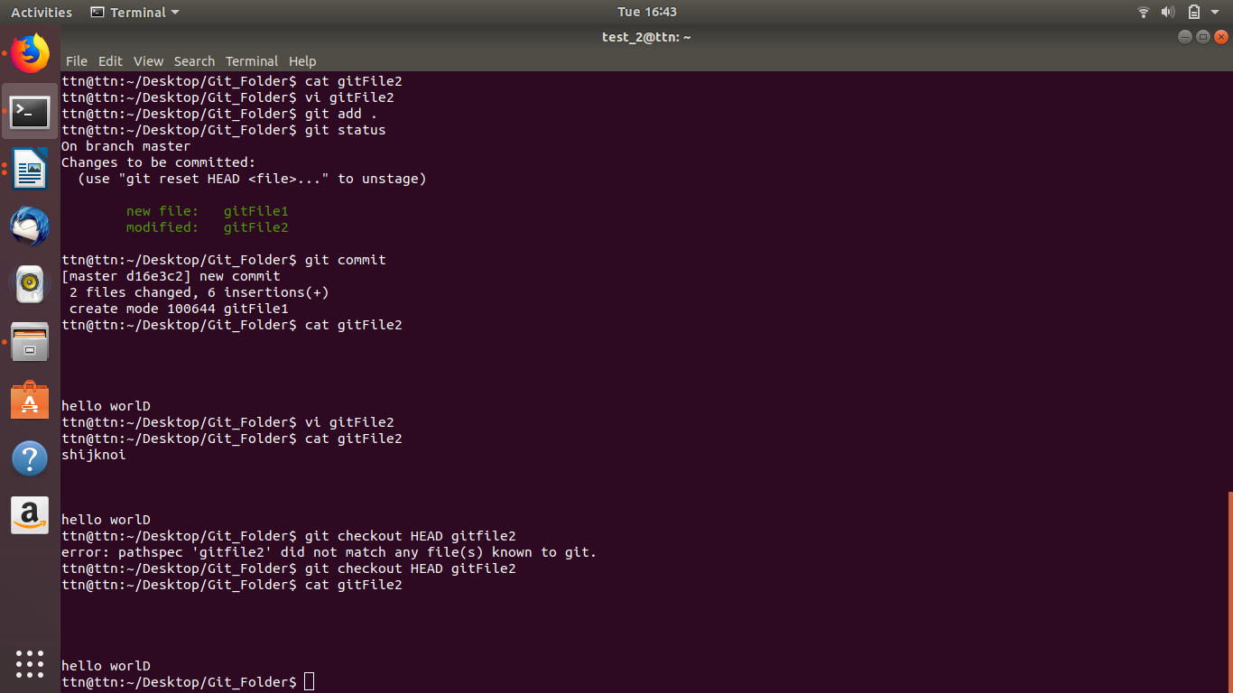

Ques 8. Push changes to Github.
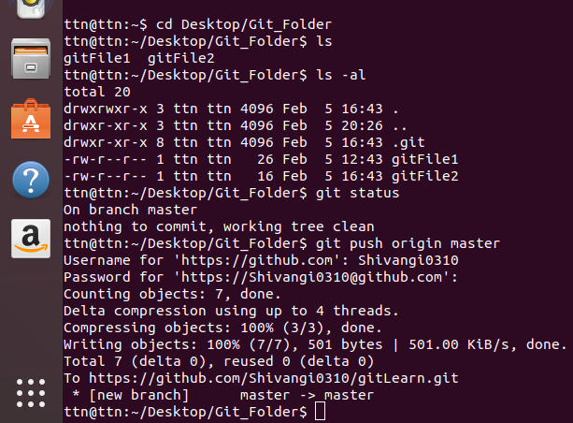

Ques 9. Clone the repository
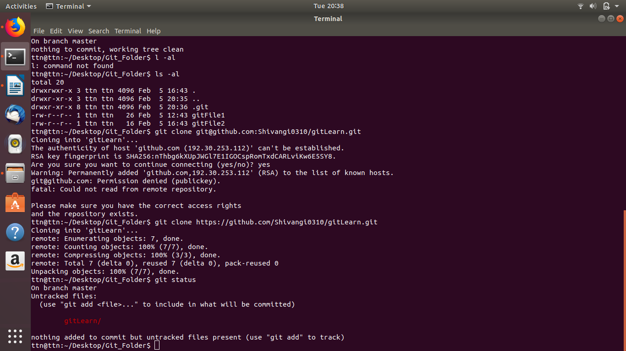

Ques 11. Check differences between a file and its staged version.
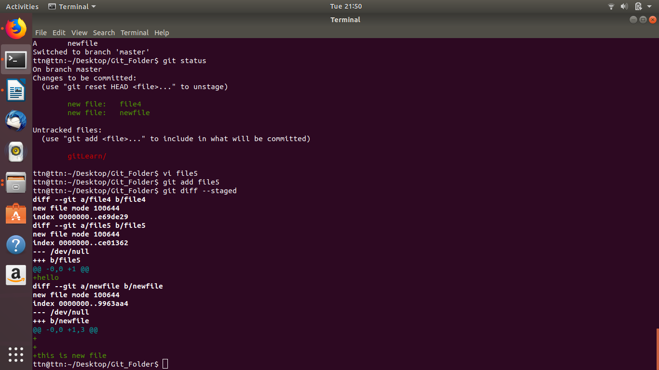

Ques 12. Ignore a few files to be checked in
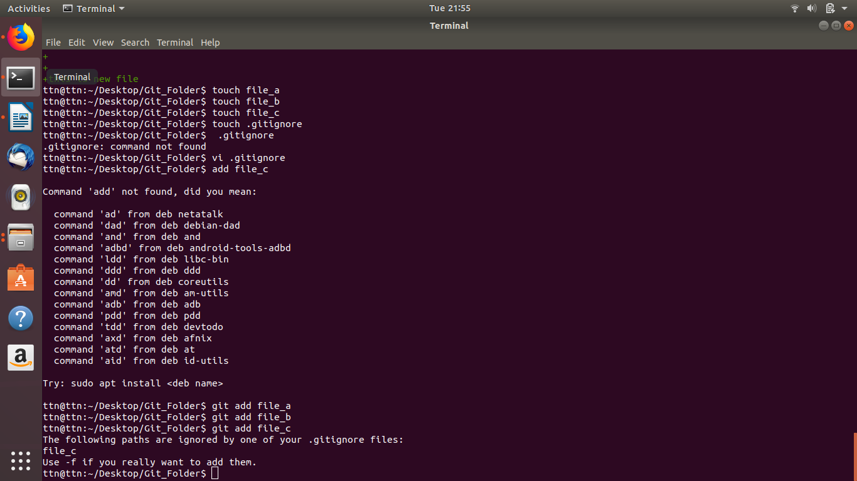

Ques13. Create new branch
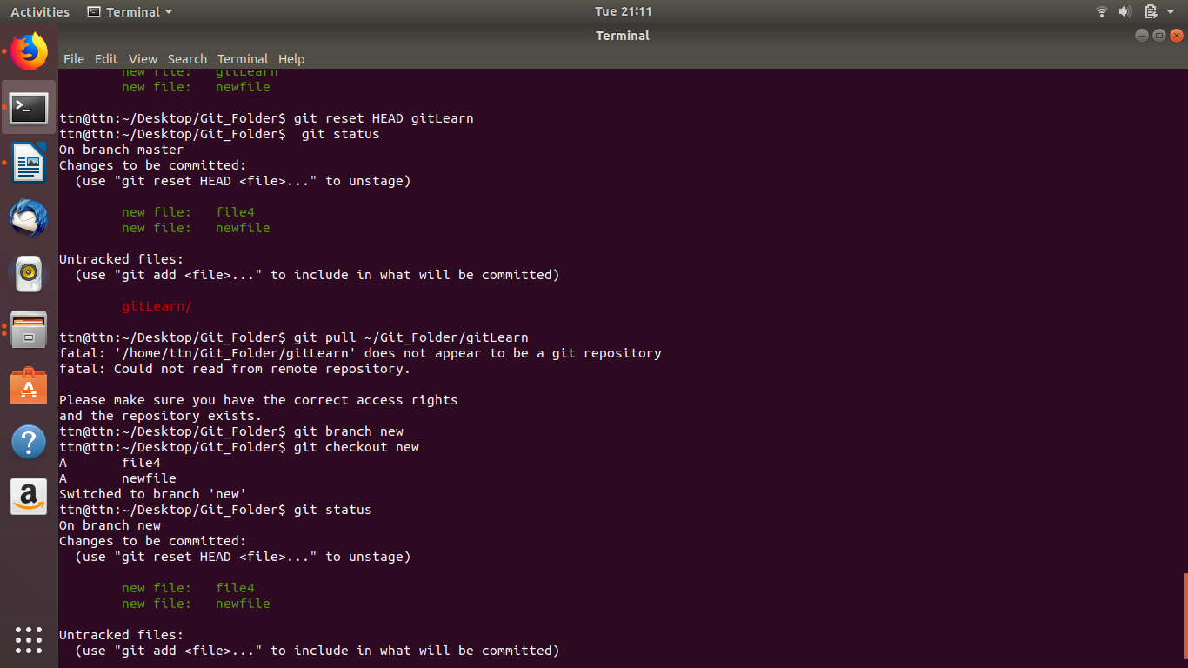

Ques 14. Diverge them with commits
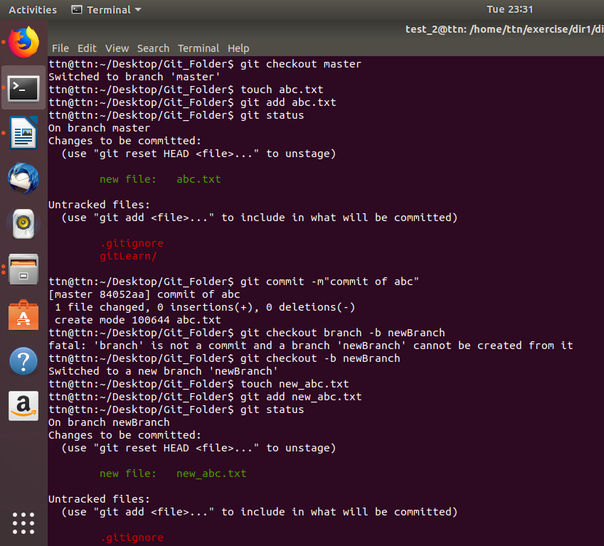

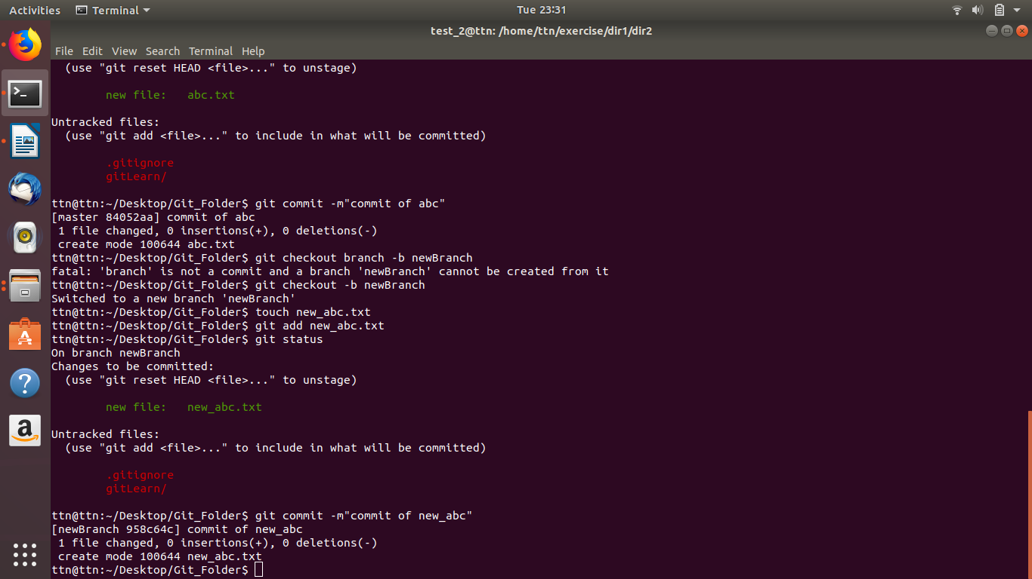

Ques 15. Edit the same file at the same line on both branches and commit.

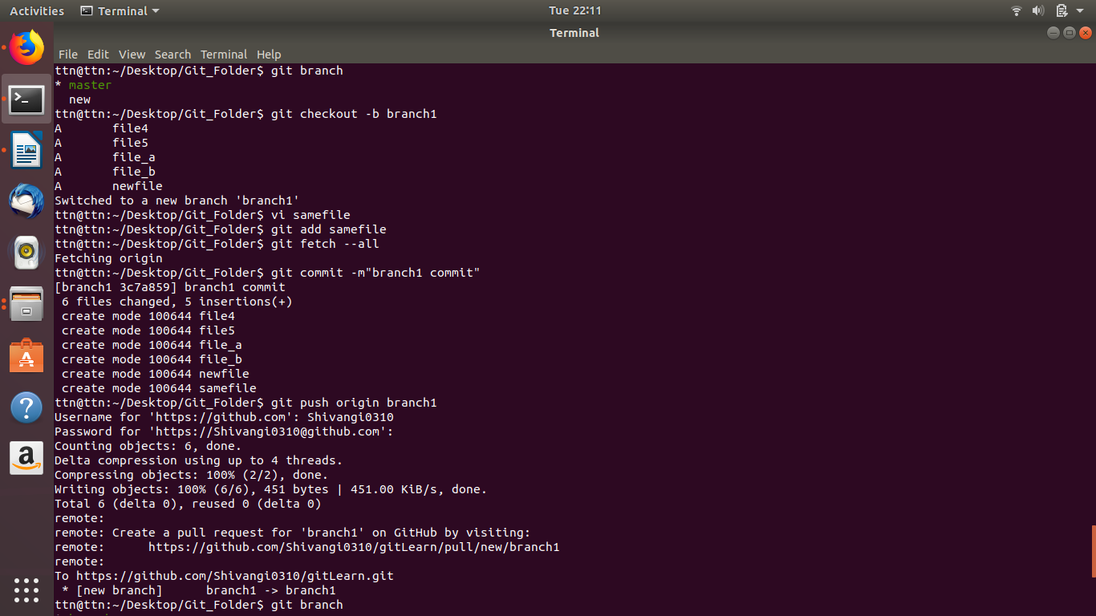
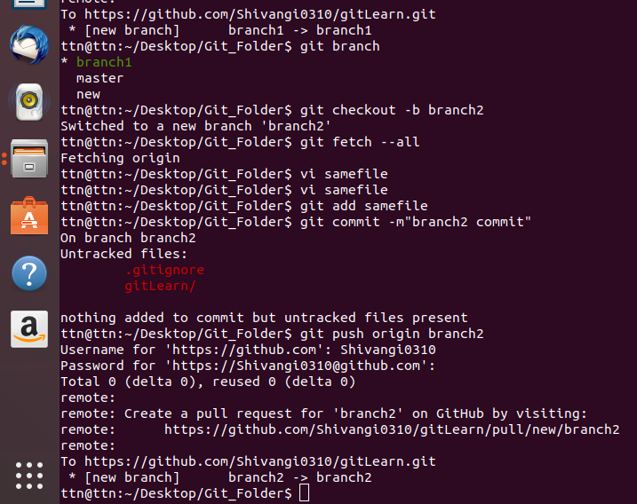

Ques 17. Stash the changes and pop them
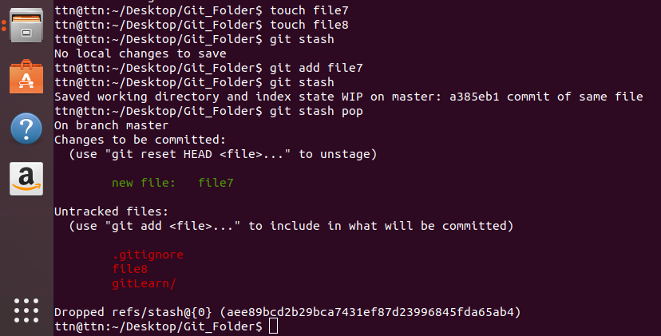

ques 16.Try merging and resolve merge conflicts
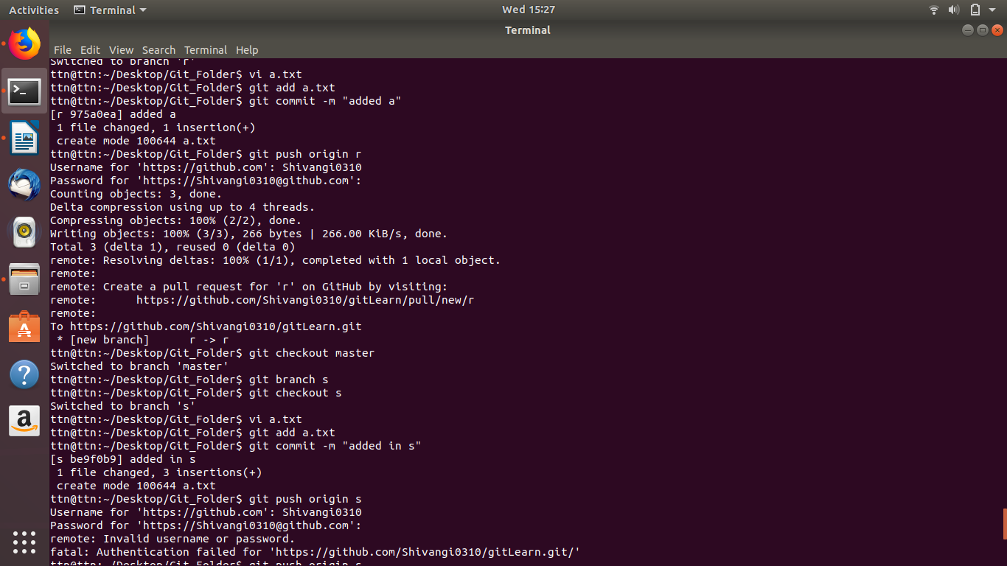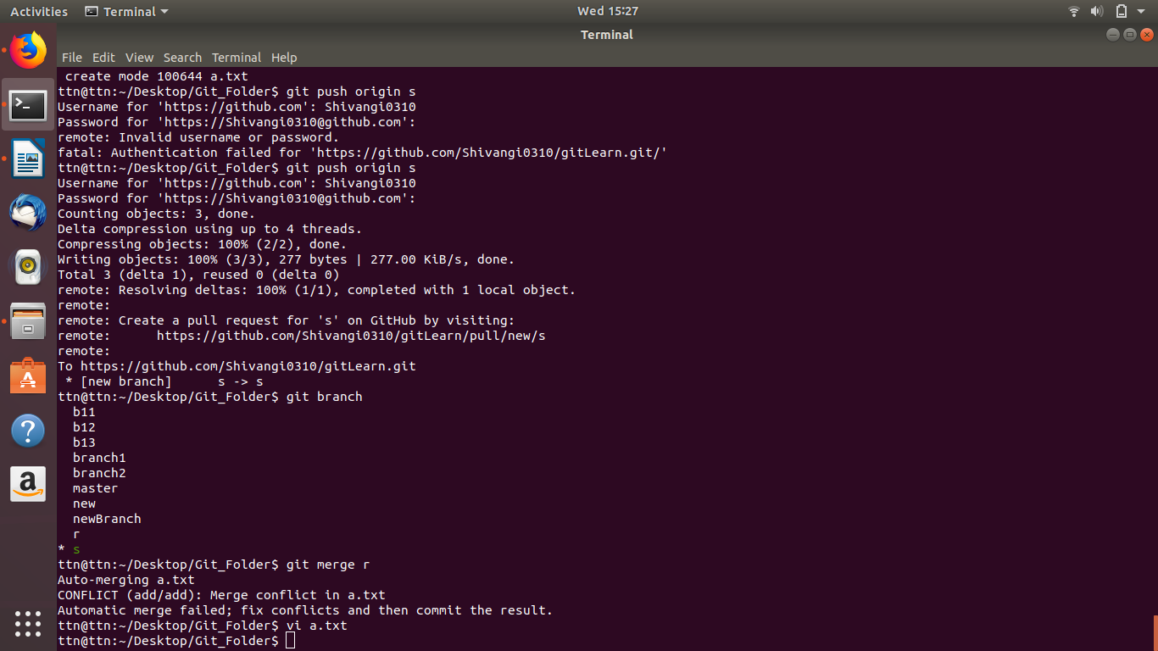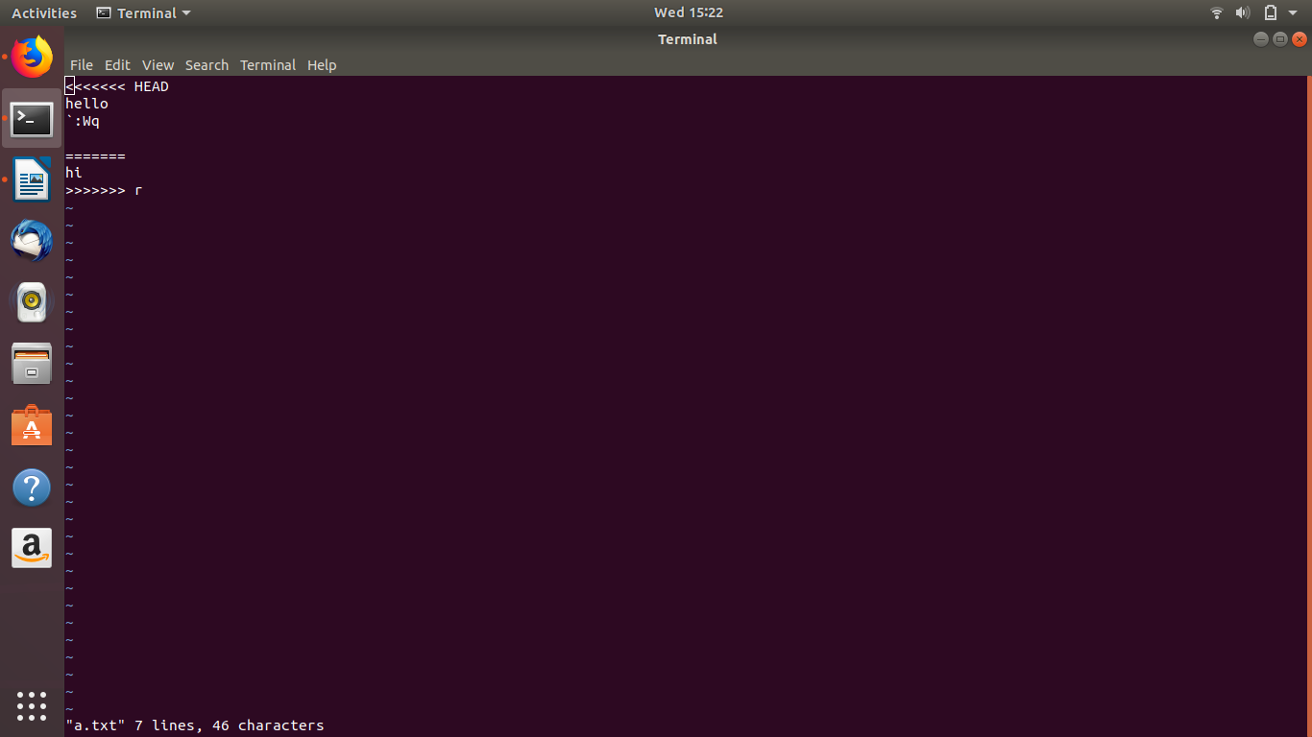
Doubt questions:

ques 10. Add changes to one of the copies and pull the changes in the other.

ques 16.Try merging and resolve merge conflicts

Ques 18. Add the following code to your .bashrc file : color_prompt="yes"
parse_git_branch() {
git branch 2> /dev/null | sed -e '/^[^*]/d' -e 's/* \(.*\)/(\1)/'
}
if [ "$color_prompt" = yes ]; then
PS1='\u@\h\[\033[00m\]:\[\033[01;34m\]\W\[\033[01;31m\] $(parse_git_branch)\[\033[00m\]\$ '
else
PS1='\u@\h:\W $(parse_git_branch)\$ '
fi
unset color_prompt force_color_prompt

