Branch name change
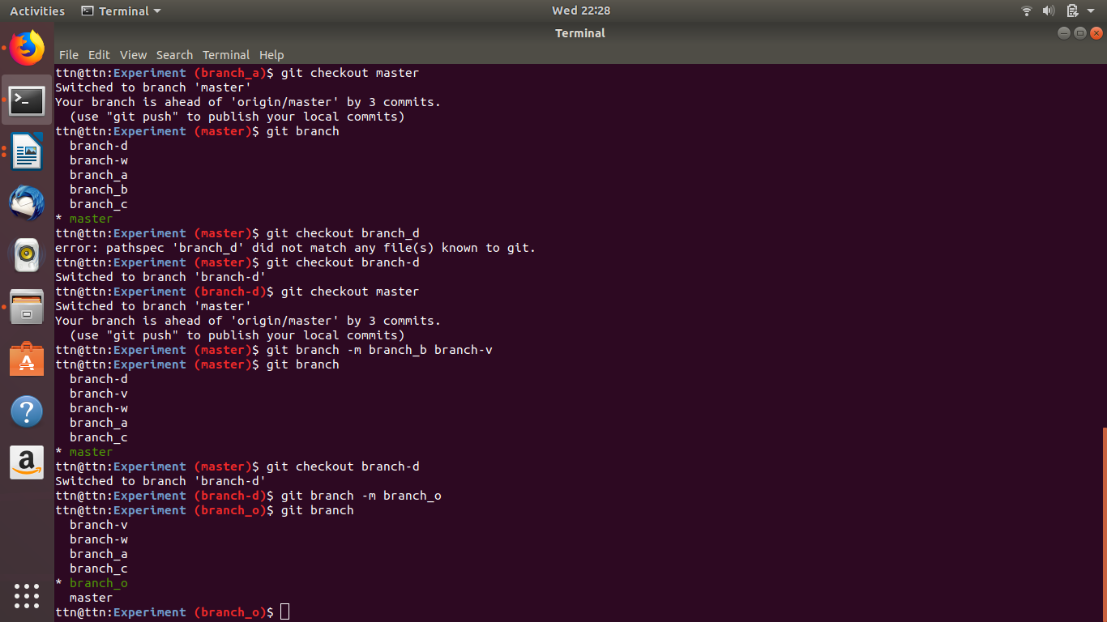

1. git branch -m oldbranchname newbranchname
2. git branch -m newbranchname (if checkout in same branch)

