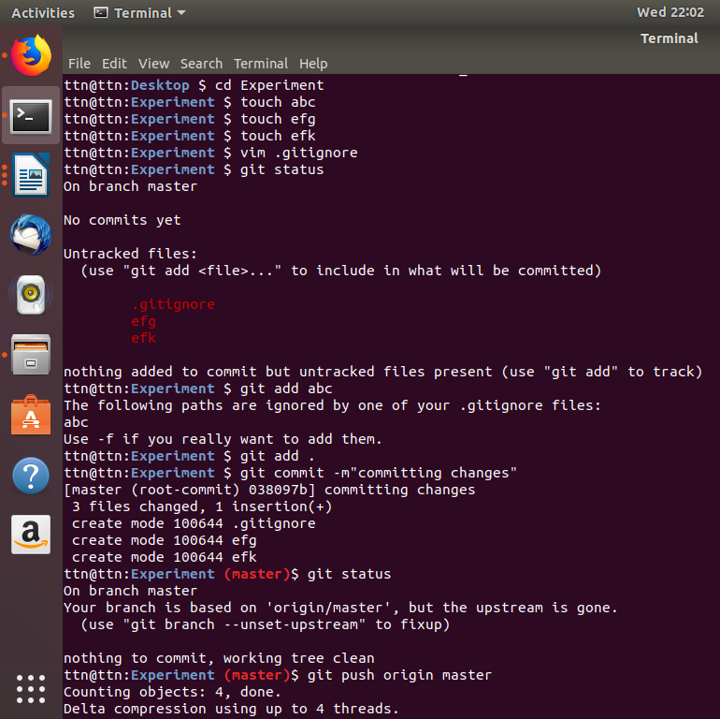
Added untracked file “abc” in gitigone and pushed rest.

Then editted gitignore and added pushed file efg and executed the comand:
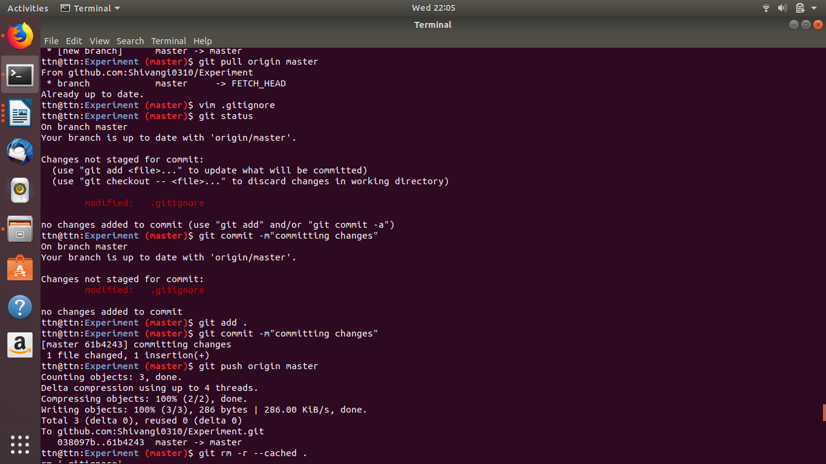

then committing everything again and pushed:

