1.How are inline and block elements different from each other?
Ans.
A<span> tag is used as an inline element and a <div> tag is used as a block level element. Block elements does not take full width of the page unlike inline elements.
They just take the size of data betweeen their opening and closing tag.
Examples of block elements: Heading <h1> to <h6>, list <li> and <ol>.
Inline elements take the width of whole page irrespective of element size.
Examples of inline elements: anchor<a>, emphasis <em>, image <img>.
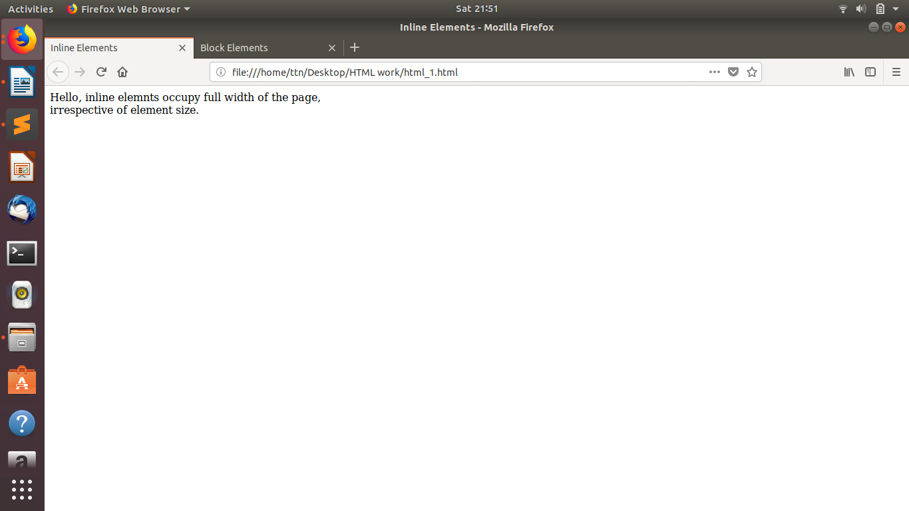
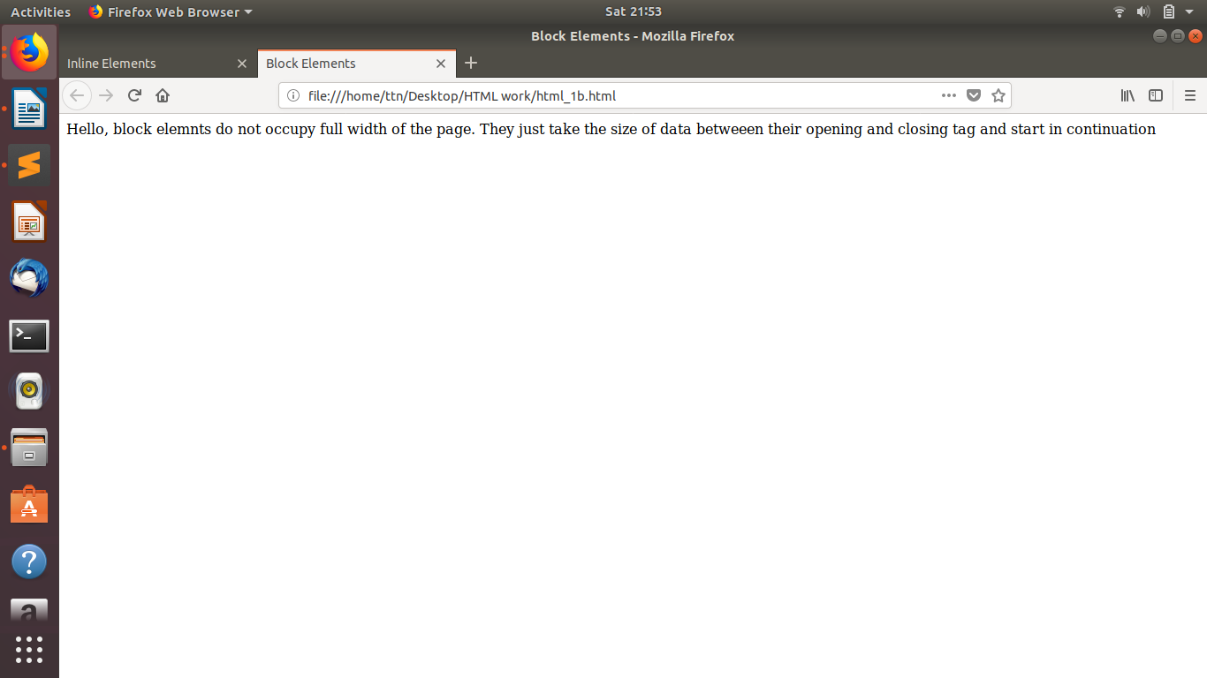

2.Explain the difference between visibility:hidden and display:none
Ans.
Visibility:hidden- It hides an element, but it will still take up the same space as before and also will affect the layout of the page.
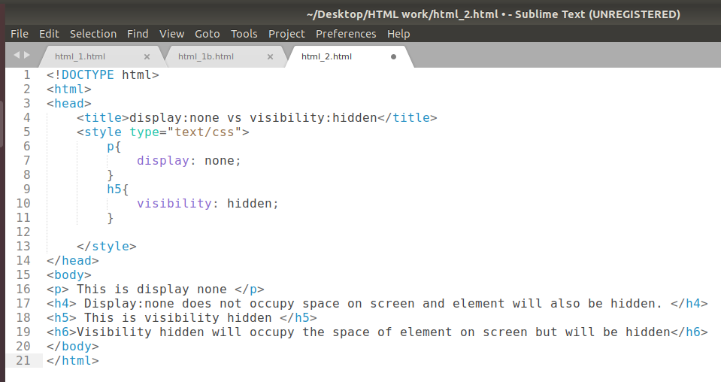
Display :none- It hides the element and does not takes up its space on page.
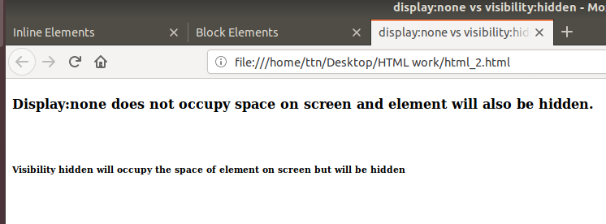

3. Explain the clear and float properties.
Ans.
Float: The float property is used for positioning and formatting content. For e.g. , positioning an image to left or right.
Float properties:
1. left - The element floats to the left of its container
2. right- The element floats to the right of its container
3. none - The element be displayed just where it occurs in the text. This is default.
4. inherit - The element inherits the float value of its parent

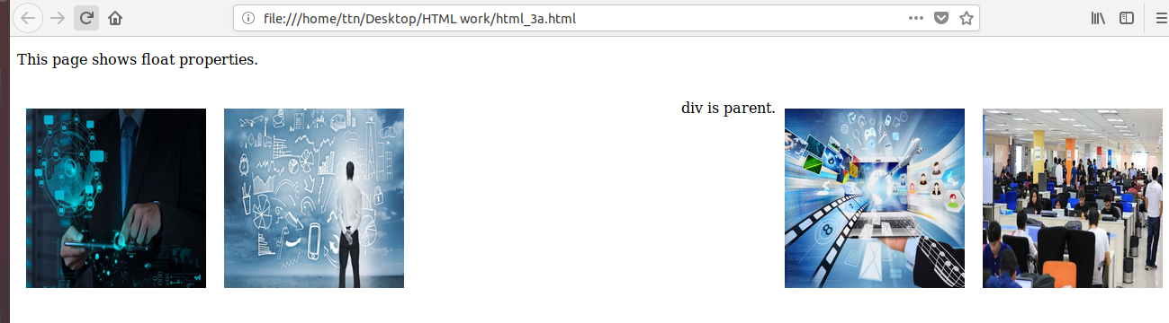

Clear:
The clear property specifies what elements can float beside the cleared element and on which side.
Clear properties:
1. none - Allows floating elements on both sides. This is default
2. left - No floating elements allowed on the left side
3. right- No floating elements allowed on the right side
4. both - No floating elements allowed on either the left or the right side
5. inherit - The element inherits the clear value of its parent
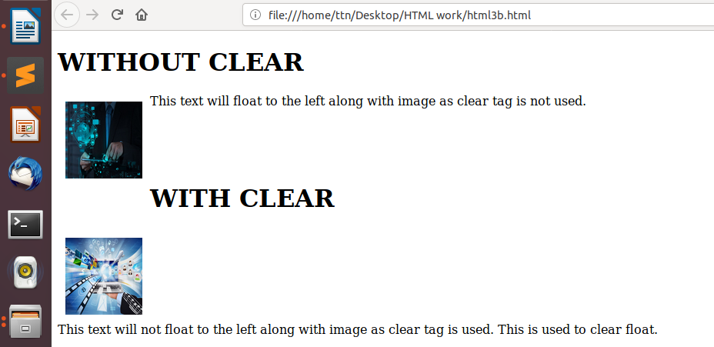

4. explain difference between absolute, relative,fixed and static.
Ans.
The position property specifies the position of an element on page.
There are 5 positions used in css:
1. postion:static- Default value.
2. postion: relative- Relative positioning moves an element RELATIVE to its original position.
3. position: absolute- The element is positioned relative to its first positioned ancestor element
4. position: fixed- The element is positioned relative to the browser window.
5 position: sticky- The element is positioned based on the user's scroll position
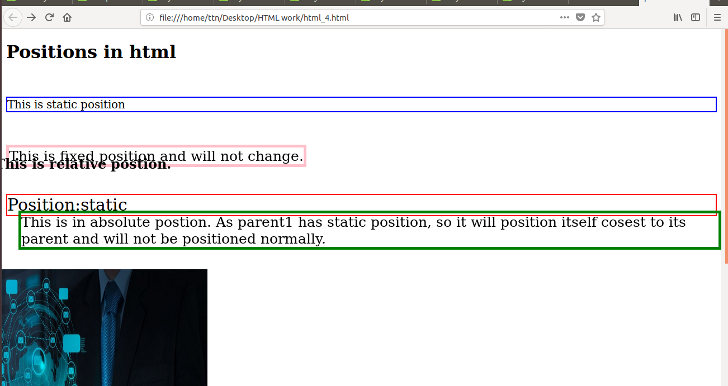

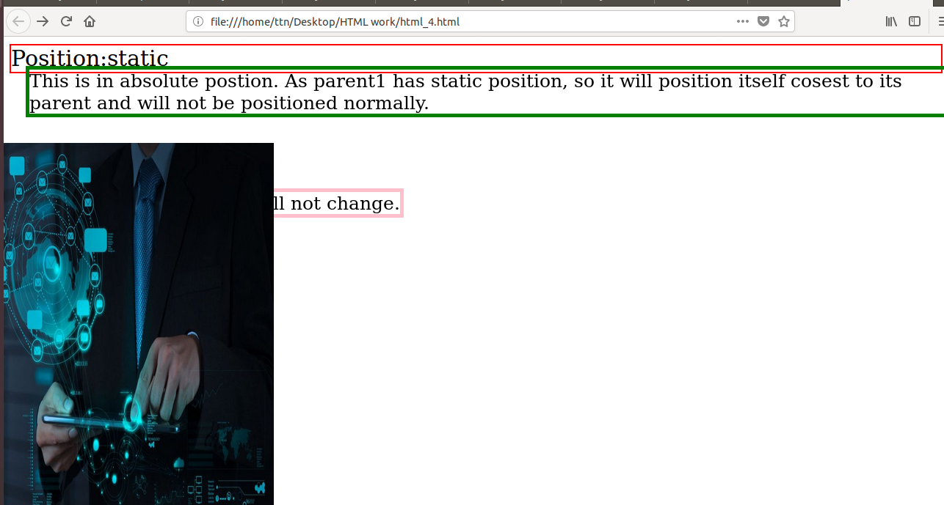

5. Write the HTML code to create a table in which there are 4 columns( ID , Employee Name, Designation, Department) and at least 6 rows. Also do some styling to it.
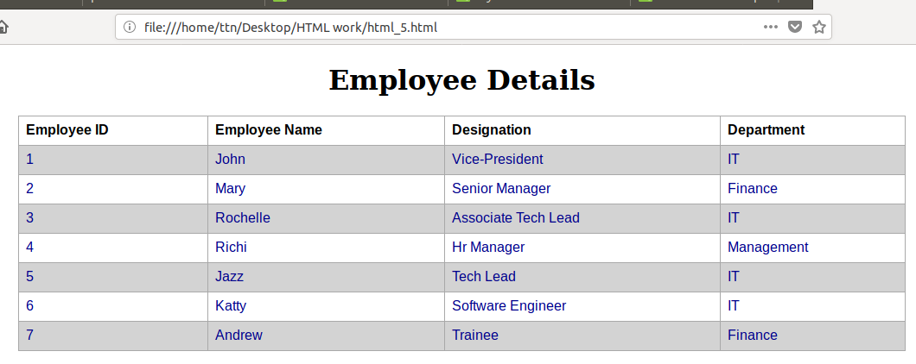
Ans.

6. Why do we use meta tags?
Ans.
Metadata is information about data. The <meta> tag is used provides metadata about the HTML document. Metadata is not be displayed on the page, but is machine parsable.
Meta elements are typically used to specify page description, keywords, author of the document, last modified, and other metadata.
The metadata can be used by browsers in terms of how to display content or reload page, search engines in terms of keywords, or other web services.
<meta> tags always go inside the <head> element. Metadata is always passed as name/value pairs.
EXAMPLE:
<meta name="description" content="HTML tutorial">
<meta name="keywords" content="HTML,CSS">
<meta name="author" content="ABC">
*<meta name="viewport" content="width=device-width, initial-scale=1.0">
A <meta> viewport element gives the browser instructions on how to control the page's dimensions and scaling.
The width=device-width part sets the width of the page to follow the screen-width of the device (which will vary depending on the device).
The initial-scale=1.0 part sets the initial zoom level when the page is first loaded by the browser.

7. Explain box model.
Ans.
In CSS, the term "box model" is used to describe design and layout. All HTML elements are considered as boxes.
The CSS box model is a box that act as a wrapper around every HTML element. It consists of:
Content - The actual content of box consisting of text, images and other media.
Padding - Clears an area around the content. The padding is transparent.
Border – A border that is put around padding and content together.
Margin - Clears an area outside the border. The margin is transparent
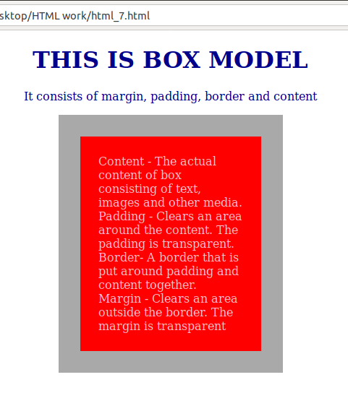

8. What are the different types of CSS Selectors?
Ans.
In CSS, selectors are patterns used to select the element which are to be styled.
Most commonly used:
.classname- Selects all elements with classname specified
#id- Selects all elements with id specified
element_name- Selects all elements with element specified
* - Selects all elements
Most commonly used Combinations :
1.element element : div p (selects all p inside div.)
2. element, element: div, p (selects all div and p elemets present in body)
3. element + element: div+p (Selects all p elements that are placed immediately after div elements)
4. element>element: div>p (Selects all elements where the parent is element)
5. ::after : p::after (Insert something after the content of each element)
6. ::before : p::before (Insert something before the content of each element)
and many more...

9. Define Doctype.
The <!DOCTYPE> declaration must be the very first tag in HTML document, before the <html> tag.
The <!DOCTYPE> declaration is not an HTML tag; it is an instruction to the web browser about what version of HTML the page is written in.
In HTML 5, there is only one <!doctype> tag used - <!DOCTYPE html>

10. Explain 5 HTML5 semantic tags.
Ans.
Semantic elements = elements with a meaning.
Non-semantic elements : <div> and <span> which tell nothing about their elements.
Semantic elements:
1. <section> : The section element defines a section in a document. These are group of related elements usually with heading.
2. <article>: It defines independent text and should be readable irrespective of other text.
Used for blogs, news, forums etc.
3. <aside>: The <aside> element defines some content aside from the content where it is placed in.
The <aside> content should be related to the surrounding content.
4. nav: The <nav>element defines a set of navigation links.
5. figure and figcaption: This is used to add a visual explanation to an image.
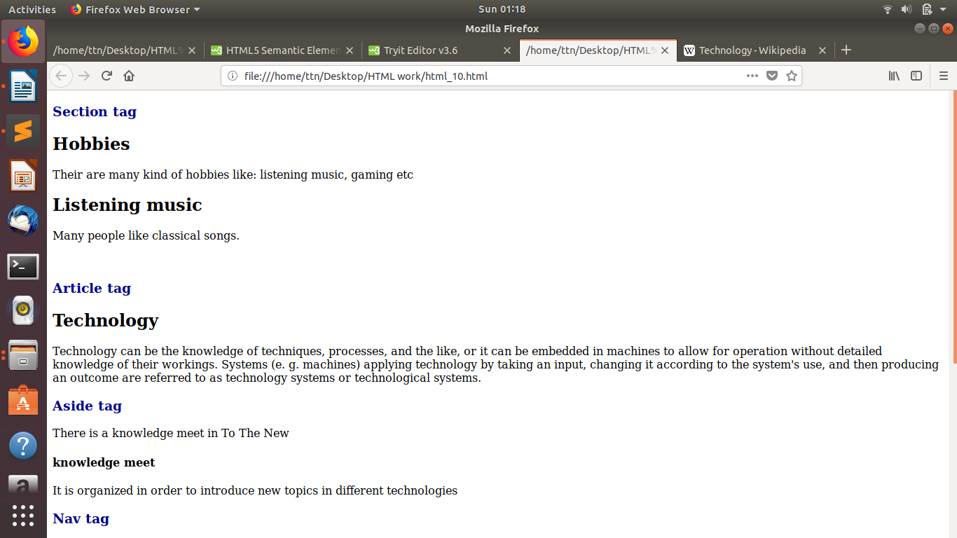

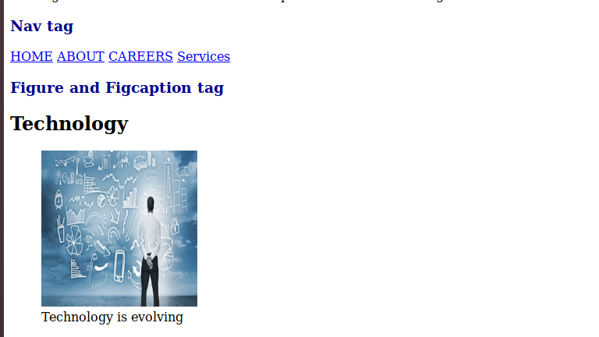

11. Create HTML for web-page.jpg (check resources, highest weightage for answers)
12. Create HTML for form.png (check resources, highest weightage for answers)
QUES 11 and 12 uploaded in separate files.

