MYSQL Assignment:

Show database:
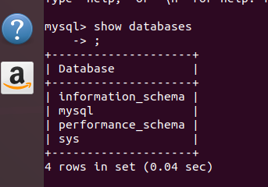

Q1 Create Database

Create database order_management;

use order_management;

show order_management;
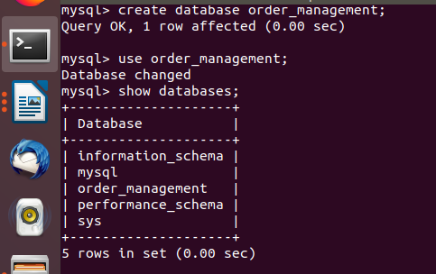

Ques 3. Create tables:

I. Customer:

create table customer(cust_id int(20) primary key auto_increment, cust_name varchar(100), mobile_num bigint(20) NOT NULL, age int(20));

desc customer;
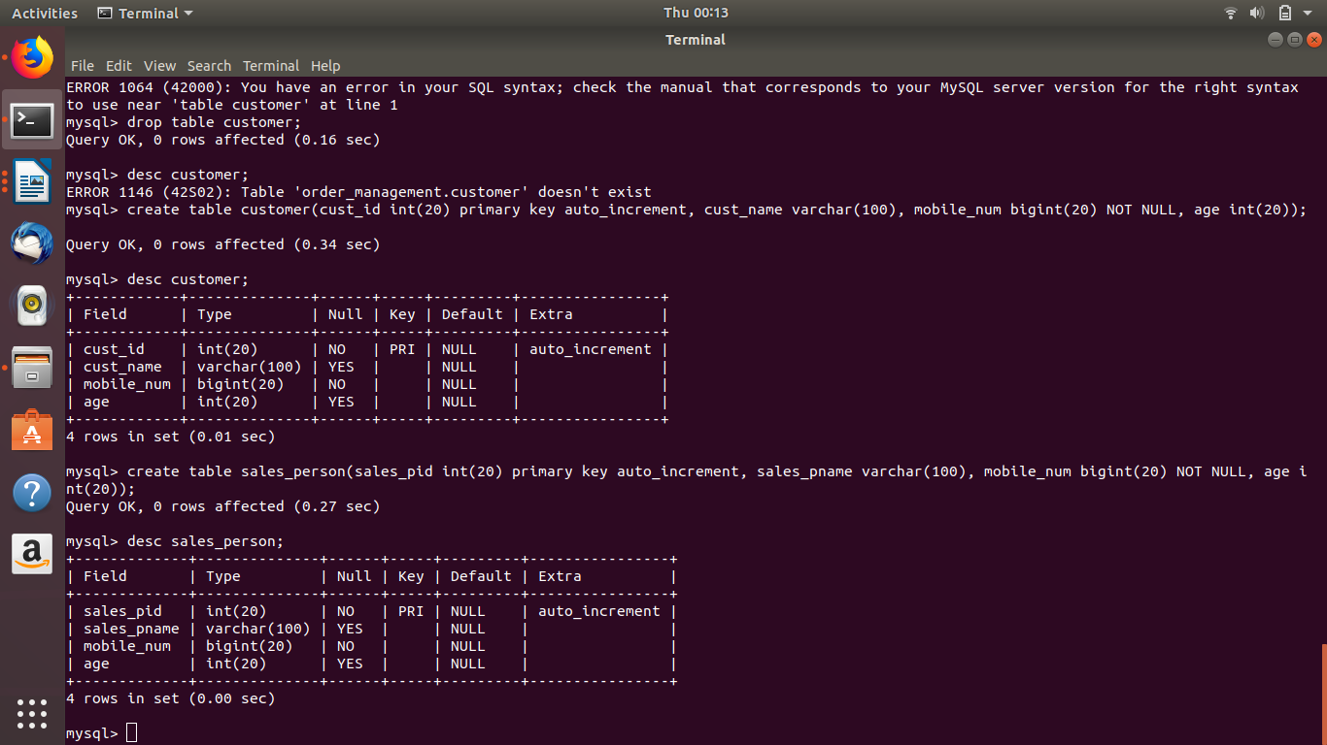

II sales_person:

create table sales_person(sales_pid int(20) primary key auto_increment, sales_pname varchar(100), mobile_num bigint(20) NOT NULL, age int(20));

desc sales_person;

III Orders:

create table orders(order_id int(20) auto_increment, cust_id int(20), sales_pid int(20), primary key(order_id,cust_id, sales_pid), foreign key cust_ord(cust_id) references customer(cust_id), foreign key sales_p(sales_pid) references sales_person(sales_pid));

desc orders;

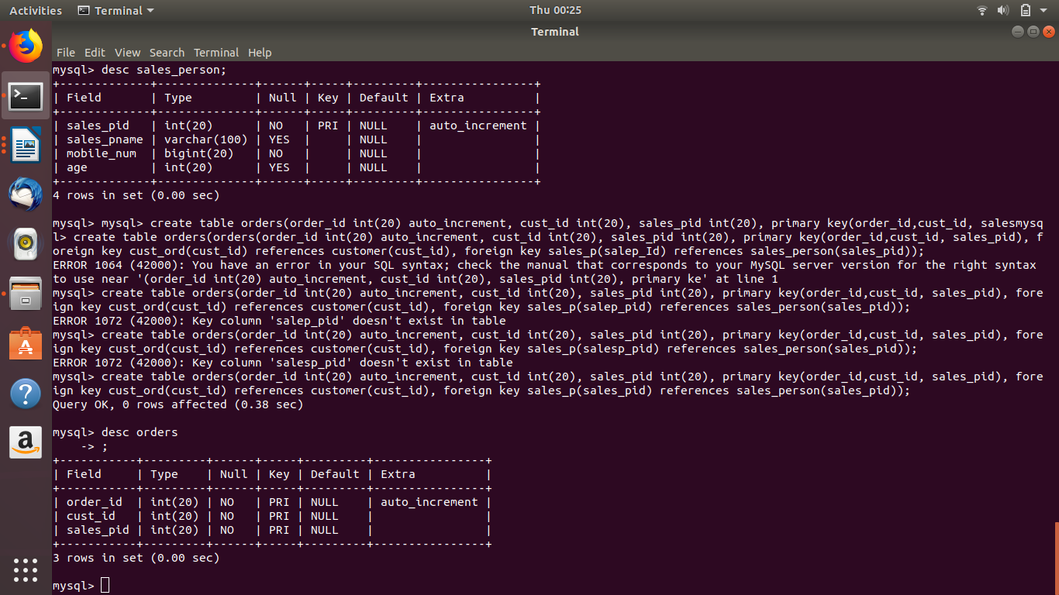

Ques 4. Insert sample data:

I. customer:

insert into customer values( 1,"aakash", 7636477377, 23);
insert into customer values( 2,"kamal", 9836877377, 27);
insert into customer values( 3,"sukirti", 8756877377, 26);
insert into customer values( 4,"mudit", 9867773737, 29);
insert into customer values( 5,"joyesh", 8757773737, 30);

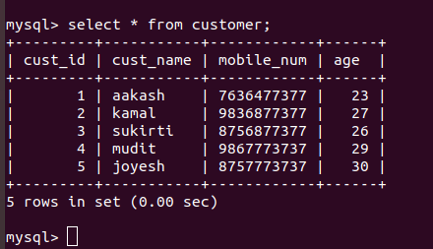

II. sales_person:

insert into sales_person values( 1,"karishma", 8766477377, 43);

insert into sales_person values( 2,"rajat", 8787677377, 42);

insert into sales_person values( 3,"raj", 8787678777, 34);

insert into sales_person values( 4,"anil", 8787978777, 32);

insert into sales_person values( 5,"mikunj", 9087978777, 25);

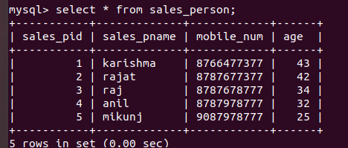

III. Orders

insert into orders values(1, 1,2 );
insert into orders values(2, 1,3 );
insert into orders values(3, 5,4 );
insert into orders values(4, 3,3 );
insert into orders values(5, 3,3 );
insert into orders values(6, 5,4 );
insert into orders values(7, 5,5 );
insert into orders values(8, 5,2 );
insert into orders values(9, 3,1 );
insert into orders values(10, 3,1 );
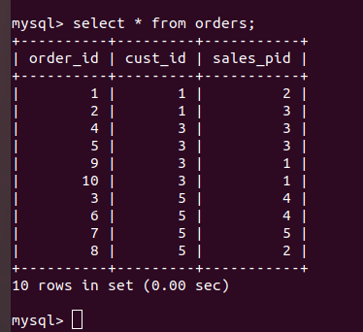

Ques 5. Find the sales person have multiple orders.

select * from sales_person where sales_pid in (select sales_pid from orders group by sales_pid having count(*)>1);

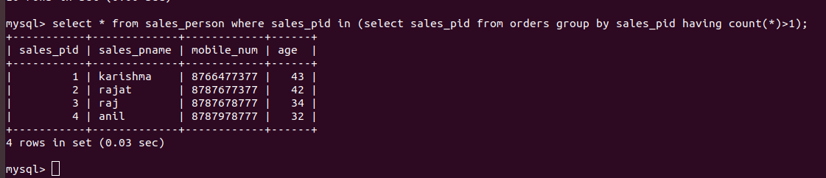

Ques 6. Find the all sales person details along with order details

select o.order.sales_pid, s.sales_pname,s.mobile_num, s.age from orders o inner join sales_person s on o.sales_pid=s.sales_pid;

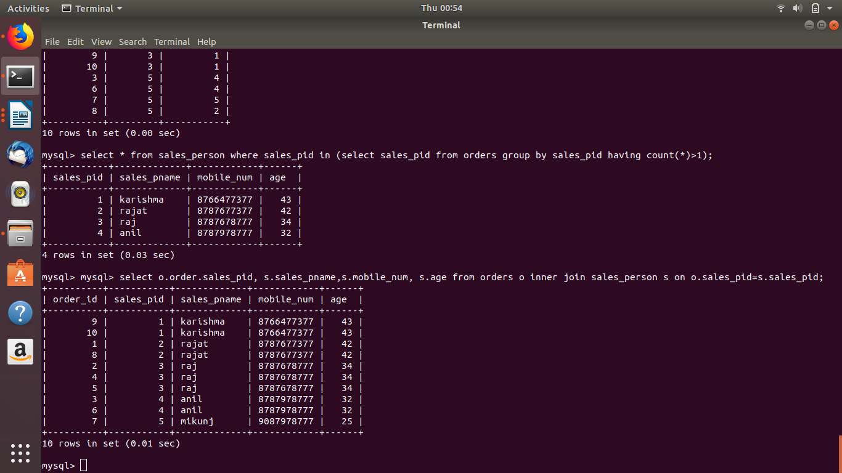

Ques 7. Create index

create index customer_index on customer(cust_name);

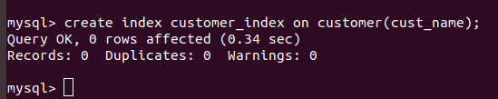

Ques 8. How to show index on a table

show index from orders;
show index from customer;

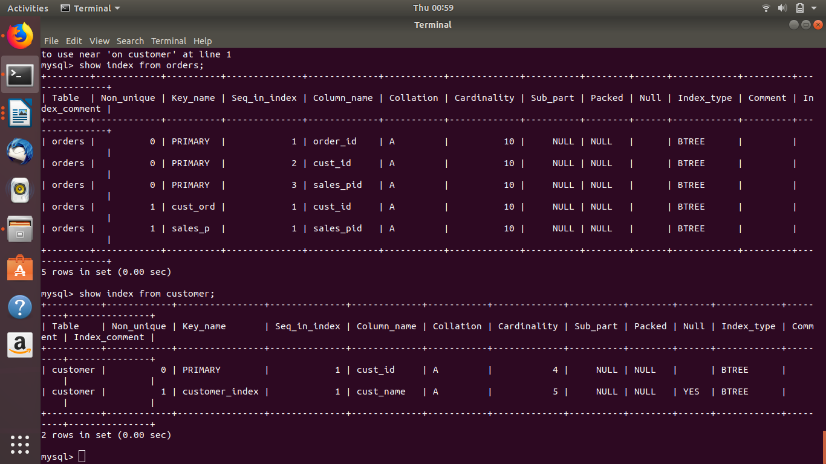

Ques 9. Find the order number, sale person name, along with the customer to whom that order belongs to.

select o.order_id, s.sales_pname, c.cust_name from orders o inner join sales_person s on o.sales_pid= s.sales_pid inner join customer c on o.cust_id = c.cust_id;

