Groovy scripting lang, based on java
freedom to write the syntax as u want to execute
in java we need psvm

but in a scripting lang we directly write code and execute
whenver we compile groovy it makes a byte code and .class compiled by jvm only .
groovy safe as java but also provides static type checking and compilation.

Groovy 2.5.6 mostly used version
First release in 2007
james strachan and bob mcwhirter

why groovy?
Semicolons optional
parenthesis
typing-type defination of variables
public keyword-everything is public no concept of private keyword
return keyword-we can skip it groovy returns last line of method
we can use it but it gives freedom to not to use it.
No getter setters

groovy is expressive, concise, readable
optional typing v/s duck typing
dyamic typing =duck typing
def keyword can be used instead of datatypes as def creates a variable of object class

groovysh command opens groovy sheel in your terminal
println “hello”
hello
===>null
it shows print type is null nothing is returned.
Def str=”name”
alvis operator-----
condition ?:false
if condition is true it will execute it else it will return false.
Ex:
“hello” ?: “none”
===>hello
“” ?: “bye”
===>bye

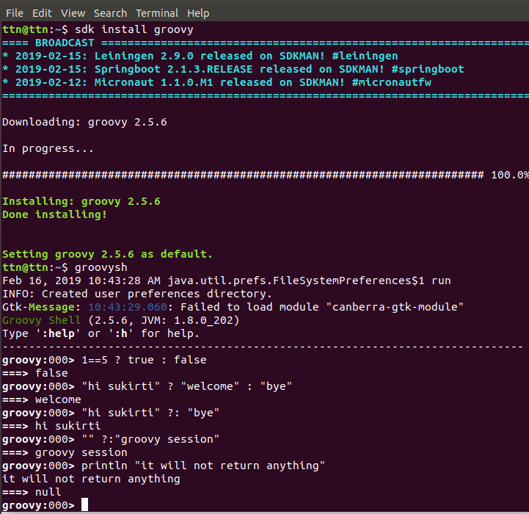

groovy console v/s groovy shell

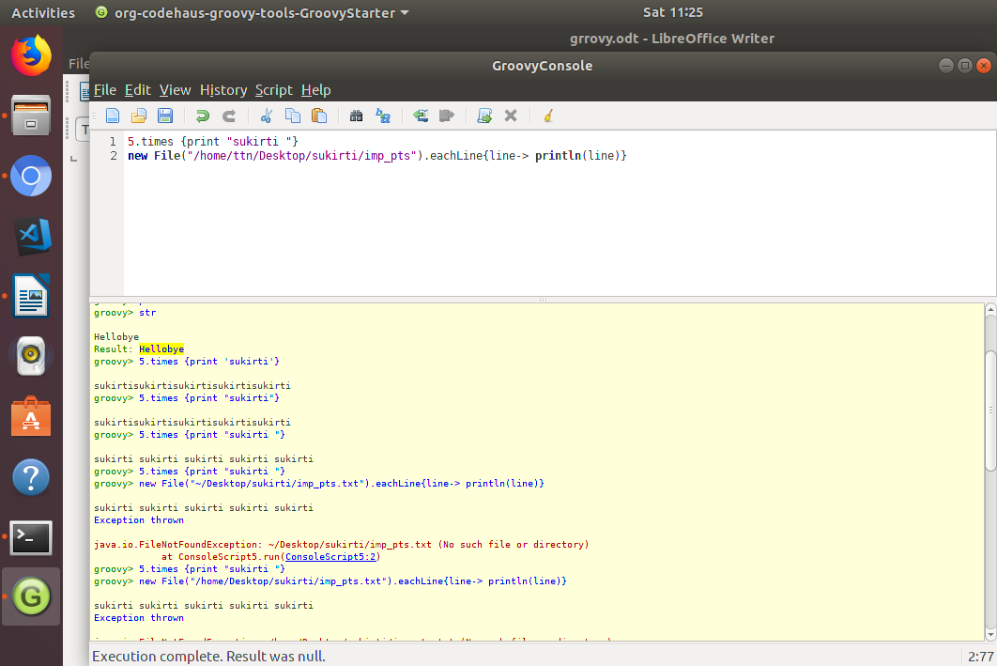
gdk is an enhancement over jdk.
Ex: eachline,ties etc methods
gdk makes a class file and then provides it to jdk

groovy closures:
block of code written inside curly braces.
Method accepts closure as parameters.
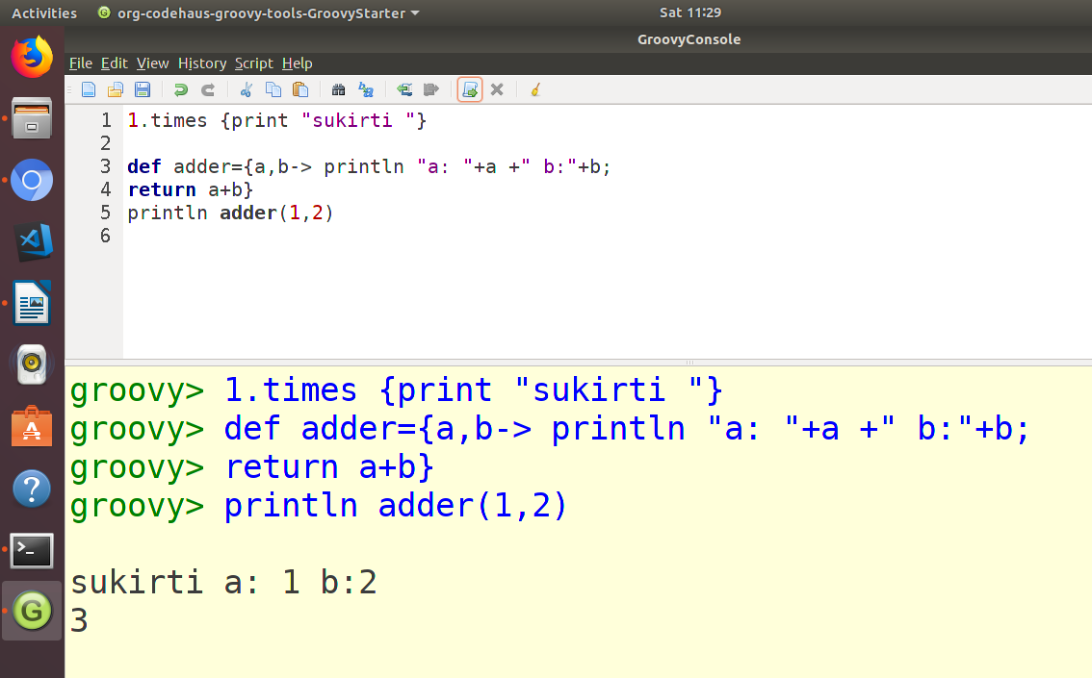
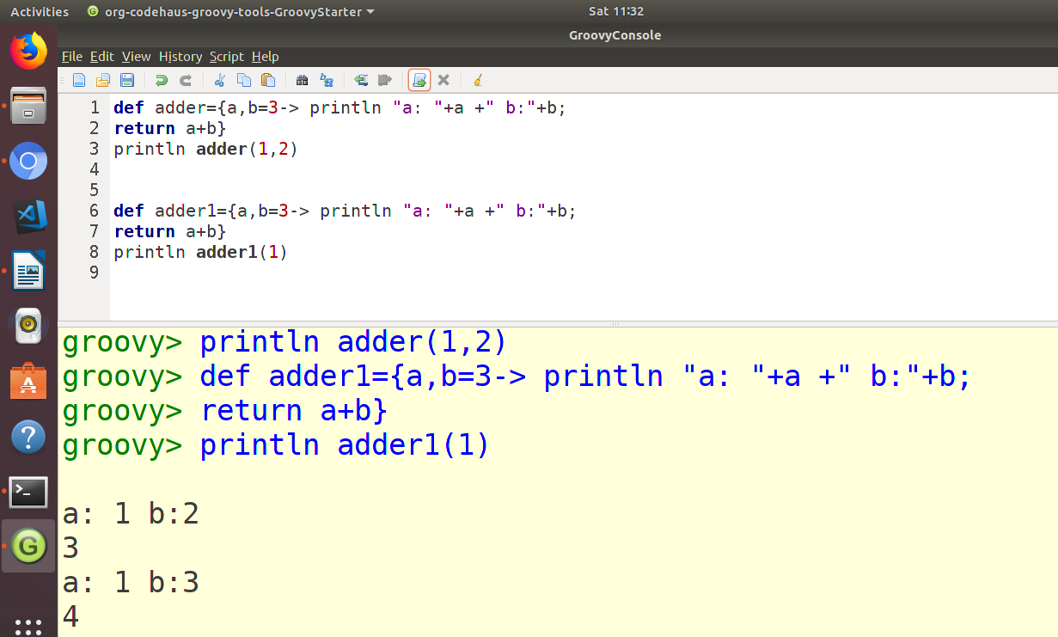
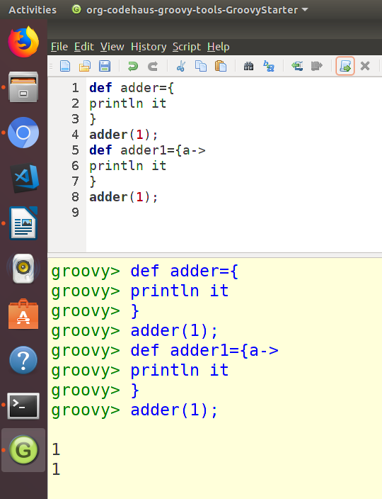
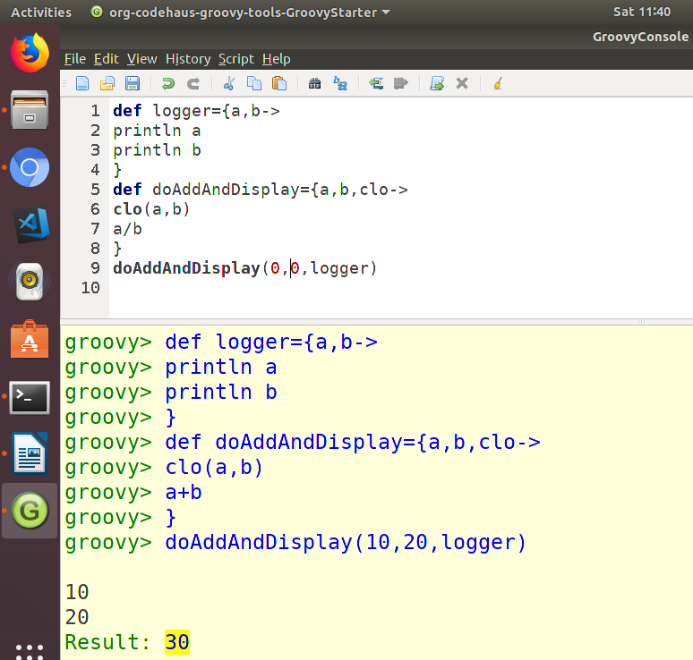
Assert is a testing keyword if its true it will return true else it will throw exception.
String “”,’’,/”Fdfdff”Cvd;;’’’’”/
if want to use $ to retrieve any variable vale use single quotes for string n double qutes for return statement.

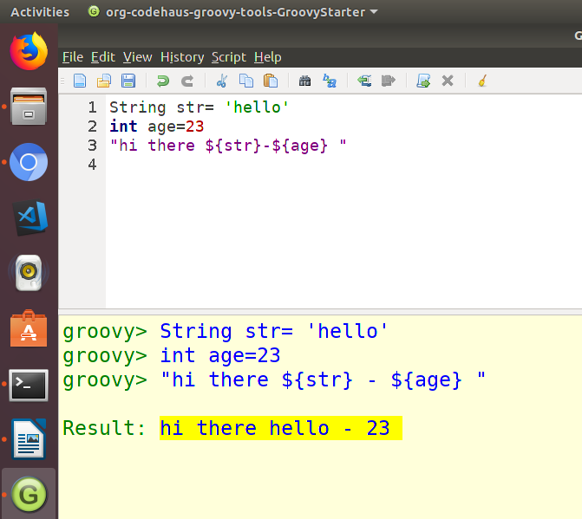
Groovy allows operator overloading.
Ex:
return type for opertor overloadng is class itself never use int or tring as it will break operator chaining
don’t change the natural flow.
Return typr must be of first parameter
All operators in Groovy are method calls.

To protect a private field from accidental
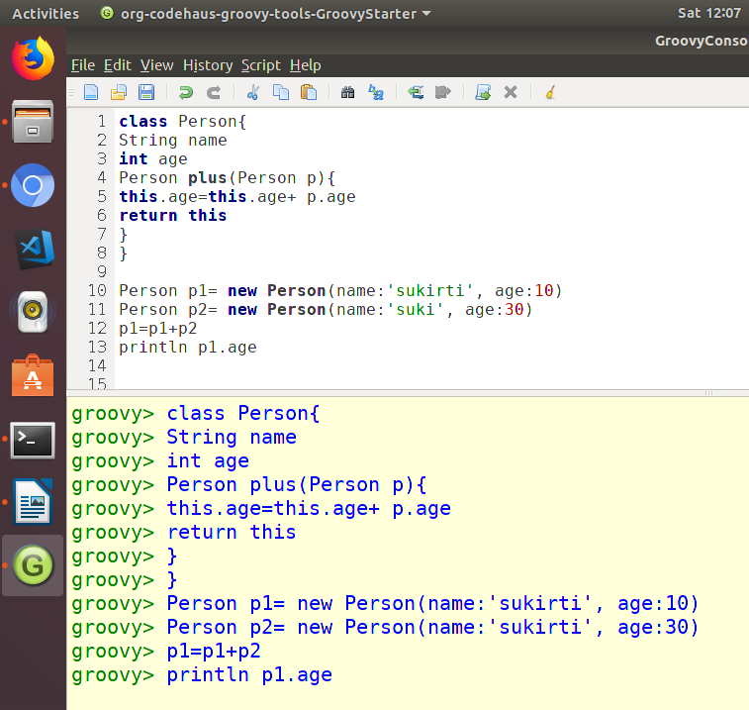

modification in Groovy, you can add a pair of do-nothing getters and setters.

void getName() {}
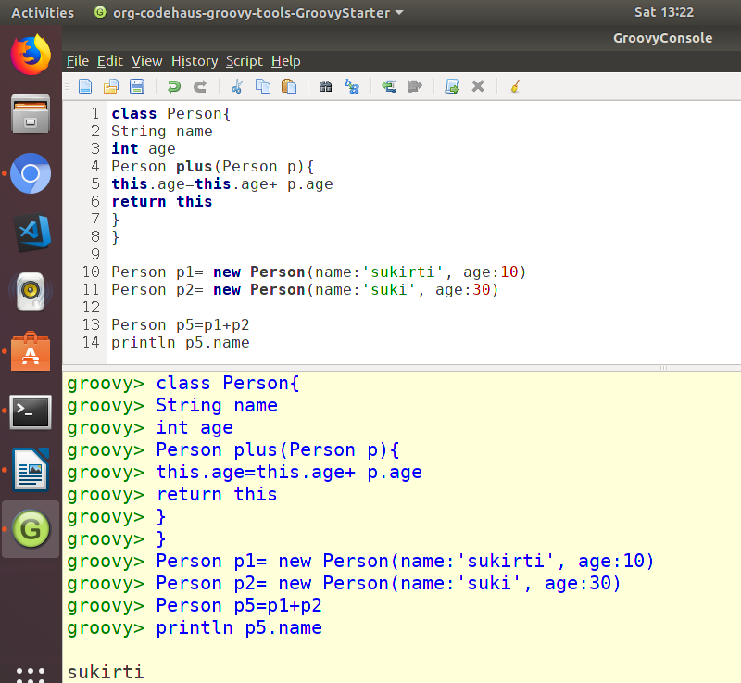
void setName(String name) {}

append,eachline, returns null so n further chaining
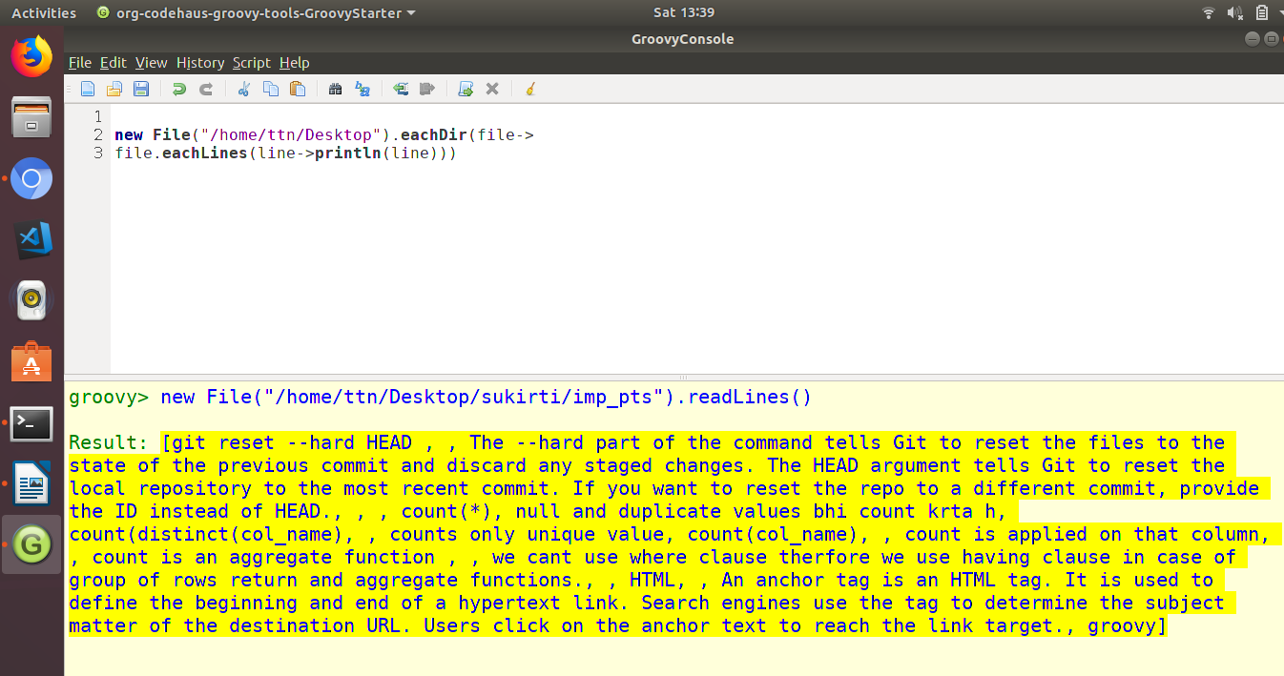
@operatoris used to avoid getters and setters.
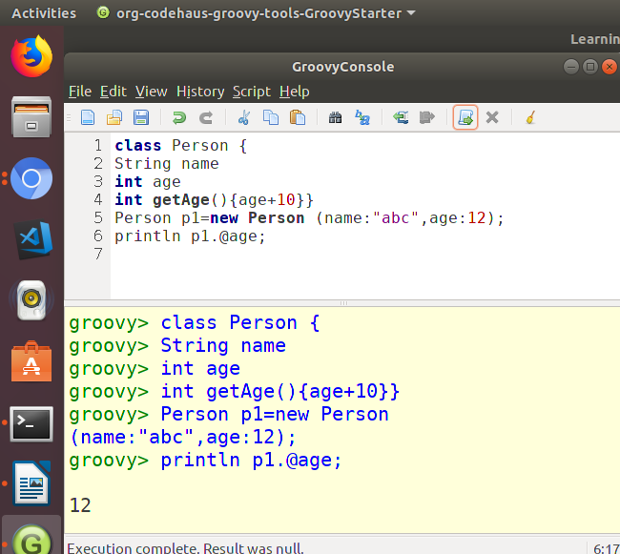

List.getAt(2..5) it includes both indexes plus in between
list.unique()// it alter the original list
while list as set it stores the list somewhere else it doesnot alters the original list
find returns object
findAll returns list
collate means sublisting

