The Open Source Audit — LibreOffice
Course: Open Source Software | Unit Coverage: 1–5
Student Name: Shivangi Panigrahy
Registration Number: 24BEC10032
Date of Submission: 31 March 2026

Table of Contents

1. Introduction
2. Part A — Origin and Philosophy
- A1. The Problem LibreOffice Was Created to Solve
- A2. The License — What It Actually Says
- A3. The Ethics of Open Source
3. Part B — Linux Footprint
4. Part C — The FOSS Ecosystem
5. Part D — Open Source vs Proprietary (Critical Analysis)
6. Shell Script Documentation
7. Conclusion
8. References

1. Introduction

LibreOffice is one of the most remarkable stories in the history of open source software. It is not just a free office suite — it is proof that communities of developers can take back control from corporations, fork a project, and build something that serves millions of people across the world without being owned by any single entity.

This audit examines LibreOffice across five dimensions: its origin and the problem it was created to solve, the specific freedoms its license grants and denies, the ethical questions its existence raises, how it lives on a Linux system, and how it compares to its most powerful proprietary rival, Microsoft Office.

Alongside this report, five shell scripts demonstrate practical Linux and shell scripting skills, each connected to the themes of open source, transparency, and automation.

Part A — Origin and Philosophy

A1. The Problem LibreOffice Was Created to Solve

To understand LibreOffice, you have to go back to 1999 — and to a company called Sun Microsystems.

In 1999, Sun Microsystems purchased StarDivision, a German software company that had been developing StarOffice, a proprietary office suite, since the 1980s. StarOffice was notable because it ran on multiple platforms and was ambitious in scope. Sun saw an opportunity: instead of keeping it fully proprietary, they released the source code as an open source project called OpenOffice.org in October 2000. The idea was to challenge Microsoft Office's monopoly and give the world a free, open alternative for word processing, spreadsheets, presentations, and databases.

For a decade, OpenOffice.org grew into a legitimate alternative. Governments in Germany, France, and Brazil adopted it. Schools and universities used it. Developers contributed code from around the world. It was far from perfect, but it was a functioning, free office suite that tens of millions of people relied on.

Then, in 2010, everything changed.

Oracle Corporation acquired Sun Microsystems in January 2010 in a deal worth approximately $7.4 billion. Along with Sun's other assets — including Java and the Solaris operating system — Oracle inherited OpenOffice.org. The open source community immediately became anxious. Oracle had a reputation for aggressive legal action around intellectual property, and developers who had spent years contributing to OpenOffice.org began to worry about what Oracle's ownership would mean for the project's future.

Their worries proved well-founded. Oracle showed little interest in investing in OpenOffice.org or in working collaboratively with its community. The company laid off many of the engineers who had been working on the project full-time. Communication between Oracle and the developer community broke down. Oracle's licensing decisions and general attitude made many contributors feel that the project they had built was no longer theirs.

A group of leading OpenOffice.org contributors — including developers from companies like Novell, Red Hat, Google, Canonical, and Mandriva — decided they had seen enough. In September 2010, they announced the creation of The Document Foundation and the fork of OpenOffice.org into a new project: LibreOffice. The name combined the French and Spanish word for freedom (*libre*) with *office*, making the political statement explicit from the very first keystroke.

The Document Foundation invited Oracle to join as an equal partner and transfer the OpenOffice.org brand to the new foundation. Oracle refused. Instead, Oracle eventually donated OpenOffice.org to the Apache Software Foundation in 2011, where it continues to exist as Apache OpenOffice — though with far fewer active contributors and a much slower development pace than LibreOffice.

The problem LibreOffice solved was not merely technical. It solved a governance problem: what happens to an open source project when a corporation that does not care about the community takes control of it? The answer, it turned out, was to use the rights that open source licensing provides — the right to fork — and build something better, together, under a foundation that could never be sold to a corporation.

Today, LibreOffice is maintained by The Document Foundation, a not-for-profit charitable organisation registered in Germany. It has millions of users worldwide, is the default office suite in most major Linux distributions, and is actively developed by both volunteers and paid contributors from companies across the industry. The fork succeeded completely, and it succeeded because of the freedoms that open source licensing guaranteed.

A2. The License — What It Actually Says

LibreOffice is released under the **Mozilla Public License 2.0 (MPL 2.0)**. Some parts of the codebase also retain older LGPL (GNU Lesser General Public License) licensing from the OpenOffice.org era, making it a dual-licensed project in practice. However, MPL 2.0 is the primary license governing new contributions.

#### The Four Freedoms of Free Software

Richard Stallman of the GNU Project defined four essential freedoms that free software must grant:

- **Freedom 0:** The freedom to run the program for any purpose
- **Freedom 1:** The freedom to study how the program works and change it
- **Freedom 2:** The freedom to redistribute copies
- **Freedom 3:** The freedom to distribute modified versions to others

LibreOffice's MPL 2.0 license grants **all four** of these freedoms. Anyone can download LibreOffice, run it without restriction, study its source code (which is available on GitHub), modify it for their needs, and distribute their modified version to others.

Can a Company Take LibreOffice, Modify It, and Sell It?

This is where MPL 2.0 becomes interesting. Unlike the GPL, which requires that the *entire* program remain open source if any GPL code is used, MPL 2.0 uses a **file-level copyleft** model. This means:

- If a company modifies an existing LibreOffice source file, they must release those modifications to that specific file under MPL 2.0.
- However, they can combine LibreOffice code with their own proprietary code files without being required to open-source their proprietary additions.

So in practice: a company can take LibreOffice, modify it, and sell it — but they must share back the changes they make to the LibreOffice source files themselves. They can build proprietary plugins or wrappers around it without releasing those. This is a deliberate design choice that makes MPL 2.0 more business-friendly than the GPL while still protecting the core project.

GPL vs MIT: The Key Difference

The GPL (GNU General Public License) and MIT License represent opposite ends of the open source licensing spectrum:

The GPL is a **copyleft** license. It requires that anyone who distributes a GPL-licensed program — or any program that incorporates GPL code — must make their full source code available under the GPL. This is sometimes called "viral" licensing, because the GPL requirement propagates to any software that touches it. The GPL is designed to protect the community: it ensures that improvements made to the software cannot be locked away.

The MIT License is a **permissive** license. It allows anyone to do almost anything with the software — including incorporating it into proprietary programs and selling it without ever releasing their source code. The only requirement is that the original copyright notice is preserved.

For a personal project, which would I choose? For something I wanted to keep free and ensure nobody could commercialise without contributing back, I would choose the GPL. For a library or tool I wanted to see adopted as widely as possible — even by companies building proprietary products — I would choose MIT. The right choice depends on what outcome you are trying to produce, not which license is more "open."

Free as in Free Beer vs Free as in Freedom

This distinction, popularised by the free software movement, is fundamental:

- **Free as in free beer** means no cost. You pay nothing for the software.
- **Free as in freedom** means you have the right to do what you want with it: study it, change it, and share it.

These two concepts often travel together but are not the same. A company could give away software for free (free beer) while keeping the source code entirely secret, which means you have no freedom to understand or modify it. Conversely, free software (freedom) might sometimes cost money — you can sell free software.

LibreOffice is both. It costs nothing to download, and you have full freedom to study and modify its source code. Microsoft Office, by contrast, is neither: it costs money, and its source code is entirely secret. Adobe Reader is free beer but not free as in freedom — you can download it at no cost but cannot study or modify how it works.

A3. The Ethics of Open Source

Should All Software Be Open Source?

**The argument for:** Software has become infrastructure. The operating systems running hospitals, the tools controlling power grids, the platforms managing financial transactions — these are no longer the private concern of the companies that build them. When critical software is proprietary, society is dependent on companies whose interests may not align with public good. Open sourcing this infrastructure would allow security researchers to find vulnerabilities before attackers do, allow governments to audit the systems they depend on, and allow communities to maintain software long after the original developer loses interest. There is a strong democratic argument that tools built for the public benefit should be inspectable by the public.

**The argument against:** Software development requires enormous investment. Skilled engineers need to earn salaries, companies need to fund research, and someone has to pay for the servers and testing infrastructure that make good software possible. If all software were required to be open source, the commercial incentive to invest in building it would collapse. Some software — particularly security-critical code — may also be better protected from attack if its implementation details are not public. Not every organisation has the capacity to audit source code even if it is available, meaning the theoretical benefits of openness do not always materialise in practice.

The honest answer is that neither position is absolute. The most successful model appears to be a mixed ecosystem: open source for infrastructure, platforms, and tools that benefit from community contribution; proprietary licensing for specialised software where the commercial model funds ongoing development that would not otherwise occur.

Is It Ethical to Build Profitable Products on Free Community Labour?

Companies like Red Hat, Google, and Meta have built enormously profitable businesses partly on top of Linux, which was built by unpaid contributors. Is this ethical?

The case that it is ethical rests on the fact that open source contributors chose their license knowing what it permitted. If a developer releases code under the MIT License or GPL, they are explicitly consenting to others using it — including commercially. The license is the consent. Red Hat, furthermore, contributes enormous resources back to the Linux kernel and to other open source projects, making this a genuine exchange rather than pure extraction.

The case that it is not ethical is more uncomfortable. Many open source contributors are individuals who contributed code in good faith to a community project, without anticipating that their unpaid work would directly enable billion-dollar corporations. There is something uncomfortable about a company generating vast profits from a workforce that is never compensated. The open source community has increasingly grappled with this through models like Open Collective, GitHub Sponsors, and the introduction of licenses like the Business Source License (BSL) that restrict commercial use.

The LibreOffice situation is instructive here: Oracle's acquisition of OpenOffice.org and its subsequent neglect of the community was widely seen as a betrayal — not of any legal contract, but of the implicit social contract of open source. The community's response — forking to create LibreOffice under a foundation that cannot be acquired — was a structural solution to an ethical problem.

Standing on the Shoulders of Giants

Isaac Newton's phrase "standing on the shoulders of giants" describes how knowledge accumulates: each generation builds on what came before. In software, this is literally true. Every web browser uses OpenSSL for encryption. Every Linux system uses the GNU toolchain. Python's scientific libraries are built on C code written decades ago. LibreOffice itself is built on top of hundreds of open source libraries.

Open source enables this accumulation of knowledge in a way that proprietary software cannot. When code is open, it can be studied, improved, and built upon indefinitely. When it is locked, knowledge dies with the company that holds it. The history of software is full of proprietary systems that became unusable when their vendors went out of business — taking irreplaceable functionality with them. Open source projects like TeX, which has been in continuous use since 1978, demonstrate that software maintained by communities outlasts software maintained by corporations.

Does open source enable or undermine original innovation? I would argue it primarily enables it. LibreOffice's existence is only possible because its predecessors' code was open. Python's ecosystem is only possible because the language itself is open. The original innovation that matters in software is rarely the code itself — it is the idea, the architecture, the community. Code is the implementation. Open source lets implementations persist and evolve so that the ideas they contain are never lost.

Part B — Linux Footprint

LibreOffice is deeply integrated into the Linux ecosystem and is available on virtually every major Linux distribution through the standard package manager.

Installation Method

On **Debian/Ubuntu-based** systems (which includes most consumer Linux distributions), LibreOffice is installed via `apt`:

```bash
sudo apt update
sudo apt install libreoffice
```

On **Red Hat/Fedora-based** systems, it is installed via `dnf`:

```bash
sudo dnf install libreoffice
```

LibreOffice can also be downloaded as a tarball from the official website (libreoffice.org) and installed manually. This method is useful when the distribution's package manager offers an older version and the user wants the latest stable release. The The Document Foundation also provides Flatpak and Snap packages, which allow installation in a sandboxed container independent of the underlying distribution.

Key Directories

After installation on a Debian/Ubuntu system, LibreOffice files live in several locations:

| Directory | Contents |
|---|---|
| `/usr/lib/libreoffice/` | Core application binaries and libraries |
| `/usr/share/libreoffice/` | Shared data: templates, dictionaries, help files |
| `/usr/bin/libreoffice` | Symlink to the main launcher script |
| `/etc/libreoffice/` | System-wide configuration files |
| `~/.config/libreoffice/` | Per-user configuration, macros, custom settings |
| `/var/log/` | System logs (LibreOffice itself does not maintain its own log in /var/log) |

The separation between system-wide files (`/usr/`) and per-user files (`~/.config/libreoffice/`) reflects a core Unix security principle: system configuration is controlled by the administrator, while user preferences are controlled by the user. This means one user's LibreOffice customisations cannot affect another user's session.

User and Group

LibreOffice runs as the **logged-in user** — it does not use a dedicated service account or escalated privileges. This is appropriate for a desktop application, because it means LibreOffice can only access files and resources that the current user is permitted to access. If a malicious document attempted to exploit a LibreOffice vulnerability to access system files or other users' data, the user-level process privilege would limit the damage.

This contrasts with server software like Apache HTTP Server, which runs as a dedicated `www-data` or `apache` user with strictly limited permissions, specifically to prevent a web-server compromise from affecting the rest of the system.

Service Management

LibreOffice is a desktop application rather than a system service, so it is not managed by `systemctl` in normal use. However, LibreOffice does expose a **headless mode** that can be run as a background service for document conversion:

```bash
# Start LibreOffice in headless server mode (for document conversion tasks)
libreoffice --headless --accept="socket,host=localhost,port=2002;urp;"

# Convert a document to PDF using headless mode
libreoffice --headless --convert-to pdf document.docx

# Check if a LibreOffice process is running
ps aux | grep soffice
```

Organisations that use LibreOffice for automated document conversion can wrap this in a systemd service unit to manage it like any other service.

Update Model

On Debian/Ubuntu, LibreOffice receives updates through the standard `apt` mechanism:

```bash
sudo apt update && sudo apt upgrade
```

Security patches are released by The Document Foundation and packaged by distribution maintainers. When a critical vulnerability is discovered in LibreOffice, the community patches it, releases a new version, and the fix reaches users through their distribution's package update pipeline — often within days. This is the open source security model in practice: many eyes review the code, vulnerabilities are reported publicly, and fixes are distributed to all users simultaneously at no cost.

Part C — The FOSS Ecosystem

Dependencies

LibreOffice does not exist in isolation. It depends on a substantial ecosystem of open source libraries:

- **Cairo:** A 2D graphics rendering library (LGPL/MPL) used for drawing document elements
- **Fontconfig:** Font management on Linux systems
- **Harfbuzz:** An open source text shaping engine for rendering complex scripts
- **libxml2:** XML parsing, used extensively for handling the ODF file format
- **ICU (International Components for Unicode):** For international text handling and locale support
- **Python:** LibreOffice embeds a Python interpreter for macro scripting
- **Java (OpenJDK):** Some LibreOffice features (particularly database connectivity via JDBC) require Java
- **Boost:** A collection of C++ libraries used in LibreOffice's internal code
- **NSS (Network Security Services):** For document signing and encryption features

This dependency graph illustrates a core characteristic of the FOSS ecosystem: projects are not built from scratch; they are assembled from reusable components, each maintained by its own community.

What LibreOffice Has Enabled and Inspired

LibreOffice's existence has had several downstream effects:

- **OnlyOffice** and **Collabora Online** are web-based office suites that build on or compete alongside LibreOffice, serving the cloud collaboration market that Google Workspace and Microsoft 365 dominate
- **Collabora Office** is a commercially supported fork of LibreOffice specifically for enterprise and mobile use, demonstrating the MPL 2.0 dual-licensing model in practice
- The **ODF (Open Document Format)** standard — the native file format of LibreOffice — has been adopted by governments worldwide as the mandatory format for public documents, partly because of LibreOffice's advocacy
- LibreOffice demonstrated that the Document Foundation governance model (a vendor-neutral foundation) was viable for large open source projects, influencing how other projects have structured themselves since

Community and Governance

LibreOffice is governed by **The Document Foundation (TDF)**, a charitable foundation incorporated in Berlin, Germany. The foundation has a Board of Directors elected by its membership, which includes individual contributors and sponsoring organisations.

Community interaction happens through:
- **Mailing lists:** The primary channel for developer discussion (lists.freedesktop.org/mailman/listinfo/)
- **IRC/Matrix:** Real-time chat at `#libreoffice-dev` on Libera.Chat
- **Bugzilla:** The bug tracker at bugs.documentfoundation.org
- **LibreOffice Conference:** An annual conference that brings contributors together
- **The Wiki:** wiki.documentfoundation.org for documentation and developer resources

The governance model explicitly prevents any single company from controlling LibreOffice. This was the direct lesson learned from the OpenOffice.org / Oracle situation — the foundation structure is a constitutional defence against corporate capture.

Part D — Open Source vs Proprietary (Critical Analysis)

The closest proprietary alternative to LibreOffice is **Microsoft Office** (Microsoft 365 subscription or perpetual licence).

| Dimension | LibreOffice | Microsoft Office |
|---|---|---|
| **Cost** | Free to download and use. Enterprise support from Collabora or partner companies is paid, but the software itself costs nothing. | Microsoft 365 subscription: approx. ₹4,900–₹12,600/year per user. One-time perpetual licence also available at higher upfront cost. |
| **Security (code audit)** | Source code is fully public. Security researchers worldwide can audit and report vulnerabilities. Patches are community-reviewed. | Source code is proprietary. Security relies on Microsoft's internal teams and external auditors under NDA. Users cannot verify what the software is doing. |
| **Support and reliability** | Community support via forums, mailing lists, and documentation. Paid support available through TDF partners. May lag behind Microsoft in compatibility with complex .docx files. | Commercial SLA-backed support. Tight integration with other Microsoft products (Teams, SharePoint, OneDrive). .docx is Microsoft's native format — perfect compatibility guaranteed. |
| **Freedom to modify** | Full freedom. Source code is available; you can compile and customise your own build. Organisations can patch LibreOffice themselves without waiting for TDF. | No freedom to modify. Users are entirely dependent on Microsoft's development roadmap. |
| **Community vs corporate control** | Controlled by a vendor-neutral charitable foundation. No single corporation can dictate direction or discontinue the product. | Controlled entirely by Microsoft. The product exists as long as Microsoft chooses to support it; features appear and disappear at Microsoft's discretion. |

Overall Verdict:

For most individual users and small organisations, LibreOffice is an entirely capable Microsoft Office replacement. It handles standard word processing, spreadsheets, and presentations competently, and its ODF format is an international standard. The zero cost is a significant advantage, particularly for schools, NGOs, and government organisations operating under budget constraints.

However, for organisations deeply integrated into the Microsoft ecosystem — those using SharePoint, Teams, and Azure Active Directory together — LibreOffice's imperfect .docx compatibility and lack of native cloud collaboration tools represent real friction costs. In these environments, the true cost of LibreOffice may be higher than its licence price suggests when staff productivity and compatibility issues are factored in.

For a new deployment that is not already locked into Microsoft's ecosystem, I would recommend LibreOffice without hesitation. For an organisation trying to migrate away from Microsoft, a phased transition is realistic and worthwhile, but it requires investment in training and workflow adjustment.

Would I contribute to LibreOffice? Yes. The Document Foundation has a well-maintained contributor onboarding guide, there are "easy hacks" tagged in Bugzilla for new contributors, and the project genuinely matters to the people who use it every day. Contributing to LibreOffice is contributing to the independence of millions of users from a single corporation's licensing decisions.

Shell Script Documentation

Script 1 — System Identity Report

**File:** `script1_system_identity.sh`

**Purpose:** This script functions as a welcome screen that introduces both the student and the Linux system. It was designed to demonstrate the foundational shell scripting skill of gathering live system information and presenting it in a formatted way.

**Shell concepts used:**
- **Variables:** Student name, registration number, and software choice are stored in named variables (`STUDENT_NAME`, `REG_NUMBER`, `SOFTWARE_CHOICE`) and referenced throughout the output with `$`
- **Command substitution (`$()`):** The `$(uname -r)` syntax executes a command and captures its output as a string that can be stored in a variable. This is used for kernel version, distro name, username, uptime, and date/time
- **Piping and text processing:** The distro name is extracted by piping `cat /etc/os-release` through `grep` to find the relevant line, then through `cut` to extract the value, then through `tr` to remove surrounding quotes
- **`echo` and output formatting:** All output uses `echo` with careful spacing to create a visually structured display

The script demonstrates that even simple output formatting requires understanding how Linux stores information about itself — in files like `/etc/os-release` and through commands like `uname`, `whoami`, and `uptime`.

**To run:** `bash script1_system_identity.sh`

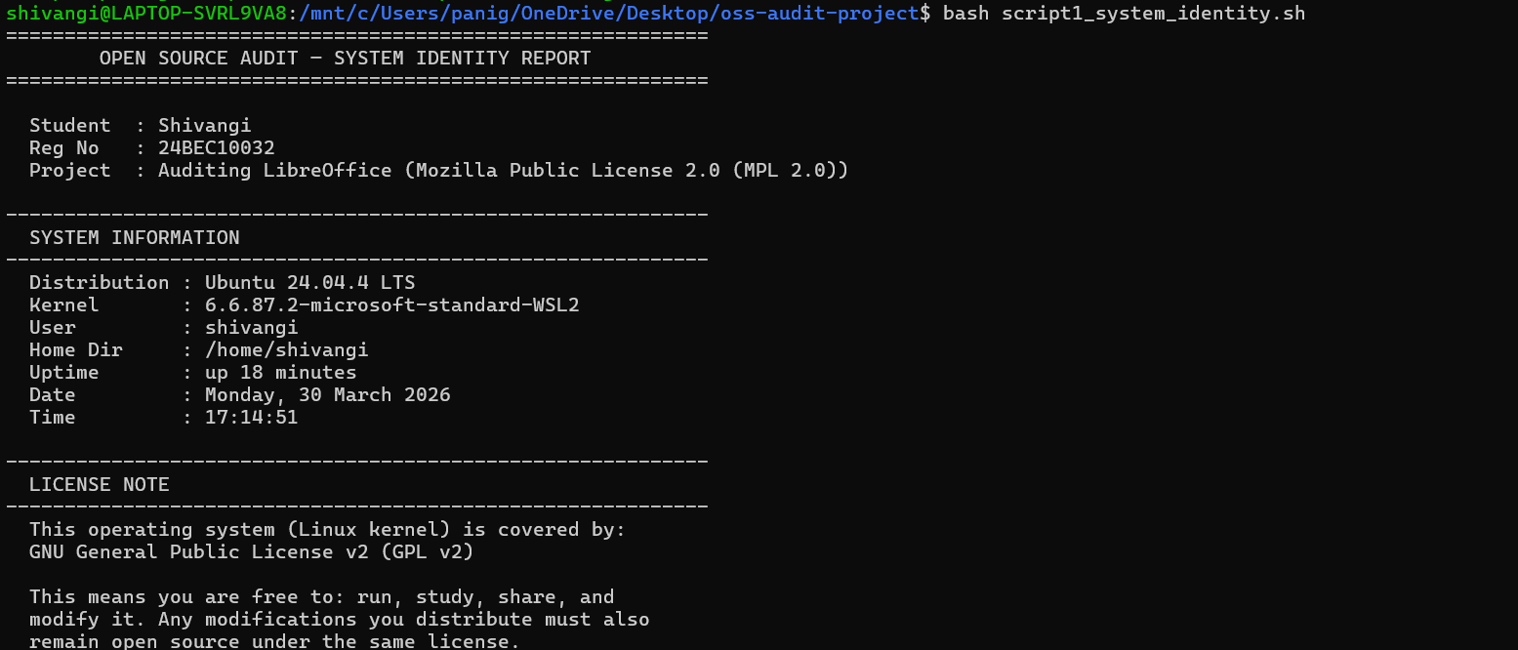

Script 2 — FOSS Package Inspector

**File:** `script2_package_inspector.sh`

**Purpose:** This script checks whether LibreOffice (or any specified package) is installed on the system, retrieves its version and license information, and uses a case statement to print a contextual philosophy note.

**Shell concepts used:**
- **`if-then-else`:** The script first detects whether the system uses `rpm` or `dpkg`, then uses `if` to check whether the package is installed, branching to different output depending on the result
- **`case` statement:** A `case` block matches the package name against known software values and prints a tailored philosophy note for each. The `*` wildcard case handles any unrecognised package
- **Pipes with `grep`:** `rpm -qi` or `dpkg -s` output is piped through `grep -E` to filter only the Version, License, and Summary fields
- **`command -v`:** Used to detect which package manager is available, making the script portable across RPM-based and Debian-based distributions

**To run:** `bash script2_package_inspector.sh`

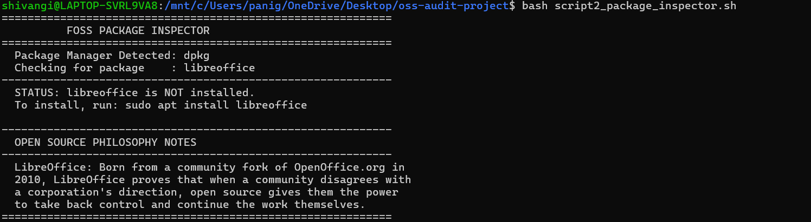

Script 3 — Disk and Permission Auditor

**File:** `script3_disk_auditor.sh`

**Purpose:** This script iterates through a list of important Linux system directories and reports the permissions, owner, group, and disk usage of each. It then performs an additional audit specifically on LibreOffice's installation and configuration directories.

**Shell concepts used:**
- **`for` loop with array:** The `DIRS` array is defined with a list of directories, and the `for DIR in "${DIRS[@]}"` loop iterates over each element
- **`if [ -d "$DIR" ]`:** The directory existence check prevents errors when a directory does not exist on a particular system
- **`ls -ld` with `awk`:** `ls -ld` produces a long listing of the directory itself (not its contents), and `awk` extracts specific fields by position
- **`du -sh`:** Reports disk usage in human-readable format (`-h`) for the single directory (`-s`)
- **String expansion:** `${SIZE:-N/A}` uses parameter expansion to substitute `N/A` if the `SIZE` variable is empty

The LibreOffice-specific section demonstrates how to use shell variables (`$HOME`) to construct paths that adapt to the current user's environment.

**To run:** `bash script3_disk_auditor.sh`

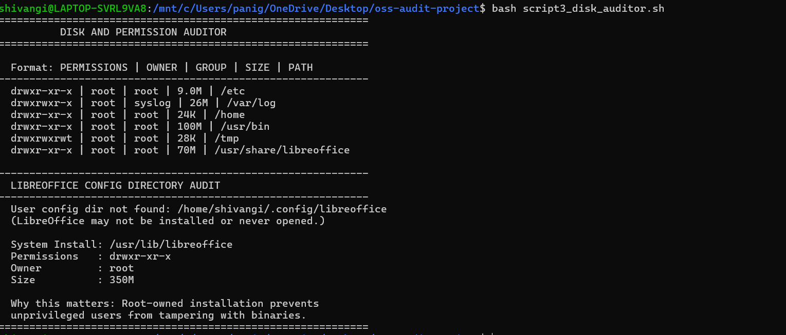

Script 4 — Log File Analyzer

**File:** `script4_log_analyzer.sh`

**Purpose:** This script accepts a log file path and a keyword as command-line arguments, counts how many lines in the file contain the keyword, and prints the last five matching lines.

**Shell concepts used:**
- **Command-line arguments (`$1`, `$2`):** The log file path and keyword are passed when the script is called, making it reusable for any log file
- **`${2:-"error"}`:** Default value syntax — if no keyword is provided, the script defaults to `"error"`
- **Do-while style loop:** Bash lacks a native `do-while` construct, so this is simulated with `while true; do ... break; done`. The loop retries up to `MAX_RETRIES` times if the log file is empty
- **`while IFS= read -r LINE`:** The standard pattern for reading a file line by line without modifying whitespace or interpreting escape sequences
- **`if echo "$LINE" | grep -iq "$KEYWORD"`:** A case-insensitive keyword search on each line, using `grep -i` for case-insensitivity and `-q` for quiet mode (no output, just an exit code)
- **Counter variable:** `COUNT=$((COUNT + 1))` uses arithmetic expansion to increment the counter
- **`grep | tail -5`:** A pipeline to find all matching lines and return only the last five

**To run:** `bash script4_log_analyzer.sh /var/log/syslog error`

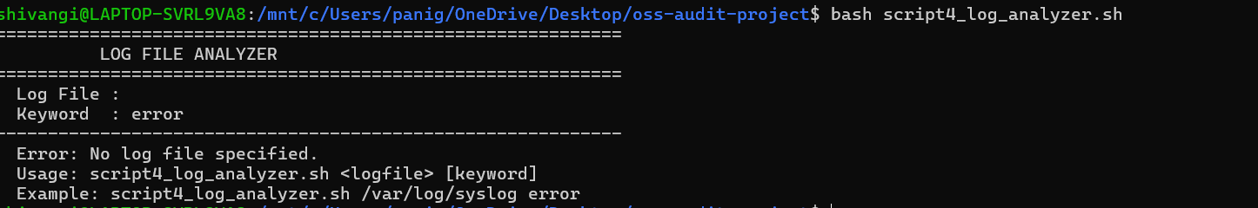

Script 5 — The Open Source Manifesto Generator

**File:** `script5_manifesto_generator.sh`

**Purpose:** This creative script takes three user inputs interactively, composes a personalised open source philosophy statement from them, saves it to a file named after the current user, and displays the result.

**Shell concepts used:**
- **`read -p`:** Interactive user input with an inline prompt, used three times to collect the tool name, the user's definition of freedom, and their intended open source contribution
- **String concatenation:** Variables from user input (`$TOOL`, `$FREEDOM`, `$BUILD`) are embedded directly into paragraph strings using double-quoted strings, where variable expansion happens automatically
- **Writing to a file with `>` and `>>`:** The first write uses `>` to create/overwrite the file; subsequent writes use `>>` to append additional content
- **`cat`:** Used at the end to read and display the saved manifesto file
- **`$(whoami)`:** Used to personalise the output filename with the current username
- **Function as alias concept:** A `get_today()` function is defined to demonstrate the alias concept — just as shell aliases provide shorthand commands, functions encapsulate reusable logic. The function is called with `$(get_today)` to capture its output

**To run:** `bash script5_manifesto_generator.sh`

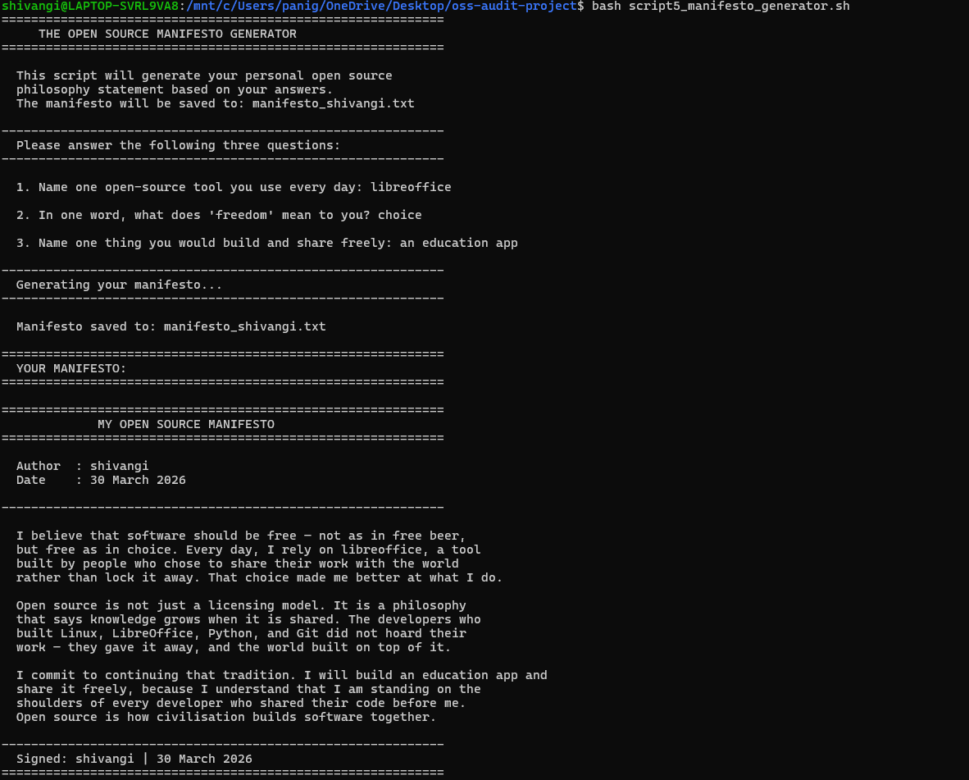

Conclusion

The LibreOffice audit reveals a project that is significant not just as software but as a political act. It exists because of the freedoms that open source licensing provides — specifically the freedom to fork — and it has used those freedoms to build a genuinely useful tool that is answerable to its community rather than to any corporation.

The MPL 2.0 license strikes a balance between protecting the community's contributions and allowing commercial adoption, making it more business-friendly than the GPL while still ensuring that improvements to the core codebase remain open. LibreOffice demonstrates that the GPL is not the only way to keep software free.

The ethical questions this project raises — about who should control the tools that societies depend on, about the relationship between community labour and corporate profit, about the sustainability of open source development — do not have easy answers. But they are questions that every software professional should be willing to ask and think about seriously.

The five shell scripts in this submission demonstrate that understanding open source is not purely philosophical. It is practical: open source tools like `bash`, `grep`, `awk`, and `du` — themselves covered by open source licenses — are the instruments through which Linux systems are managed, audited, and understood every day.

References

- The Document Foundation. *LibreOffice Release Notes and Documentation*. libreoffice.org
- Mozilla Foundation. *Mozilla Public License 2.0*. mozilla.org/en-US/MPL/2.0/
- GNU Project. *The Free Software Definition*. gnu.org/philosophy/free-sw.html
- Open Source Initiative. *The Open Source Definition*. opensource.org/osd
- Raymond, Eric S. *The Cathedral and the Bazaar*. catb.org/~esr/writings/cathedral-bazaar/
- Shotts, William. *The Linux Command Line*. linuxcommand.org
- SPDX License List. spdx.org/licenses
- Wikipedia. *History of LibreOffice*. en.wikipedia.org/wiki/LibreOffice
- The Document Foundation. *Governance and Statutes*. documentfoundation.org/governance/
- Fogel, Karl. *Producing Open Source Software*. producingoss.com

