Process Design Document (PDD)

Client: Amadeus  
Prepared By: [Shivangi Pal]  
Date: [08/08/25]

# 1. Process Overview

Amadeus, one of GRN Connect’s key B2B clients, was facing issues in validating API responses for hotel availability and pricing. The manual process involved QA and business teams using Postman/Swagger to trigger APIs, reviewing JSON/XML responses, and recording results in Excel. This was time-consuming, error-prone, and delayed onboarding for new clients. The objective is to automate API response validation to improve accuracy, reduce manual effort, and accelerate testing cycles.

# 2. Stakeholders

• Client: Amadeus   
• Process Owner: QA Lead – Amadeus Account  
• Business Analyst: Shivangi Pal  
• SMEs: QA/Testing Team  
• RPA Developer: UiPath Developer  
• IT Support: API/Backend Team

# 3. As-Is Process Description

1. QA team triggers API calls using Postman.  
2. Review API response for status code, mandatory fields, and business rules.  
3. Record results in Excel from Kibana.  
4. Escalate failures to developers.  
  
Pain Points: Each validation takes ~5–10 mins, with ~500 API calls daily (~40 hours weekly). Manual effort leads to fatigue, inconsistent validations, and missed errors.

# 4. Process Map

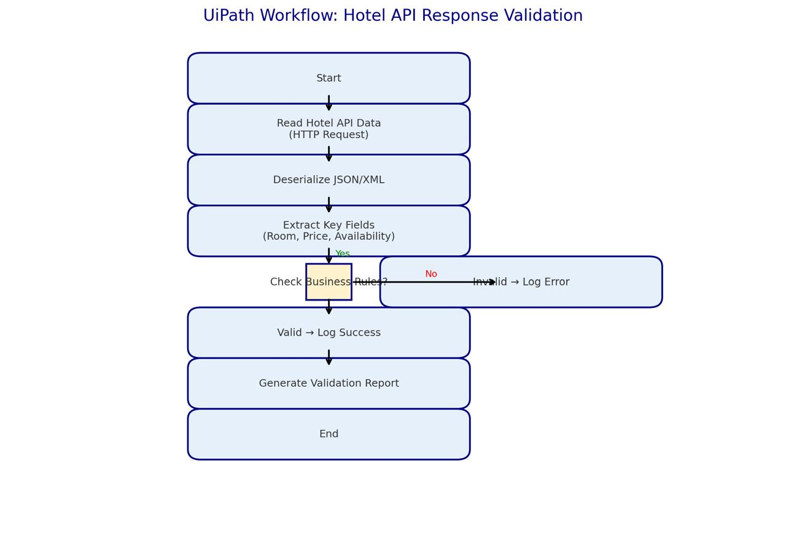

# 5. Business Rules

• Response status code must be 200.  
• Cut-off time should be 10 seconds  
• Hotel Name, Price, and Currency fields must not be null.  
• Currency must follow (USD).  
• Price must be greater than 0.  
• Availability flag must be Boolean (true/false).  
• If any validation fails, mark as exception.

# 6. Exception Scenarios

• API timeout or no response.  
• Response contains unexpected format.  
• Missing mandatory fields (Hotel Name, Price, Currency).  
• Mismatch between request parameters and response data.

# 7. Volumes & Frequencies

• Average: 500 API responses per day.  
• Frequency: Continuous testing during sprints; bulk validation during release cycles.  
• Peak: ~1,000 responses during pre-release regression testing.

# 8. Pain Points / Current Challenges

• Mismatch in the cut-off setting of agent on API (24.7 seconds) and on Travelgate (10 seconds)  
• Inconsistent validation between QA members.  
•Records logs from TRAVELGATEX.  
•.Hotel ID requests are more than 40  
•.Serach Response time is high

# 9. Automation Feasibility

• Rule-based validations: Yes.  
• Input format: Structured JSON/XML.  
• Process stability: High (standardized API schema).  
• Exception handling: Defined.  
Feasibility: HIGH.

# . SLA Feasibility

• Search/ Availability errors – 15%.  
• Quote Level :- 5%

• Booking Level : 3%

**Analysis Result AMADEUS FEEDBACK:-**

* Dubai search (Check-in: 29th Aug, 1 night, Nationality: UAE) – 62 hotels loaded in 16 seconds
* Same search with South Africa nationality – 29 hotels loaded in 12 seconds
* Same search with India nationality – 9 hotels loaded in 10 seconds

**GRN FEEDBACK:-**

* As per the system configuration, the cut-off time is set to 10 seconds and 24.7 seconds.  
  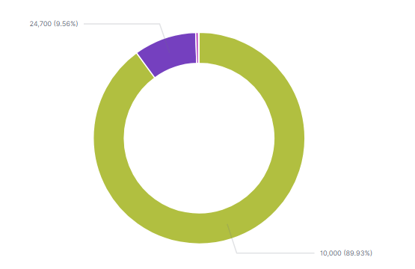
* However, during testing, we observed that only the search responses received within 8 seconds are being displayed on client UI.
* This indicates that any search response exceeding 8 seconds is being discarded, despite the defined threshold being 10 seconds.
* Please refer to the table below where you can see a total of 47 Hotel IDs (HIDs) were responded to within 8 seconds, and the exact results are visible on your UI (screenshot attached for your reference).  
    
  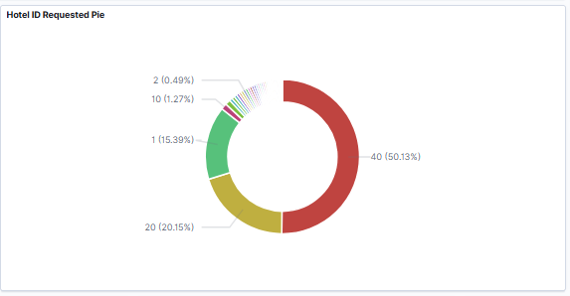

We request Amadeus development team to kindly investigate why the system is treating the 8-second mark as the effective cut-off, instead of the configured 10 seconds, and discarding responses received after that.

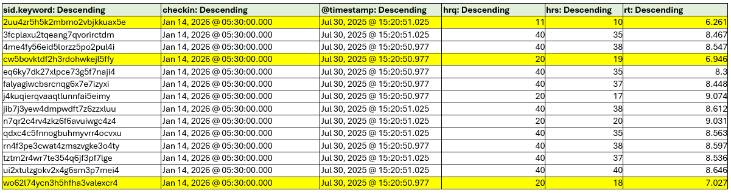

UIPATH API TIMEOUT WORKFLOW :-

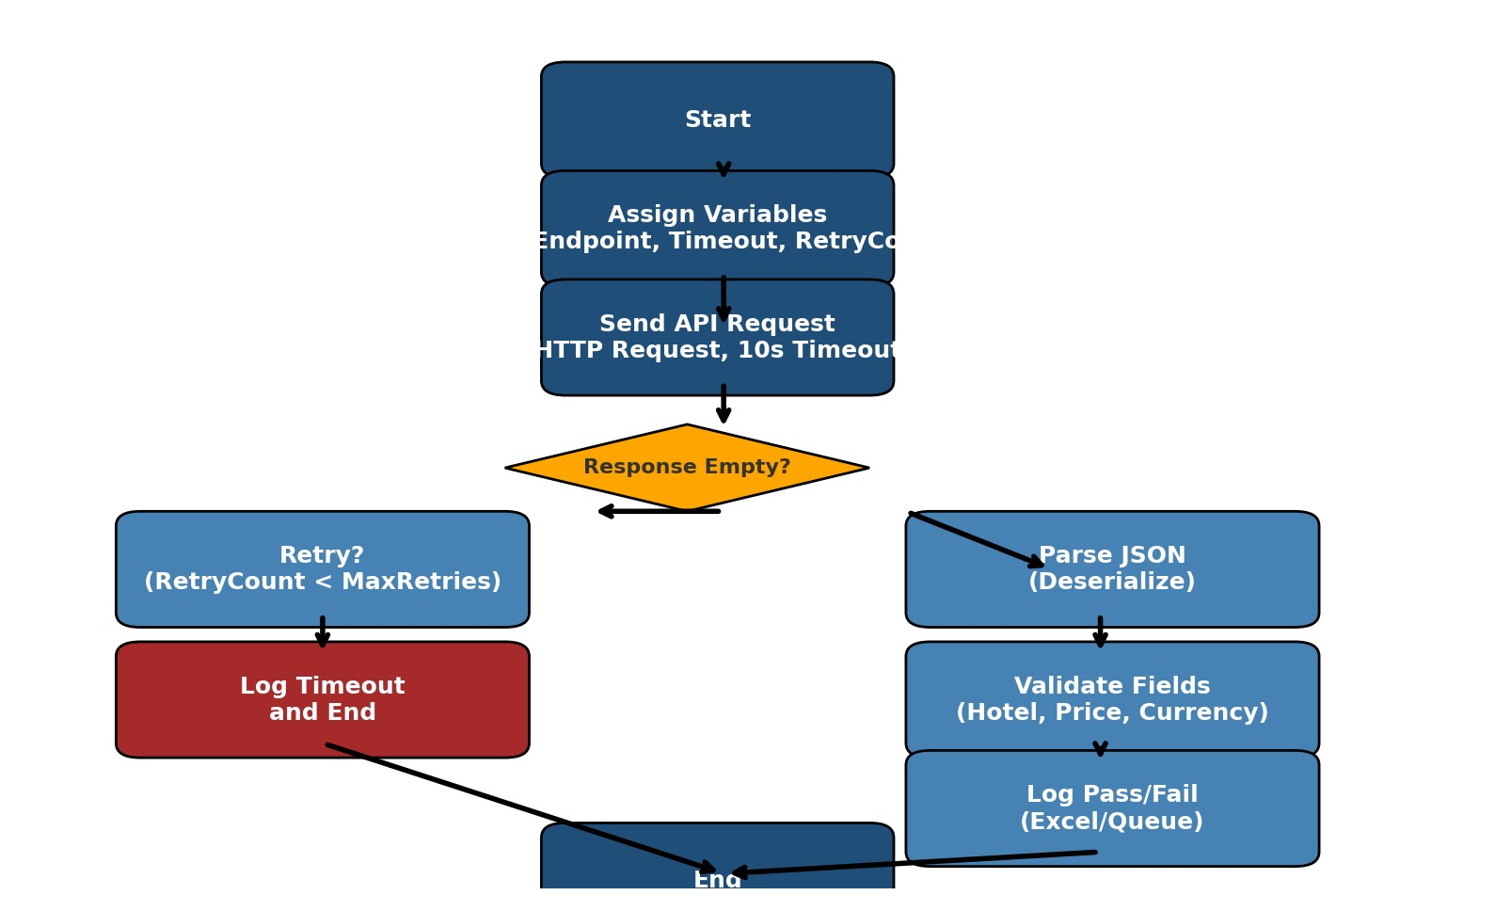

Current Status :- Ticket is opened with AMADEUS to reduce the HID request and fix it to 20 only , waiting for the feedback