Municipal Waste Prediction and Recycling Performance Classification
Using MongoDB, PyMongo, Machine Learning and a Streamlit Dashboard
Submitted by: Shivangi Singh
Roll No: 16
Registration No: 12316998
Submitted to: Dr. Ashu
29th October 2026

Contents
Abstract
1. Introduction
2. Problem Statement
3. Project Objective
4. Scope and Limitations
5. Dataset Description
6. Tools and Technologies
7. System Design and Workflow
8. MongoDB / PyMongo Implementation
9. Data Preprocessing and Exploratory Analysis
10. Model Implementation
11. Evaluation Results
12. Streamlit Dashboard
13. Testing and Validation
14. Practical Significance
15. Limitations and Future Work
16. Conclusion
References
Appendix A: Run Instructions
Appendix B: Descriptive Statistics
Appendix C: Glossary

Abstract
Municipal solid waste management needs reliable information about how much waste each community produces and how well it separates waste for recycling. This project builds a complete data workflow on a public dataset of 4,341 Italian municipalities. The data are stored and queried in MongoDB with PyMongo, cleaned with scikit-learn pipelines, and used for two machine learning tasks: a regression that predicts waste per inhabitant, and a classification that assigns each municipality a Low, Medium or High recycling-performance class. A Random Forest Regressor reached R² = 0.473 and MAE = 76.9 kg per person per year; a Decision Tree classifier reached 69.6% accuracy (macro F1 = 0.693), and a Random Forest Classifier reached 77.0%. Predictions and metrics are stored back in MongoDB and shown in a Streamlit dashboard. The project is a municipality-level analytics prototype and does not claim to monitor individual bins in real time.
Keywords: municipal solid waste, recycling, MongoDB, PyMongo, Random Forest, Decision Tree, regression, classification, Streamlit.

1. Introduction
Municipal solid waste (MSW) management is one of the main services provided by local governments. The amount of waste produced by each inhabitant, and the share of waste that is collected separately for recycling, differ widely between municipalities. These differences depend on demographics, geography, economic conditions and the way the waste fee is charged to households.
This project builds a data-driven system around a public dataset of Italian municipalities. The data are stored and queried in MongoDB through the PyMongo driver, and machine learning models built with scikit-learn are used to (a) predict how much waste a municipality produces per inhabitant, and (b) classify the recycling performance of a municipality as Low, Medium or High. The predictions and the evaluation metrics are written back to MongoDB so that the whole workflow, from raw data to results, lives in the database.

2. Problem Statement
Municipal waste datasets contain many fields describing population, geography, waste composition, collection rates, costs and infrastructure. Reviewing them manually does not easily reveal patterns or give repeatable predictions. The problem addressed here is to build a reproducible workflow that stores the records in a database, cleans them, explores the key relationships, predicts waste per person, and groups municipalities by recycling performance, while reporting model quality honestly and avoiding data leakage.

3. Project Objective
The aim of the project is to implement a complete MongoDB + PyMongo + Machine Learning workflow and to evaluate it with the metrics required by the course: Accuracy, R² score, MAE, Precision, Recall and F1-score. The specific objectives are:
- Load the waste dataset into MongoDB and perform CRUD, filtering, aggregation and indexing operations with PyMongo.
- Clean and prepare the data: handle missing values, outliers, skewed variables and categorical features.
- Regression task: predict the waste produced per inhabitant (kg/person/year) with Linear Regression and a Random Forest Regressor; evaluate with R², MAE and RMSE.
- Classification task: predict the recycling performance class (Low / Medium / High) with a Decision Tree, Logistic Regression and a Random Forest Classifier; evaluate with Accuracy, Precision, Recall, F1-score and the confusion matrix.
- Store the predictions and the model metrics in MongoDB and present them in a Streamlit dashboard.

4. Scope and Limitations
Included in scope | Not claimed by this project
Municipality-level waste analytics | Individual-bin or household-level predictions
Waste per person regression | Real-time bin overflow detection
Relative recycling-class classification | Official regulatory classification or compliance rating
MongoDB storage with PyMongo (local or Atlas) | A production service with live municipal data feeds
Charts and a Streamlit prototype dashboard | Forecasting of future dates or collection routes
Table 1: Scope of the project
The dataset is cross-sectional (one record per municipality) and not a time-stamped stream of sensor readings. Predicting overflow of individual bins or planning daily collection routes would need bin-level, time-series or route data, which this dataset does not contain.

5. Dataset Description
The dataset (waste_fee.csv) is public data on municipal waste and waste fees in Italy (Kaggle: "Municipal Waste Management Cost Prediction"). It contains 4,341 rows (one per municipality) and 39 columns. The column groups are summarised in Table 2.
Group | Columns | Description
Identifiers | region, province, name, istat, sample | Location names and the official municipality code (istat). 20 regions and 102 provinces.
Geography and size | area, pop, alt, isle, sea, pden, wden, urb, geo | Area, population, altitude, island/coastal flags, population density, urbanisation level.
Fee system | fee, d_fee | Fee type: PAYT (pay-as-you-throw) or STANDARD; d_fee is the 0/1 version.
Waste composition (%) | organic, paper, glass, wood, metal, plastic, raee, texile, other | Percentage share of each waste fraction (raee = electronic waste).
Waste totals | msw, msw_so, msw_un, sor | Total municipal waste (kg), sorted and unsorted waste (kg), and the sorted-collection percentage sor = msw_so / msw x 100.
Costs | tc, cres, csor | Waste management cost variables (total, residual-waste and sorted-waste cost).
Economy and infrastructure | gdp, wage, finance, roads, proads, s_wteregio, s_landfill | Economic indicators, road network and regional shares of waste-to-energy and landfill.
Table 2: Dataset column groups

5.1 Data quality
The dataset is moderately imbalanced with respect to the fee system: 557 municipalities use a PAYT fee and 3,784 use a standard fee. Several waste composition and economic columns contain missing values (for example wood 25%, textile 23% and organic 12% missing), and six rows have no name or geographic information. Population is strongly right-skewed: the median municipality has about 3,500 inhabitants, while the largest has about 2.6 million. One region label was written inconsistently ("piemonte").
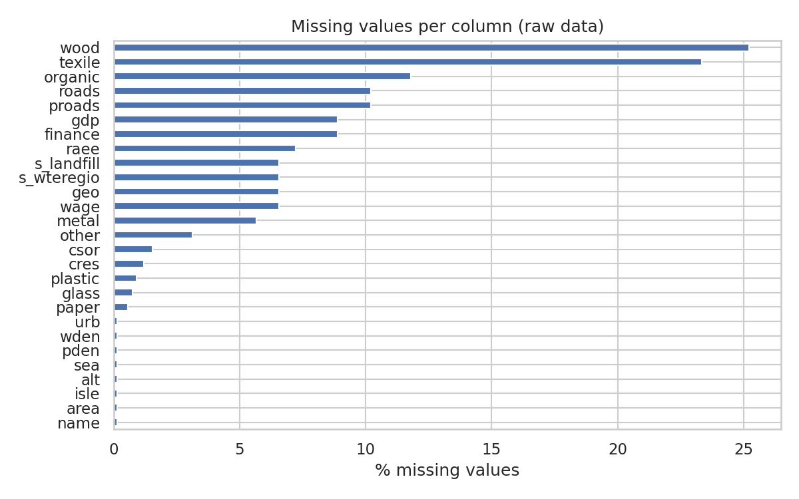
Figure 1: Percentage of missing values per column in the raw data
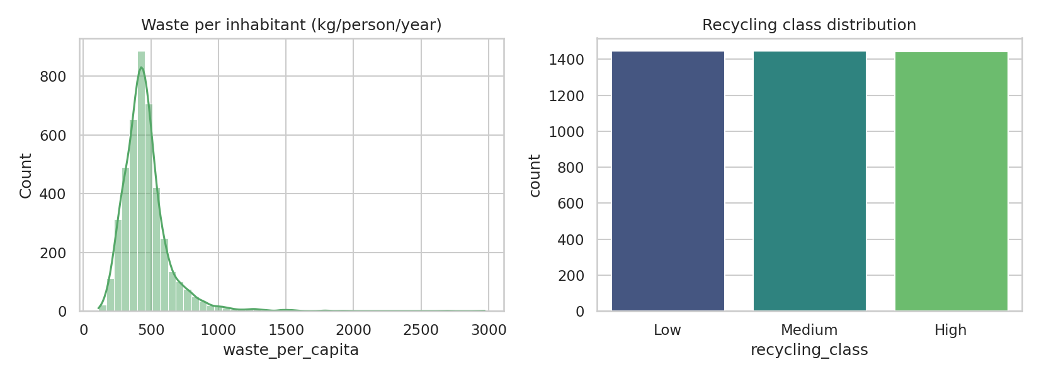
Figure 2: Distribution of waste per inhabitant (left) and of the recycling class (right)

6. Tools and Technologies
Component | Technology | Purpose
Language | Python 3 | All data processing, modelling and the dashboard
Database | MongoDB (local or Atlas) | Stores municipalities, predictions and model metrics
Database driver | PyMongo | CRUD, queries, aggregation and indexes from Python
Data processing | pandas, NumPy | Loading, cleaning and feature engineering
Machine learning | scikit-learn | Pipelines, Random Forest, Decision Tree, Linear and Logistic Regression, metrics
Visualisation | Matplotlib, Seaborn | Exploratory and evaluation charts
Dashboard | Streamlit | Interactive exploration, prediction form and metrics
Configuration | python-dotenv, joblib | Connection settings in .env; saving trained models
Table 3: Technology stack

7. System Design and Workflow
The workflow starts with the CSV file, which is loaded into MongoDB. All later steps read the data back from MongoDB, preprocess it, train and evaluate the models, and finally write predictions and metrics to MongoDB and to the dashboard.
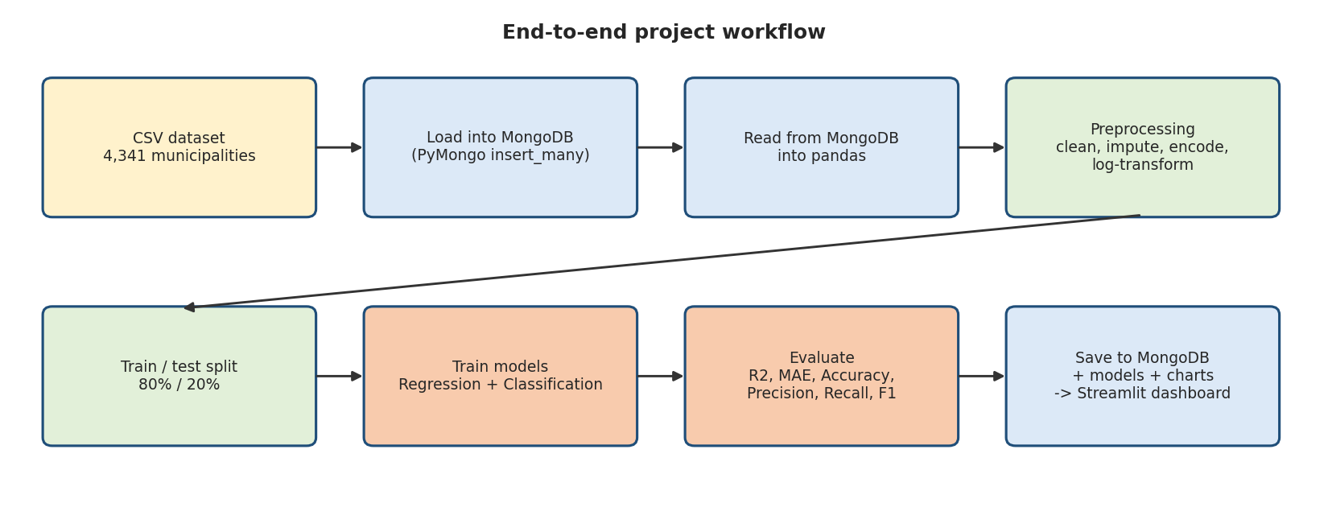
Figure 3: End-to-end project workflow
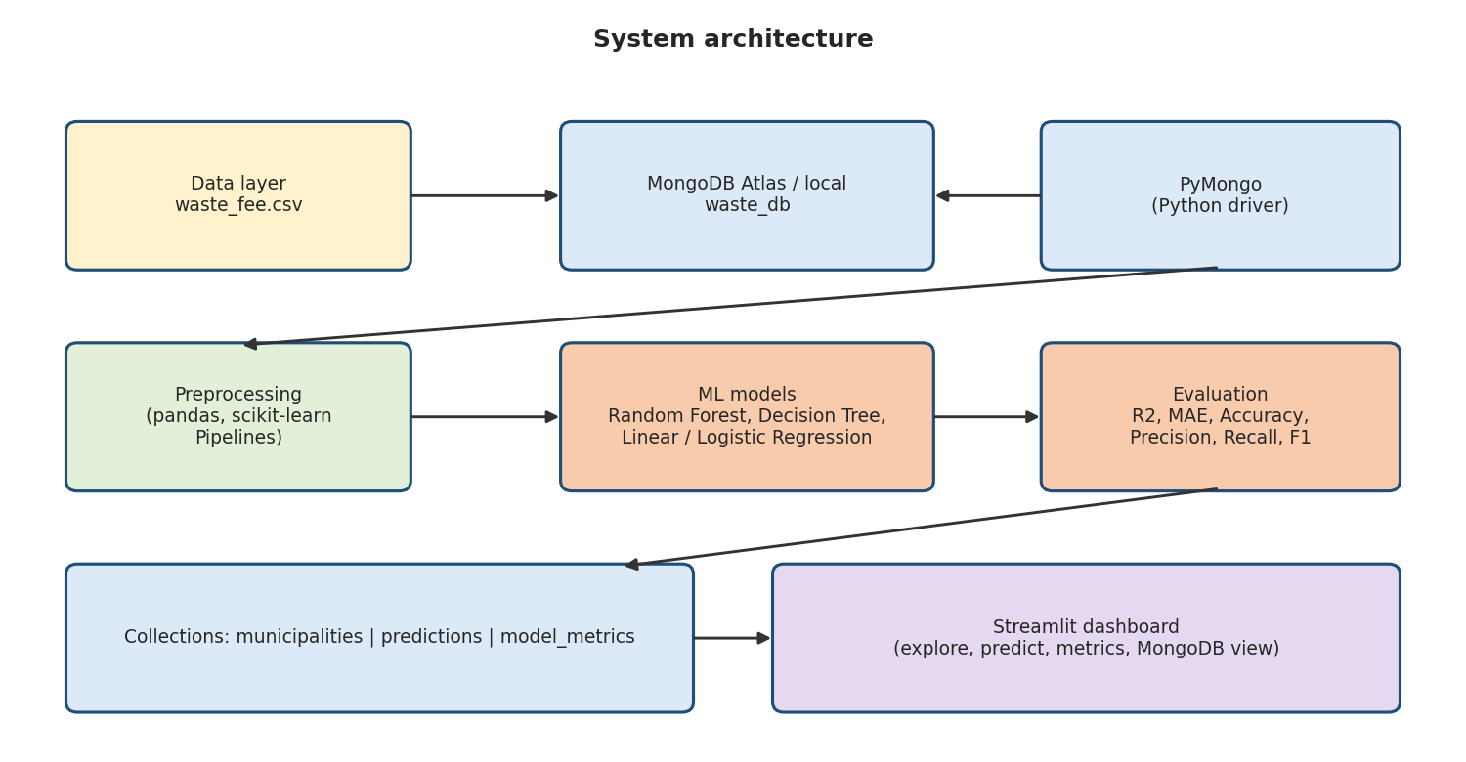
Figure 4: High-level system architecture
File | Purpose
config.py | Connects to MongoDB (local or Atlas) with PyMongo; reads MONGO_URI and MONGO_DB from the environment or .env file.
load_data.py | Loads the CSV into the municipalities collection and creates indexes.
train_models.py | Reads from MongoDB, preprocesses, trains and evaluates models, saves predictions, metrics, charts and models.
mongo_operations.py | Demonstrates CRUD, filtering, aggregation and indexes.
make_diagrams.py | Creates the workflow and architecture diagrams.
app.py | Streamlit dashboard.
run_all.py | Runs the complete pipeline in one command.
Table 4: Project modules

8. MongoDB / PyMongo Implementation

8.1 Database design
A database named waste_db is used with three collections:
- municipalities: one document per municipality (the 39 CSV columns). Missing values are stored as null.
- predictions: one document per test-set municipality with the actual and predicted value (regression) or class (classification), plus a timestamp.
- model_metrics: one document per trained model with its metrics, training/test sizes and, for classifiers, the confusion matrix.

8.2 Connection, loading and indexing
The connection string is read from the MONGO_URI environment variable (or a .env file), so the same code works with a local MongoDB server and with MongoDB Atlas, and no password is written in the source code. The CSV file is read with pandas, NaN values are converted to None, NumPy types are converted to native Python types and the records are inserted with insert_many(). An index on region speeds up regional queries and a unique index on istat guarantees that every municipality appears only once.

8.3 Operations demonstrated
Operation | PyMongo method | Example in the project
Create | insert_many, insert_one | Load 4,341 municipalities; insert a test municipality.
Read | find, find_one, count_documents | Filter PAYT municipalities with sor > 90 sorted by sor; count municipalities per fee type.
Update | update_one, update_many | Change the fee system of a document; flag municipalities with sor >= 85 as top_recycler.
Delete | delete_one | Remove the test municipality.
Aggregate | aggregate ($group, $avg, $sort, $limit) | Average sor by region and by fee system.
Index | create_index | Indexes on region and on istat (unique).
Table 5: MongoDB operations used in the project
The aggregation by fee system shows a clear difference: PAYT municipalities have an average separate-collection share of 78.09%, compared with 64.49% for municipalities with a standard fee. Regions with the highest average are Veneto (78.16%), Sardegna (75.17%) and Lombardia (71.77%). The full output of the operations is saved in outputs/mongodb_operations_log.txt.

8.4 Example documents
The three collections store the following kinds of documents (shortened). A municipality document keeps the original CSV fields; a prediction document links back to the municipality through its istat code; a metrics document stores the scores and the confusion matrix of one model.
municipalities:
{
"region": "Emilia_Romagna",
"province": "Ferrara",
"name": "Comacchio",
"istat": 38006,
"area": 283.75,
"pop": 22648,
"fee": "PAYT",
"d_fee": 1,
"organic": null,
"paper": 4.363508425607245,
"msw": 33956781,
"sor": 60.07
}

predictions:
{
"istat": 17064,
"name": "Corzano",
"region": "Lombardia",
"task": "classification",
"actual_class": "Low",
"predicted_class": "Medium",
"created_at": "2026-10-29 04:23:58.657000"
}

model_metrics:
{
"task": "classification",
"model": "Decision Tree",
"metrics": {
"Accuracy": 0.6955,
"Precision": 0.6921,
"Recall": 0.6955,
"F1": 0.6934
},
"confusion_matrix": [
[234, 42, 13],
[56, 161, 72],
[13, 68, 208]
],
"labels": ["Low", "Medium", "High"],
"train_size": 3468,
"test_size": 867,
"created_at": "2026-10-29 04:23:58.657000"
}

8.5 Key PyMongo code
Loading the CSV into MongoDB (simplified from load_data.py):
df = pd.read_csv(DATA_CSV)
df = df.astype(object).where(df.notna(), None) # NaN -> None (stored as BSON null)
records = df.to_dict("records")

col = get_db()["municipalities"]
col.drop()
col.insert_many(records)
col.create_index("region")
col.create_index("istat", unique=True)

Aggregation by region (simplified from mongo_operations.py):
pipeline = [
{"$group": {"_id": "$region",
"avg_sor": {"$avg": "$sor"},
"n": {"$sum": 1}}},
{"$sort": {"avg_sor": -1}},
]
for doc in col.aggregate(pipeline):
print(doc["_id"], round(doc["avg_sor"], 2), doc["n"])

[Insert here: screenshot of MongoDB Atlas (Browse Collections) showing the waste_db collections.]

9. Data Preprocessing and Exploratory Analysis
The models read their data directly from MongoDB (collection.find) into a pandas DataFrame and then apply the following steps.
- Removing invalid rows. Six rows had no municipality name and no geographic information; they were removed, leaving 4,335 rows.
- Fixing labels. One region was written in lowercase ("piemonte") and was standardised to "Piemonte".
- Creating the targets. Regression target: waste_per_capita = msw / pop (kg per inhabitant per year). Classification target: recycling_class, obtained by splitting sor into three equally sized groups using the 33rd and 67th percentiles (63.61% and 76.37%): Low (sor up to 63.61%), Medium, High (above 76.37%). The three classes are therefore balanced (about 1,445 municipalities each).
- Avoiding data leakage. msw, msw_so, msw_un and sor are used to build the targets, so they are excluded from the features. The column wden was also excluded: it was verified to be exactly msw / area (waste density), i.e. a direct function of the regression target. An early trial that still contained wden gave an unrealistic R² of 0.84 with Linear Regression, which is how the leak was detected. The cost columns (tc, cres, csor) are results of waste management and were also excluded from the main models (a sensitivity check is shown in Section 11.9), together with identifier columns.
- Missing values. Numeric features were imputed with the median and categorical features with the most frequent value, inside a scikit-learn Pipeline so that the imputation values are learned from the training data only.
- Skewed variables. pop, area, pden and roads were transformed with log(1 + x).
- Encoding. region and fee were one-hot encoded.
- Scaling. Numeric features were standardised for Linear and Logistic Regression; tree-based models do not need scaling.
- Train/test split. 80% training (3,468 rows) and 20% testing (867 rows) with random_state = 42; the classification split is stratified by class.

9.1 Exploratory analysis
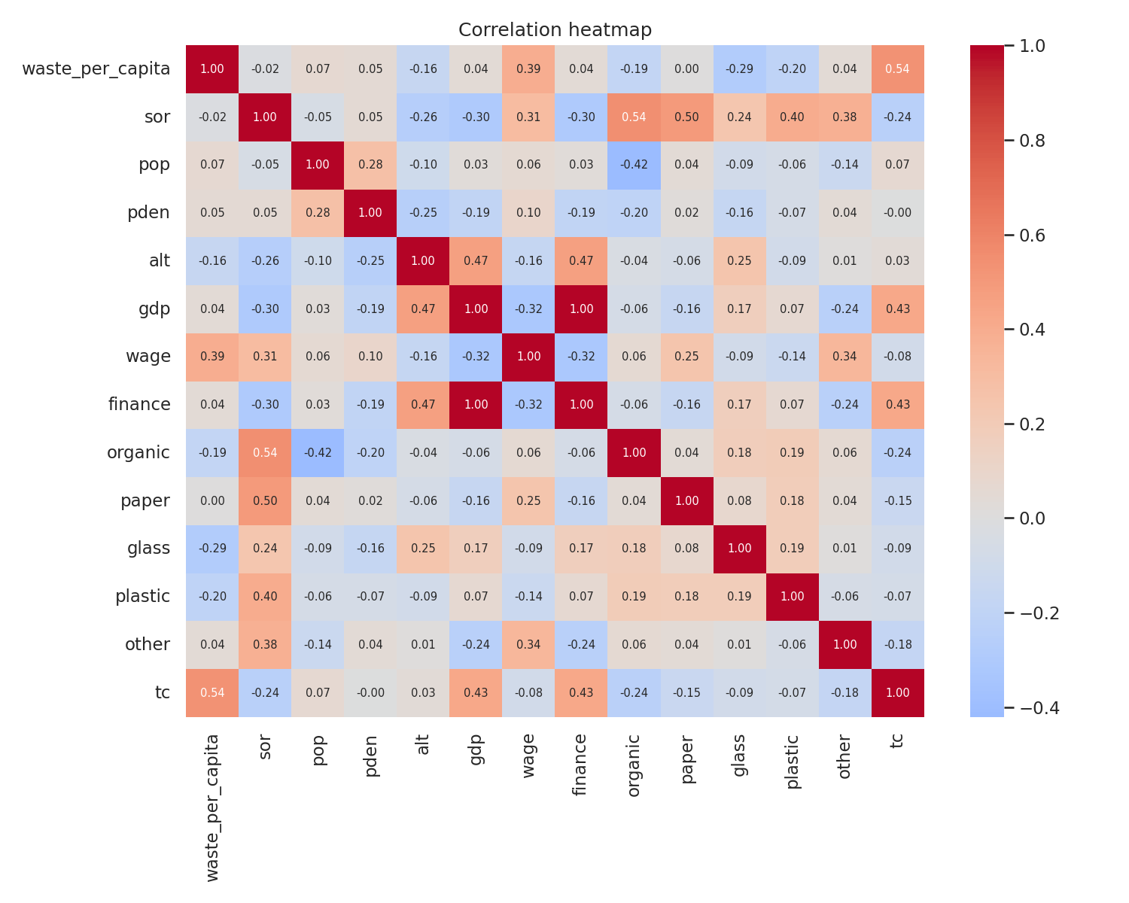
Figure 5: Correlation heatmap of the main numeric variables
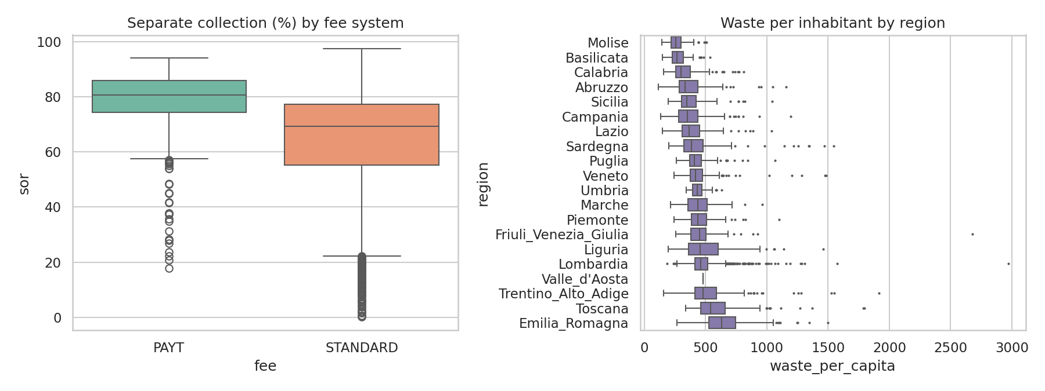
Figure 6: Separate collection by fee system (left) and waste per inhabitant by region (right)
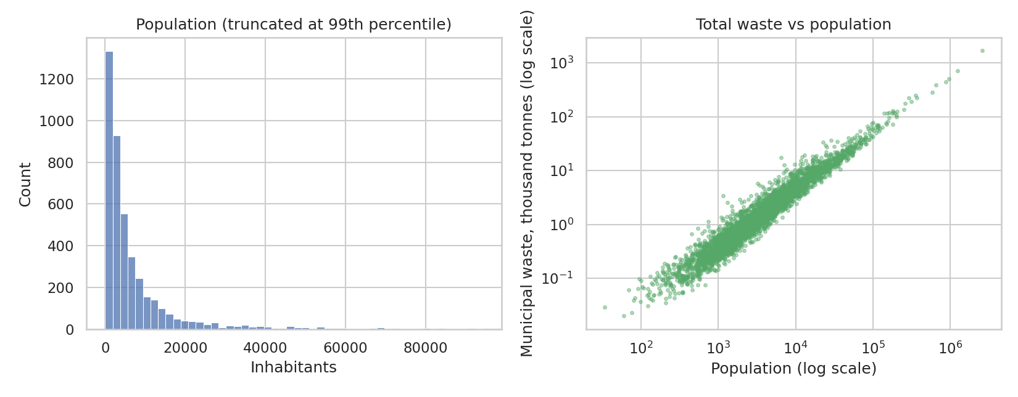
Figure 7: Population distribution (left) and total waste versus population (right, log scales)
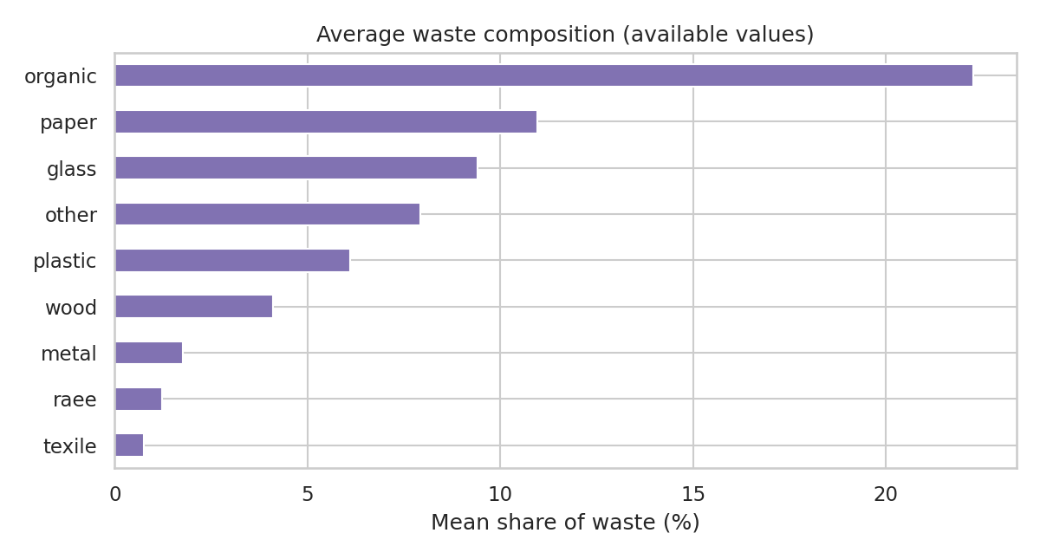
Figure 8: Average waste composition
The exploratory charts show that municipalities with a PAYT fee separate a larger share of their waste, that waste per inhabitant differs between regions, that total waste grows almost proportionally with population, and that organic waste is the largest single waste fraction.

9.2 Statistical comparison of fee systems
A Mann-Whitney U test (which does not assume a normal distribution) and a Welch t-test were used to compare municipalities with a PAYT fee (n = 557) with those that have a standard fee (n = 3778).
Variable | PAYT mean | Standard mean | PAYT median | Standard median | p-value
Separate collection (%) | 78.1 | 64.5 | 80.7 | 69.2 | < 0.001
Waste per person (kg/year) | 495.9 | 453.5 | 464.2 | 431.2 | < 0.001
Table 6: PAYT versus standard fee (p-value from the Mann-Whitney U test)
Separate collection is clearly higher with PAYT: 78.1% on average against 64.5%, a difference of about 13.6 percentage points, and the p-value is far below 0.001, so the difference is very unlikely to be due to chance. Waste per person is also slightly higher in PAYT municipalities (495.9 against 453.5 kg), which shows that the two groups differ in other ways as well. PAYT is concentrated in some regions (for example about 38% of municipalities in Veneto but none in Sardegna), so these tests show an association and not proof that the fee system itself causes the difference.

9.3 Regional comparison
Region | Municipalities | Avg separate collection (%) | Avg waste (kg/person) | PAYT share (%)
Veneto | 261 | 78.2 | 446.2 | 38.3
Sardegna | 121 | 75.2 | 451.0 | 0.0
Lombardia | 1228 | 71.8 | 482.2 | 14.2
Trentino Alto Adige | 157 | 71.2 | 534.9 | 83.4
Friuli Venezia Giulia | 183 | 70.9 | 458.9 | 18.0
Marche | 103 | 70.0 | 441.2 | 1.0
Valle d'Aosta | 1 | 69.2 | 478.4 | 0.0
Piemonte | 114 | 67.7 | 457.0 | 3.5
Umbria | 59 | 67.4 | 446.5 | 3.4
Abruzzo | 155 | 67.0 | 379.1 | 2.6
Emilia Romagna | 308 | 66.4 | 652.4 | 24.7
Campania | 405 | 63.4 | 367.0 | 0.0
Lazio | 188 | 60.5 | 388.4 | 1.1
Liguria | 179 | 59.8 | 499.6 | 2.8
Toscana | 231 | 58.6 | 586.1 | 10.4
Sicilia | 212 | 56.2 | 375.3 | 0.5
Molise | 70 | 54.4 | 274.0 | 0.0
Puglia | 126 | 53.8 | 435.2 | 0.0
Calabria | 165 | 52.5 | 330.9 | 0.0
Basilicata | 69 | 43.4 | 284.7 | 0.0
Table 7: Regional summary, sorted by average separate collection
The northern regions with a high PAYT share (for example Veneto) have the highest separate collection, while southern regions are lower. Valle d'Aosta has only one municipality in the data, so its row should not be generalised.

10. Model Implementation

10.1 Regression: waste per inhabitant
Two regressors were trained on the same preprocessed features. Linear Regression is the simple baseline. The Random Forest Regressor (300 trees, minimum 2 samples per leaf) can capture non-linear effects and interactions between variables. Both are evaluated on the unseen test set and with 5-fold cross-validation on the training set.

10.2 Classification: recycling performance
A Decision Tree Classifier is the main interpretable model. Its hyper-parameters were tuned with GridSearchCV (5-fold, macro F1) over max_depth {3, 5, 7, 10, None} and min_samples_leaf {1, 5, 10, 20}; the best setting was max_depth = None (unlimited) and min_samples_leaf = 10. Logistic Regression and a Random Forest Classifier (300 trees) were trained for comparison.

10.3 Storing the results
After evaluation, the test-set predictions (the Random Forest regression values and the Decision Tree classes) are inserted in the predictions collection, and the metrics of all five models are inserted in the model_metrics collection. The fitted models are also saved with joblib so that the dashboard can make new predictions without retraining.

10.4 Key implementation code
Reading the data from MongoDB and building the two targets (simplified from train_models.py):
col = get_db()["municipalities"]
df = pd.DataFrame(list(col.find({}, {"_id": 0})))

df["waste_per_capita"] = df["msw"] / df["pop"] # regression target
q1, q2 = df["sor"].quantile([1/3, 2/3])
df["recycling_class"] = pd.cut(df["sor"], [-np.inf, q1, q2, np.inf],
labels=["Low", "Medium", "High"]) # classification target

Preprocessing pipeline (imputation, scaling and one-hot encoding are learned on the training data only):
preprocessor = ColumnTransformer([
("num", Pipeline([("imputer", SimpleImputer(strategy="median")),
("scaler", StandardScaler())]), numeric_columns),
("cat", Pipeline([("imputer", SimpleImputer(strategy="most_frequent")),
("onehot", OneHotEncoder(handle_unknown="ignore"))]),
["region", "fee"]),
])

Tuning the Decision Tree with cross-validation:
grid = GridSearchCV(dt_pipe,
{"model__max_depth": [3, 5, 7, 10, None],
"model__min_samples_leaf": [1, 5, 10, 20]},
cv=5, scoring="f1_macro")
grid.fit(X_train, y_train)

11. Evaluation Results

11.1 Metrics used
- R² score: share of the variance of the target explained by the model (1 is perfect).
- MAE: mean absolute error in kg per person per year; RMSE penalises large errors more.
- Accuracy: share of municipalities placed in the correct class.
- Precision, Recall and F1-score: computed per class and macro-averaged (each class has equal weight).
Metric | Formula | Meaning
R² score | 1 - SS_res / SS_tot | Share of the variance of the target explained by the model
MAE | (1/n) x sum |y - ŷ| | Average absolute error, in kg per person per year
RMSE | sqrt((1/n) x sum (y - ŷ)²) | Like MAE but large errors count more
Accuracy | correct predictions / all predictions | Share of municipalities in the right class
Precision | TP / (TP + FP) | Of the municipalities predicted in a class, how many really belong to it
Recall | TP / (TP + FN) | Of the municipalities in a class, how many were found
F1-score | 2 x Precision x Recall / (Precision + Recall) | Balance of precision and recall
Table 8: Evaluation metrics (TP = true positives, FP = false positives, FN = false negatives)

11.2 Regression results
Model | R² (test) | MAE | RMSE | CV R² (5-fold) | R² (train)
Linear Regression | 0.350 | 87.8 | 163.9 | 0.458 ± 0.043 | 0.473
Random Forest Regressor | 0.473 | 76.9 | 147.5 | 0.568 ± 0.035 | 0.907
Table 9: Regression results on the test set (MAE and RMSE in kg/person/year)
The Random Forest Regressor is the better regression model: it explains about 47% of the variance (R² = 0.473) against 35% for Linear Regression, and its average error is 76.9 kg per person per year compared with 87.8 kg. The median waste production in the dataset is about 436 kg per person, so the MAE corresponds to roughly 18% of a typical value.
The result is moderate rather than excellent. The Random Forest fits the training data much better (R² = 0.907) than the test data, which shows over-fitting. The scatter plot in Figure 9 also shows that the largest errors come from a small number of municipalities with very high waste per inhabitant (above 1,000 kg), which are probably tourist or commuter towns where the resident population does not reflect the real number of waste producers. The variables available here do not capture this effect.
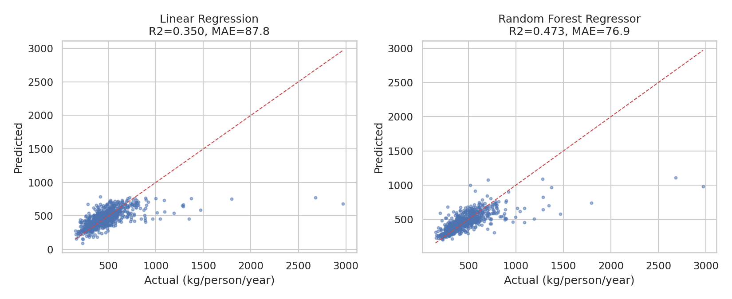
Figure 9: Actual versus predicted waste per inhabitant on the test set
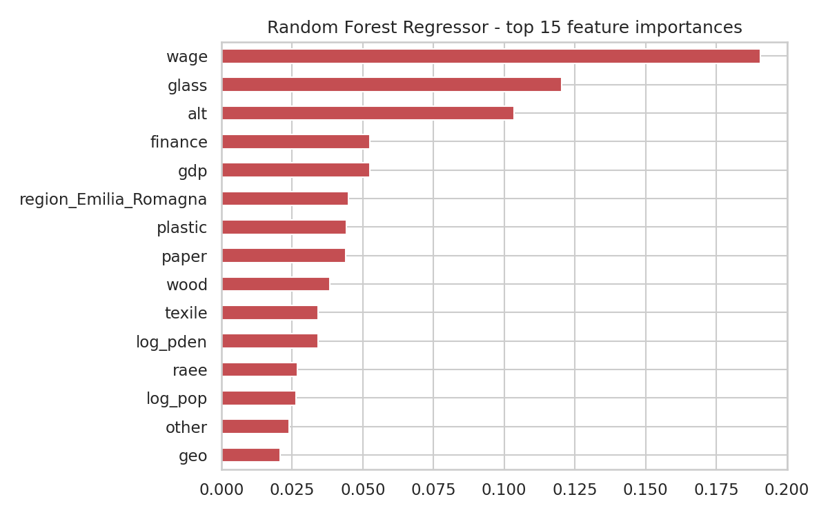
Figure 10: Most important features of the Random Forest Regressor

11.3 Classification results
Model | Accuracy | Precision | Recall | F1-score | CV Accuracy | Train Acc.
Decision Tree | 69.6% | 0.692 | 0.696 | 0.693 | 70.0% | 84.1%
Logistic Regression | 74.3% | 0.744 | 0.743 | 0.743 | 73.5% | 74.8%
Random Forest Classifier | 77.0% | 0.772 | 0.770 | 0.770 | 77.4% | 99.9%
Table 10: Classification results on the test set (Precision, Recall and F1 are macro-averaged)
The Random Forest Classifier achieved the best results (accuracy 77.0%, macro F1 0.770), followed by Logistic Regression (74.3%) and the Decision Tree (69.6%). With three balanced classes, random guessing would give about 33%, so all models learn useful patterns. The Decision Tree is the least accurate but the easiest to explain; its training accuracy (84.1%) compared with its test accuracy shows some over-fitting, even after tuning.

11.4 Decision Tree: per-class results and confusion matrix
Class | Precision | Recall | F1-score | Support
Low | 0.772 | 0.810 | 0.791 | 289
Medium | 0.594 | 0.557 | 0.575 | 289
High | 0.710 | 0.720 | 0.715 | 289
Macro average | 0.692 | 0.696 | 0.693 | 867
Table 11: Per-class metrics of the Decision Tree
Actual \ Predicted | Low | Medium | High
Low | 234 | 42 | 13
Medium | 56 | 161 | 72
High | 13 | 68 | 208
Table 12: Confusion matrix of the Decision Tree (test set)
The Low and High classes are recognised best (F1 0.791 and 0.715). The Medium class is the hardest (F1 0.575): most errors are between neighbouring classes (Medium confused with Low or High), while Low and High are rarely confused with each other. This is expected because the class boundaries were created by cutting a continuous variable, so municipalities close to a threshold are inherently difficult to separate.
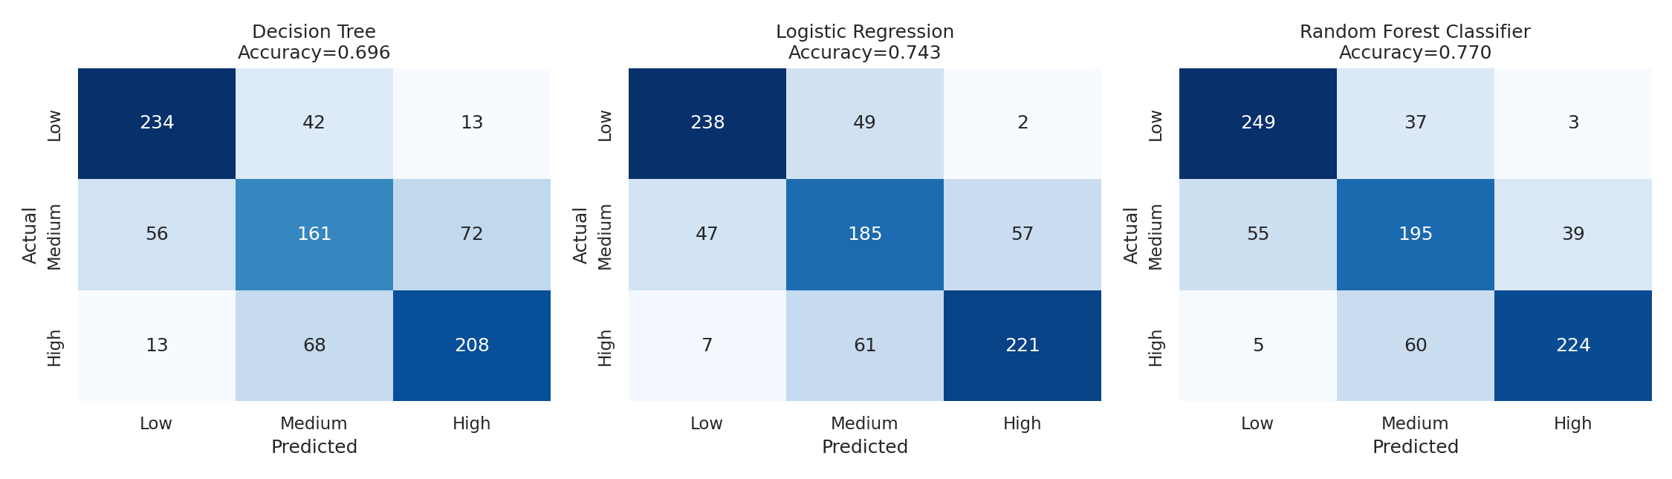
Figure 11: Confusion matrices of the three classifiers
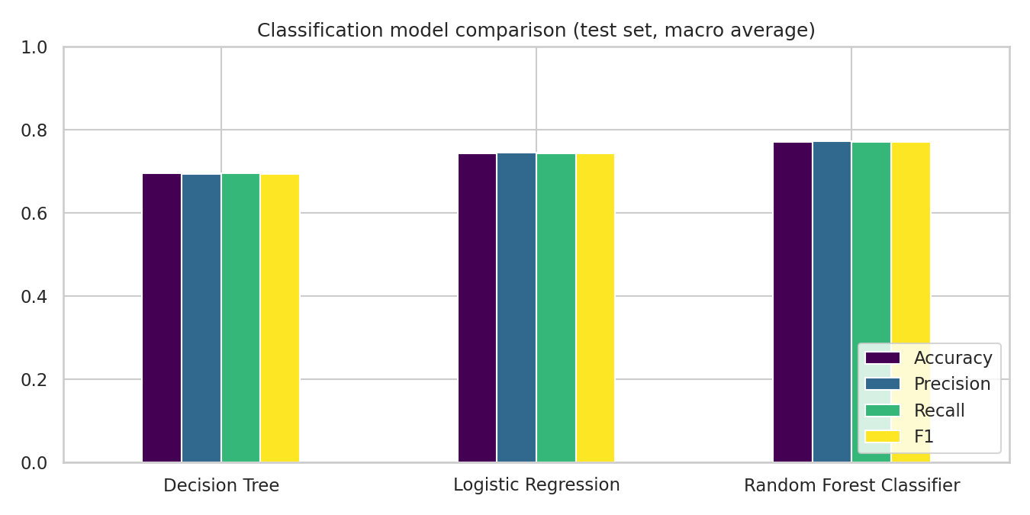
Figure 12: Comparison of the classification models
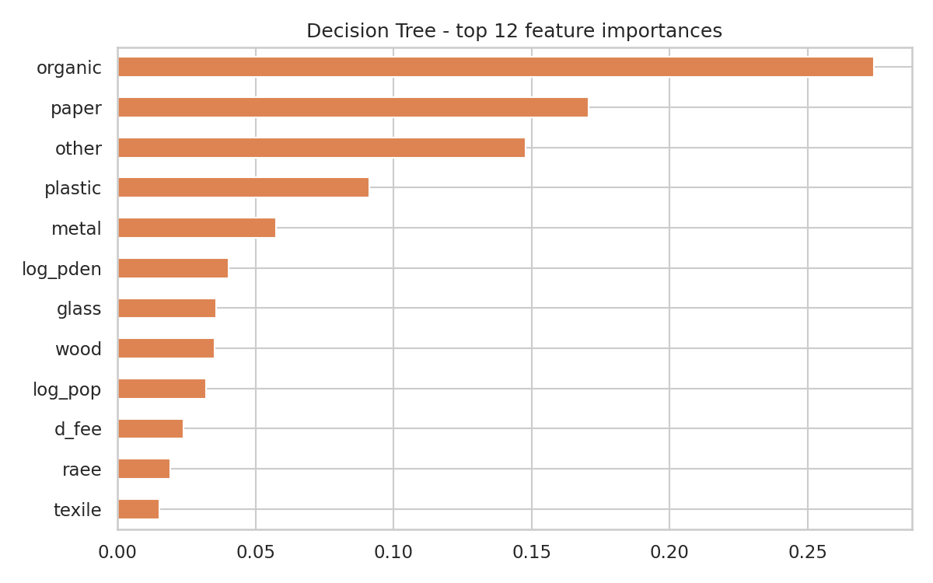
Figure 13: Most important features of the Decision Tree
The Decision Tree relies mostly on the waste composition (organic, paper, other waste, plastic). These shares are measured from the waste stream itself, so they describe how recycling behaviour is reflected in the waste rather than being causes of it. The fee system and population density have a smaller but visible influence.

11.5 Per-class results for all classifiers
Model | Class | Precision | Recall | F1-score
Decision Tree | Low | 0.772 | 0.810 | 0.791
Decision Tree | Medium | 0.594 | 0.557 | 0.575
Decision Tree | High | 0.710 | 0.720 | 0.715
Logistic Regression | Low | 0.815 | 0.824 | 0.819
Logistic Regression | Medium | 0.627 | 0.640 | 0.634
Logistic Regression | High | 0.789 | 0.765 | 0.777
Random Forest Classifier | Low | 0.806 | 0.862 | 0.833
Random Forest Classifier | Medium | 0.668 | 0.675 | 0.671
Random Forest Classifier | High | 0.842 | 0.775 | 0.807
Table 13: Per-class metrics of the three classifiers (test set)
All three models behave in the same way: the Low and High classes are recognised well and the Medium class is the hardest. The Random Forest has the best balance of precision and recall in every class.

11.6 Hyper-parameter tuning of the Decision Tree
GridSearchCV tested 20 combinations of tree depth and minimum leaf size with 5-fold cross-validation on the training data. The six best combinations are shown below.
max_depth | min_samples_leaf | CV macro F1 | Std. deviation
None | 10 | 0.698 | 0.015
10 | 10 | 0.697 | 0.012
7 | 10 | 0.693 | 0.013
7 | 5 | 0.690 | 0.008
7 | 1 | 0.690 | 0.010
10 | 5 | 0.688 | 0.009
Table 14: Best Decision Tree settings found by grid search
A minimum of 10 samples per leaf was consistently best. Without such a limit the tree memorises the training data. Depth matters little once the leaf size is limited, because the leaf limit already controls the size of the tree.

11.7 Over-fitting check
Model | Train score | Cross-validation | Test score | Train - test
Linear Regression (R²) | 0.473 | 0.458 | 0.350 | 0.123
Random Forest Regressor (R²) | 0.907 | 0.568 | 0.473 | 0.434
Decision Tree (accuracy) | 0.841 | 0.700 | 0.696 | 0.145
Logistic Regression (accuracy) | 0.748 | 0.735 | 0.743 | 0.005
Random Forest Classifier (accuracy) | 0.999 | 0.774 | 0.770 | 0.229
Table 15: Training, cross-validation and test scores
Logistic Regression shows almost no gap (0.005), so it generalises well but is limited by its simple form. Linear Regression has low scores on both sets. The Decision Tree (gap 0.145) and especially the two Random Forests (gaps 0.434 and 0.229) fit the training data much better than new data, which is typical for fully grown trees. For the classifiers the cross-validation and test accuracies agree closely (within 0.01), so these results are stable. For the regression models the test R² is lower than the cross-validation R² (0.473 against 0.568 for the Random Forest), so the true R² is probably between about 47.3% and 56.8% of the variance; a few extreme municipalities can move this score a lot in a single split.

11.8 Error analysis of the regression model
The 867 test municipalities were analysed with the predictions stored in MongoDB. The average error is almost zero (3.8 kg, so the model is not biased), the median absolute error is 45.9 kg, 53% of the predictions are within 50 kg of the true value, 78% are within 100 kg, and 5.9% are wrong by more than 200 kg.
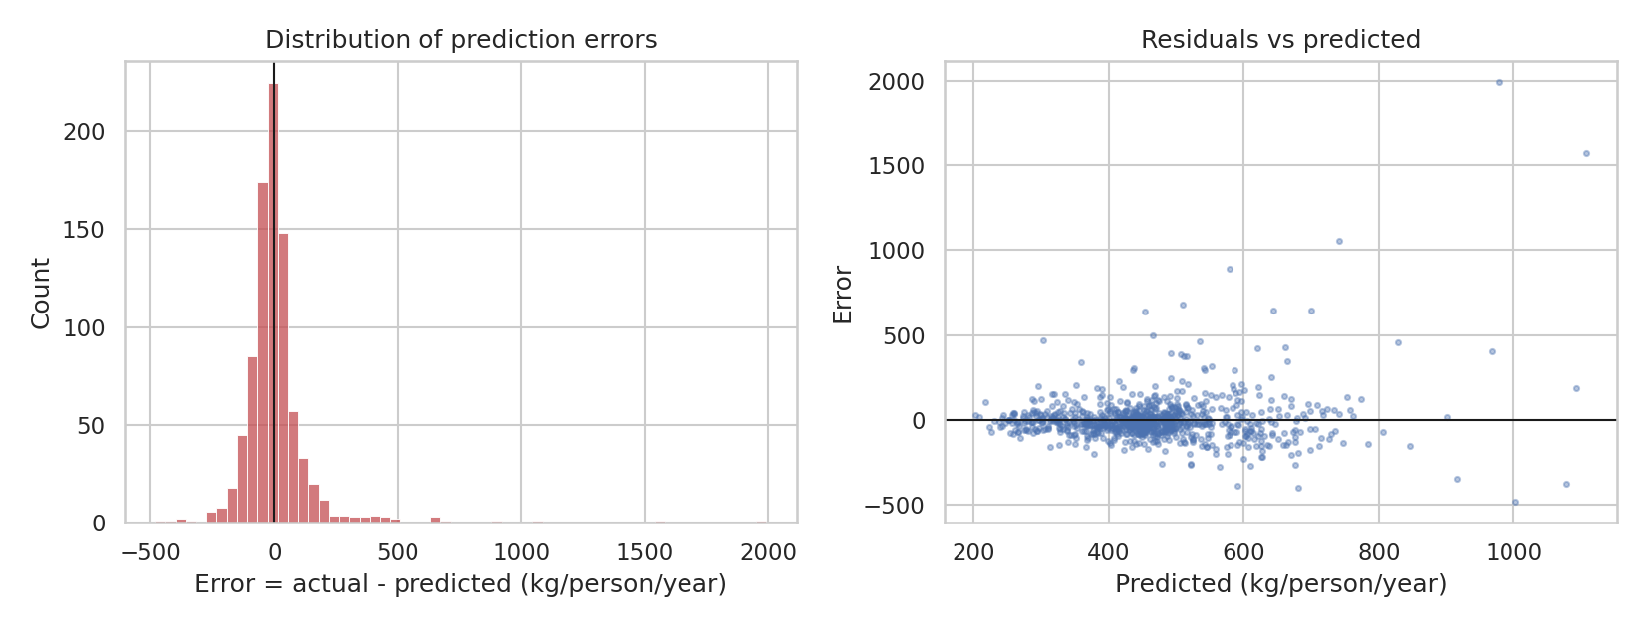
Figure 14: Distribution of prediction errors (left) and errors against predicted values (right)
The errors are very unevenly distributed. The 14 municipalities with more than 1,000 kg of waste per person have a mean absolute error of 740.6 kg, while all the others have only 66.0 kg. Table 16 lists the ten largest errors.
Municipality | Region | Population | Actual (kg) | Predicted (kg)
Limone sul Garda | Lombardia | 1,151 | 2971 | 977
Lignano Sabbiadoro | Friuli Venezia Giulia | 6,447 | 2680 | 1108
Bibbona | Toscana | 3,209 | 1795 | 741
Stintino | Sardegna | 1,501 | 1468 | 578
Moniga del Garda | Lombardia | 2,436 | 1191 | 510
San Teodoro | Sardegna | 4,540 | 1347 | 700
Caorle | Veneto | 11,793 | 1287 | 643
Griante | Lombardia | 623 | 1090 | 454
San Giovanni di FassaSèn Jan | Trentino Alto Adige | 3,345 | 966 | 464
L'Aquila | Abruzzo | 66,964 | 521 | 1002
Table 16: The ten largest prediction errors in the test set
All ten are small municipalities in which the model strongly under-predicts waste. Several, such as Limone sul Garda, Lignano Sabbiadoro and Stintino, are well-known holiday destinations: their waste comes from many visitors, but the data only contain the resident population. This supports the explanation given in Section 11.2 and shows the most useful improvement for the model: adding tourist arrivals or seasonal population.

11.9 Sensitivity check: effect of the cost columns
To show how much the feature choice matters, the Random Forest regression was repeated with the cost columns (tc, cres, csor) added as inputs. R² rises from 0.473 to 0.635 and MAE falls from 76.9 to 65.2 kg. This gain is not used as the main result because costs are a consequence of how much waste is collected and treated, so they would not be known when estimating waste in advance. The check also shows why results from different feature sets should not be compared without knowing which columns were used.
Regression feature set | R² (test) | MAE (kg/person/year)
Main model (no costs, no wden) | 0.473 | 76.9
Sensitivity: costs added | 0.635 | 65.2
Table 17: Random Forest regression with and without cost columns

11.10 Model selection
Task | Selected model | Reason
Waste per person estimation | Random Forest Regressor | Higher R² and lower MAE and RMSE than Linear Regression on the test set
Recycling class (best accuracy) | Random Forest Classifier | Highest accuracy and F1 of the three classifiers
Recycling class (interpretable) | Decision Tree | Required model of the project; its rules and feature importances can be explained
Table 18: Model selection
These are empirical choices for this dataset and this train/test split, and should be re-checked if the data or the feature definitions change.

12. Streamlit Dashboard
The dashboard (app.py) reads the municipalities from MongoDB and uses the saved models. It has five tabs:
- Overview: number of municipalities, total waste, average waste per person and average separate collection, with charts by fee system and region.
- Explore: filter by region and fee system, browse the records and see waste composition and distributions.
- Predict: a form where the user enters a region, fee system, population, area, altitude, economic indicators and waste composition; the app returns the predicted waste per person, the estimated total waste, and the predicted recycling class with probabilities from the Decision Tree and the Random Forest.
- Model evaluation: metric tables, confusion matrices and feature-importance charts.
- MongoDB: collection sizes, a live aggregation by region, stored metrics and stored predictions.
Inputs that the user does not set take the median value of the dataset. The predictions are decision-support estimates and not official assessments.
[Insert here: screenshot of the Streamlit dashboard (Predict tab).]

13. Testing and Validation
Test | Expected outcome | Result
CSV loading | File opens; rows and columns detected | Passed: 4,341 rows x 39 columns
MongoDB load and indexes | 4,341 documents inserted; indexes on region and istat | Passed (confirm on your Atlas cluster and attach screenshot)
CRUD and aggregation | Insert, find, update, delete and $group work | Passed; output in mongodb_operations_log.txt
Target calculation | Only records with population > 0 are used | Passed
Leakage check | Target-defining columns and wden excluded from inputs | Passed; wden = msw / area verified
Regression and classification training | Models train; metrics saved to MongoDB and results.json | Passed; metrics in Section 11
Class balance | Three classes of similar size | Passed: about 1,445 municipalities per class
Model saving and loading | Models saved with joblib and reloaded by the app | Passed
Dashboard | App starts, tabs render, prediction form returns values | Passed in an automated test; also run streamlit run app.py
Statistical test | Fee-system difference tested with Mann-Whitney U and Welch t-test | Passed; p < 0.001 (Section 9.2)
Error analysis | Largest errors inspected using predictions stored in MongoDB | Passed (Section 11.8)
Reproducibility | Same results on re-run | Passed: fixed random_state = 42
Table 19: Testing checklist

14. Practical Significance
The project shows how a database, machine learning and a simple dashboard can support municipal waste planning. Estimates of waste per person can help compare municipalities, and the recycling classes can point to municipalities that deserve a closer look, for example those with standard fees and low separate collection. The results are decision-support information; any real decision should also use local knowledge, policy, budget and updated field data.

15. Limitations and Future Work
- The data are municipality-level and may not represent neighbourhoods, households or individual bins.
- The regression model explains less than half of the variance; tourist flows, seasonal population and collection frequency are not in the data and would probably improve it.
- Tree-based models over-fit the training data; stronger regularisation, more tuning, or gradient boosting could be tested.
- The recycling classes are relative (percentile based) and not official targets; other definitions, such as a fixed 65% target, could be explored.
- A single train/test split gives one estimate of quality; cross-validation scores are given, but external validation on new years or regions would be stronger.
- Future data with multiple years, coordinates, collection frequency and bin-level sensors would allow time-series forecasting and real bin-overflow prediction.

16. Conclusion
This project implemented a complete workflow with MongoDB, PyMongo and machine learning on a real municipal waste dataset. The data were loaded into MongoDB, queried with filtering and aggregation, cleaned and transformed, and used to train and evaluate five models. The predictions and metrics were saved back to the database and are available in a Streamlit dashboard.
- Regression: the Random Forest Regressor reached R² = 0.473 and MAE = 76.9 kg per person per year, better than Linear Regression (R² = 0.350, MAE = 87.8).
- Classification: the Decision Tree reached 69.6% accuracy (precision 0.692, recall 0.696, F1 0.693); the Random Forest Classifier was best with 77.0% accuracy and F1 0.770.
- A data-leakage column (wden) was identified and removed, so the reported scores are realistic rather than inflated.
- PAYT municipalities recycle clearly more on average (78.1% separate collection versus 64.5% for standard fees), although this is an association and not proof of cause and effect.

References
- Municipal Waste Management Cost Prediction dataset, Kaggle: https://www.kaggle.com/datasets/shashwatwork/municipal-waste-management-cost-prediction
- Pedregosa et al., Scikit-learn: Machine Learning in Python, Journal of Machine Learning Research, 12, 2825-2830, 2011.
- PyMongo documentation: https://pymongo.readthedocs.io
- MongoDB Atlas documentation: https://www.mongodb.com/docs/atlas/
- Streamlit documentation: https://docs.streamlit.io

Appendix A: Run Instructions
- Create a free MongoDB Atlas cluster, add a database user, allow your IP address under Network Access, and copy the connection string.
- Copy .env.example to .env and set MONGO_URI to the connection string (or set the MONGO_URI environment variable).
- Install the packages: pip install -r requirements.txt
- Run the complete pipeline: python run_all.py (this loads MongoDB, trains and evaluates the models, saves the results and creates the charts).
- Start the dashboard: streamlit run app.py
Individual steps can also be run separately: python load_data.py, python train_models.py and python mongo_operations.py.
The extra analyses of Sections 9.2, 9.3 and 11.8 are created by python extra_analysis.py (run after train_models.py).

Appendix B: Descriptive Statistics
Summary of all numeric columns after removing the six empty rows (4,335 municipalities). Missing values are not counted in the mean, standard deviation, minimum, median and maximum.
Variable | Missing % | Mean | Std | Min | Median | Max
tc | 0.0 | 154.3 | 76.10 | 25.69 | 136.6 | 977.4
cres | 1.2 | 54.20 | 43.21 | 4.27 | 41.69 | 670.3
csor | 1.5 | 52.69 | 33.08 | 3.39 | 48.89 | 582.2
area | 0.0 | 41.00 | 56.78 | 0.12 | 22.73 | 1,287
pop | 0.0 | 10,209 | 53,463 | 34.00 | 3,533 | 2,617,175
alt | 0.0 | 310.1 | 280.5 | 1.00 | 240.0 | 1,816
isle | 0.0 | 0.01 | 0.07 | 0.00 | 0.00 | 1.00
sea | 0.0 | 0.17 | 0.37 | 0.00 | 0.00 | 1.00
pden | 0.0 | 405.0 | 771.2 | 2.48 | 151.3 | 12,123
wden | 0.0 | 192,058 | 359,001 | 892.2 | 68,343 | 4,978,557
urb | 0.0 | 2.49 | 0.59 | 1.00 | 3.00 | 3.00
d_fee | 0.0 | 0.13 | 0.33 | 0.00 | 0.00 | 1.00
organic | 11.8 | 22.27 | 12.75 | 0.01 | 24.97 | 61.64
paper | 0.6 | 10.96 | 3.89 | 0.00 | 10.88 | 45.29
glass | 0.8 | 9.40 | 3.71 | 0.00 | 9.09 | 39.84
wood | 25.3 | 4.11 | 2.72 | 0.00 | 4.02 | 25.12
metal | 5.7 | 1.76 | 1.35 | 0.00 | 1.54 | 20.67
plastic | 0.9 | 6.11 | 3.26 | 0.00 | 5.79 | 31.60
raee | 7.2 | 1.23 | 0.82 | 0.00 | 1.18 | 17.95
texile | 23.4 | 0.76 | 0.69 | 0.00 | 0.63 | 10.58
other | 3.1 | 7.94 | 5.15 | 0.03 | 7.13 | 37.16
msw_so | 0.0 | 3,250,237 | 15,631,751 | 0.27 | 1,038,125 | 765,130,099
msw_un | 0.0 | 2,044,581 | 17,656,727 | 6,185 | 408,460 | 926,757,220
msw | 0.0 | 5,315,085 | 32,566,360 | 19,972 | 1,523,226 | 1,691,887,319
sor | 0.0 | 66.22 | 17.74 | 0.25 | 70.84 | 97.48
geo | 6.4 | 2.29 | 0.89 | 1.00 | 3.00 | 3.00
roads | 10.1 | 101.9 | 310.0 | 1.00 | 51.00 | 14,970
s_wteregio | 6.4 | 21.87 | 15.62 | 0.00 | 24.47 | 65.12
s_landfill | 6.4 | 20.00 | 21.37 | 3.60 | 11.30 | 92.53
gdp | 8.8 | 7.23 | 0.55 | 6.04 | 7.13 | 10.54
proads | 10.1 | 4.25 | 1.16 | -3.37 | 4.36 | 8.98
wage | 6.4 | 9.45 | 0.30 | 7.87 | 9.52 | 10.48
finance | 8.8 | 7.45 | 0.57 | 6.22 | 7.34 | 10.85
top_recycler | 90.9 | 1.00 | 0.00 | 1.00 | 1.00 | 1.00
waste_per_capita | 0.0 | 458.9 | 176.5 | 111.6 | 435.8 | 2,971
Table 20: Descriptive statistics of the numeric columns

Appendix C: Glossary
Term | Meaning
MSW | Municipal solid waste: household and similar waste collected by the municipality.
sor | Share (%) of the waste that is collected separately for recycling (sorted waste / total waste x 100).
PAYT | Pay-as-you-throw: a waste fee that depends on the amount of residual waste a household produces.
RAEE | Waste electrical and electronic equipment (e-waste).
Random Forest | An ensemble of many decision trees whose predictions are averaged (regression) or voted (classification).
Decision Tree | A model that makes predictions with a sequence of yes/no rules on the input features.
Cross-validation | Repeated training and testing on different parts of the training data to estimate how well a model generalises.
Data leakage | Using information in the input features that would not be available at prediction time or that directly contains the target.
Pipeline | A scikit-learn object that chains preprocessing and a model so that all steps are learned on the training data only.
Aggregation | A MongoDB operation that groups and summarises documents, for example the average per region.
Table 21: Glossary

