#1. WAP to input a string and count the number of uppercase and lowercase letters

string=input("Enter a string: ")

uppercase_count = 0

lowercase_count = 0

for char in string:

if char.isupper():

uppercase_count += 1

elif char.islower():

lowercase_count += 1

print("Number of uppercase letters:", uppercase_count)

print("Number of lowercase letters:", lowercase_count)

OUTPUT

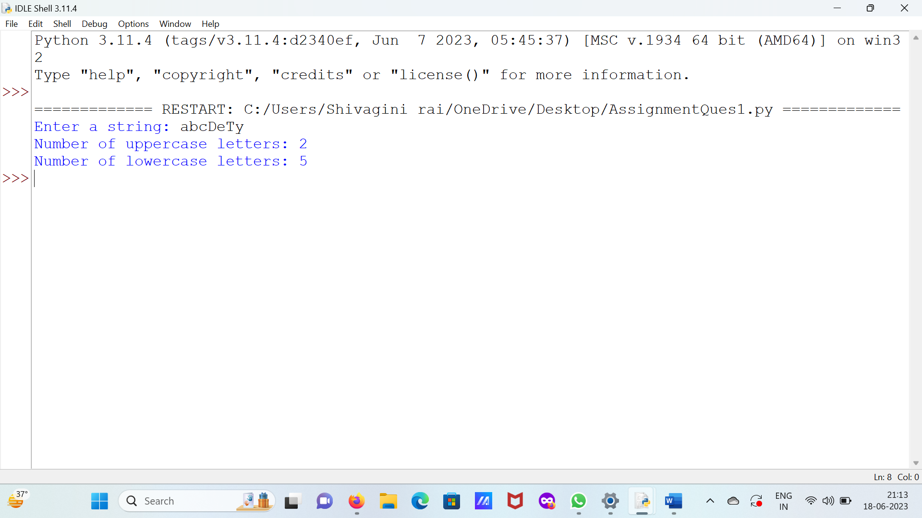

#2.Write a Python program to get a string made of the first 2 and last 2 characters of a given

#string. If the string length is less than 2, return the empty string.

s=input("Enter a string: ")

if len(s) < 2:

result = ""

else:

result = s[:2] +s[-2:]

print("Result:", result)

OUTPUT

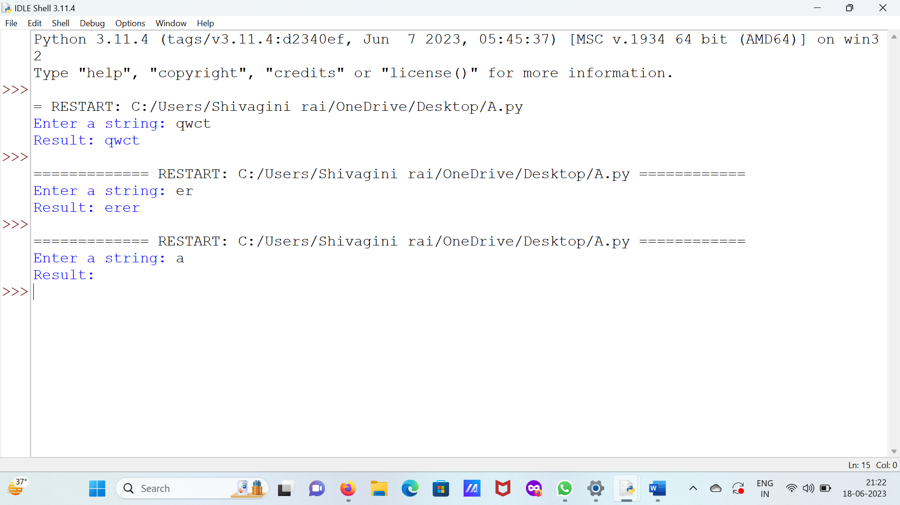

#3. Write a Python program to remove characters that have odd index values in a given string.

str=input("Enter a string: ")

result = ""

for index in range(len(str)):

if index % 2 == 0:

result +=str[index]

print("Result:", result)

OUTPUT

