

**SCHOOL OF COMPUTING SCIENCE AND ENGINEERING**

**GALGOTIA UNIVERSITY**

**GREATER NOIDA- 201306**

**OCTOBER 2020**

**MINOR PROJECT**

SMART CALORIE

**BACHELOR OF TECHNOLOGY**

**in**

**COMPUTER SCIENCE AND ENGINEERING**

***Submitted by***

**SHIVANG GUPTA (18SCSE1010039)**

**VIBHU MISHRA (18SCSE1010052 )**

**Abhishek Dubey (18SCSE1010427)**

**ABSTRACT**

A number of mobile fitness devices as well as smart watches have emerged on the technology landscape. However, the rate of adoption of these devices is still low especially in developing countries with a teeming population. On the other hand, smart phones are becoming ubiquitous given their steady price decline. To this end, the present study aims to leverage the smartphone platform by developing a smart phone fitness app that tracks the calories burnt by individuals who go about their daily activities while carrying their smart phones with them. In order to achieve this, the design specification for the application was done using Unified Modeling Language diagrams such as use case diagrams and sequence diagrams. This was then implemented using the following tools: Angular - a JavaScript framework and Ionic - a hybrid framework that was hosted via the Heroku Cloud Application Platform. The initial results show that the app can gain traction in terms of its adoption given the fact that it is cheaper to download the app than buy a new smart watch for the same purpose.

**LITERATURE REVIEWS / COMPARATIVE STUDY**

Health tracking systems can be categorized based on technological advancement into two groups namely: traditional and electronic health tracking systems. In times past, individual’s health activity was measured in an analogue manner requiring the use of analogue scales and thermometers. As the readings were taken, they were recorded in the file of the individual at a given medical centre. Such records were only found in the health facility where the readings were taken. The drawbacks of this approach include among others: the difficult to comprehend handwriting of a number of health practitioners, the records soon become bulky and duplications are often inevitable. In addition, the records are not always readily available and accessible unless a visit is made to the medical centre. Electronic health tracking systems overcame the limitations of the traditional health tracking systems and also heralded the advent of fitness tracking devices. As of today, the use of stopwatches and bathroom scales to track fitness level is gradually becoming a thing of the past in both developed and developing nations of the world. A fitness tracker or action tracker is a gadget or application for observing and following fitness-related measurements, for example, distance covered in walks or run, calorie utilization, and at times pulse and nature of rest. The term is basically used to describe devices that are connected, a significant part of the time remotely, to a PC or PDA for whole deal data taking after, an instance of wearable technology. The expression “activity trackers” now essentially alludes to wearable gadgets that screen and record an individual’s fitness action. The idea came into being out of composed logs that prompted spread sheet-style PC signs in which passages were made physically. Improvements in innovation in the late 20th and mid-21st century permit robotizing the observation and recording of fitness exercises and incorporating them into all the more effectively worn gear. Early cases incorporate wristwatch-sized bike PCs that checked attributes like speed and length. Wearable heart rate screens for competitors were accessible in 1981. Wearable fitness GPS beacons, including remote heart rate checking that coordinated with business review fitness gear found in exercise centres, were accessible in shopper review hardware by the mid-2000s. Health-tracking platforms use sensors in a user’s activity tracker or mobile device to record physical fitness activities for example walking or cycling, which are then tallied up against the user’s health goals to provide a comprehensive view of their fitness . Users can choose whom to share their health tracking data with as well as delete the data at any point in time. In this regard, fitness tracking devices and wearables - especially watches are now trending. However, the rate of adoption of these devices is low especially in developing countries with a teeming population such as Nigeria (in sub-Saharan Africa) . One reason for this low adoption among others is the high cost of the wearables. On the other hand, mobile phones are quite ubiquitous as a result of the steady decline in price and the steady rise and improvement in mobile software and apps. This study therefore explores the possibility of developing a mobile application that would serve as a substitute to the use of these wearables in tracking calorie burn in individuals.

**INTRODUCTION**

Health tracking systems can be categorized based on technological advancement into two groups namely: traditional and electronic health tracking systems . In times past, individual’s health activity was measured in an analogue manner requiring the use of analogue scales and thermometers . As the readings were taken, they were recorded in the file of the individual at a given medical center . Such records were only found in the health facility where the readings were taken. The drawbacks of this approach includes among others : the difficult to comprehend handwriting of a number of health practitioners, the records soon become bulky and duplications are often inevitable. In addition, the records are not always readily available and accessible unless a visit is made to the medical center. Electronic health tracking systems overcame the limitations of the traditional health tracking systems and also heralded the advent of fitness tracking devices . As of today, the use of stopwatches and bathroom scales to track fitness level is gradually becoming a thing of the past in both developed and developing nations of the world . A fitness tracker or action tracker is a gadget or application for observing and following fitness-related measurements, for example, distance covered in walks or run, calorie utilization, and at times pulse and nature of rest . The term is basically used to describe devices that are connected, a significant part of the time remotely, to a PC or PDA for whole deal data taking after, an instance of wearable technology . The expression “activity trackers” now essentially alludes to wearable gadgets that screen and record an individual’s fitness action . The idea came into being out of composed logs that prompted spread sheet-style PC signs in which passages were made physically. Improvements in innovation in the late 20th and mid-21st century permit robotizing the observation and recording of fitness exercises and incorporating them into all the more effectively worn gear . Early cases incorporate wristwatch-sized bike PCs that checked attributes like speed and length. Wearable heart rate screens for competitors were accessible in 1981 . Wearable fitness GPS beacons, including remote heart rate checking that coordinated with business review fitness gear found in exercise centres, were accessible in shopper review hardware by the mid-2000s . Health-tracking platforms use sensors in a user’s activity tracker or mobile device to record physical fitness activities for example walking or cycling, which are then tallied up against the user’s health goals to provide a comprehensive view of their fitness . Users can choose whom to share their health tracking data with as well as delete the data at any point in time. In this regard, fitness tracking devices and wearables - especially watches are now trending. However, the rate of adoption of these devices is low especially in developing countries with a teeming population such as Nigeria (in sub-Saharan Africa) . One reason for this low adoption among others is the high cost of the wearables . On the other hand, mobile phones are quite ubiquitous as a result of the steady decline in price and the steady rise and improvement in mobile software and apps . This study therefore explores the possibility of developing a mobile application that would serve as a substitute to the use of these wearables in tracking calorie burn in individuals. The rest of this study is structured as follows: Sect. 2 discusses related works while Sect. 3 presents the design specification of the proposed application. In Sect. 4, the design specification is implemented as a mobile application. Section 5 discusses the results obtained while Sect. 6 concludes the paper

**PROBLEM FORMULATION**

To investigate features of apps currently available for smartphones, and their users’

experiences, we conducted a review on chatting applications, evaluated their features,

and analysed a set of consumer reviews.

Contrary to what many people think, having a few platforms around is not a necessarily

a bad thing. We were able to get ideas of what to build and how and determine

which technologies and strategies to use based on their experience. Often, this was as

simple as checking their blogs. Companies like Slack regularly post development

updates (such as performance reviews, technology comparisons, and scalability posts).

Other times, we had to dig into the web to find out the different options we had and

pick out the one which we considered to be the most appropriate.

Then we created a list of advantages and disadvantages and features they lack and

also how the application we are aiming to make can rectify and overcome the lack of

features they lack.

**Required Tools -:**

Basically, the required tools for the development of this (speech to text) application require following tools:

The tools are combination of HARDWARE AND SOFTWARE:

* A laptop/pc having atleast 8 gb of RAM so it can run smoothly.
* Windows XP, Windows 7(ultimate, enterprise)
* Processor – i3, Hard Disk – 5 GB, Memory – 1GB RAM
* Android Phone with KitKat and higher
* Require ANDROID STUDIO software for the development of this application.
* JAVA/KOTLIN basic knowledge for the back-end process.
* Pen drive Etc

**MODULES DESCRIPTION**

1. **BMI CALCULATOR:**

BMI refers to (Body Mass Index) is a value derived from the mass (weight) and height of a person. The BMI is defined as the body mass divided by the square of the body height, and is universally expressed in units of kg/m2, resulting from mass in kilograms and height in meters.

So, BMI is an important reading to know the health status so we developed this module very friendly manner, in our app more than the reading you would get suggestion that in what way you have to think on further.

1. **Calorie Calculator:**

If you got your BMI health index from our app, then its to time for exercise if you are fatty person then it also requires more. To help you we have developed this module, In this module you got some basic exercise which is feed on the basis of calories burned per minute. So, you can make your daily exercise plan.

The activities are:

1. Bicycling 2. Dancing 3. Yoga 4. Jumping Rope 5. Body Stretching

6. Swimming 7. Walking

We hope you regularly care for yourself by following some activities.

1. **About Us:**

In this Section We describe us to you that we are students which took an initiative to build their first app on the serious note “Health”.

WE are:

1. Shivang Gupta (18SCSE1010039)

2. Vibhu Mishra (18SCSE1010052)

3.Abhishek Dubey (18SCSE1010427)

**MODULES DESIGN AND ARCHITECTURE**

Various materials such as journals, articles, conference proceedings, books and research papers were reviewed in order to analyse and identify the existing fitness tracking apps and to also gather requirements for the proposed mobile application. Unified Modelling Language diagrams were drawn to conceptualize the application that was to be built. These include the use case diagram, sequence diagram and state chart diagram. Figure 1 depicts the use diagram of the proposed application comprising of five use cases namely: track calorie burnt, calculate steps taken, measure distance covered, input/edit weight and input/edit height. From Fig. 1, it can be observed that the user (the actor) has access to all the five use cases. The sequence of activities especially as regarding the order of occurrence is depicted in Fig. 2. From Fig. 2, the logged in user launches or starts the application and can get an overview of what the application is about as a first time user. All the records of new users are stored in the database for future retrieval. The calorie burn rate is determined

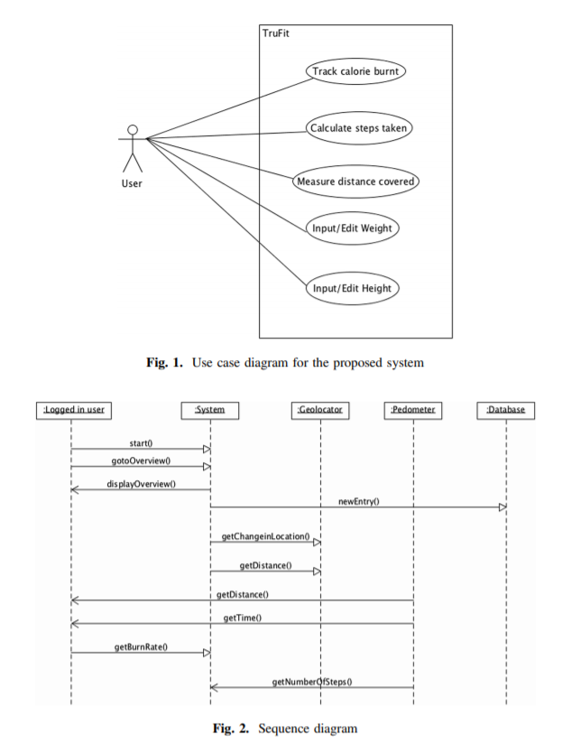

Developing a Calorie Counter Fitness App for Smartphones 25 using three elements, which include: the step count, the distance covered and the time taken. Figure 3 depicts the state diagram of the proposed application. To access the system, the user in question would have to be registered in the application’s database by filling in some biodata.

**MODULES IMPLEMENTATION AND SOURCE CODE**

**BUILD.GRADLE - :**

// Top-level build file where you can add configuration options common to all sub-projects/modules.

buildscript {

repositories {

google()

jcenter()

}

dependencies {

classpath 'com.android.tools.build:gradle:3.6.3'

// NOTE: Do not place your application dependencies here; they belong

// in the individual module build.gradle files

}

}

allprojects {

repositories {

google()

jcenter()

}

}

task clean(type: Delete) {

delete rootProject.buildDir

}

**APP/BUILD.GRADLE -:**

apply plugin: 'com.android.application'

android {

compileSdkVersion 29

buildToolsVersion "29.0.2"

defaultConfig {

applicationId "com.allstudio.smartcalorie"

minSdkVersion 21

targetSdkVersion 29

versionCode 1

versionName "1.0"

testInstrumentationRunner "androidx.test.runner.AndroidJUnitRunner"

}

buildTypes {

release {

minifyEnabled false

proguardFiles getDefaultProguardFile('proguard-android-optimize.txt'), 'proguard-rules.pro'

}

}

}

dependencies {

implementation fileTree(dir: 'libs', include: ['*.jar'])

implementation 'androidx.appcompat:appcompat:1.1.0'

implementation 'androidx.cardview:cardview:1.0.0'

implementation 'androidx.constraintlayout:constraintlayout:1.1.3'

testImplementation 'junit:junit:4.12'

androidTestImplementation 'androidx.test.ext:junit:1.1.1'

androidTestImplementation 'androidx.test. espresso: espresso-core:3.2.0'

implementation 'com. google.android.material:material:1.1.0'

}

**App/Src/Main/AndroidMainfest.xml -:**

<?xml version="1.0" encoding="utf-8"?>

<manifest xmlns:android="http://schemas.android.com/apk/res/android"

xmlns:tools="http://schemas.android.com/tools"

package="com.allstudio.smartcalorie">

<application

android:allowBackup="true"

android:icon="@mipmap/ic_launcher"

android:label="@string/app_name"

android:roundIcon="@mipmap/ic_launcher_round"

android:supportsRtl="true"

android:theme="@style/AppTheme">

<activity android:name=".PrivacyPlolicyActivity"

android:label="Privacy Policy"/>

<activity

android:name=".LaunchActivity"

android:screenOrientation="portrait"

tools:ignore="LockedOrientationActivity">

<intent-filter>

<action android:name="android.intent.action.MAIN" />

<category android:name="android.intent.category.LAUNCHER" />

</intent-filter>

</activity>

<activity

android:name=".MainActivity"

android:screenOrientation="portrait"

tools:ignore="LockedOrientationActivity" />

</application>

</manifest>

**App/Src/Main/Res/Layout/Activity_launch -:**

<?xml version="1.0" encoding="utf-8"?>

<LinearLayout xmlns:android="http://schemas.android.com/apk/res/android"

xmlns:tools="http://schemas.android.com/tools"

android:layout_width="match_parent"

android:layout_height="match_parent"

android:orientation="vertical"

android:background="@drawable/backgroud_dark_blue"

tools:context=".LaunchActivity">

<ImageView

android:layout_width="wrap_content"

android:layout_gravity="center_horizontal"

android:layout_weight="1"

android:src="@mipmap/ic_launcher_round"

android:layout_height="0dp"/>

<ProgressBar

android:layout_width="wrap_content"

android:layout_gravity="center_horizontal"

android:layout_weight="1"

android:layout_height="0dp"/>

<TextView

android:layout_gravity="center_horizontal"

android:layout_width="wrap_content"

android:textSize="34sp"

android:fontFamily="sans-serif"

android:layout_marginBottom="44dp"

android:textColor="@color/colorWhite"

android:text="@string/app_name"

android:layout_height="wrap_content"/>

</LinearLayout>

**App/Src/Main/Res/Layout/** **Activity_main -:**

<?xml version="1.0" encoding="utf-8"?>

<RelativeLayout xmlns:android="http://schemas.android.com/apk/res/android"

xmlns:tools="http://schemas.android.com/tools"

android:layout_width="match_parent"

android:background="@drawable/backgroud_dark_blue"

android:layout_height="match_parent"

tools:context=".MainActivity">

<LinearLayout

android:layout_width="match_parent"

android:orientation="vertical"

android:layout_marginBottom="64dp"

android:layout_height="match_parent">

<androidx.viewpager.widget.ViewPager

android:id="@+id/viewpager"

android:layout_width="match_parent"

android:layout_weight="1"

android:layout_height="0dp"/>

<com.google.android.material.tabs.TabLayout

android:id="@+id/tabs"

android:layout_width="match_parent"

android:background="@color/transparent"

android:layout_height="4dp" />

</LinearLayout>

<LinearLayout

android:background="@color/colorWhite"

android:layout_width="match_parent"

android:layout_alignParentBottom="true"

android:layout_height="64dp">

<TextView

android:layout_gravity="center_vertical"

android:layout_width="0dp"

android:id="@+id/m_t1"

android:layout_weight="1"

android:textColor="@color/colorAccent"

android:textSize="16sp"

android:paddingTop="8dp"

android:paddingBottom="8dp"

android:textStyle="bold"

android:gravity="center_horizontal"

android:drawableTop="@drawable/ic_bmi_24dp"

android:text="BMI"

android:layout_height="wrap_content"/>

<TextView

android:layout_gravity="center_vertical"

android:layout_width="0dp"

android:id="@+id/m_t2"

android:layout_weight="1"

android:paddingTop="8dp"

android:paddingBottom="8dp"

android:textColor="@color/colorBlack"

android:textSize="16sp"

android:visibility="gone"

android:textStyle="bold"

android:gravity="center_horizontal"

android:drawableTop="@drawable/ic_bmi_black_24dp"

android:text="BMI"

android:layout_height="wrap_content"/>

<TextView

android:layout_gravity="center_vertical"

android:layout_width="0dp"

android:layout_weight="1"

android:textColor="@color/colorAccent"

android:textSize="16sp"

android:paddingTop="8dp"

android:paddingBottom="8dp"

android:textStyle="bold"

android:visibility="gone"

android:id="@+id/m_t3"

android:gravity="center_horizontal"

android:drawableTop="@drawable/ic_whatshot_24dp"

android:text="Calorie"

android:layout_height="wrap_content"/>

<TextView

android:layout_gravity="center_vertical"

android:layout_width="0dp"

android:layout_weight="1"

android:paddingTop="8dp"

android:paddingBottom="8dp"

android:id="@+id/m_t4"

android:textColor="@color/colorBlack"

android:textSize="16sp"

android:textStyle="bold"

android:gravity="center_horizontal"

android:drawableTop="@drawable/ic_whatshot_black_24dp"

android:text="Calorie"

android:layout_height="wrap_content"/>

<TextView

android:layout_gravity="center_vertical"

android:layout_width="0dp"

android:layout_weight="1"

android:textColor="@color/colorAccent"

android:textSize="16sp"

android:paddingTop="8dp"

android:paddingBottom="8dp"

android:textStyle="bold"

android:visibility="gone"

android:id="@+id/m_t5"

android:gravity="center_horizontal"

android:drawableTop="@drawable/ic_info_24dp"

android:text="About Us"

android:layout_height="wrap_content"/>

<TextView

android:layout_gravity="center_vertical"

android:layout_width="0dp"

android:layout_weight="1"

android:paddingTop="8dp"

android:paddingBottom="8dp"

android:id="@+id/m_t6"

android:textColor="@color/colorBlack"

android:textSize="16sp"

android:textStyle="bold"

android:gravity="center_horizontal"

android:drawableTop="@drawable/ic_info_black_24dp"

android:text="About Us"

android:layout_height="wrap_content"/>

</LinearLayout>

</RelativeLayout>

**App/Src/Main/Res/Layout/** **Activity_privacy_plolicy -:**

<?xml version="1.0" encoding="utf-8"?>

<ScrollView xmlns:android="http://schemas.android.com/apk/res/android"

xmlns:tools="http://schemas.android.com/tools"

android:layout_width="match_parent"

android:layout_height="match_parent"

android:background="@color/colorPrimary"

xmlns:app="http://schemas.android.com/apk/res-auto"

tools:context=".PrivacyPlolicyActivity">

<LinearLayout

android:layout_width="match_parent"

android:paddingBottom="16dp"

android:layout_height="wrap_content">

<androidx.cardview.widget.CardView

android:layout_marginTop="8dp"

android:layout_marginBottom="16dp"

android:layout_marginLeft="8dp"

android:layout_marginRight="8dp"

app:cardCornerRadius="16dp"

android:layout_width="match_parent"

android:layout_height="wrap_content">

<TextView

android:layout_width="match_parent"

android:textSize="16sp"

android:layout_margin="16dp"

android:text="Privacy Policy\nYour privacy is important to our application and always has been. So we’ve developed a Privacy Policy that covers how we collect, use, disclose, transfer, and store your information. Please take a moment to familiarize yourself with our privacy practices. We collect information from you in order to provide corresponding service and better user experience.\n\nInformation Collection and Use\nGenerally. We may collect personal information from our users in order to provide you with a personalized, useful and efficient experience. The categories of information we collect can include: Social network\'s personal information and device\'s gallery pictures.\nNon-personal identification. We may collect non-personal identification information about installed applications, application usage information and device information. The information you give us, for example, when you give us your opinions to our application and services via our feedback channel, such as your email address, and names.\nEU USER CONSENT POLICY\nWe include certain disclosures to users in the European Economic Area (EEA) &amp; obtain their consent to use cookies or other local storage, where legally required, and to use personal data (such as AdID) to serve ads. This policy reflects the requirements of the EU ePrivacy Directive and the General Data Protection Regulation (GDPR).\n\nWe ask about permission of users which are in EEA(European Economic Area) to display ads like PERSONALIZE/NON-PERSONALIZE.\n\nPRIVACY POLICY OF THIRD PARTY SERVICE PROVIDERS USED BY THE APP\nFor a better experience, while using our Service, I may require you to provide us with certain personally identifiable information. The information that I request is retained on your device and is not collected by me in any way\n\nHOW WE USE COLLECTED INFORMATION\nWe may use your information only for serving you better as below:\n\nTo personalize user experience\nTo help develop our service- We may use Non- Personal Information to provide, maintain, improve and develop our services;\nWe may collect your non-personal information and use them for market and promotion purpose, for example, we may promote or recommend more relevant apps to you.\nWe use this information to operate, maintain, and provide to you the features and functionality of our Apps, as well as to communicate directly with you, such as to send you email messages and push notifications. We may also send you Service-related emails or messages (e.g., account verification, order confirmations, change or updates to features of our apps, technical and security notices).\n\nHow your information may be disclosed?\nWe may use your information only for serving you better as below:\n\nA. Personal Information. In general, we use Session and Usage Data internally to serve our Users and enable them to take maximum advantage of the Applications, the Services and the Site. We do not store Personal Information and therefore we do not disclose your Personal Information.\nB. Non-Personal Information. We may disclose Non-Personal Information to our trusted partners who shall comply with this privacy policy and the relevant privacy laws. We do not combine Non-Personal Information with Personal Information (such as combining your name with your unique User Device number).\nThird-Party Sites and Services\nOur application and services may contain links to third-party websites, products, and services. Our products and services may also use or offer products or services from third parties. Data collected by third party parties, which may include such things as location data or contact details, is governed by their privacy practices. We encourage you to learn about the privacy practices of those third parties. We are not responsible for, the privacy practices of Websites operated by third parties, whether they are linked to or otherwise accessible from application. The inclusion of a link or accessibility of third party Websites does not imply endorsement of such third party Website by us.\n\nTHIRD- PARTY SITES\nIn general, the Applications, the Services and the Site access third party information (such as your Facebook account information) through application interfaces. We may provide links to third-party Web sites, such as Facebook, as a service to our Users. The Site may also carry advertisements from other companies. When you click on links of third parties in an Application, the Services or the Site, you may leave the Application, the Services or the Site. Some of these third party sites may be co-branded with our name/logo or our affiliated entity's name/logo, even though they are not operated or maintained by us. This Policy does not address, and we are not responsible for, the privacy practices of Web sites operated by third parties, whether they are linked to or otherwise accessible from an Application, the Services or the Site. The inclusion of a link or accessibility of third party Websites does not imply endorsement of such third party Website by us\n\nThe data that you transfer and share through application may be intercepted, collected, used and disclosed by third parties. We are not responsible for any interception, collection, use and disclosure of your information by any third party.\n\nWill This Privacy Policy Ever Change?\nAs our Apps evolves, we may need to update this Policy to keep pace with changes in the Service, our business and laws applicable to us and you; we will, however, always maintain our commitment to respect your privacy. We will post any revisions to this Policy, along with their effective date, in an easy to find area of our website, so we recommend that you periodically check back here to stay informed of any changes. As long as you continue to use the Service, you are bound by the terms of the Privacy Policy. If you disagree with any changes to this Policy and do not wish your information to be subject to a revised Policy, you will need to close your account and/or stop using the Service.\n\nFor material changes that impact the collection, use, disclosure or retention of personal information, or for other changes where obtaining your prior consent may be required by applicable law, we will provide notice by sending you an email at the address we have on file for you prior to any changes.\n\nAdvertising and promotion\nWhat adverts you may see as a result of playing our application or using our Services. We promote our own applications and services in a number of ways. That might include cross promoting one of our applications while you are playing a different application of ours. It might also include advertising our applications within websites and other media published by others, or sending you marketing materials by email.\n\nHow secure is My Data?\nWe take the security of your data very seriously. We do not collect Personal Information, and we employ administrative, physical and electronic measures designed to protect your Non-Personal Information from unauthorized access and use. Please be aware that no security measures that we take to protect your data are absolutely guaranteed to avoid unauthorized access or use of your data.\n\nWhen you use some our applications or services, the data and content you share is visible to other users and can be read, collected or used by them. You are responsible for the information you choose to share or submit in these instances.\n\nDeletion Information\nWhen information is no longer needed, we shall delete it using reasonable measures to protect the information from unauthorized access or use.\n\nSensitive Information\nWe ask that you not send us, and you not to disclose, any sensitive Personal Information (e.g., information related to racial or ethnic origin, political opinions, religion or other beliefs, health, sexual orientation, criminal background or membership in past organizations, including trade union memberships) on or through an Application, the Services or the Site or otherwise to us."

android:fontFamily="sans-serif-condensed"

android:layout_height="wrap_content"/>

</androidx.cardview.widget.CardView>

</LinearLayout>

</ScrollView>

**App/Src/Main/Res/Layout/fragment_bmi-:**

<?xml version="1.0" encoding="utf-8"?>

<LinearLayout xmlns:android="http://schemas.android.com/apk/res/android"

xmlns:app="http://schemas.android.com/apk/res-auto"

android:orientation="vertical"

android:layout_width="match_parent"

android:background="@color/transparent"

android:layout_height="match_parent">

<androidx.cardview.widget.CardView

android:layout_margin="8dp"

android:layout_width="match_parent"

app:cardCornerRadius="16dp"

android:layout_height="match_parent">

<ScrollView

android:layout_width="match_parent"

android:layout_height="wrap_content">

<LinearLayout

android:layout_width="match_parent"

android:padding="16dp"

android:orientation="vertical"

android:layout_height="wrap_content">

<LinearLayout

android:orientation="vertical"

android:visibility="visible"

android:id="@+id/bmi_l1"

android:layout_width="match_parent"

android:layout_height="wrap_content">

<TextView

android:layout_width="wrap_content"

android:text="BMI Calculator"

android:layout_gravity="center_horizontal"

android:layout_marginTop="24dp"

android:textSize="24sp"

android:textColor="@color/colorAccent"

android:layout_height="wrap_content"/>

<LinearLayout

android:layout_margin="8dp"

android:background="@color/colorPrimary"

android:layout_width="match_parent"

android:layout_height="2dp"/>

<TextView

android:layout_width="match_parent"

android:text="Height (in centimeter)"

android:layout_marginTop="34dp"

android:textSize="16sp"

android:textColor="@color/colorBlack"

android:layout_height="wrap_content"/>

<EditText

android:layout_width="match_parent"

android:layout_marginBottom="24dp"

android:id="@+id/bmi_height"

android:inputType="numberDecimal"

android:layout_height="wrap_content"/>

<TextView

android:layout_width="match_parent"

android:text="Weight (in kilogram)"

android:textSize="16sp"

android:textColor="@color/colorBlack"

android:layout_height="wrap_content"/>

<EditText

android:inputType="numberDecimal"

android:layout_width="match_parent"

android:layout_marginBottom="24dp"

android:id="@+id/bmi_weight"

android:layout_height="wrap_content"/>

<Button

android:layout_marginTop="44dp"

android:textColor="@color/colorWhite"

android:textSize="18sp"

android:text="Calculate"

android:id="@+id/bmi_calculate"

android:layout_marginBottom="24dp"

android:layout_width="match_parent"

android:background="@color/colorPrimary"

android:layout_height="wrap_content"/>

</LinearLayout>

<LinearLayout

android:layout_width="match_parent"

android:orientation="vertical"

android:id="@+id/bmi_l2"

android:visibility="gone"

android:layout_height="wrap_content">

<TextView

android:layout_marginTop="16dp"

android:layout_width="wrap_content"

android:text="BMI Results"

android:textSize="24sp"

android:layout_gravity="center_horizontal"

android:textColor="@color/colorPrimary"

android:layout_height="wrap_content"/>

<LinearLayout

android:layout_margin="8dp"

android:background="@color/colorPrimary"

android:layout_width="match_parent"

android:layout_height="2dp"/>

<TextView

android:layout_width="match_parent"

android:text="BMI Index"

android:textSize="16sp"

android:layout_marginTop="34dp"

android:textColor="@color/colorBlack"

android:layout_height="wrap_content"/>

<TextView

android:textSize="24sp"

android:text="15.2"

android:id="@+id/bmi_index"

android:textColor="@color/colorAccent"

android:layout_width="match_parent"

android:layout_marginBottom="24dp"

android:layout_height="wrap_content"/>

<TextView

android:layout_width="match_parent"

android:text="Category"

android:textSize="16sp"

android:textColor="@color/colorBlack"

android:layout_height="wrap_content"/>

<TextView

android:textSize="24sp"

android:id="@+id/bmi_category"

android:text="Severely underweight"

android:textColor="@color/colorAccent"

android:layout_width="match_parent"

android:layout_marginBottom="8dp"

android:layout_height="wrap_content"/>

<TextView

android:textSize="18sp"

android:id="@+id/bmi_info"

android:layout_width="match_parent"

android:layout_marginBottom="24dp"

android:layout_height="wrap_content"/>

<Button

android:layout_marginTop="44dp"

android:textColor="@color/colorWhite"

android:textSize="18sp"

android:text="Return"

android:id="@+id/bmi_return"

android:layout_marginBottom="24dp"

android:layout_width="match_parent"

android:background="@color/colorPrimary"

android:layout_height="wrap_content"/>

</LinearLayout>

</LinearLayout>

</ScrollView>

</androidx.cardview.widget.CardView>

</LinearLayout>

**App/Src/Main/Res/Layout/** **fragment_calorie -:**

<?xml version="1.0" encoding="utf-8"?>

<LinearLayout xmlns:android="http://schemas.android.com/apk/res/android"

xmlns:app="http://schemas.android.com/apk/res-auto"

android:orientation="vertical"

android:layout_width="match_parent"

android:background="@color/transparent"

android:layout_height="match_parent">

<androidx.cardview.widget.CardView

android:layout_margin="8dp"

android:layout_width="match_parent"

app:cardCornerRadius="16dp"

android:paddingBottom="34dp"

android:layout_height="match_parent">

<ScrollView

android:layout_width="match_parent"

android:layout_height="wrap_content">

<LinearLayout

android:layout_width="match_parent"

android:padding="16dp"

android:orientation="vertical"

android:layout_height="wrap_content">

<LinearLayout

android:orientation="vertical"

android:visibility="visible"

android:id="@+id/cal_l1"

android:layout_width="match_parent"

android:layout_height="wrap_content">

<TextView

android:layout_width="wrap_content"

android:text="Calorie Calculator"

android:layout_gravity="center_horizontal"

android:layout_marginTop="24dp"

android:textSize="24sp"

android:textColor="@color/colorAccent"

android:layout_height="wrap_content"/>

<LinearLayout

android:layout_margin="8dp"

android:background="@color/colorPrimary"

android:layout_width="match_parent"

android:layout_height="2dp"/>

<TextView

android:layout_width="match_parent"

android:text="Exercise"

android:layout_marginTop="34dp"

android:textSize="16sp"

android:textColor="@color/colorBlack"

android:layout_height="wrap_content"/>

<Spinner

android:layout_width="match_parent"

android:layout_marginBottom="24dp"

android:spinnerMode="dropdown"

android:id="@+id/cal_spinner"

android:layout_height="34dp"/>

<TextView

android:layout_width="match_parent"

android:text="Time (in minutes)"

android:textSize="16sp"

android:textColor="@color/colorBlack"

android:layout_height="wrap_content"/>

<EditText

android:id="@+id/cal_input_time"

android:inputType="numberDecimal"

android:layout_width="match_parent"

android:layout_marginBottom="24dp"

android:layout_height="wrap_content"/>

<Button

android:layout_marginTop="44dp"

android:textColor="@color/colorWhite"

android:textSize="18sp"

android:text="Calculate"

android:id="@+id/cal_calculate"

android:layout_marginBottom="24dp"

android:layout_width="match_parent"

android:background="@color/colorPrimary"

android:layout_height="wrap_content"/>

</LinearLayout>

<LinearLayout

android:layout_width="match_parent"

android:orientation="vertical"

android:id="@+id/cal_l2"

android:visibility="gone"

android:layout_height="wrap_content">

<TextView

android:layout_marginTop="16dp"

android:layout_width="wrap_content"

android:text="Calorie Burned"

android:textSize="24sp"

android:layout_gravity="center_horizontal"

android:textColor="@color/colorPrimary"

android:layout_height="wrap_content"/>

<LinearLayout

android:layout_margin="8dp"

android:background="@color/colorPrimary"

android:layout_width="match_parent"

android:layout_height="2dp"/>

<TextView

android:layout_width="match_parent"

android:text="Work"

android:textSize="16sp"

android:layout_marginTop="34dp"

android:textColor="@color/colorBlack"

android:layout_height="wrap_content"/>

<TextView

android:textSize="24sp"

android:text="Cycling"

android:id="@+id/cal_work"

android:textColor="@color/colorAccent"

android:layout_width="match_parent"

android:layout_marginBottom="24dp"

android:layout_height="wrap_content"/>

<TextView

android:layout_width="match_parent"

android:text="Time"

android:textSize="16sp"

android:textColor="@color/colorBlack"

android:layout_height="wrap_content"/>

<TextView

android:textSize="24sp"

android:id="@+id/cal_time"

android:text="50 Minutes"

android:textColor="@color/colorAccent"

android:layout_width="match_parent"

android:layout_marginBottom="24dp"

android:layout_height="wrap_content"/>

<TextView

android:layout_width="match_parent"

android:text="Calorie Burned"

android:textSize="16sp"

android:textColor="@color/colorBlack"

android:layout_height="wrap_content"/>

<TextView

android:textSize="24sp"

android:id="@+id/cal_burn"

android:text="226 CAL"

android:textColor="@color/colorAccent"

android:layout_width="match_parent"

android:layout_marginBottom="24dp"

android:layout_height="wrap_content"/>

<Button

android:layout_marginTop="44dp"

android:textColor="@color/colorWhite"

android:textSize="18sp"

android:text="Return"

android:id="@+id/cal_return"

android:layout_marginBottom="24dp"

android:layout_width="match_parent"

android:background="@color/colorPrimary"

android:layout_height="wrap_content"/>

</LinearLayout>

</LinearLayout>

</ScrollView>

</androidx.cardview.widget.CardView>

</LinearLayout>

**App/Src/Main/Res/Layout/** **fragment_contact_us -:**

<?xml version="1.0" encoding="utf-8"?>

<LinearLayout xmlns:android="http://schemas.android.com/apk/res/android"

xmlns:app="http://schemas.android.com/apk/res-auto"

android:orientation="vertical"

android:background="@color/transparent"

android:layout_width="match_parent"

android:layout_height="match_parent">

<androidx.cardview.widget.CardView

android:layout_margin="8dp"

android:layout_width="match_parent"

app:cardCornerRadius="16dp"

android:layout_height="match_parent">

<ScrollView

android:layout_width="match_parent"

android:layout_height="wrap_content">

<LinearLayout

android:layout_width="match_parent"

android:padding="16dp"

android:orientation="vertical"

android:layout_height="wrap_content">

<TextView

android:layout_width="wrap_content"

android:text="Developed By"

android:layout_gravity="center_horizontal"

android:layout_marginTop="24dp"

android:textSize="24sp"

android:textColor="@color/colorAccent"

android:layout_height="wrap_content"/>

<LinearLayout

android:layout_margin="8dp"

android:background="@color/colorPrimary"

android:layout_width="match_parent"

android:layout_height="2dp"/>

<TextView

android:layout_width="match_parent"

android:text="1. Vibhu Mishra"

android:layout_marginTop="34dp"

android:textSize="24sp"

android:textColor="@color/colorBlack"

android:layout_height="wrap_content"/>

<TextView

android:layout_width="match_parent"

android:layout_marginBottom="16dp"

android:textColor="@color/colorAccent"

android:layout_marginStart="28dp"

android:text="18SCSE1010052"

android:textSize="18sp"

android:layout_height="wrap_content"/>

<LinearLayout

android:background="@color/colorBlack80"

android:layout_marginLeft="16dp"

android:layout_width="match_parent"

android:layout_marginBottom="16dp"

android:layout_height="2dp"/>

<TextView

android:layout_width="match_parent"

android:text="2. Shivang Gupta"

android:textSize="24sp"

android:textColor="@color/colorBlack"

android:layout_height="wrap_content"/>

<TextView

android:layout_width="match_parent"

android:layout_marginBottom="24dp"

android:textColor="@color/colorAccent"

android:layout_marginStart="28dp"

android:text="18SCSE1010039"

android:textSize="18sp"

android:layout_height="wrap_content"/>

<LinearLayout

android:background="@color/colorBlack80"

android:layout_marginLeft="16dp"

android:layout_width="match_parent"

android:layout_marginBottom="16dp"

android:layout_height="2dp"/>

<Button

android:layout_marginTop="44dp"

android:textColor="@color/colorWhite"

android:textSize="18sp"

android:text="Privacy Policy"

android:id="@+id/privacy"

android:layout_marginBottom="24dp"

android:layout_width="match_parent"

android:background="@color/colorPrimary"

android:layout_height="wrap_content"/>

</LinearLayout>

</ScrollView>

</androidx.cardview.widget.CardView>

</LinearLayout>

**App/Src/Main/Res/Values/Colors -:**

<?xml version="1.0" encoding="utf-8"?>

<resources>

<color name="colorPrimary">#30475e</color>

<color name="colorPrimaryDark">#222831</color>

<color name="colorAccent">#f2a365</color>

<color name="colorWhite">#fff</color>

<color name="colorBlack">#000000</color>

<color name="transparent">#00000000</color>

<color name="colorBlack80">#60000000</color>

</resources>

**App/Src/Main/Res/Values/** **ic_launcher_background -:**

<?xml version="1.0" encoding="utf-8"?>

<resources>

<color name="ic_launcher_background">#FFFFFF</color>

</resources>

**App/Src/Main/Res/Values/** **strings -:**

<resources>

<string name="app_name">Smart Calorie</string>

<!-- <string name="privacy">Privacy Policy\nYour privacy is important to our application and always has been. So we’ve developed a Privacy Policy that covers how we collect, use, disclose, transfer, and store your information. Please take a moment to familiarize yourself with our privacy practices. We collect information from you in order to provide corresponding service and better user experience.\n\nInformation Collection and Use\nGenerally. We may collect personal information from our users in order to provide you with a personalized, useful and efficient experience. The categories of information we collect can include: Social network\'s personal information and device\'s gallery pictures.\nNon-personal identification. We may collect non-personal identification information about installed applications, application usage information and device information. The information you give us, for example, when you give us your opinions to our application and services via our feedback channel, such as your email address, and names.\nEU USER CONSENT POLICY\nWe include certain disclosures to users in the European Economic Area (EEA) &amp; obtain their consent to use cookies or other local storage, where legally required, and to use personal data (such as AdID) to serve ads. This policy reflects the requirements of the EU ePrivacy Directive and the General Data Protection Regulation (GDPR).\n\nWe ask about permission of users which are in EEA(European Economic Area) to display ads like PERSONALIZE/NON-PERSONALIZE.\n\nPRIVACY POLICY OF THIRD PARTY SERVICE PROVIDERS USED BY THE APP\nFor a better experience, while using our Service, I may require you to provide us with certain personally identifiable information. The information that I request is retained on your device and is not collected by me in any way\n\nHOW WE USE COLLECTED INFORMATION\nWe may use your information only for serving you better as below:\n\nTo personalize user experience\nTo help develop our service- We may use Non- Personal Information to provide, maintain, improve and develop our services;\nWe may collect your non-personal information and use them for market and promotion purpose, for example, we may promote or recommend more relevant apps to you.\nWe use this information to operate, maintain, and provide to you the features and functionality of our Apps, as well as to communicate directly with you, such as to send you email messages and push notifications. We may also send you Service-related emails or messages (e.g., account verification, order confirmations, change or updates to features of our apps, technical and security notices).\n\nHow your information may be disclosed?\nWe may use your information only for serving you better as below:\n\nA. Personal Information. In general, we use Session and Usage Data internally to serve our Users and enable them to take maximum advantage of the Applications, the Services and the Site. We do not store Personal Information and therefore we do not disclose your Personal Information.\nB. Non-Personal Information. We may disclose Non-Personal Information to our trusted partners who shall comply with this privacy policy and the relevant privacy laws. We do not combine Non-Personal Information with Personal Information (such as combining your name with your unique User Device number).\nThird-Party Sites and Services\nOur application and services may contain links to third-party websites, products, and services. Our products and services may also use or offer products or services from third parties. Data collected by third party parties, which may include such things as location data or contact details, is governed by their privacy practices. We encourage you to learn about the privacy practices of those third parties. We are not responsible for, the privacy practices of Websites operated by third parties, whether they are linked to or otherwise accessible from application. The inclusion of a link or accessibility of third party Websites does not imply endorsement of such third party Website by us.\n\nTHIRD- PARTY SITES\nIn general, the Applications, the Services and the Site access third party information (such as your Facebook account information) through application interfaces. We may provide links to third-party Web sites, such as Facebook, as a service to our Users. The Site may also carry advertisements from other companies. When you click on links of third parties in an Application, the Services or the Site, you may leave the Application, the Services or the Site. Some of these third party sites may be co-branded with our name/logo or our affiliated entity's name/logo, even though they are not operated or maintained by us. This Policy does not address, and we are not responsible for, the privacy practices of Web sites operated by third parties, whether they are linked to or otherwise accessible from an Application, the Services or the Site. The inclusion of a link or accessibility of third party Websites does not imply endorsement of such third party Website by us\n\nThe data that you transfer and share through application may be intercepted, collected, used and disclosed by third parties. We are not responsible for any interception, collection, use and disclosure of your information by any third party.\n\nWill This Privacy Policy Ever Change?\nAs our Apps evolves, we may need to update this Policy to keep pace with changes in the Service, our business and laws applicable to us and you; we will, however, always maintain our commitment to respect your privacy. We will post any revisions to this Policy, along with their effective date, in an easy to find area of our website, so we recommend that you periodically check back here to stay informed of any changes. As long as you continue to use the Service, you are bound by the terms of the Privacy Policy. If you disagree with any changes to this Policy and do not wish your information to be subject to a revised Policy, you will need to close your account and/or stop using the Service.\n\nFor material changes that impact the collection, use, disclosure or retention of personal information, or for other changes where obtaining your prior consent may be required by applicable law, we will provide notice by sending you an email at the address we have on file for you prior to any changes.\n\nAdvertising and promotion\nWhat adverts you may see as a result of playing our application or using our Services. We promote our own applications and services in a number of ways. That might include cross promoting one of our applications while you are playing a different application of ours. It might also include advertising our applications within websites and other media published by others, or sending you marketing materials by email.\n\nHow secure is My Data?\nWe take the security of your data very seriously. We do not collect Personal Information, and we employ administrative, physical and electronic measures designed to protect your Non-Personal Information from unauthorized access and use. Please be aware that no security measures that we take to protect your data are absolutely guaranteed to avoid unauthorized access or use of your data.\n\nWhen you use some our applications or services, the data and content you share is visible to other users and can be read, collected or used by them. You are responsible for the information you choose to share or submit in these instances.\n\nDeletion Information\nWhen information is no longer needed, we shall delete it using reasonable measures to protect the information from unauthorized access or use.\n\nSensitive Information\nWe ask that you not send us, and you not to disclose, any sensitive Personal Information (e.g., information related to racial or ethnic origin, political opinions, religion or other beliefs, health, sexual orientation, criminal background or membership in past organizations, including trade union memberships) on or through an Application, the Services or the Site or otherwise to us.</string>-->

</resources>

**App/Src/Main/Res/Values/** **styles -:**

<resources>

<!-- Base application theme. -->

<style name="AppTheme" parent="Theme.AppCompat.Light.DarkActionBar">

<!-- Customize your theme here. -->

<item name="colorPrimary">@color/colorPrimary</item>

<item name="colorPrimaryDark">@color/colorPrimaryDark</item>

<item name="colorAccent">@color/colorAccent</item>

</style>

</resources>

**App/Src/Main/Java/Com/Allstudio/Smartcalorie/** **BMIFragment -:**

package com.allstudio.smartcalorie;

import android.os.Bundle;

import android.view.LayoutInflater;

import android.view.View;

import android.view.ViewGroup;

import android.widget.Button;

import android.widget.EditText;

import android.widget.LinearLayout;

import android.widget.TextView;

import android.widget.Toast;

import androidx.annotation.NonNull;

import androidx.annotation.Nullable;

import androidx.fragment.app.Fragment;

import static java.lang.Math.round;

public class BMIFragment extends Fragment {

private EditText eHeight, eWeight;

private TextView tIndex, tCategory, tBMIInfo;

private LinearLayout l1, l2;

@Nullable

@Override

public View onCreateView(@NonNull LayoutInflater inflater, @Nullable ViewGroup container, @Nullable Bundle savedInstanceState) {

return inflater.inflate(R.layout.fragment_bmi, container, false);

}

@Override

public void onViewCreated(@NonNull View view, @Nullable Bundle savedInstanceState) {

super.onViewCreated(view, savedInstanceState);

Button bCalculate, bReturn;

eHeight = view.findViewById(R.id.bmi_height);

eWeight = view.findViewById(R.id.bmi_weight);

tCategory = view.findViewById(R.id.bmi_category);

tIndex = view.findViewById(R.id.bmi_index);

tBMIInfo = view.findViewById(R.id.bmi_info);

l1 = view.findViewById(R.id.bmi_l1);

l2 = view.findViewById(R.id.bmi_l2);

bReturn = view.findViewById(R.id.bmi_return);

bCalculate = view.findViewById(R.id.bmi_calculate);

bCalculate.setOnClickListener(new View.OnClickListener() {

@Override

public void onClick(View v) {

String h = eHeight.getText().toString().trim();

String w = eWeight.getText().toString().trim();

if(h.length() > 0){

if(w.length() > 0){

showBMIResults(Double.parseDouble(h), Double.parseDouble(w));

} else {

ts("Please Enter Weight to calculate BMI");

}

} else {

ts("Please Enter Height to calculate BMI");

}

}

});

bReturn.setOnClickListener(new View.OnClickListener() {

@Override

public void onClick(View v) {

l1.setVisibility(View.VISIBLE);

l2.setVisibility(View.GONE);

}

});

}

private void showBMIResults(double height, double weight) {

l1.setVisibility(View.GONE);

l2.setVisibility(View.VISIBLE);

double bmi = calculateBmi(height, weight);

tIndex.setText(String.format("%.2f",bmi));

tCategory.setText(getCategory(bmi));

tBMIInfo.setText(getInfo(bmi));

}

private String getInfo(double bmi) {

if (bmi < 18.5) {

return "A BMI of less than 18.5 indicates that you are underweight, so you may need to put on some weight. You are recommended to ask your doctor or a dietitian for advice.";

}

if (bmi < 25) {

return "Your BMI indicates that you are at a healthy weight for your height. By maintaining a healthy weight, you lower your risk of developing serious health problems";

}

if (bmi < 30) {

return "A BMI of 25-29.9 indicates that you are slightly overweight. You may advised to loose some weight for health reasons. You are recommended to talk to your doctor or a dietitian for advice.";

}

return "A BMI of over 30 indicates that you are heavily overweight. Your health may be at risk if you do not loose weight. You are recommended to talk to your doctor or a dietitian for advice.";

}

private String getCategory(double bmi) {

if (bmi < 15) {

return "Very severely underweight";

}

if (bmi < 16) {

return "Severely underweight";

}

if (bmi < 18.5) {

return "Underweight";

}

if (bmi < 25) {

return "Normal (healthy weight)";

}

if (bmi < 30) {

return "Overweight";

}

if (bmi < 35) {

return "Obese Class I (Moderately obese)";

}

if (bmi < 40) {

return "Obese Class II (Severely obese)";

}

if (bmi < 45) {

return "Obese Class III (Very severely obese)";

}

if (bmi < 50) {

return "Obese Class IV (Morbidly Obese)";

}

if (bmi < 60) {

return "Obese Class V (Super Obese)";

}

return "Obese Class VI (Hyper Obese)";

}

private double calculateBmi(double height, double weight) {

return round(weight / Math.pow(height/100, 2) * 10d) / 10d;

}

private void ts(String message){

Toast.makeText(getContext(), message, Toast.LENGTH_SHORT).show();

}

}

**App/Src/Main/Java/Com/Allstudio/Smartcalorie/** **CalorieFragment -:**

package com.allstudio.smartcalorie;

import android.os.Bundle;

import android.view.LayoutInflater;

import android.view.View;

import android.view.ViewGroup;

import android.widget.AdapterView;

import android.widget.ArrayAdapter;

import android.widget.Button;

import android.widget.EditText;

import android.widget.LinearLayout;

import android.widget.Spinner;

import android.widget.TextView;

import android.widget.Toast;

import androidx.annotation.NonNull;

import androidx.annotation.Nullable;

import androidx.fragment.app.Fragment;

public class CalorieFragment extends Fragment {

private LinearLayout l1, l2;

private EditText eTime;

private TextView tTime, tWork, tBurn;

private int currentItem = 0;

private String[] items = new String[] {"Bicycling", "Dancing", "Yoga", "Jumping Rope", "Body Stretching", "Swimming", "Walking"};

@Nullable

@Override

public View onCreateView(@NonNull LayoutInflater inflater, @Nullable ViewGroup container, @Nullable Bundle savedInstanceState) {

return inflater.inflate(R.layout.fragment_calorie, container, false);

}

@Override

public void onViewCreated(@NonNull View view, @Nullable Bundle savedInstanceState) {

super.onViewCreated(view, savedInstanceState);

l1 = view.findViewById(R.id.cal_l1);

l2 = view.findViewById(R.id.cal_l2);

eTime = view.findViewById(R.id.cal_input_time);

tBurn = view.findViewById(R.id.cal_burn);

tTime = view.findViewById(R.id.cal_time);

tWork = view.findViewById(R.id.cal_work);

Button bCalculate = view.findViewById(R.id.cal_calculate);

Button bReturn = view.findViewById(R.id.cal_return);

Spinner dropDown = view.findViewById(R.id.cal_spinner);

ArrayAdapter<String> adapter = new ArrayAdapter<>(getActivity(), android.R.layout.simple_spinner_dropdown_item, items);

dropDown.setAdapter(adapter);

dropDown.setOnItemSelectedListener(new AdapterView.OnItemSelectedListener() {

@Override

public void onItemSelected(AdapterView<?> parent, View view, int position, long id) {

currentItem = position;

}

@Override

public void onNothingSelected(AdapterView<?> parent) { }

});

bReturn.setOnClickListener(new View.OnClickListener() {

@Override

public void onClick(View v) {

l1.setVisibility(View.VISIBLE);

l2.setVisibility(View.GONE);

}

});

bCalculate.setOnClickListener(new View.OnClickListener() {

@Override

public void onClick(View v) {

String t = eTime.getText().toString().trim();

if(t.length() > 0){

calculateCalories(Double.parseDouble(t));

} else {

ts("Please Enter Time to calculate Calories Burn");

}

}

});

}

private void calculateCalories(double time) {

l1.setVisibility(View.GONE);

l2.setVisibility(View.VISIBLE);

String t = time + " Minutes";

tTime.setText(t);

tWork.setText(items[currentItem]);

tBurn.setText(getCalBurn(time));

}

private String getCalBurn(double time){

switch (currentItem){

case 0:

return String.format("%.2f CAL",3.8 * time);

case 1:

return String.format("%.2f CAL",6.6 * time);

case 2:

return String.format("%.2f CAL",4.6 * time);

case 3:

return String.format("%.2f CAL",13 * time);

case 4:

return String.format("%.2f CAL",2.8 * time);

case 5:

return String.format("%.2f CAL",12.1 * time);

case 6:

return String.format("%.2f CAL",5 * time);

default:

return String.format("%.2f CAL",4 * time);

}

}

private void ts(String message){

Toast.makeText(getContext(), message, Toast.LENGTH_SHORT).show();

}

}

**App/Src/Main/Java/Com/Allstudio/Smartcalorie/** **CategoryAdapter -:**

package com.allstudio.smartcalorie;

import androidx.annotation.NonNull;

import androidx.fragment.app.Fragment;

import androidx.fragment.app.FragmentManager;

import androidx.fragment.app.FragmentPagerAdapter;

public class CategoryAdapter extends FragmentPagerAdapter {

CategoryAdapter(@NonNull FragmentManager fm, int behavior) {

super(fm, behavior);

}

@NonNull

@Override

public Fragment getItem(int position) {

if (position == 0) {

return new BMIFragment();

} else if (position == 1) {

return new CalorieFragment();

} else {

return new ContactUsFragment();

}

}

@Override

public int getCount() {

return 3;

}

}

**App/Src/Main/Java/Com/Allstudio/Smartcalorie/** **ContactUsFragment -:**

package com.allstudio.smartcalorie;

import android.content.Intent;

import android.os.Bundle;

import android.view.LayoutInflater;

import android.view.View;

import android.view.ViewGroup;

import androidx.annotation.NonNull;

import androidx.annotation.Nullable;

import androidx.fragment.app.Fragment;

public class ContactUsFragment extends Fragment {

@Nullable

@Override

public View onCreateView(@NonNull LayoutInflater inflater, @Nullable ViewGroup container, @Nullable Bundle savedInstanceState) {

return inflater.inflate(R.layout.fragment_contact_us, container, false);

}

@Override

public void onViewCreated(@NonNull View view, @Nullable Bundle savedInstanceState) {

super.onViewCreated(view, savedInstanceState);

view.findViewById(R.id.privacy).setOnClickListener(new View.OnClickListener() {

@Override

public void onClick(View v) {

Intent i = new Intent(getContext(), PrivacyPlolicyActivity.class);

getContext().startActivity(i);

}

});

}

}

**App/Src/Main/Java/Com/Allstudio/Smartcalorie/** **LaunchActivity -:**

package com.allstudio.smartcalorie;

import androidx.annotation.NonNull;

import androidx.appcompat.app.AppCompatActivity;

import android.content.Intent;

import android.os.Bundle;

import android.os.CountDownTimer;

import android.widget.Toast;

public class LaunchActivity extends AppCompatActivity {

boolean isLoaded = false;

@Override

protected void onCreate(Bundle savedInstanceState) {

super.onCreate(savedInstanceState);

setContentView(R.layout.activity_launch);

if(getSupportActionBar() != null){

getSupportActionBar().hide();

}

if(!isLoaded){

isLoaded = true;

new CountDownTimer(2000, 2000){

@Override

public void onTick(long millisUntilFinished) { }

@Override

public void onFinish() {

Intent i = new Intent(LaunchActivity.this, MainActivity.class);

startActivity(i);

finish();

}

}.start();

}

}

}

**App/Src/Main/Java/Com/Allstudio/Smartcalorie/** **MainActivity -:**

package com.allstudio.smartcalorie;

import androidx.annotation.NonNull;

import androidx.appcompat.app.AppCompatActivity;

import androidx.fragment.app.Fragment;

import androidx.fragment.app.FragmentManager;

import androidx.fragment.app.FragmentPagerAdapter;

import androidx.viewpager.widget.ViewPager;

import android.os.Bundle;

import android.view.View;

import android.widget.AutoCompleteTextView;

import android.widget.TextView;

import com.google.android.material.tabs.TabLayout;

public class MainActivity extends AppCompatActivity {

private TextView t1,t2,t3,t4, t5, t6;

private ViewPager viewPager;

@Override

protected void onCreate(Bundle savedInstanceState) {

super.onCreate(savedInstanceState);

setContentView(R.layout.activity_main);

if(getSupportActionBar() != null){

getSupportActionBar().hide();

}

t1 = findViewById(R.id.m_t1);

t2 = findViewById(R.id.m_t2);

t3 = findViewById(R.id.m_t3);

t4 = findViewById(R.id.m_t4);

t5 = findViewById(R.id.m_t5);

t6 = findViewById(R.id.m_t6);

viewPager = findViewById(R.id.viewpager);

TabLayout tabLayout = findViewById(R.id.tabs);

tabLayout.setupWithViewPager(viewPager);

CategoryAdapter adapter = new CategoryAdapter(getSupportFragmentManager(), FragmentPagerAdapter.BEHAVIOR_RESUME_ONLY_CURRENT_FRAGMENT);

viewPager.setAdapter(adapter);

viewPager.addOnPageChangeListener(new ViewPager.OnPageChangeListener() {

@Override

public void onPageScrolled(int i, float v, int i1) { }

@Override

public void onPageSelected(int i) {

if(i == 0){

t1.setVisibility(View.VISIBLE);

t2.setVisibility(View.GONE);

t3.setVisibility(View.GONE);

t4.setVisibility(View.VISIBLE);

t5.setVisibility(View.GONE);

t6.setVisibility(View.VISIBLE);

} else if (i == 1) {

t1.setVisibility(View.GONE);

t2.setVisibility(View.VISIBLE);

t3.setVisibility(View.VISIBLE);

t4.setVisibility(View.GONE);

t5.setVisibility(View.GONE);

t6.setVisibility(View.VISIBLE);

} else {

t1.setVisibility(View.GONE);

t2.setVisibility(View.VISIBLE);

t3.setVisibility(View.GONE);

t4.setVisibility(View.VISIBLE);

t5.setVisibility(View.VISIBLE);

t6.setVisibility(View.GONE);

}

}

@Override

public void onPageScrollStateChanged(int i) { }

});

t2.setOnClickListener(new View.OnClickListener() {

@Override

public void onClick(View v) {

viewPager.setCurrentItem(0, true);

}

});

t4.setOnClickListener(new View.OnClickListener() {

@Override

public void onClick(View v) {

viewPager.setCurrentItem(1, true);

}

});

t6.setOnClickListener(new View.OnClickListener() {

@Override

public void onClick(View v) {

viewPager.setCurrentItem(2, true);

}

});

}

}

**App/Src/Main/Java/Com/Allstudio/Smartcalorie/** **PrivacyPlolicyActivity -:**

package com.allstudio.smartcalorie;

import androidx.appcompat.app.AppCompatActivity;

import android.os.Bundle;

public class PrivacyPlolicyActivity extends AppCompatActivity {

@Override

protected void onCreate(Bundle savedInstanceState) {

super.onCreate(savedInstanceState);

setContentView(R.layout.activity_privacy_plolicy);

}

}

**App/Src/Main/Java/Com/Allstudio/Smartcalorie/** **SharedMemory -:**

package com.allstudio.smartcalorie;

import android.content.Context;

import android.content.SharedPreferences;

public class SharedMemory {

private SharedPreferences prefs;

SharedMemory(Context ctx) {prefs = ctx.getSharedPreferences("SCREEN_SETTINGS", Context.MODE_PRIVATE);}

}

**OUTPUTS AND DISCUSSIONS**

**OUTPUT SCREENSHOTS -:**

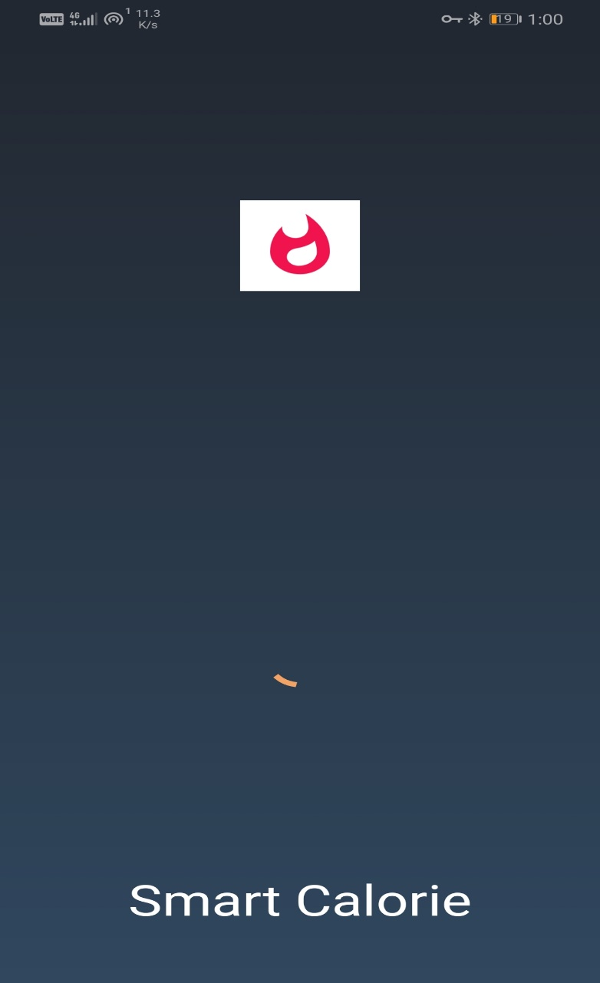

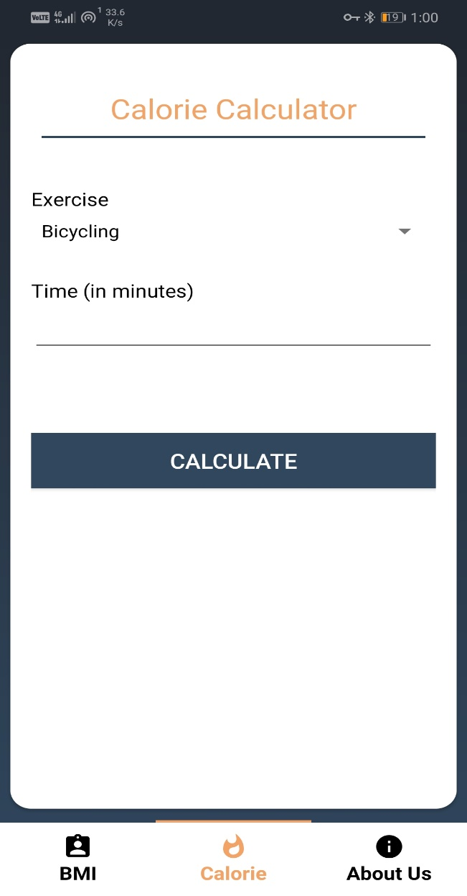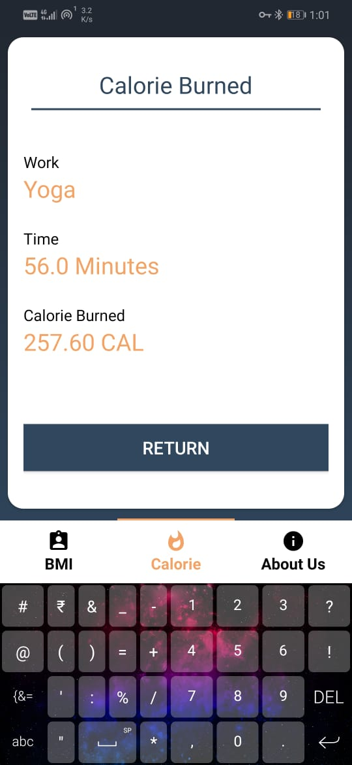

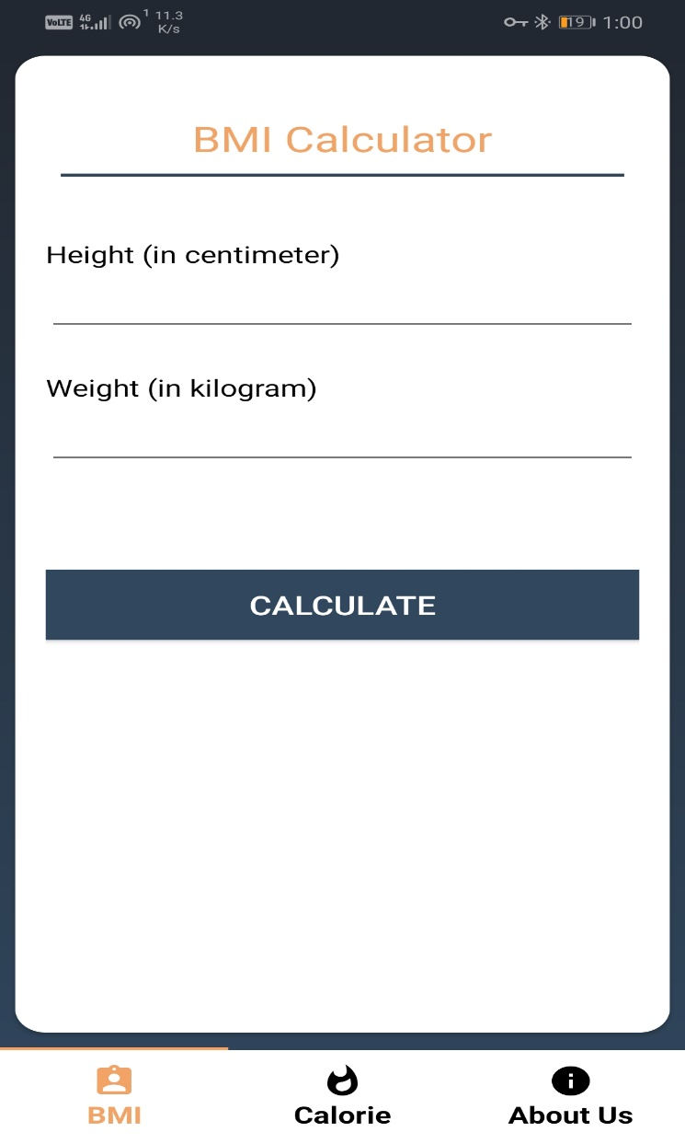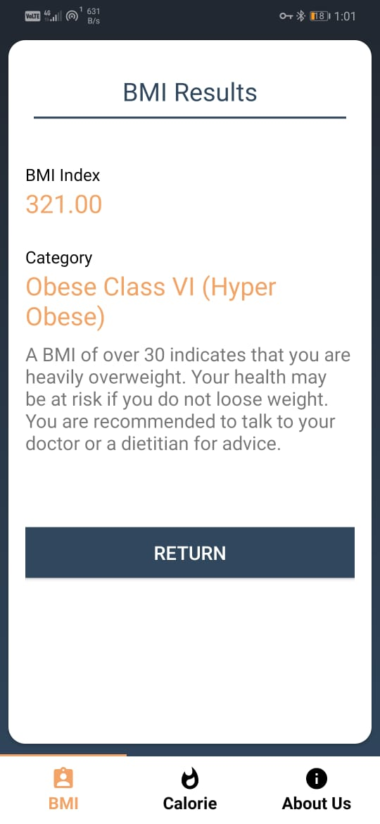

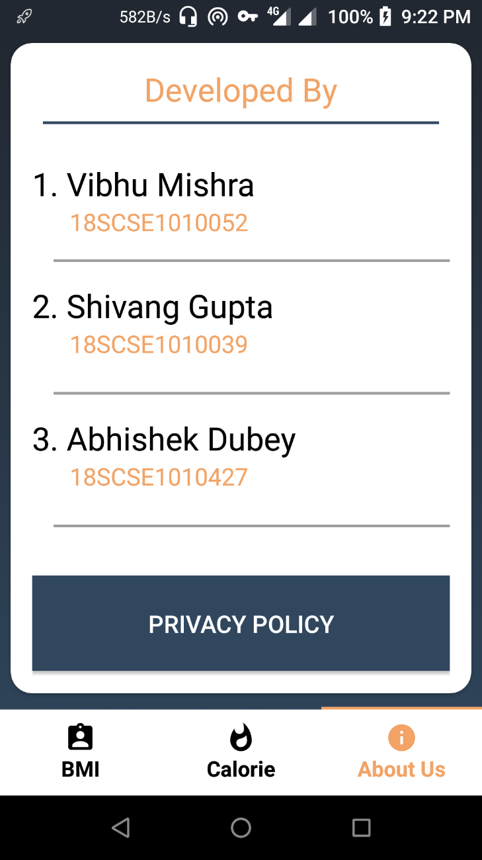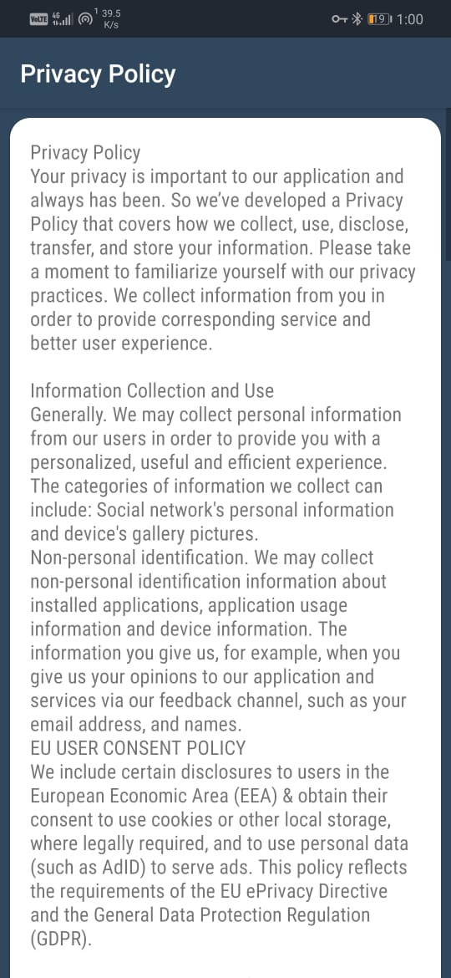

**DISCUSSION -:**

This research project is significant to the field of medicine especially as it relates to the fitness of the human body. Developing the application as an Android-based app improves its accessibility via smartphones given the wide spread adoption of Android-based mobile devices. In addition, there is cost savings for the consumer, as there would be no more need to purchase a wearable. The mobile application developed tracks fitness data over time; calculates the number of calories burnt while exercising; monitors weight loss and number of steps taken; and improves the overall fitness of an individual unlike the application developed in [31] which basically provides advice about obtaining a healthy diet. Calorie Fit-Burn trackers have seen a lot of advances in the health and fitness sector of technology. This study, thriving on the recommendations of earlier researchers has decided to make it standalone, hence making it easily accessible at once to every average person who cannot afford to purchase a fitness band or an additional hardware, it would help improve good standard of living and in turn reduce health diseases and death brought about by the lack of exercise. This application has been built with some of the latest technologies hence; it enjoys the security benefits that come with those time-tested technologies. When deployed, it would greatly help users achieve their fitness and health goals. With such information as knowing the amount of calories burnt per activity makes for room to calculate the calorie intake and maintain a healthy and balanced life

**CONCLUSION AND FUTURE WORKS**

The mobile Calorie Fit-Burn Tracker has been built using Angular (a framework of JavaScript) compiled with Ionic Framework which allows for compiling across all mobile platforms i.e. Android, iOS, and Windows mobile. It is believed that the application would give rise to healthy living amongst the average of people, due to the plus side that it does not require an additional hardware (bands or watches) to function with. This project has been deployed as a mobile application to allow easy access for users. However, with the rapid growth in the use of cheaper fitness bands, it would be profitable for such platforms to be exploited. This would bring about greater portability and access to a wider range of persons. The following activities are planned for future work: • Conduct of usability evaluation to obtain feedback from users • Integration with Smart Watches and Devices: Due to the increase in smart watches and health fitness bands. According to Moore’ Law, fitness bands and electronic devices would get cheaper along the years with better performance. Hence the need of an integration with fitness bands and smart watches • Implementation of various Activities: This current platform only caters for walking and running; a provision needs to be made to accommodate other physical activities. • Setting Workout Goals: Users should possess the ability to set out their desired workout rate, exercises and weight loss goal in which they aim to achieve.