**Industrial Internship Report on**

**Prediction of Agriculture Crop Production in India**

**Prepared by**

|  |
| --- |
| *Executive Summary* |
| This report provides details of the Industrial Internship provided by Up-Skill Campus and The IoT Academy in collaboration with Industrial Partner Uni-converge Technologies Pvt Ltd (UCT).  This internship was focused on a project/problem statement provided by UCT. We had to finish the project including the report in 6 weeks’ time.  My project was ‘Prediction of Agriculture Crop Production in India’ provide an overview of the Prediction of Agriculture Crop Production in India and present the findings and results.  The prediction of agriculture crop production in India is a crucial aspect of the country's agricultural planning and management. India's agriculture sector plays a pivotal role in its economy, employing a significant portion of the workforce and contributing significantly to GDP. However, crop production is highly dependent on various factors, including climatic conditions, soil health, water availability, and technological advancements.  Despite advancements in technology and data availability, there are challenges in accurately predicting crop production in India. Inadequate data infrastructure, limited access to technology in rural areas, and difficulties in integrating diverse datasets remain significant obstacles.  This internship gave me a very good opportunity to get exposure to Industrial problems and design/implement solution for that. It was an overall great experience to have this internship. I’m very grateful to be a part of this UPSKILL CAMPUS as an Intern. |

**-Yandra Venkata Shivani**

**TABLE OF CONTENTS**

1 Preface 3

2 Introduction 4

2.1 About UniConverge Technologies Pvt Ltd 4

2.2 About upskill Campus 8

2.3 Objective 9

2.4 Reference 9

2.5 Glossary 10

3 Problem Statement 11

4 Existing and Proposed solution 12

5 Proposed Design/ Model 13

6 Performance Test 14

7 My learnings 15

8 Future work scope 16

# Preface

Agriculture has been the backbone of India's economy for centuries, providing livelihoods to millions and contributing significantly to the nation's Gross Domestic Product (GDP). As the population continues to grow and environmental factors become more unpredictable due to climate change, the need for accurate prediction of crop production has never been more crucial. The ability to forecast crop yields empowers farmers, policymakers, and stakeholders to make informed decisions, manage resources efficiently, and ensure food security for the nation.

This preface delves into the topic of "Prediction of Agriculture Crop Production in India," exploring the importance, challenges, methodologies, and potential solutions that play a pivotal role in shaping the agricultural landscape of the country. Modern technologies, such as remote sensing, satellite imagery, climate data, and artificial intelligence, have revolutionized crop production prediction.

Machine learning algorithms and data analytics process vast amounts of information, including historical yield records, soil health parameters, and weather patterns, to generate precise forecasts. Real-time information dissemination through mobile applications and internet-based platforms enhances the accessibility and usability of predictions for farmers in remote regions.

Challenges, such as climate change, unpredictable weather patterns, and the outbreak of pests and diseases, pose significant obstacles to accurate predictions. Additionally, limited access to technology and data gaps in certain regions hinder the development of comprehensive and inclusive prediction models.

The vision for the future of crop production prediction in India involves a dynamic ecosystem driven by data-driven insights, artificial intelligence, and collaborative efforts. By leveraging technology, harnessing the power of big data, and integrating traditional knowledge with modern practices, India can strengthen its agricultural resilience, ensure food security, and boost farmer prosperity.

The prediction of agriculture crop production in India using Exploratory Data Analysis (EDA) is a data-driven approach that involves examining and analyzing agricultural datasets to gain insights into the factors influencing crop yields. EDA helps to identify patterns, trends, and relationships in the data, enabling informed decision-making and more accurate predictions.

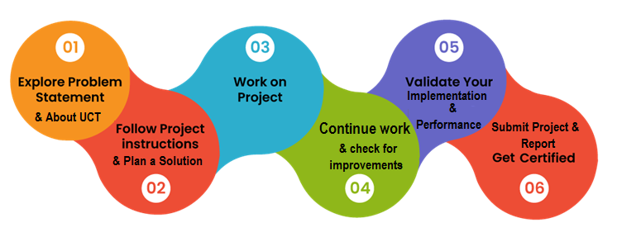

I extend my heartfelt gratitude to Upskill Campus, whose invaluable guidance and support have been instrumental in the successful completion of this project. Their expertise and encouragement have greatly enriched this endeavor, and I am sincerely grateful for their assistance

Dear Juniors,

The prediction of agriculture crop production in India through Exploratory Data Analysis (EDA) tools and processes is a data-driven approach that empowers stakeholders to make informed decisions and improve agricultural outcomes. EDA involves collecting and analyzing diverse agricultural datasets to uncover valuable insights and relationships between crop yields and various influencing factors.

The process begins with data collection from various sources, including historical crop yields, climate data, soil health parameters, and agricultural practices. The collected data is then cleaned and preprocessed to handle missing values, outliers, and inconsistencies.

During the EDA process, various data visualization techniques are applied to understand the distribution and patterns of the data. Graphs, charts, and maps help to visualize crop yield trends over time, spatial distribution, and correlations between different variables.

EDA also involves conducting statistical analyses to uncover insights into the relationships between crop production and factors such as rainfall, temperature, soil fertility, and crop management practices. Correlation analysis and regression modeling can be used to quantify the impact of these factors on crop yields.

Moreover, the identification of anomalies or unusual patterns during EDA can provide valuable information for understanding crop failures or potential risks.

EDA plays a vital role in feature selection, where relevant variables are identified to build predictive models. Machine learning algorithms can be applied to the preprocessed data to create predictive models that forecast crop yields based on historical trends and environmental factors.

The findings from the EDA process facilitate evidence-based decision-making for farmers, policymakers, and stakeholders in the agriculture sector. It allows for better resource allocation, risk mitigation, and the formulation of effective agricultural policies to improve crop productivity and ensure food security in India.

In conclusion, the application of EDA in predicting agriculture crop production in India empowers stakeholders with valuable insights into the complex interactions between various factors influencing crop yields. By leveraging data visualization, statistical analysis, and machine learning techniques, EDA enhances the accuracy of crop production predictions and supports sustainable agricultural practices for the nation's economic growth and food sufficiency.

I would like to extend my appreciation to my fellow team mentors for their hard work and dedication. Their collaborative spirit and commitment to excellence were vital in achieving our project's objectives.

Best regards,

Y.V. Shivani

# Introduction

## About Uni Converge Technologies Pvt Ltd

A company established in 2013 and working in Digital Transformation domain and providing Industrial solutions with prime focus on sustainability and roIe.

At Uni Converge, we pride ourselves on our client-centric approach, where we collaborate closely with our clients to understand their unique requirements and objectives. By leveraging the latest technologies and best practices, we design and implement tailored solutions that drive business growth and efficiency.

As we look towards the future, Uni Converge remains dedicated to pushing the boundaries of technology, staying at the forefront of industry trends, and consistently delivering solutions that create a lasting impact for our clients.

With a commitment to excellence, quality, and customer satisfaction, we have earned the trust of a diverse clientele spanning various industries, from startups to established enterprises. Our proven track record of successful project deliveries has made us a preferred technology partner for companies seeking innovative and reliable solutions.

For developing its products and solutions it is leveraging various**Cutting Edge Technologies e.g., Internet of Things (IoT), Cyber Security, Cloud computing (AWS, Azure), Machine Learning, Communication Technologies (4G/5G/LoRaWAN), Java Full Stack, Python, Front end**etc.



1. UCT IoT Platform **(****)**

**UCT Insight** is an IOT platform designed for quick deployment of IOT applications on the same time providing valuable “insight” for your process/business. It has been built in Java for backend and ReactJS for Front end. It has support for MySQL and various NoSQL Databases.

* It enables device connectivity via industry standard IoT protocols - MQTT, CoAP, HTTP, Modbus TCP, OPC UA
* It supports both cloud and on-premises deployments.

It has features to  
• Build Your own dashboard  
• Analytics and Reporting  
• Alert and Notification  
• Integration with third party application (Power BI, SAP, ERP)  
• Rule Engine

An IoT (Internet of Things) platform is a comprehensive software solution that facilitates the development, deployment, and management of IoT applications and devices. These platforms act as a middleware, enabling seamless communication and data exchange between various IoT devices and applications.

Features of an IoT platform may include:

Device Management: Provisioning, monitoring, and controlling IoT devices, including over-the-air updates and remote management.

Data Ingestion and Analytics: Capturing, storing, and processing data generated by IoT devices for real-time or historical analysis.

Connectivity: Supporting various communication protocols and ensuring secure and reliable data transmission between devices and the platform.

Security: Implementing robust security mechanisms to protect data, devices, and communications from potential threats.

Application Development: Enabling developers to build custom IoT applications using APIs, SDKs, and other development tools.

Integration: Facilitating integration with other systems and services to extend the platform's capabilities.

Visualization and Reporting: Providing dashboards, reports, and data visualization tools for insights and decision-making.

Scalability: Supporting the ability to handle a large number of connected devices and data points as the IoT deployment grows.

 

1. **Smart Factory Platform (****)**

* Factory watch is a platform for smart factory needs.

It provides Users/ Factory :

* with a scalable solution for their Production and asset monitoring
* OEE and predictive maintenance solution scaling up to digital twin for your assets.
* to unleased the true potential of the data that their machines are generating and helps to identify the KPIs and also improve them.
* A modular architecture that allows users to choose the service that they what to start and then can scale to more complex solutions as per their demands.

Its unique SaaS model helps users to save time, cost and money. 

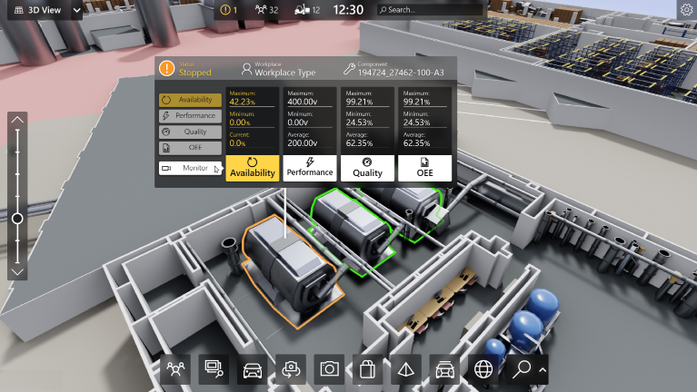

1.  based Solution

UCT is one of the early adopters of LoRaWAN technology and providing solution in Agritech, Smart cities, Industrial Monitoring, Smart Street Light, Smart Water/ Gas/ Electricity metering solutions etc.

1. Predictive Maintenance

UCT is providing Industrial Machine health monitoring and Predictive maintenance solution leveraging Embedded system, Industrial IoT and Machine Learning Technologies by finding Remaining useful life time of various Machines used in production process.



## About upskill Campus (USC)

UpSkill Campus along with The IoT Academy and in association with Uni Converge Technologies has facilitated the smooth execution of the complete internship process.

USC is a career development platform that delivers **personalized executive coaching** in a more affordable, scalable and measurable way.



Seeing need of upskilling in self paced manner along-with additional support services e.g. Internship, projects, interaction with Industry experts, Career growth Services

<https://www.upskillcampus.com/>

UpSkill Campus aiming to upskill 1 million learners in next 5 year



## The IoT Academy

The IoT academy is EdTech Division of UCT that is running long executive certification programs in collaboration with EICT Academy, IITK, IITR and IITG in multiple domains. An IoT academy is an educational institution, training center, or online platform that provides comprehensive learning opportunities to individuals or professionals seeking to enhance their knowledge and skills in the field of IoT.

## Objectives of this Internship program

The objective for this internship program was to

 ☛ get practical experience of working in the industry.

 ☛ to solve real world problems.

 ☛ to have improved job prospects.

 ☛ to have Improved understanding of our field and its applications.

 ☛ to have Personal growth like better communication and problem solving.

## Reference

[1] <https://www.kaggle.com/code/pratikicecool96/agricultrue-output-india>

[2] <https://www.kaggle.com/code/aanchaljayal/crop-production-in-india-eda-project>

## Glossary

|  |  |
| --- | --- |
| Term | Definition |
| EDA | Exploratory Data Analysis; the process of visually and statistically exploring and summarizing data. |
| Crop Production | The quantity of crops harvested in a specific area over a defined period. |
| Prediction | Forecasting future crop production based on historical data and relevant influencing factors. |
| India | The country where the agriculture crop production prediction is being carried out. |
| Exploratory  Data Analysis | A preliminary data analysis technique to discover patterns, trends, and relationships in the data. |
| Data Cleaning | The process of identifying and correcting errors and inconsistencies in the collected data. |
| Data Visualization | Representing data in graphical or visual formats, such as charts, graphs, and maps, to gain insights. |
| Climate Data | Information related to weather conditions, including rainfall, temperature, humidity, etc. |
| Data Analytics | Analyzing data using statistical and computational techniques to extract insights and patterns. |
| Feature Selection | Identifying the most relevant variables (features) for building predictive models. |
| Correlation Analysis | Identifying the degree of association between two or more variables in the dataset. |
| Regression Modeling | A statistical technique to model the relationship between dependent and independent variables. |

**Problem Statement:**

The agricultural sector in India plays a critical role in the country's economy and sustains the livelihoods of a significant portion of the population. Accurate prediction of agriculture crop production is essential for efficient resource allocation, planning, and decision-making to ensure food security and support sustainable agricultural practices.

The Problem: The current challenge lies in developing a robust prediction model for agriculture crop production in India using Exploratory Data Analysis (EDA). The goal is to leverage historical crop yield data, climate information, soil health parameters, and other relevant factors to forecast crop production for specific regions and timeframes accurately.

Key Challenges:

1. Data Complexity: Agricultural data can be vast, diverse, and sometimes incomplete. The challenge is to clean, preprocess, and integrate data from various sources to ensure data quality and consistency.

2. Climate Variability: India's diverse climate patterns, including monsoons, droughts, and extreme weather events, present a complex environment for accurate crop production prediction.

3. Seasonal and Regional Variations: Crop production varies significantly across seasons and regions. Developing a model that captures these variations effectively is crucial.

4. Limited Data Accessibility: Some regions may lack sufficient data infrastructure, posing challenges in acquiring comprehensive and up-to-date datasets.

5. Identifying Relevant Features: Selecting the most relevant features from the extensive dataset that significantly impact crop production is vital to build accurate predictive models.

Objectives:

The main objectives of this project are as follows:

1. To explore and analyze historical agriculture crop yield data, climate data, and soil health parameters using EDA techniques

2. To identify patterns, trends, and correlations between crop production and influencing factors

3. To develop a predictive model that accurately forecasts crop production for various crops, regions, and timeframes.

4. To evaluate the model's performance, including accuracy, precision, and recall, using appropriate evaluation metrics.

5. To provide actionable insights and recommendations for farmers, policymakers, and stakeholders to optimize resource allocation and support sustainable agricultural practices.

The successful implementation of this project will contribute to informed decision-making, improved agricultural productivity, and enhanced food security in India. By leveraging EDA techniques to predict crop production, we aim to empower stakeholders with valuable insights to address the challenges and opportunities in the agricultural sector effectively.

# Existing and Proposed solution

**Existing Solution:**

Currently, the prediction of agriculture crop production in India relies on traditional statistical models and historical data analysis. Experts and agricultural researchers use regression models and time-series analysis to forecast crop yields based on past trends and factors like rainfall, temperature, and soil health.

However, the existing solution has limitations due to its reliance on static models and a limited set of factors. It may not fully capture the complexities of India's diverse climate, soil conditions, and changing agricultural practices. Additionally, the traditional approach may not consider real-time data, making it less adaptive to dynamic environmental changes.

**Proposed Solution**

To overcome the limitations of the existing solution, the proposed approach involves the application of Exploratory Data Analysis (EDA) in predicting agriculture crop production in India. EDA leverages modern technologies, data visualization, and advanced statistical techniques to gain deeper insights into the data and identify hidden patterns and relationships.

1. Data Collection and Preprocessing: The proposed solution will gather a wide range of data, including historical crop yields, climate data, soil health parameters, and socio-economic factors. The data will undergo rigorous cleaning and preprocessing to ensure data quality and consistency.

2. Data Visualization and Feature Selection: EDA techniques will be employed to visualize the data and identify relevant features that significantly impact crop production. Interactive charts, graphs, and spatial maps will help understand regional variations and trends.

3. Correlation Analysis and Machine Learning: The proposed solution will perform correlation analysis to measure the relationships between crop yields and influencing factors. Machine learning algorithms, such as decision trees, random forests, and gradient boosting, will be applied to develop predictive models.

4. Real-time Data Integration: Unlike the existing solution, the proposed approach will integrate real-time data, including weather updates and satellite imagery, to adapt the models to changing environmental conditions.

5. Model Evaluation and Improvement: The developed predictive models will be evaluated using cross-validation techniques and appropriate evaluation metrics to ensure accuracy and reliability. Continuous model refinement and improvement will be undertaken to enhance prediction performance.

6. Actionable Insights and Recommendations: The proposed solution will provide actionable insights and recommendations based on the model predictions. Farmers, policymakers, and stakeholders will receive timely information to optimize resource allocation, plan crop rotations, and implement sustainable agricultural practices.

By leveraging EDA techniques, the proposed solution aims to provide a more comprehensive, dynamic, and accurate prediction of agriculture crop production in India. The integration of real-time data and advanced machine learning algorithms will enhance the adaptability and precision of the models, supporting data-driven decision-making for a sustainable and resilient agricultural sector.

**Benefits of the Proposed System:**

* Enhanced Accuracy and Precision: By leveraging EDA techniques and machine learning algorithms, the proposed system can achieve higher accuracy in crop production predictions. The integration of diverse datasets and real-time data enables the models to adapt to changing environmental conditions, resulting in more precise forecasts.
* Improved Resource Allocation: Accurate predictions provided by the proposed system empower farmers and policymakers to allocate resources more efficiently. This includes optimized water usage, appropriate fertilizer application, and timely pest and disease management, leading to increased crop yields and reduced wastage.
* Sustainable Agricultural Practices: The system's actionable insights and recommendations promote sustainable agricultural practices. Farmers can make informed decisions on crop rotations, cover cropping, and other conservation methods to maintain soil health and biodiversity while reducing the environmental impact.
* Enhanced Food Security: With more accurate crop production predictions, the proposed system aids in ensuring food security in India. By effectively planning and managing agricultural activities, potential food shortages can be anticipated and mitigated, ensuring a stable food supply for the population.
* Timely Decision-Making: Real-time data integration allows stakeholders to respond promptly to changing climatic conditions and other influencing factors. Timely decisions based on updated information can prevent crop losses and minimize financial risks.

## Code submission (GitHub link)

https://github.com/Shivani-49/UpSkillCampus/blob/main/Prediction_of_Agriculture_Crop_Production_in_India_USC_UCT.ipynb

## Report submission (GitHub link):

## https://github.com/Shivani-49/UpSkill-Campus

# Proposed Design/ Model

The proposed design for the prediction of agriculture crop production in India using Exploratory Data Analysis (EDA) involves a multi-step approach that leverages modern technologies, data visualization, and advanced statistical techniques.

1. Data Collection and Preprocessing:

-Gather a comprehensive dataset that includes historical crop yields, climate data (rainfall, temperature, humidity), soil health parameters (fertility, pH, nutrients), geographical information, and other relevant factors.

-Clean and preprocess the data to handle missing values, outliers, and inconsistencies, ensuring data quality and consistency.

1. Data Visualization and Feature Selection:

-Apply data visualization techniques to understand the distribution and patterns of the data. Create interactive charts, graphs, and maps to identify trends and regional variations in crop yields.

-Conduct correlation analysis to measure the relationships between crop yields and influencing factors, helping identify the most relevant features for prediction.

1. Machine Learning Model Development:

-Utilize various machine learning algorithms, such as decision trees, random forests, gradient boosting, and support vector machines, to develop predictive models.

-Split the dataset into training and testing sets to train the models and evaluate their performance.

1. Model Training and Validation:

-Train the predictive models on the training dataset, using features identified during feature selection.

-Use cross-validation techniques to validate the models and prevent overfitting, ensuring robustness and generalizability.

1. Real-time Data Integration:

-Integrate real-time data, such as weather updates and satellite imagery, to make the models adaptive to current environmental conditions.

-Update the models periodically to incorporate new data and enhance prediction accuracy.

1. Model Evaluation and Performance Metrics:

-Evaluate the predictive models using appropriate evaluation metrics, such as Mean Absolute Error (MAE), Mean Squared Error (MSE), and R-squared, to assess their accuracy and reliability.

-Compare the performance of different models to select the most suitable one for crop production prediction.

1. Actionable Insights and Recommendations:

-Generate actionable insights and recommendations based on the model predictions.

-Provide timely information to farmers, policymakers, and stakeholders to optimize resource allocation, plan crop rotations, and implement sustainable agricultural practices.

1. Deployment and Integration:

-Implement the predictive model into a user-friendly application or platform accessible to farmers and relevant stakeholders.

-Integrate the proposed system with existing agricultural databases and decision-support systems for seamless data flow.

Continuous monitoring, evaluation, and refinement will ensure that the model remains effective and relevant in the ever-changing agricultural landscape.

# Performance Test

Performing performance tests on predictions of agriculture crop production in India using Exploratory Data Analysis (EDA) involves a series of steps to evaluate the accuracy and effectiveness of the predictive models. Performance testing on predictions of agriculture crop production in India is essential to evaluate the accuracy and reliability of the predictive models.

Here are the key steps involved in conducting performance tests:

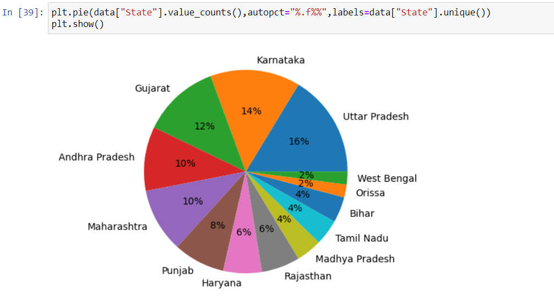

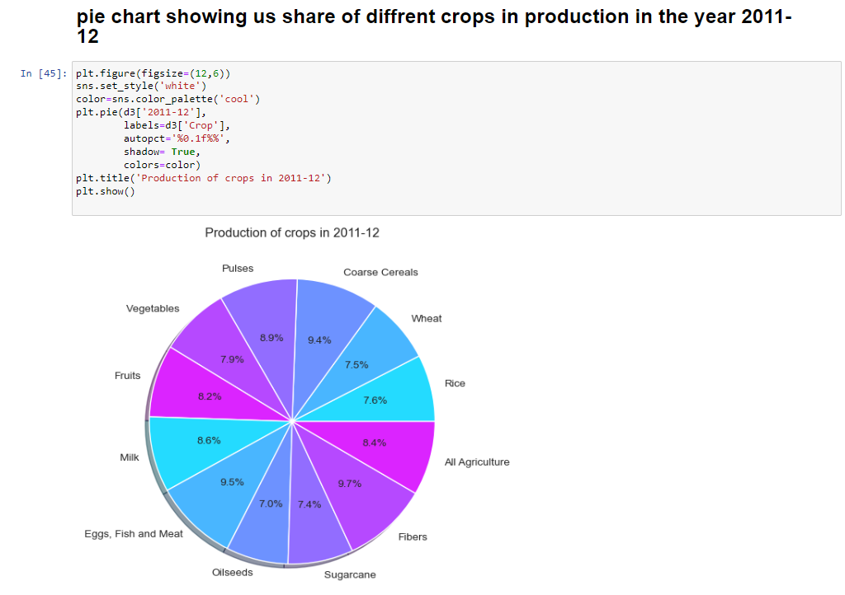

# My learnings

The project on predictions of agriculture crop production in India using Exploratory Data Analysis (EDA) offers students a transformative learning experience. This project offers a valuable learning experience for students. Through this project, I have gained practical knowledge and skills in various areas:

1. Domain Knowledge: Students deepen their understanding of agriculture, crop production, and the factors influencing yields in India.
2. Data Handling: They acquire skills in data collection, preprocessing, and cleaning, dealing with real-world agricultural datasets.
3. Exploratory Data Analysis (EDA): Students visualize and interpret patterns and trends in data, identifying significant features and correlations impacting crop production.
4. Machine Learning: Students explore machine learning algorithms to build predictive models based on historical data and relevant variables.
5. Interdisciplinary Insights: This project bridges agricultural science and data science, encouraging integration of knowledge from multiple disciplines.
6. Practical Application: Students apply theoretical concepts to real-world scenarios, translating analytical insights into actionable recommendations.
7. Problem-Solving: They develop critical thinking skills to address challenges in data analysis and model development.
8. Collaboration: Students work with stakeholders, data experts, and domain specialists, enhancing their teamwork and communication skills.
9. Sustainability Awareness: The project fosters an understanding of the environmental and social impact of agricultural practices.
10. Research and Innovation: The project inspires students to explore further research avenues and related topics in agricultural data analytics.

# Future work scope

The future work scope on predictions of agriculture crop production in India using Exploratory Data Analysis (EDA) is promising and can be extended to address several key areas to enhance the accuracy, applicability, and impact of the predictive models. Here are some potential future work scopes:

1. Incorporating Advanced Machine Learning Techniques: Explore and implement more advanced machine learning algorithms and techniques, such as deep learning, ensemble methods, and time-series forecasting models, to improve the accuracy and robustness of the predictive models.

2. Big Data Integration: With the ever-increasing availability of agricultural data, consider integrating big data analytics and cloud computing to handle vast datasets, leading to more comprehensive and precise predictions.

3. Spatial-Temporal Analysis: Implement spatial-temporal analysis to understand how crop production varies over different regions and timeframes, enabling localized and season-specific predictions.

4. Climate Change Adaptation: Factor in the impacts of climate change on agriculture, and develop models that can adapt to changing climate patterns, making predictions more resilient and reliable.

5. Remote Sensing and Satellite Imagery: Utilize remote sensing technologies and satellite imagery to capture real-time data on crop health, vegetation indices, and soil moisture, providing valuable input for prediction models.

6. Crowd Sourced Data: Consider incorporating crowd Sourced data from farmers and local communities to supplement existing datasets, enhancing the granularity and inclusivity of the predictive models.

7. Dynamic Model Updating: Develop methods for dynamically updating the predictive models based on real-time data, ensuring the models remain relevant and accurate as conditions change.

8. Decision Support System Integration: Integrate the predictive models into decision support systems for farmers and policymakers, providing real-time insights and recommendations to aid decision-making.

9. Multi-Crop Predictions: Expand the scope of the predictive models to cover multiple crops, allowing for a comprehensive analysis of crop production trends and patterns across various agricultural commodities.

10. Collaboration and Stakeholder Engagement: Collaborate with agricultural research institutions, government agencies, and NGOs to gather domain-specific expertise and ensure the predictive models meet the needs of diverse stakeholders.

11. Uncertainty Analysis: Include uncertainty analysis techniques to quantify the uncertainties associated with the predictions, providing a clearer understanding of prediction reliability and risk.

12. Long-Term Yield Predictions: Extend the time horizon of predictions to make long-term yield projections, assisting long-term agricultural planning and policy formulation.

By exploring these future work scopes, the prediction of agriculture crop production in India using EDA can evolve into a more robust, adaptable, and impactful tool for supporting sustainable agriculture, enhancing food security, and driving agricultural development in the country.

**Conclusion:**

In conclusion, the project has been a rewarding learning experience that has equipped us with valuable skills in data analytics, machine learning, and critical thinking. We believe that the insights gained and the predictive models developed will contribute significantly to advancing agricultural practices in India. As we look to the future, we are inspired to continue exploring innovative research avenues to further enhance the impact of data analytics in agriculture and address the ever-evolving challenges in this vital sector.