QUERY:
Display the highest paid employee in each departments.

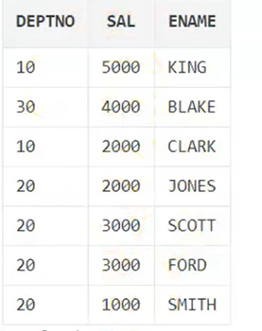

Here we use GROUP BY query
Refer :
https://www.geeksforgeeks.org/sql-group-by/?ref=lbp
We are categorize maximum salary based on deptno
First data separeated into department wise then max is applied for each function.

SELECT max(sal),deptno
FROM emp
GROUP BY deptno;

Suppose want to find emplyess in each department

Count return number of rows in tabel
SELECT COUNT(*),deptno
FROM emp
GROUP BY deptno;

