Predictive Modeling and Risk Scoring
for Bank Customer Churn
A Machine Learning Research Study
Prepared by Shivani K
Data Analyst Portfolio Project

1. Introduction & Background
Customer churn — the loss of existing customers — directly affects a retail bank's revenue stability, customer lifetime value, and cross-sell potential. Traditional churn analysis is retrospective: it explains why customers left after the fact. This project instead builds a predictive churn intelligence system that assigns a churn risk probability to each customer before they leave, enabling proactive rather than reactive retention strategies.
The primary objectives of this study are to: (1) predict customer churn with high accuracy, (2) generate churn probability scores for individual customers, and (3) identify the key behavioral and demographic drivers of churn in an explainable way, so that retention actions can be targeted rather than broad and costly.

2. Dataset Description
The dataset consists of 10,000 customer records from a European retail bank, spanning three markets: France, Germany, and Spain. Each record includes demographic attributes (age, gender, geography), account attributes (credit score, balance, tenure, number of products, credit card ownership), engagement indicators (active membership status), and the target variable Exited (1 = churned, 0 = retained).
The dataset was found to be clean, with no missing values and no duplicate customer records. However, it is imbalanced: only 20.4% of customers churned, while 79.6% were retained. This imbalance was a critical consideration throughout modeling, since a naive model could achieve 80% accuracy by simply predicting "no churn" for every customer — while completely failing at the actual business objective of identifying at-risk customers.

3. Exploratory Data Analysis
Overall Churn Distribution
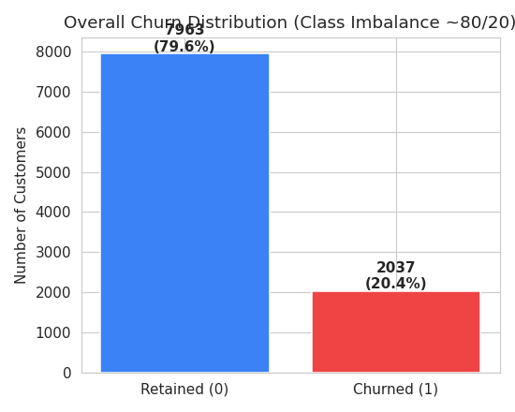
Figure 1: Class distribution shows a 79.6% / 20.4% imbalance between retained and churned customers.
Churn Rate by Geography, Gender, and Activity Status
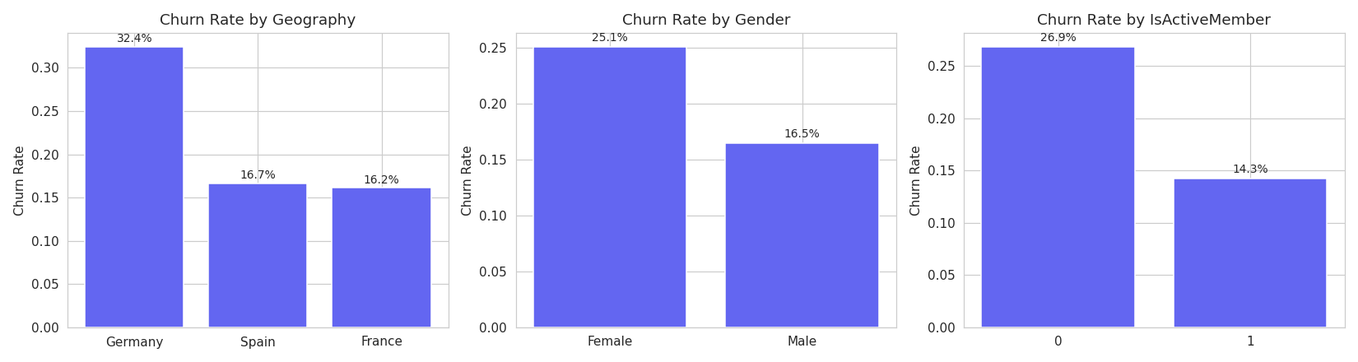
Figure 2: Germany shows a markedly higher churn rate than France or Spain. Inactive members churn at nearly double the rate of active members.
Churn Rate by Number of Products — the Strongest Pattern
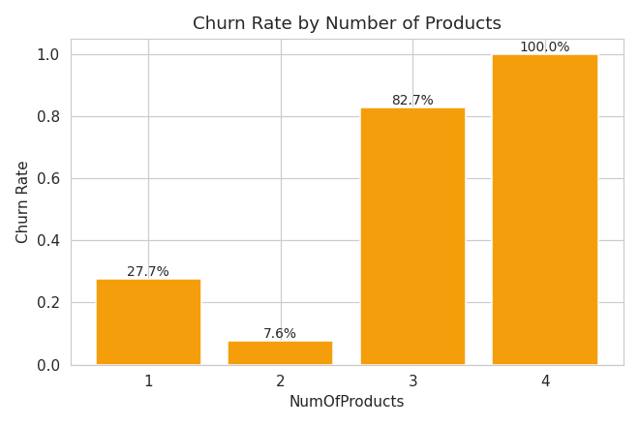
Figure 3: Churn rate does not decrease linearly with more products. Customers with 2 products are the most loyal (~8% churn), but customers with 3 or 4 products churn at 82% and 100% respectively.
This is the single most important — and most counter-intuitive — finding in the dataset. A common assumption is that customers holding more products are more "locked in" and therefore more loyal. The data directly contradicts this: product count beyond 2 is a near-certain predictor of churn, likely reflecting frustration from over-bundling, forced cross-selling, or product complexity rather than genuine loyalty.
Geography | Churn Rate
Germany | ~32%
France | ~16%
Spain | ~17%
NumOfProducts | Churn Rate
1 product | ~25%
2 products | ~8%
3 products | ~82%
4 products | ~100%
Activity Status | Churn Rate
Inactive Member | ~27%
Active Member | ~14%

Numeric Feature Distributions
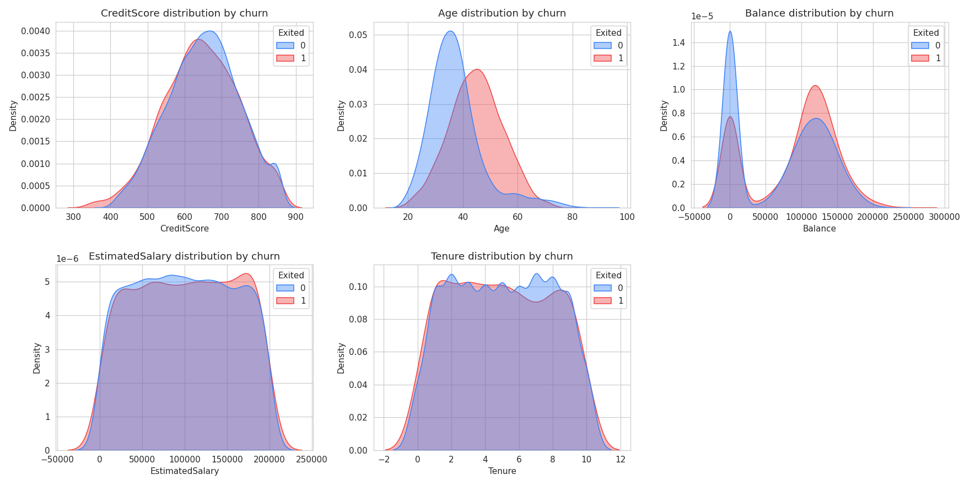
Figure 4: Age shows the clearest separation between churned and retained customers; Tenure, CreditScore, and EstimatedSalary show minimal separation.
Correlation Structure
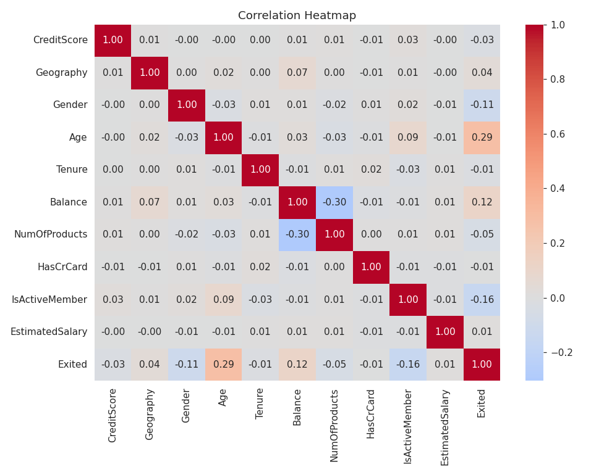
Figure 5: Correlation heatmap of numeric and encoded categorical features.
Age was confirmed as a strong driver: churned customers average 45 years old, compared to 37 for retained customers. In contrast, Tenure (5.03 vs. 4.93 years) and CreditScore (651 vs. 645) showed almost no difference between churned and retained groups, indicating these are weak predictors despite intuitively seeming relevant.

4. Methodology
Preprocessing
- Removed non-informative identifier columns (CustomerId, Surname).
- One-hot encoded categorical variables (Geography, Gender).
- Applied stratified train-test splitting (80/20) to preserve the churn class ratio in both sets.
- Scaled numerical features for the Logistic Regression baseline (tree-based models do not require scaling).
Feature Engineering
- Balance-to-Salary ratio — captures financial position relative to income.
- Engagement × Product interaction — combines activity status with product count into a single signal.
- Age × Tenure interaction — captures whether long-tenured older customers behave differently from newer, younger ones.
- Product density and zero-balance flag — additional derived indicators of account behavior.
Class Imbalance Handling
Given the 80/20 imbalance, all models were trained with class-weight balancing (or equivalent scale-position weighting for XGBoost) to prevent the models from defaulting to the majority "no churn" prediction.

5. Model Development & Evaluation
Five models were trained and compared: Logistic Regression (interpretability baseline), Decision Tree, Random Forest, Gradient Boosting, and XGBoost. Each was evaluated on Accuracy, Precision, Recall, F1-Score, and ROC-AUC on a held-out 20% test set.
Model | Accuracy | Precision | Recall | F1-Score | ROC-AUC
Random Forest | 0.819 | 0.542 | 0.700 | 0.611 | 0.867
XGBoost | 0.807 | 0.518 | 0.745 | 0.611 | 0.867
Gradient Boosting | 0.869 | 0.786 | 0.487 | 0.601 | 0.870
Decision Tree | 0.758 | 0.445 | 0.769 | 0.564 | 0.826
Logistic Regression | 0.713 | 0.387 | 0.705 | 0.500 | 0.776

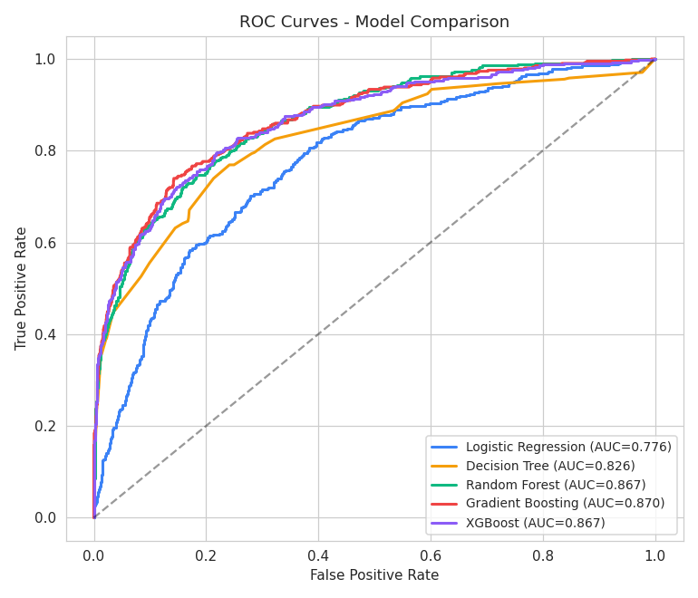
Figure 6: ROC curves for all five models. Random Forest, XGBoost, and Gradient Boosting show similar discriminative ability (AUC ≈ 0.87).
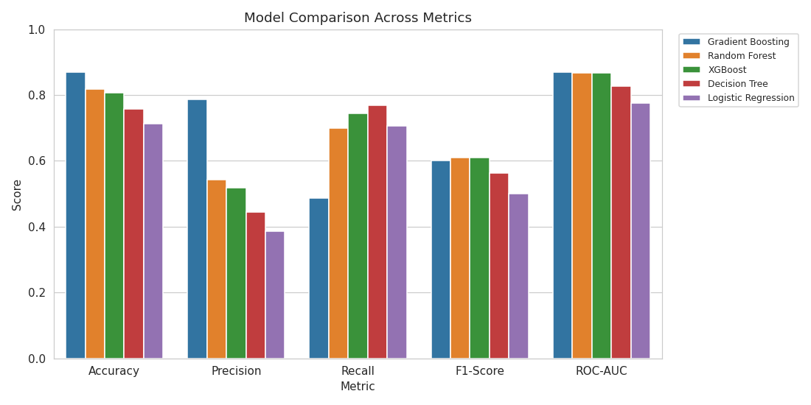
Figure 7: Side-by-side metric comparison across all five models.
Model Selection Rationale
Gradient Boosting achieved the highest ROC-AUC (0.870), but its Recall was only 48.7% — meaning it failed to identify more than half of the customers who actually churned. For a retention system, this is a costly failure mode: a missed churner is a lost customer the bank never had the chance to retain. Random Forest, by contrast, achieved a Recall of 70.0% with a nearly identical F1-Score (0.611 vs. 0.601) and only a marginally lower ROC-AUC (0.867 vs. 0.870).
For this reason, Random Forest was selected as the final model, using F1-Score — which balances Precision and Recall — as the selection criterion rather than ROC-AUC alone. This decision reflects the business objective stated in the project brief: capturing actual churners for proactive retention outreach, not simply maximizing a single aggregate statistic.
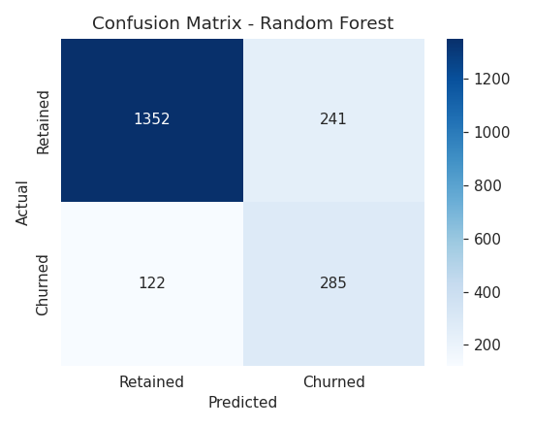
Figure 8: Confusion matrix for the selected Random Forest model on the test set.

6. Model Explainability
Feature importance and SHAP (SHapley Additive exPlanations) values were used to interpret the Random Forest model's predictions — a requirement for regulatory compliance and business trust in any churn intervention system.
Feature | Importance
Age | 31.3%
NumOfProducts | 19.0%
Engagement_product (Active × Products) | 9.2%
Balance | 6.4%
Age_tenure (Age × Tenure) | 5.1%
Geography_Germany | 5.1%
Balance_to_Salary | 4.3%
EstimatedSalary | 3.8%
IsActiveMember | 3.6%
CreditScore | 3.4%

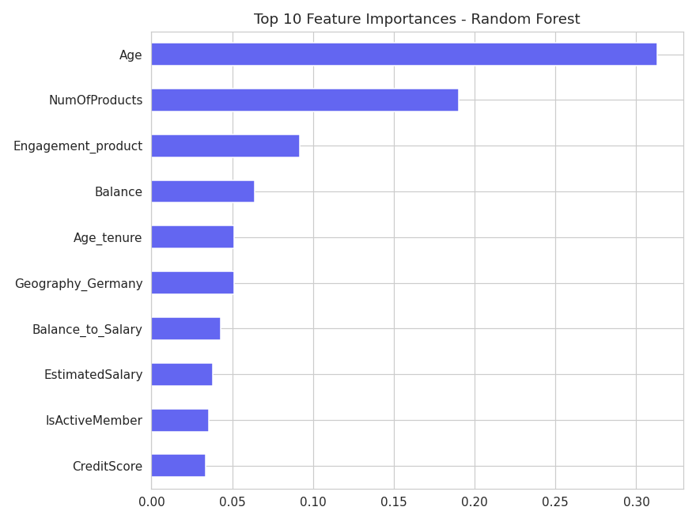
Figure 9: Top 10 feature importances from the Random Forest model.
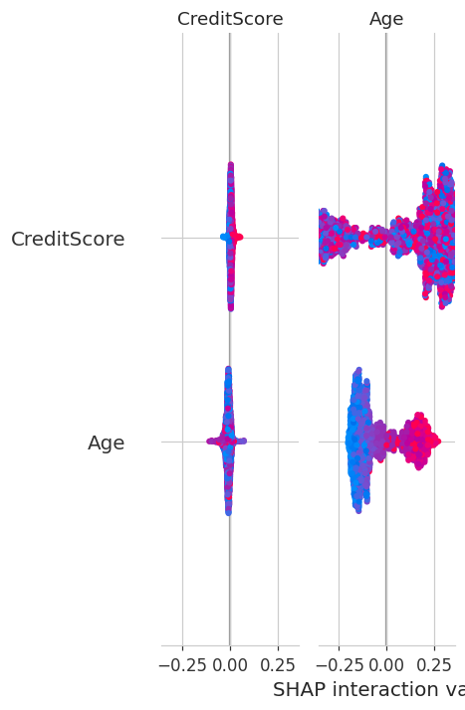
Figure 10: SHAP summary plot showing both the magnitude and direction of each feature's impact on individual predictions.
The model's top drivers — Age, NumOfProducts, and the Engagement×Product interaction — directly corroborate the patterns identified manually during exploratory data analysis. This alignment between manual EDA findings and the model's learned feature importances is a strong indicator that the model has captured genuine, explainable patterns rather than spurious correlations.

7. Business Recommendations
- Investigate the 3–4 product segment directly. Since this segment churns at 82–100%, the bank should audit whether these customers were cross-sold products they didn't want, and consider proactive outreach or account reviews for anyone recently reaching 3+ products.
- Prioritize retention campaigns for customers aged 45+, who churn at a meaningfully higher rate than younger customers.
- Design a Germany-specific retention strategy, given churn rates nearly double those seen in France and Spain — potential causes worth investigating include competitive pressure, service quality, or product-market fit in that region.
- Use the deployed churn risk calculator to score customers in real time and route high-risk customers (≥50% predicted probability) to retention specialists before they act on leaving.
- Re-evaluate cross-sell incentive structures, since aggressive product bundling appears to correlate with churn rather than loyalty — the opposite of its intended effect.

8. Conclusion
This project reframes bank customer churn from a reactive, demographic-only lens to a proactive, behavior-driven intelligence system. By combining exploratory analysis, engineered interaction features, and an explainable Random Forest model, the resulting system not only predicts churn with strong discriminative power (ROC-AUC 0.867) but also surfaces clear, actionable drivers — most notably, the counter-intuitive relationship between product count and churn. The accompanying Streamlit dashboard operationalizes these findings into a live tool for churn risk scoring, scenario simulation, and driver exploration, providing a foundation for targeted, cost-effective retention strategy going forward.

