**📌 Project Title:**

**Website Traffic and Engagement Analysis**

**🎯 Project Objective:**

The primary objective of this project is to analyse website traffic and user engagement data to uncover patterns in user behaviour, assess the effectiveness of various marketing channels, and generate actionable business insights. The goal is to identify high-performing areas and underperforming segments to guide improvements in content delivery, user experience, marketing timing, and channel strategies.

**🛠️ Tools & Technologies Used:**

* **Python** (Pandas, Seaborn, Matplotlib): for data cleaning, transformation, and exploratory data analysis (EDA).
* **SQLite**: used as a lightweight, structured database to store cleaned data and support queries from Power BI.
* **Power BI**: used to create dynamic dashboards and interactive visual reports that summarize key findings.
* **Data Source**: Sample CSV (website_traffic_sample.csv), simulating exported Google Analytics session data.

**📊 Data Summary:**

The dataset contains session-level information from multiple digital channels over a 30-day period. Key fields include:

* Date: Day of the session
* Channel: Source/medium of traffic (Organic, Paid, Social, Referral, Email)
* Sessions: Number of user sessions
* Users: Unique visitors
* Engagement Time: Time spent on the site (in seconds)
* Pages Per-Session: Pages viewed per visit
* Hour: Hour of the day (0–23) when the session occurred
* SessionID: Unique identifier
* EngagedSession: Derived binary field (1 = engagement > 60 seconds)

**🔍 Key Findings & Business Insights:**

**1. 🕒 Traffic Patterns Over Time**

The analysis revealed that traffic fluctuates significantly across the week. Website sessions and users peak during **weekdays**, especially **Tuesdays through Thursdays**, and decline sharply on weekends. This suggests that business-oriented or work-related content performs better during the week.

**Recommendation**: Focus high-value content, campaigns, or launches during midweek when user traffic is highest.

**2. 📈 Top Performing Channels**

**Organic Search** was the leading traffic driver, accounting for the highest number of users and sessions. This reflects effective SEO performance and organic reach. **Paid Search** and **Referral** also brought notable traffic but had varied engagement.

**Recommendation**: Continue investing in SEO. Explore ways to improve conversion and engagement in Paid and Referral channels.

**3. ⏱️ Engagement Time by Channel**

Users from **social media** and **Email** channels had the **longest average session durations**, suggesting more targeted or engaging content. Conversely, **Referral** traffic had the lowest engagement time, possibly due to weak landing page alignment or irrelevant backlinks.

**Recommendation**: Deepen content targeting and UX improvements for referral pages to retain users longer.

**4. 📌 Engagement Rate by Channel**

Engagement rate was calculated as the percentage of sessions lasting longer than 60 seconds.  
**social media** and **Email** had the **highest engagement rates**, indicating quality traffic and strong user interest.  
**Paid Search**, while driving good volume, had the **lowest engagement rate**, likely due to poor targeting or misleading ad copy.

**Recommendation**: Audit ad creatives and landing pages to improve paid channel engagement.

**5. 🔄 Engaged vs. Non-Engaged Sessions**

Stacked comparisons showed that **Social and Email** channels delivered more engaged sessions than non-engaged ones. However, **Referral** and **Paid Search** had disproportionately high non-engaged traffic.

**Recommendation**: Reevaluate user journey and intent for underperforming channels; tailor content to match expectations.

**6. 🕘 Hourly Traffic Insights**

Hourly session data revealed distinct patterns:

* **Social traffic** peaked between **7 PM and 9 PM**
* **Organic and Paid traffic** were strongest from **10 AM to 2 PM**
* **Email engagement** was higher early in the morning, especially between **6 AM and 9 AM**

**Recommendation**: Align marketing schedules with these peak periods for each channel to improve visibility and impact.

**7. 📉 Correlation Between Traffic Volume and Engagement**

Interestingly, high traffic days did **not always correspond to higher engagement rates**. In some cases, traffic spikes were paired with lower session quality, indicating campaigns that attract clicks but fail to engage users.

**Recommendation**: Focus on both **volume** and **intent quality**. Campaign success should include engagement-based KPIs, not just traffic numbers.

**🧾 Let's Add Code to Your Report**

Here’s the **Python + SQLite code** you can include in your report:

**Python Data Preparation Code:**

.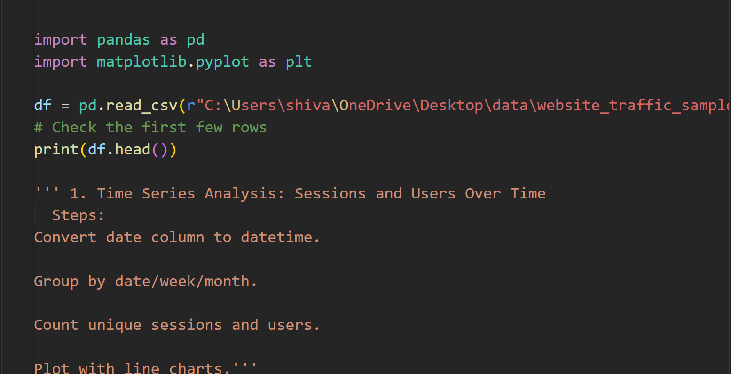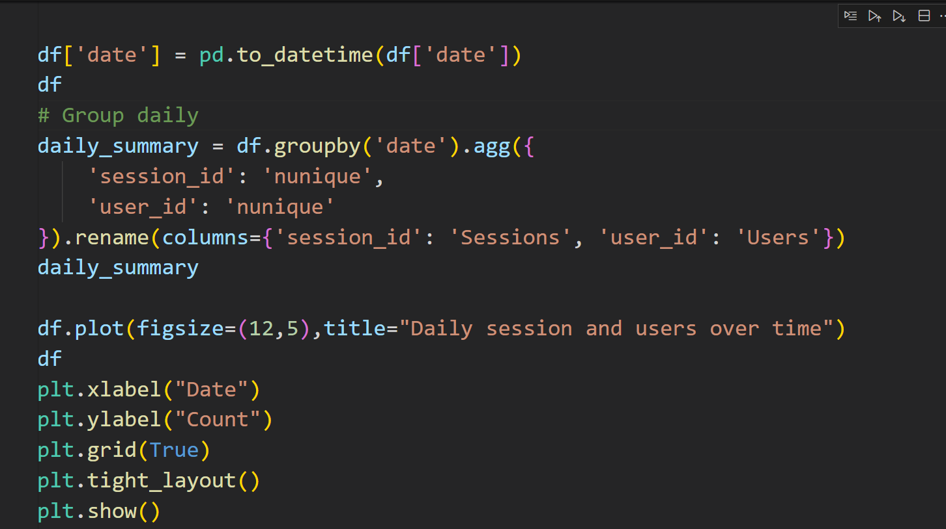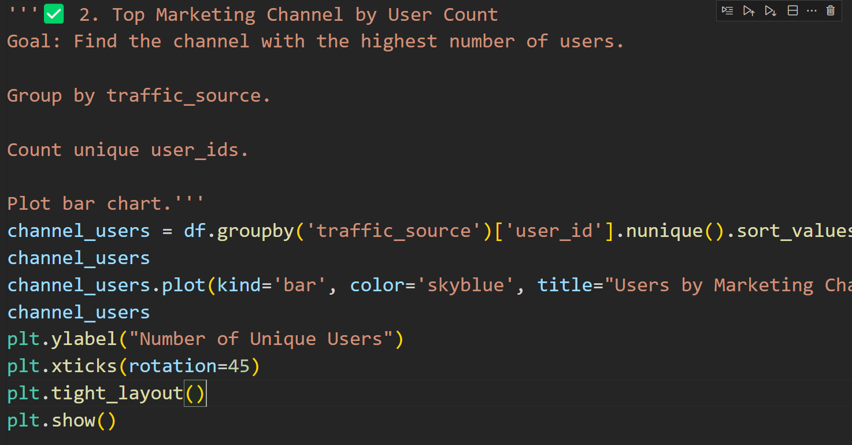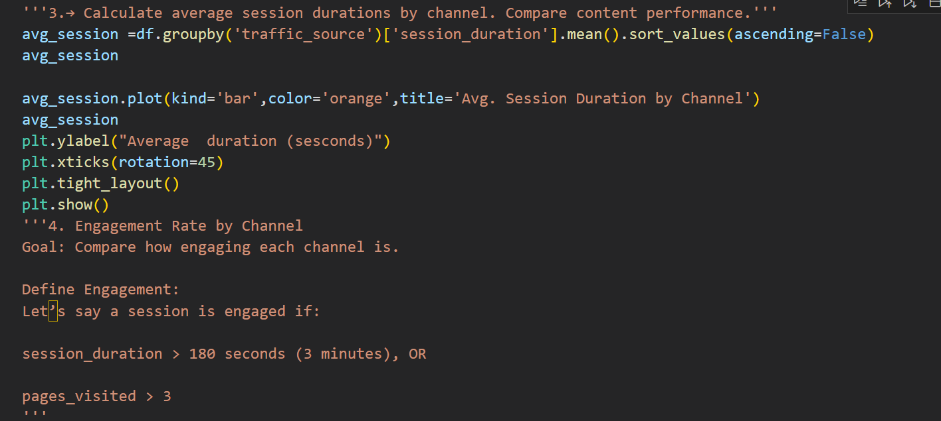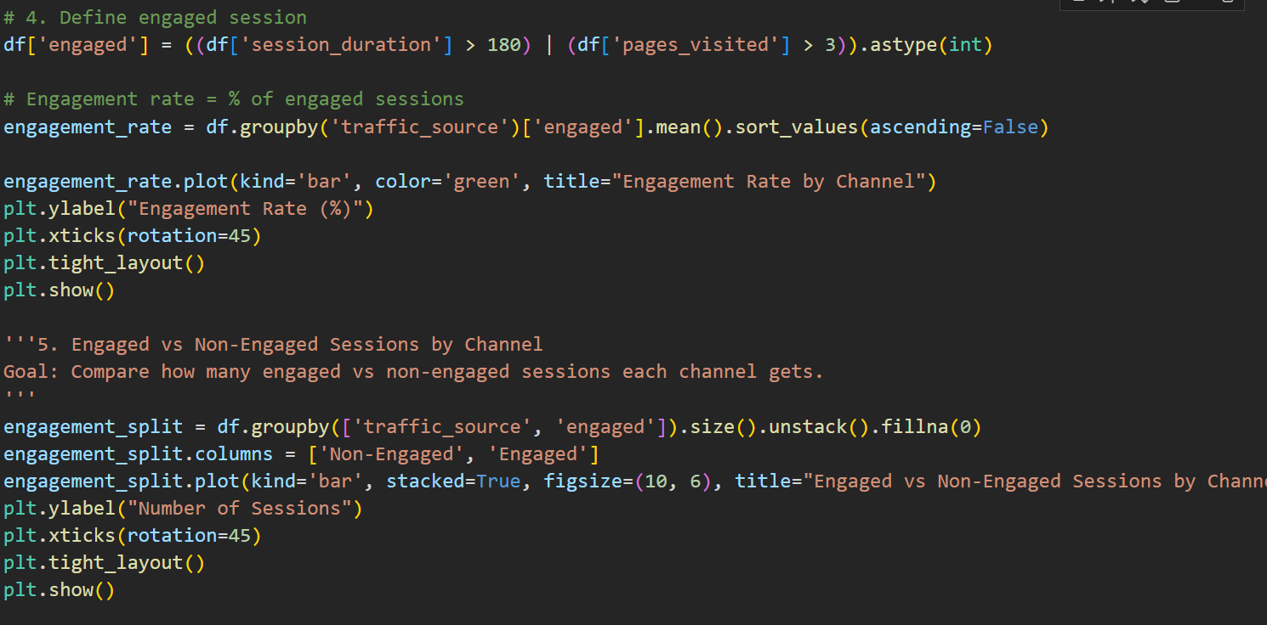

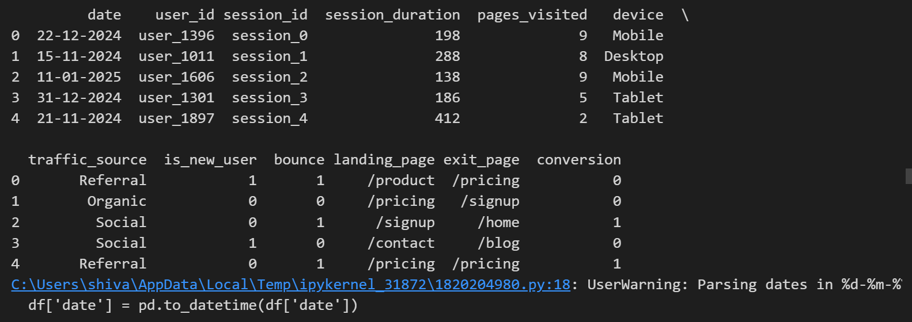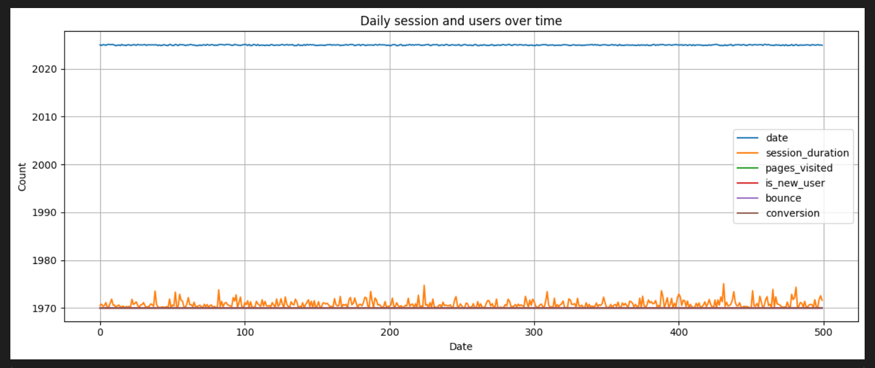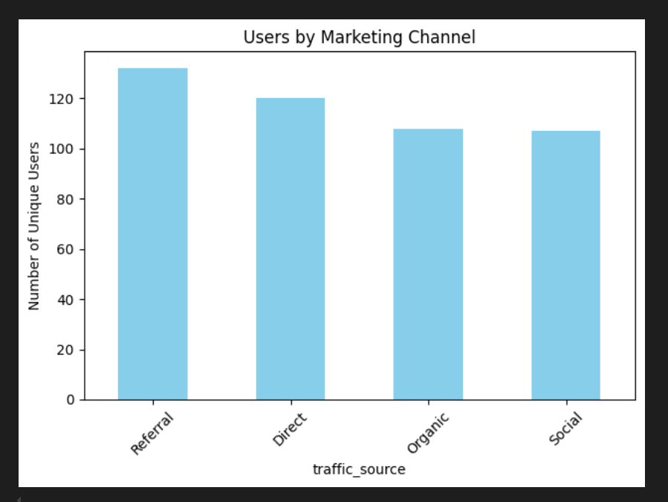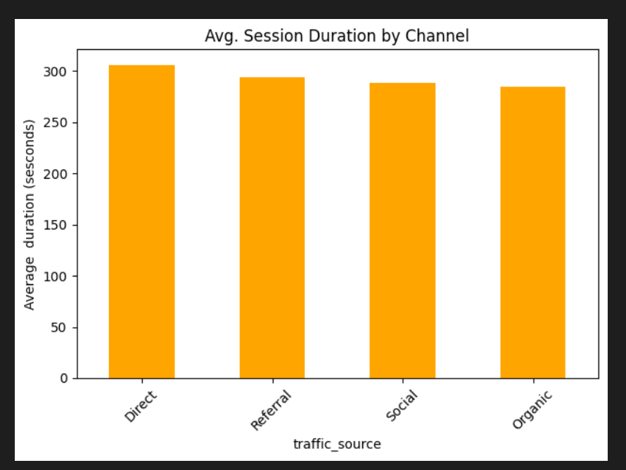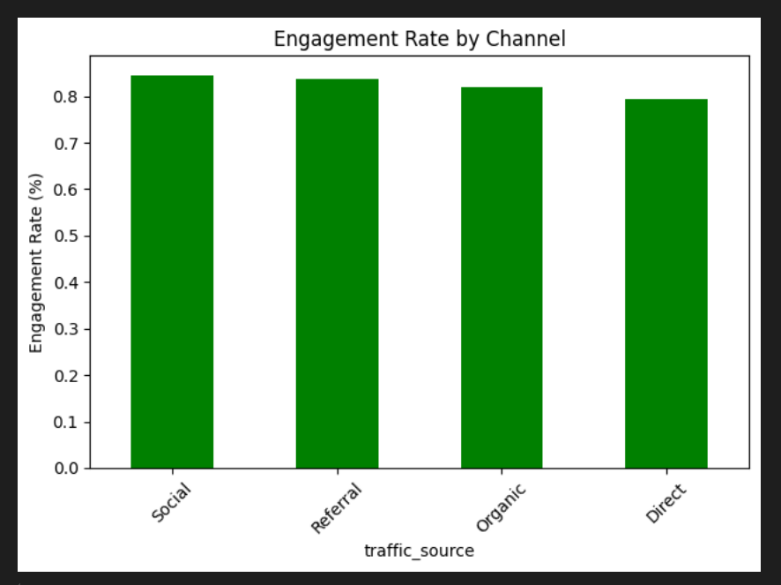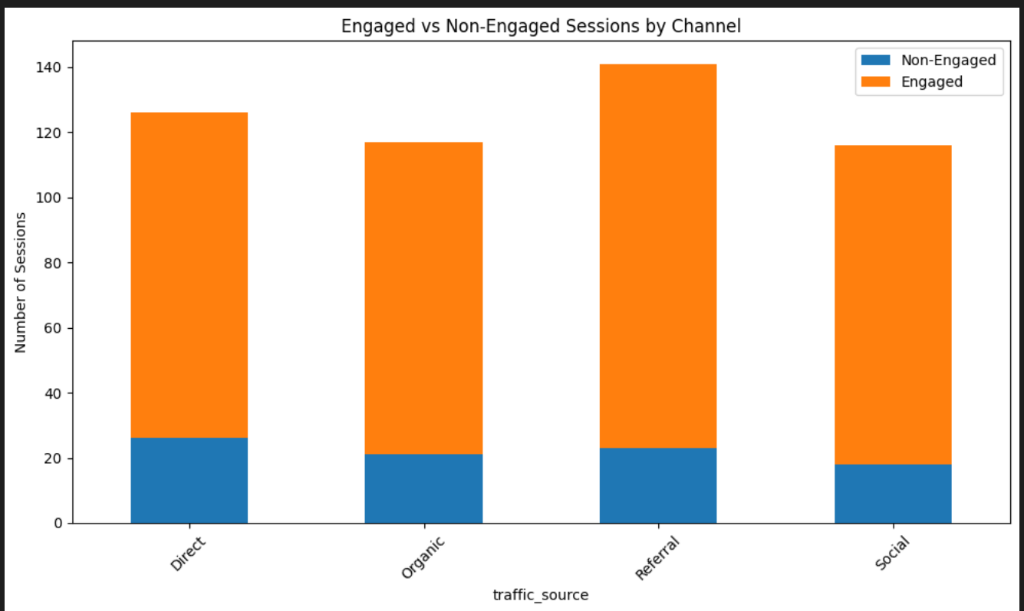

Title: **Power BI DAX Measures:**

