Implementation

This implementation proposes a scalable and novel property/land transaction framework and an efficient trust value based consensus approach to provide a fast, secure, transparent, and tamperproof land registration system. The proposed architecture is based on the blockchain technology and here we have used Inter Planetary File System (IPFS) as a distributed and Peer-to-Peer (P2P) network for implementation of our application. Therefore all registry offices in state, willing to deploy the proposed system must join the proposed blockchain based framework in order to provide a fast and transparent verification and registration process to people.

Prerequiste
- IPFS configuration for the Windows.
- Gcc compiler as example codeblock should be installed on your system.

- To implement the IPFS we will use "go-ipfs_v0.4.13_windows-amd64”, this ipfs utility is available on IPFS official website. go-ipfs is built on top of Golang, which allows for some cross platform compatibility. However, it doesn’t cover everything.
- This directory contains a "ipfs.exe" files to execute the ipfs commands.
- Install codeblock and copy the extracted file inside bin folder of the codeblock. ( I have used (C:\Users\DELL\Desktop\thesis\go-ipfs\CodeBlocks\MinGW\bin) path and set the same inside the directory as a path.)
ipfs init
In case IPFS is being used for the first time it need to be initialed first. Initializes IPFS by executing following command “ipfs init”. This command will generate the IPFS peer id of the system and install IPFS properties.

ipfs config show

To see the properties of the system run the following command:“ipfs config”. This command will show the IPFS properties of the system including peer id. This peer id is used for swarm P2P connection with other peers.
.

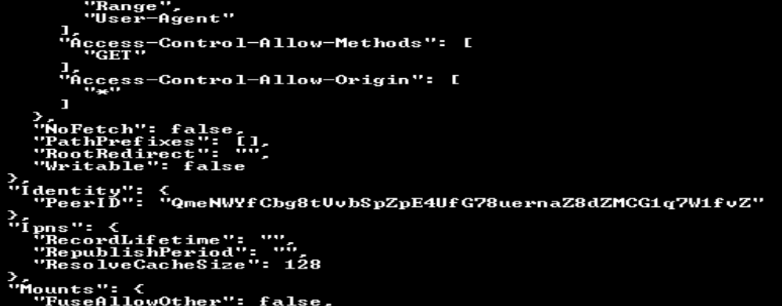

ipfs daemon
To use the IPFS first start the IPFS in the system and to start the IPFS run the command: ”ipfs daemon” (In Windows). After successful execution of daemon command, IPFS will start on the system and this will also show the IPFS address of the system for various services.

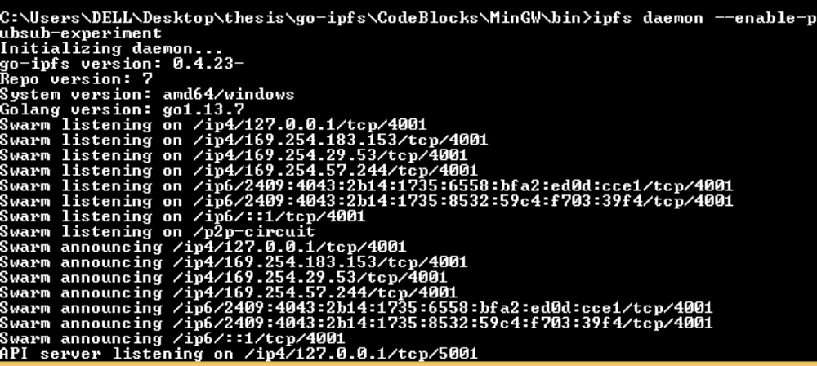

ipfs daemon –enable-pubsub-experiment

For IPFS to handle publishing and subscribing daemon with pubsub functionality enabled need to be started. To start daemon with pubsub functionality use the command on the terminal “ ipfs daemon –enable-pubsub- experiment”. To use the further IPFS command, open another command prompt.

Creating P2P swarm Connection

To create a connection to any peer in the network, its swarm address and peer id are required. For creating P2P swarm,swarm address is used. The swarm address of a node is of the form /ip4/172.31.134.5/tcp/4001 and peer ID is of the form: “PeerID”: “QmPJZoMUigNFkPTN533CRevrqjqRLVQ22VRV6htePeEqpn”. The command to create a connection between two nodes is “ipfs swarm connect /p2p swarm address/ipfs/ peer Id”. A success message will be shown in output after the execution of command.

This is the setup before actual process of consensus…………………
Now suppose you have connected More than 3 system N1, N2, N3.
N1->Leader miner
Do this process for each transaction:
- Run create_trust_new.c at each node.
Purpose of this is to make entry of all the miners in trust.txt file with their trust values. It stores the information of all the miners in the file peer.txt.

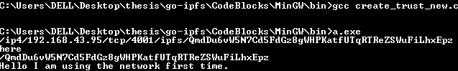

- Run subscribe_block.c file on all node except leader node. It will start listening and subscribing the transactions from leader.
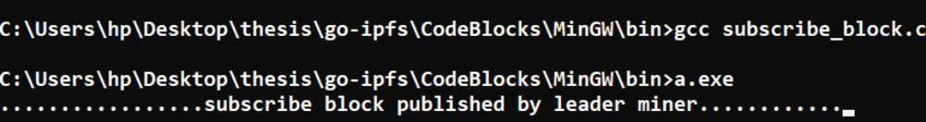

- Run the subscribe_response.c file at leader sothat it will be able to listen and subscribe the responses from consensus miners.

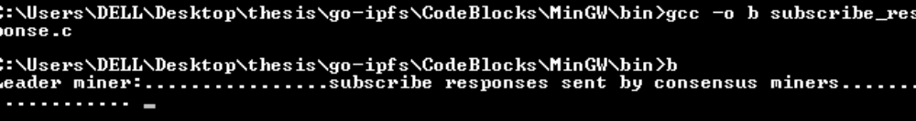

- Run the subscribe_result.c same as above at the other nodes except leader.
It will start listening the final result at all nodes published by leader.

- Run the publish.c ( here publish_new4.c) file at leader.
It will convert the transaction details in the form of block and publish that block using pubsub command. Then wait for the responses from consensus miners.

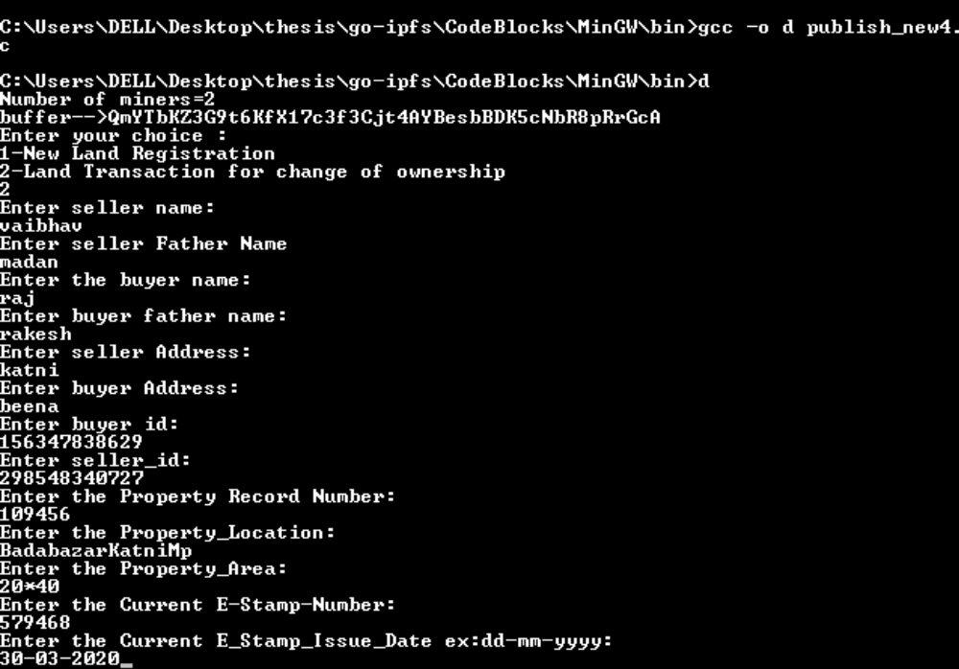

- Run ver_res.c file at other miners.
It will check that the miner is consensus miner or not. If it is consensus miner then it will verify that block and send the responses to leader.

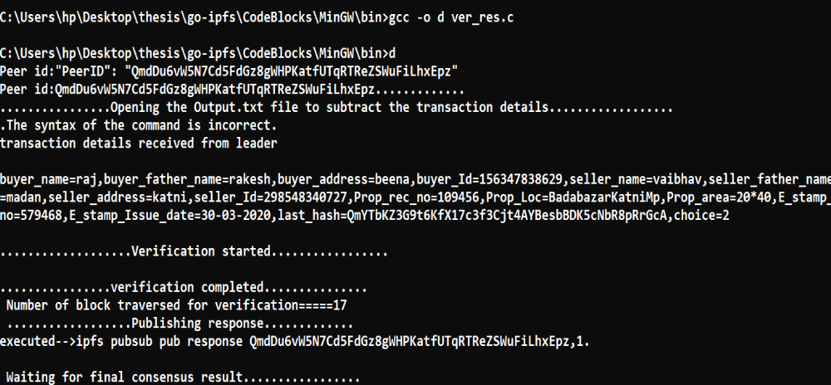

Publish.c publishes the transaction details that are subscribed by consensus miners and consensus miners verify that block and send response that is subscribed by the leader miner. Leader apply consensus and get the final result and publish it to all nodes and start updating the trust values of consensus miners based on their responses. And all nodes add or discard the block based on final result.

