**Dataset**

Fundamentally, the cornerstone of training any machine learning or deep learning model lies in the availability of suitable data. To address this requirement, we have assembled a dataset sourced from the [MRL Eye Dataset](http://mrl.cs.vsb.cz/eyedataset) ,comprising a diverse collection of images depicting both open and closed eyes. This dataset was meticulously curated by compiling eye images from a cohort of 37 individuals, consisting of 33 men and 4 women.

This dataset encompasses a comprehensive collection of infrared images, encompassing both low and high resolutions. These images were captured under a diverse range of lighting conditions using various infrared imaging devices. The inclusion of images captured under different lighting conditions and with different devices ensures a robust evaluation of algorithm performance across varying real-world scenarios. The images have been carefully categorized into several distinct classes or categories based on specific criteria relevant to infrared image analysis.

The images in the dataset are stored in a well-defined format and are accompanied by detailed annotations that specify key characteristics of each image. For example, each annotated image is named according to a specific convention, such as **'s0012_03054_0_1_0_2_1_01'**. This naming convention serves to encode important properties of the image, which are specified in the following manner:

* **Subject ID:** the first term (s0012) signifies the subject id of the image.
* **Image ID:** the second term signifies the image ID. Overall, this dataset consists of 84,898 images.
* **Gender** **[0 - man, 1- woman]:** the dataset includes demographic annotations for each image, specifying the gender of individuals depicted (male or female) in the image.
* **Glasses** **[0- No, 1- Yes]:** each eye image in the dataset is annotated to indicate whether the subject is wearing glasses or not.
* **Eye State** **[0-Closed, 1-Open]:** this property contains data pertaining to two distinct eye states: open and closed.
* **Reflections [0-none, 1-small, 2-big]:** we categorized reflections into three distinct states based on their size: no reflection, small reflection and large reflection.
* **Lighting Conditions [0-bad, 1-good]:** each image in the dataset is categorized into two states—'good lighting condition' and ‘bad lighting condition'—based on the ambient lighting conditions present during image capture,
* **Sensor ID [01 - RealSense, 02 - IDS, 03 - Aptina]:** the dataset comprises images captured using three distinct sensors: the Intel RealSense RS 300 sensor, offering a resolution of 640 x 480 pixels; the IDS Imaging sensor, which captures images at 1280 x 1024 resolution; and the Aptina sensor, providing images at 752 x 480 resolution.

An illustration of image annotations within the provided dataset:

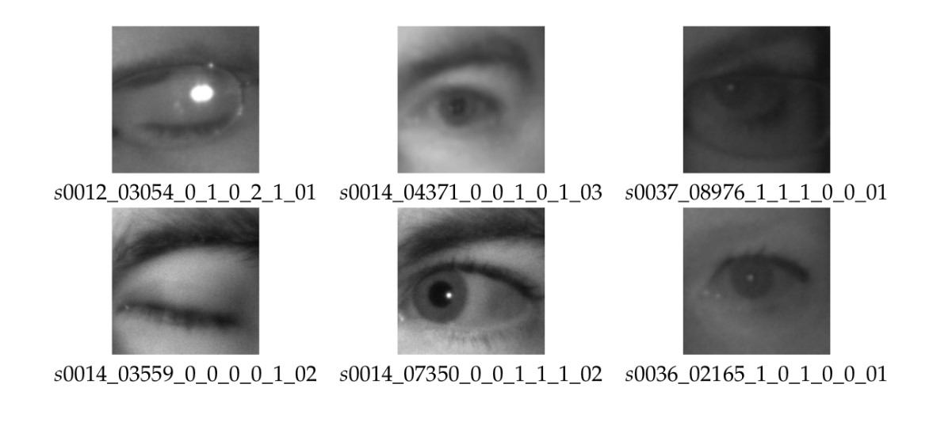

The following images showcase examples of open and closed eyes extracted from this dataset:

