|  |
| --- |
| **Team ID :** LTVIP2025TMID54810 |
| **Project Name :** ShopSmart: Your Digital Grocery Store Experience |

**Integration**

Integration is the process of combining and connecting the frontend and backend components of the online flower shop web application to create a unified and fully functional system. It involves establishing communication channels, exchanging data, and ensuring seamless interaction between the frontend UI and backend APIs. The following activities are part of the integration process:

Landing page:-

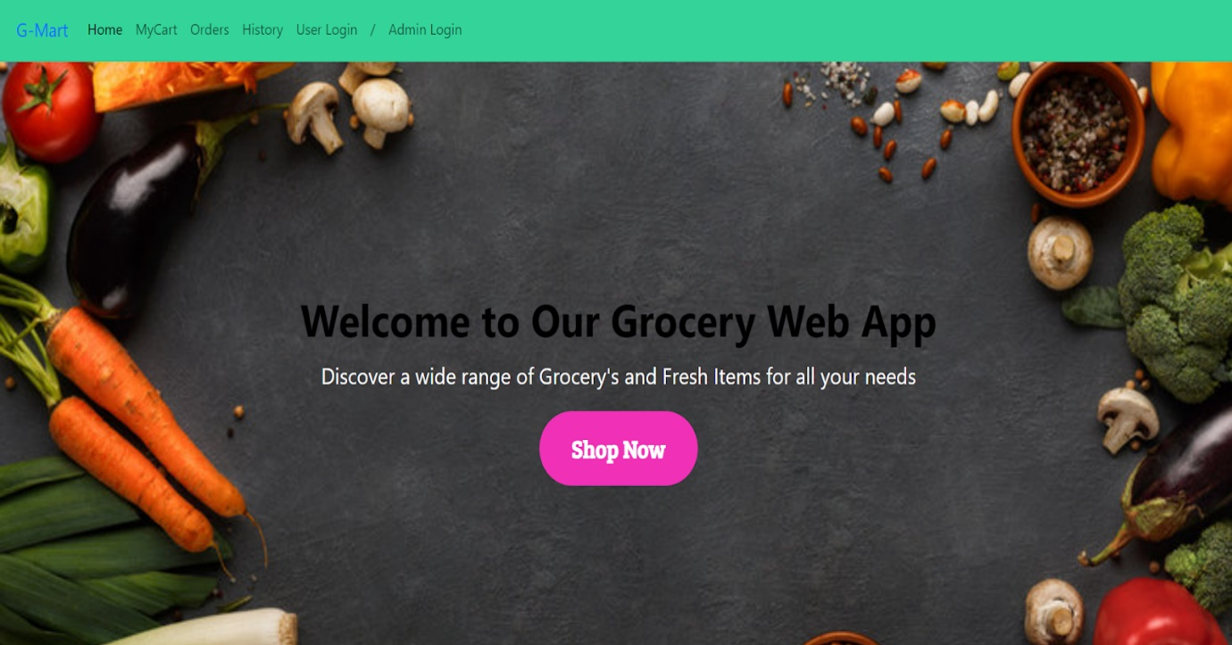

Login Page:-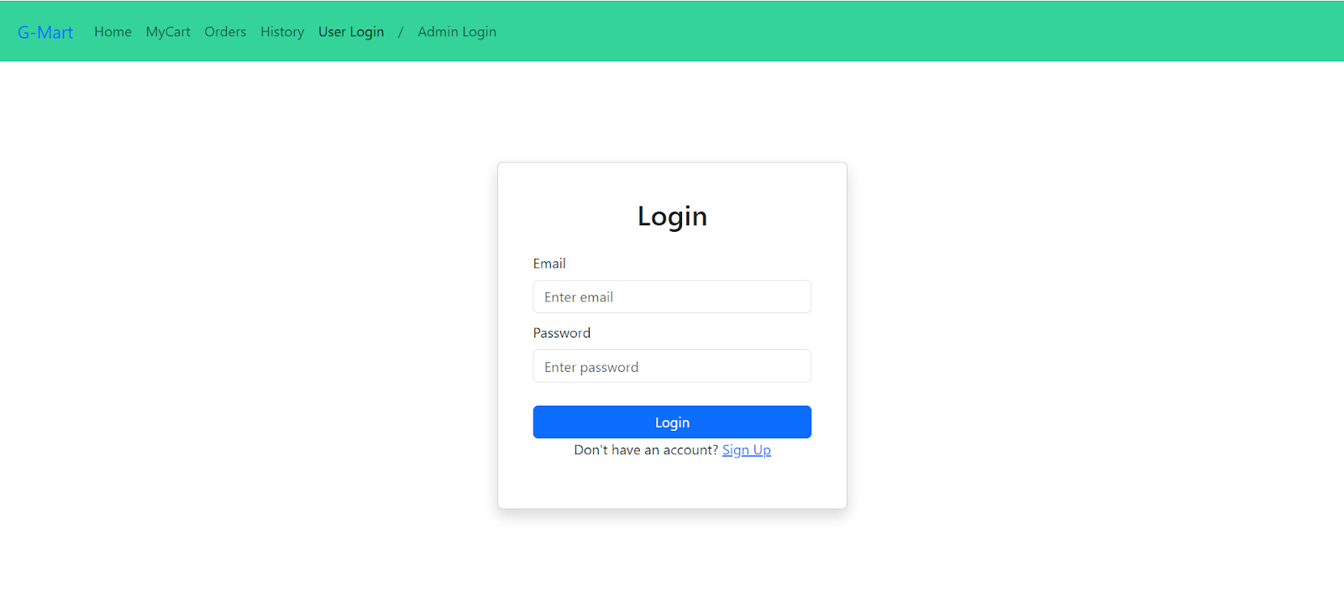

Items Page:- 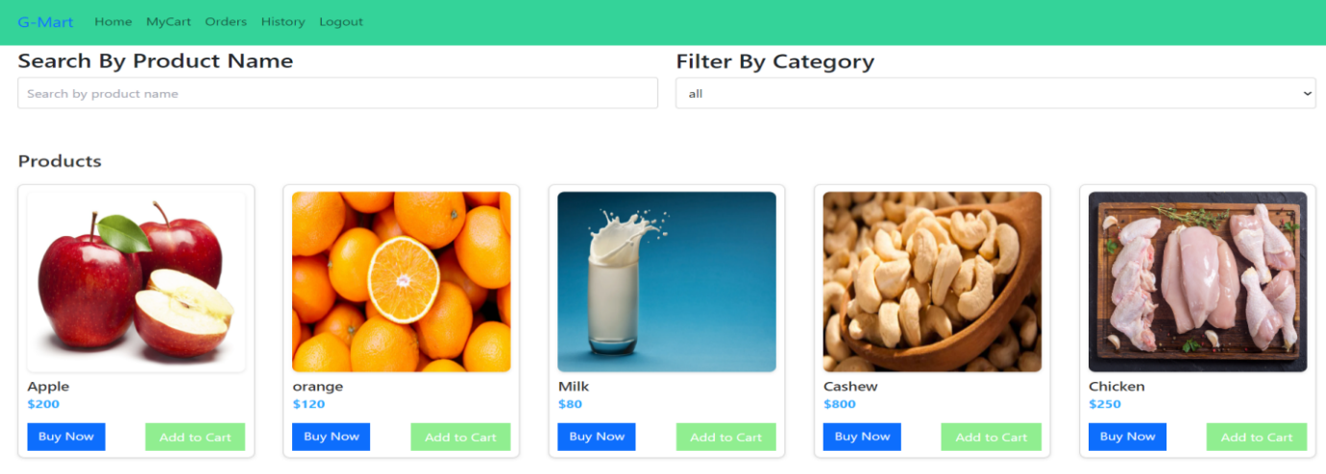

My Cart:-

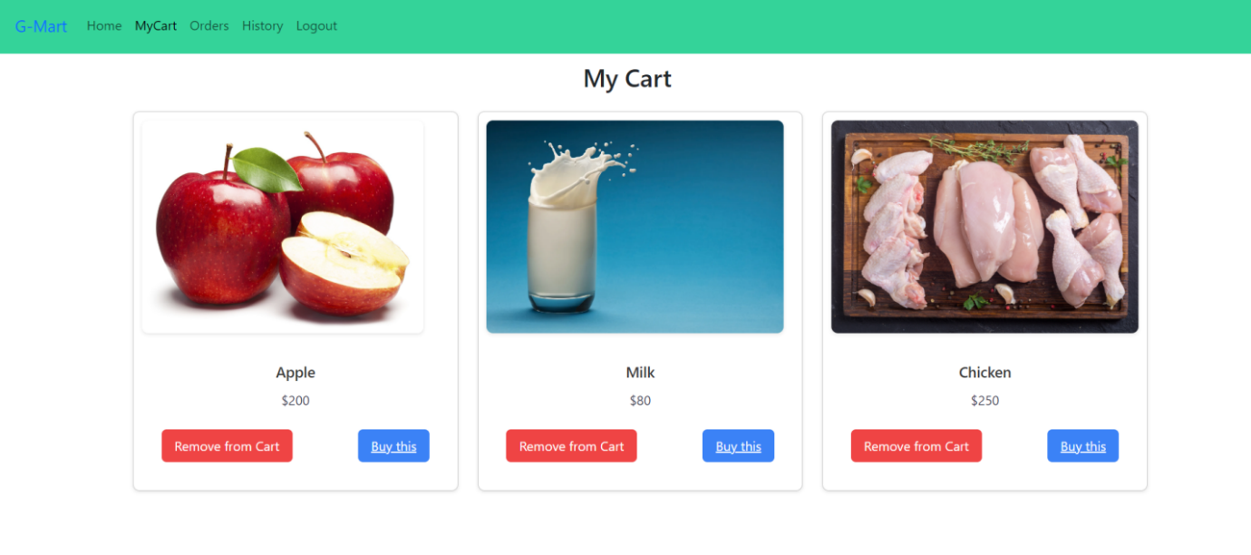

My Orders Page:-

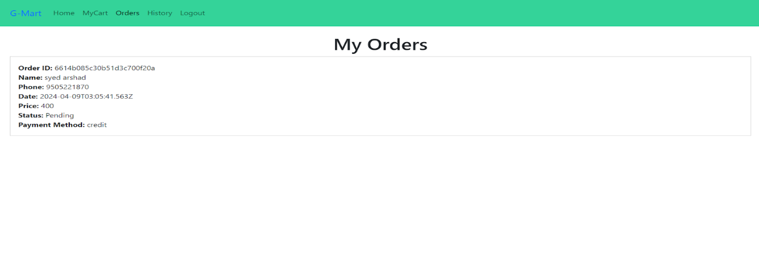

My History Page:-

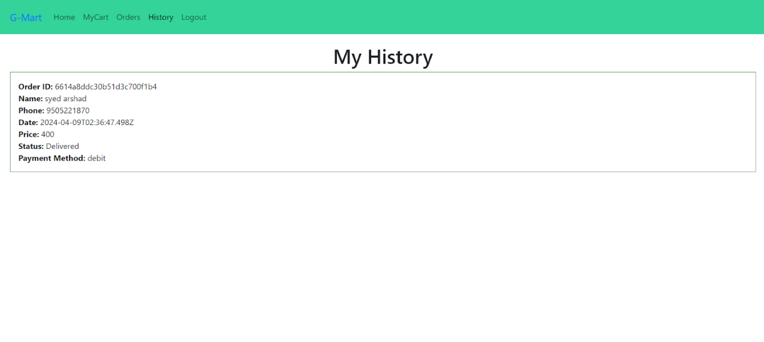Place Order Page:-

Place Order Page:-

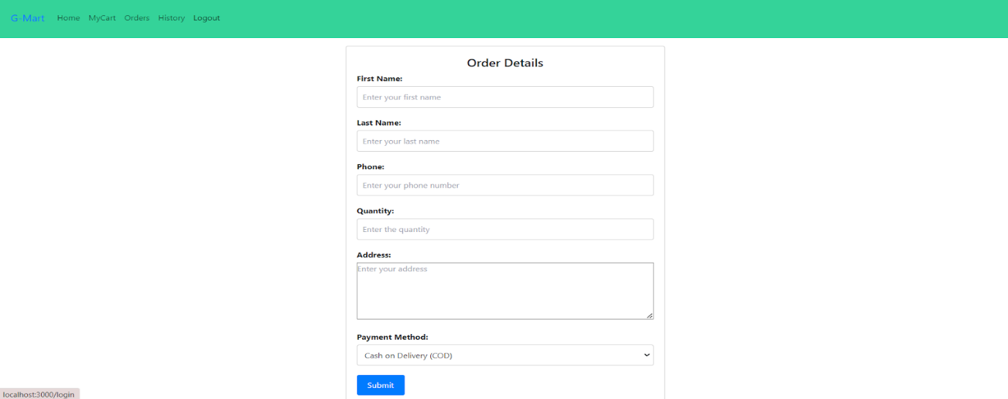

Users Page:-

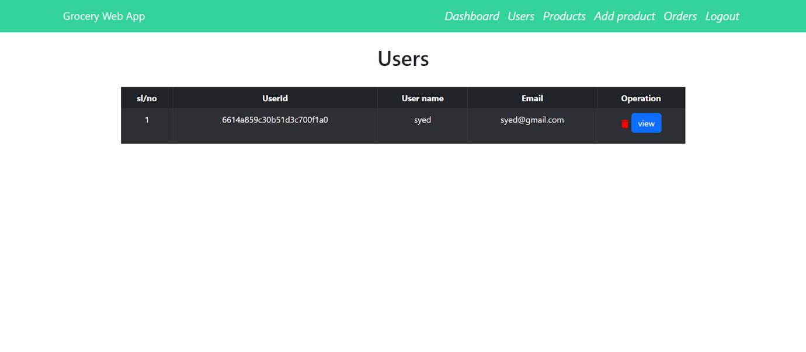

Add Product page:-

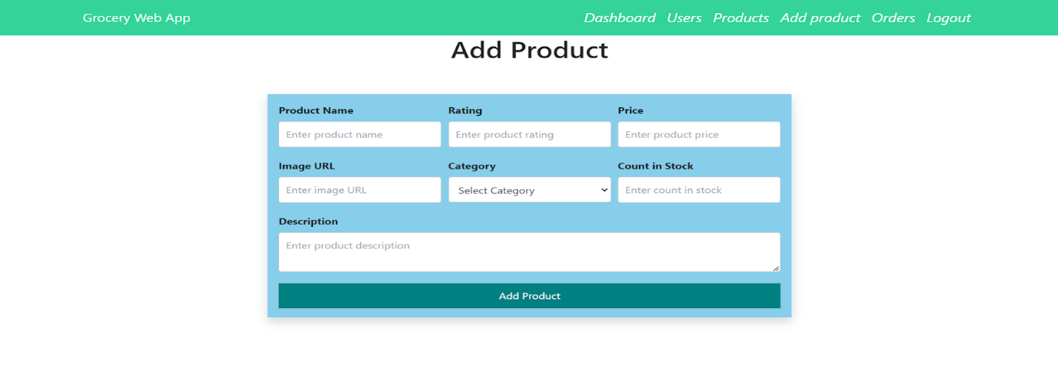

Admin Orders Page:-



Admin Orders Page:-

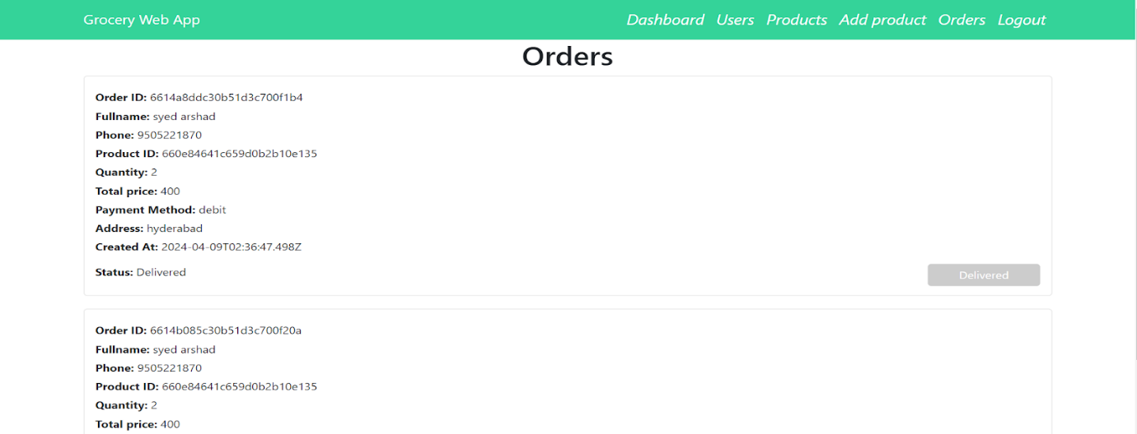

The demo of the app is available at:-

<https://drive.google.com/file/d/1HLowcIqs2d8lxTprS2jqPmR4AOnUW8xD/view?usp=drive_link>