

CODEKSHETRA HACKATHON
Round 1: Idea Proposal Document
Track: Software Edition Only

Team Information

No. | Member Name | Institute Name | Role
1 | Shivani Mali | Sanjay Ghodawat Institute | Team Leader
2
3
4

Team Size Requirement: Minimum 2 and Maximum 4 Members.
Team Name: Project Name: Selected Theme:

1.Abstract

Malnutrition continues to be a serious public health challenge in India, especially among children under five years of age. According to NFHS-5 (2019–21), a significant percentage of children suffer from stunting, wasting, and underweight conditions, highlighting the need for early detection and timely intervention. Although multiple government programs exist, lack of real-time monitoring, personalized guidance, and delayed decision-making in rural and hard-to-reach areas remain major barriers.

To address this challenge, we developed CNIS (Climate Nutrition Intelligence System), an AI-powered web and mobile platform designed to help parents and frontline health workers detect, track, and prevent malnutrition at an early stage. The system collects child health data such as age, height, weight, vaccination details, and optional photo input, along with location and climate information. Using an intelligent risk analysis engine, CNIS generates personalized nutrition recommendations, seasonal diet plans, vaccination tracking, and health alerts.

The platform also includes innovative features such as a Voice-Based Nutrition Assistant, climate-aware diet recommendations, polio dose tracking, and automated reminders, making it practical and accessible for rural communities. Built using modern technologies like React, Firebase, TensorFlow.js, and AI APIs, CNIS aims to transform raw health data into actionable nutrition intelligence.

Overall, CNIS focuses on preventive healthcare by combining AI, climate intelligence, and user-friendly design to support early intervention and improve child health outcomes.
2.ProblemStatement
Malnutrition remains a critical challenge affecting child health and development, especially in rural, tribal, and low-income regions of India. Despite the presence of government initiatives such as POSHAN Abhiyaan, ICDS, and Mid-Day Meal programs, a large number of children continue to suffer from undernutrition due to late detection, poor monitoring, and lack of personalized guidance for caregivers.
One of the major problems is that existing systems are mostly reactive — action is often taken only after visible signs of malnutrition appear. Frontline health workers and parents frequently lack easy-to-use digital tools that can help them monitor child growth, track vaccination schedules, and receive timely nutrition recommendations. Additionally, current solutions rarely consider important factors such as local climate, seasonal food availability, and regional conditions, which directly influence dietary needs.
In many remote areas, limited access to healthcare experts and delayed intervention further increase health risks for children. Manual record-keeping and fragmented health data also make it difficult to identify vulnerable children early and provide preventive care.
Therefore, there is a strong need for an intelligent, accessible, and preventive system that can integrate child health data, environmental factors, and AI-driven insights to support early detection, continuous monitoring, and actionable nutrition guidance. CNIS aims to address these challenges by providing a smart, climate-aware, and user-friendly solution for child nutrition management.

3.MarketAnalysis-ProsandCons

Market Overview
Child malnutrition remains a major global and national health concern, creating a strong demand for technology-driven healthcare solutions. Governments, NGOs, healthcare workers, and parents are increasingly adopting digital tools for child health monitoring, vaccination tracking, and nutrition guidance. With the rise of AI-based healthcare applications and increasing smartphone penetration in rural areas, there is a growing opportunity for smart, preventive health platforms like CNIS (Climate Nutrition Intelligence System).
Existing solutions mainly focus on record keeping, general nutrition advice, or vaccination tracking, but very few systems provide climate-aware, personalized, and AI-driven nutrition intelligence. This creates a market gap that CNIS aims to address.

Advantages (Pros) of CNIS
- Climate-Aware Intelligence
Provides nutrition recomx`mendations based on weather and seasonal conditions.

- Early Risk Detection
AI-based analysis helps identify malnutrition risk before severe symptoms appear.

- Integrated Platform
Combines health assessment, vaccine tracking, diet planning, and reminders in one system.

- Voice-Based Interaction
Supports users who may have difficulty typing or reading.

- User-Friendly Design
Designed for non-technical users like parents and frontline workers.

- Scalable & Low-Cost Deployment
Web-based system accessible via mobile and desktop without installation.

- Real-Time Data & Analytics
Helps health workers make faster decisions.

Limitations (Cons) / Challenges
- Internet Dependency
Requires internet connectivity for real-time AI and cloud features.

- Data Privacy Concerns
Handling child health data requires strict security and compliance measures.

- Initial User Training Needed
Frontline workers may require guidance to use digital tools effectively.

- Accuracy Depends on Data Input
Incorrect measurements may affect prediction quality.

- Scalability Challenges in Remote Areas
Infrastructure limitations may affect adoption in some regions.

Market Opportunity
The increasing focus on preventive healthcare, digital health initiatives, and AI-driven solutions creates a strong opportunity for CNIS. Government programs and NGOs can integrate such systems to improve monitoring and reduce malnutrition cases through early intervention.
4.TargetUsers

The primary target users of CNIS (Climate Nutrition Intelligence System) are individuals and organizations involved in child health monitoring and nutrition management.
Target Users include:
- Parents and Caregivers – To monitor child growth, receive personalized nutrition guidance, and track vaccination schedules.

- ASHA Workers and Anganwadi Workers – For field data collection, early malnutrition detection, and providing timely health guidance in rural areas.

- Healthcare Volunteers and NGOs – To support community health programs, monitor child nutrition status, and conduct surveys.

- Government Health Departments and Programs – For large-scale child health monitoring, analytics, and preventive healthcare planning.

- Rural and Low-Resource Communities – Where access to nutrition experts is limited and digital decision-support tools can improve early intervention and awareness.
5.ExistingSolutions

Several digital health and nutrition solutions already exist in the market that support child health monitoring, growth tracking, and nutrition awareness. These solutions mainly focus on data recording, vaccination tracking, or general nutrition guidance.
1. Government Nutrition Monitoring Systems
Poshan Tracker App (India)
Used by Anganwadi workers to record child growth, nutrition services, and beneficiary data in real time. It includes growth charts and monitoring features for children and mothers.
Limitations:
- Mainly focused on data collection and monitoring
- Limited personalized nutrition recommendations
- No climate-based diet intelligence

2. Child Growth & Development Tracking Apps
Apps such as KidsCur Baby Care Growth Chart help parents track child development milestones, vaccination schedules, and health records digitally.
Limitations:
- Mostly record-based tracking
- Generic guidance instead of AI-driven analysis
- Not designed for field health workers

3. Growth Analysis & Nutrition Tools
WHO Anthro Tools provide standardized growth assessment based on WHO child growth standards and anthropometric data analysis.
Limitations:
- Designed mainly for analysis and research use
- Requires technical understanding
- Not user-friendly for parents or rural workers

4. General Nutrition & Food Tracking Apps
AI-based food tracking apps provide meal logging and nutrition analysis for general health and fitness users.
Limitations:
- Focus on calorie tracking rather than child malnutrition
- Not designed for child-specific healthcare
- No vaccination or field monitoring features

5. Vaccination Tracking Initiatives
Some regions have introduced AI-based vaccination tracking systems to improve immunization coverage and reminders.
Limitations:
- Focus only on vaccination
- No integrated nutrition intelligence or diet planning
6.CompetitiveAdvantage

CNIS (Climate Nutrition Intelligence System) offers several unique advantages that differentiate it from existing child health and nutrition solutions. While most available systems focus only on data recording or general guidance, CNIS combines AI intelligence, environmental context, and preventive healthcare into one integrated platform.

Key Competitive Advantages
- Climate-Aware Nutrition Intelligence
CNIS provides diet recommendations based on location, weather, and seasonal conditions, making suggestions practical and region-specific.

- AI-Based Malnutrition Risk Prediction
The system analyzes child health data such as age, height, weight, and optional image input to identify malnutrition risks at an early stage.

- Integrated Health Management
Unlike separate tools, CNIS combines nutrition guidance, vaccination tracking, health assessment, and alerts within a single platform.

- Voice-Based Nutrition Assistant
Users can speak instead of typing, improving accessibility for parents and frontline workers with limited digital literacy.

- Preventive Healthcare Approach
CNIS focuses on early detection and intervention rather than treatment after severe malnutrition occurs.

- Field-Friendly and Easy to Use
Designed for ASHA workers and rural communities with a simple interface and minimal data entry.

- Scalable and Low-Cost Deployment
Web-based architecture allows easy access across devices without requiring installation, making it suitable for large-scale adoption.
7.MarketImpact

CNIS (Climate Nutrition Intelligence System) has the potential to create significant social and healthcare impact by improving early detection and prevention of child malnutrition. By combining AI-based analysis, climate-aware nutrition guidance, and easy-to-use digital tools, the system supports better decision-making for caregivers and healthcare workers.

Expected Market Impact

- Early Detection of Malnutrition
Helps identify at-risk children at an early stage, reducing severe health complications.

- Improved Child Health Outcomes
Personalized nutrition and seasonal diet recommendations support better growth and development.

- Support for Frontline Health Workers
Enables ASHA and Anganwadi workers to monitor children more effectively and provide timely interventions.

- Better Vaccination Tracking
Reduces missed doses through reminders and schedule monitoring.

- Digital Transformation in Rural Healthcare
Introduces smart, data-driven healthcare support in low-resource areas.

- Scalability for Government and NGO Programs
Can be integrated into large-scale child health initiatives and nutrition campaigns.

Overall Impact
CNIS has the potential to reduce malnutrition rates, improve healthcare efficiency, and promote preventive child healthcare by transforming raw health data into actionable nutrition intelligence.

8.ProposedSolution

The proposed solution is CNIS (Climate Nutrition Intelligence System), an AI-powered web and mobile platform designed to support early detection, monitoring, and prevention of child malnutrition. The system helps parents, caregivers, and frontline health workers by providing intelligent, personalized, and climate-aware nutrition guidance.

CNIS collects essential child health information such as age, height, weight, symptoms, vaccination details, and optional photo input. It also captures location data and fetches climate information through APIs. This data is processed by an AI-based risk engine that analyzes health indicators along with environmental conditions to identify possible malnutrition risks.

Based on the analysis, the system generates personalized nutrition recommendations, seasonal diet suggestions, vaccine tracking updates, and practical care guidance. Additional features such as a Voice-Based Nutrition Assistant allow users to interact with the system using speech, making it more accessible for rural and low-literacy users.

The solution follows a preventive healthcare approach by enabling early intervention rather than late treatment. Data is securely stored in the cloud and displayed through an easy-to-use dashboard that shows risk levels, diet plans, alerts, and reports.

Overall, CNIS transforms raw child health and climate data into actionable nutrition intelligence, helping improve child health outcomes and supporting large-scale deployment in community healthcare programs.

Technology Stack

Component | Technology Used
Frontend | React (Vite), JavaScript, HTML, CSS
Backend | Firebse Cloud Functions, Gemini AI API
Database | Firebase Firestore
Cloud / Deployment | Vercel, Firebase Hosting
Other Tools / APIs | Firebase Authentication, TensorFlow.js, i18next, Web Speech API, Speech Synthesis API, Browser Notifications / Firebase Cloud Messaging

Innovativeness

CNIS (Climate Nutrition Intelligence System) introduces an innovative approach to child healthcare by combining artificial intelligence, climate intelligence, and preventive nutrition guidance into a single platform. Unlike traditional health monitoring systems that focus only on record keeping or generic recommendations, CNIS provides intelligent, context-aware decision support for early malnutrition prevention.

Unique Technical Contributions
- Integration of child health data with real-time climate and environmental information.
- AI-based malnutrition risk prediction for early intervention.
- Unified platform combining nutrition guidance, vaccination tracking, and health assessment.

Advanced Features
- Climate-Aware Nutrition Engine that adapts diet recommendations based on season and weather.
- Voice-Based Nutrition Assistant enabling speech interaction for better accessibility.
- Seasonal Diet Recommendation System suggesting locally suitable foods.
- Real-time analytics and dashboard for monitoring child health progress.

Differentiation Factors
- Preventive healthcare focus instead of reactive treatment.
- Personalized recommendations rather than generic diet advice.
- Designed specifically for parents, ASHA workers, and rural communities.
- Scalable, web-based architecture suitable for large-scale deployment.

Overall, CNIS stands out as an innovative solution by transforming health data and environmental context into actionable nutrition intelligence, making child healthcare smarter, accessible, and more effective.

Show Stoppers and Risk Analysis

1. Technical Risks
- Accuracy of AI predictions depends on correct input data such as height, weight, and age.
- Internet dependency for cloud services and real-time climate data fetching.
- Device limitations in rural areas may affect performance or usability.
- Integration of multiple APIs (AI, weather, voice processing) may create dependency issues.

2. Regulatory or Compliance Risks
- The system handles sensitive child health data, requiring strong privacy and security measures.
- Guardian consent must be properly collected before storing personal data.
- Future deployment may require compliance with healthcare data protection standards and government regulations.
- Data misuse or unauthorized access could create legal and ethical concerns.

3. Scalability Challenges
- Large-scale adoption may increase cloud storage and processing requirements.
- High user traffic could affect system performance without optimized backend infrastructure.
- Managing real-time analytics and large datasets from multiple regions may require advanced scaling strategies.

4. Future Uncertainties
- Changes in government healthcare policies or data regulations.
- Variation in technology adoption among rural users.
- Dependency on third-party APIs and cloud services.
- Need for continuous AI model improvement to maintain accuracy and reliability.

Overall, while CNIS offers strong innovation and impact potential, addressing these risks through secure architecture, scalable infrastructure, and compliance planning will be essential for real-world deployment.

Prototype / Wireframes
Include screenshots or provide demo link.
Demo Video Link: Insert Link Here

Use Case / System Flow Diagram

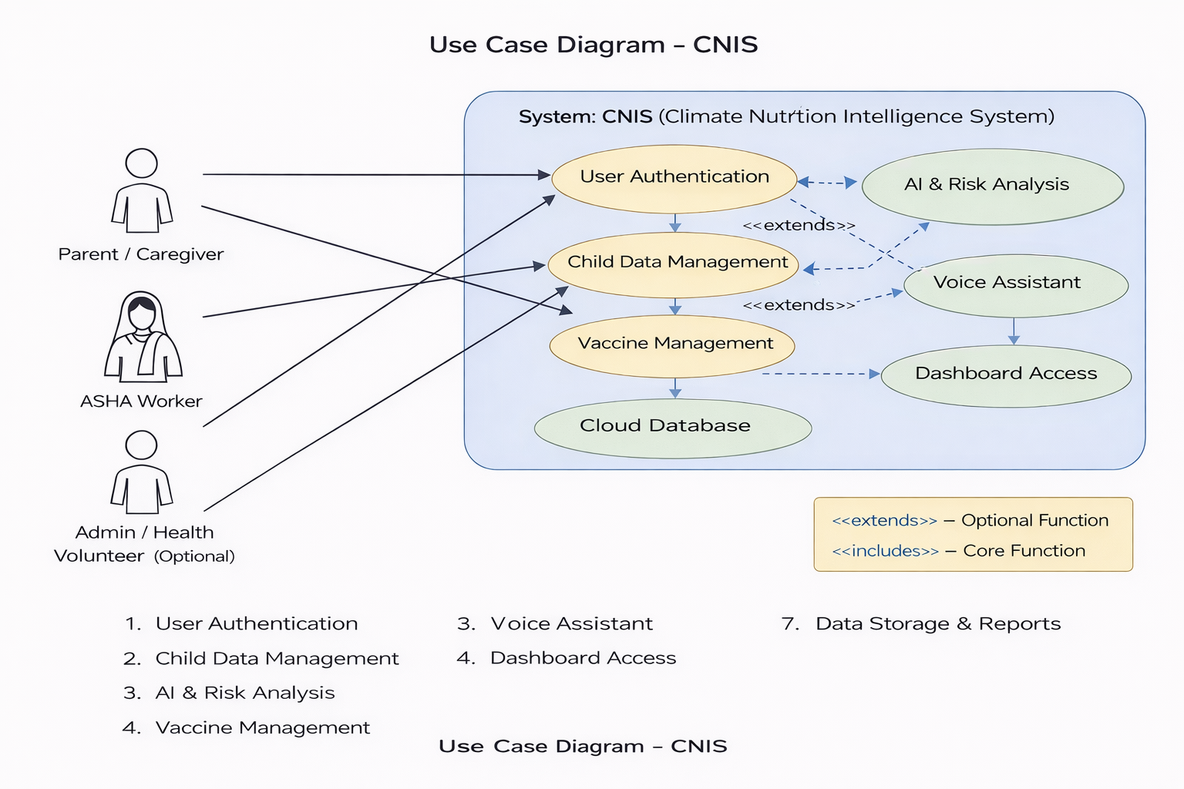

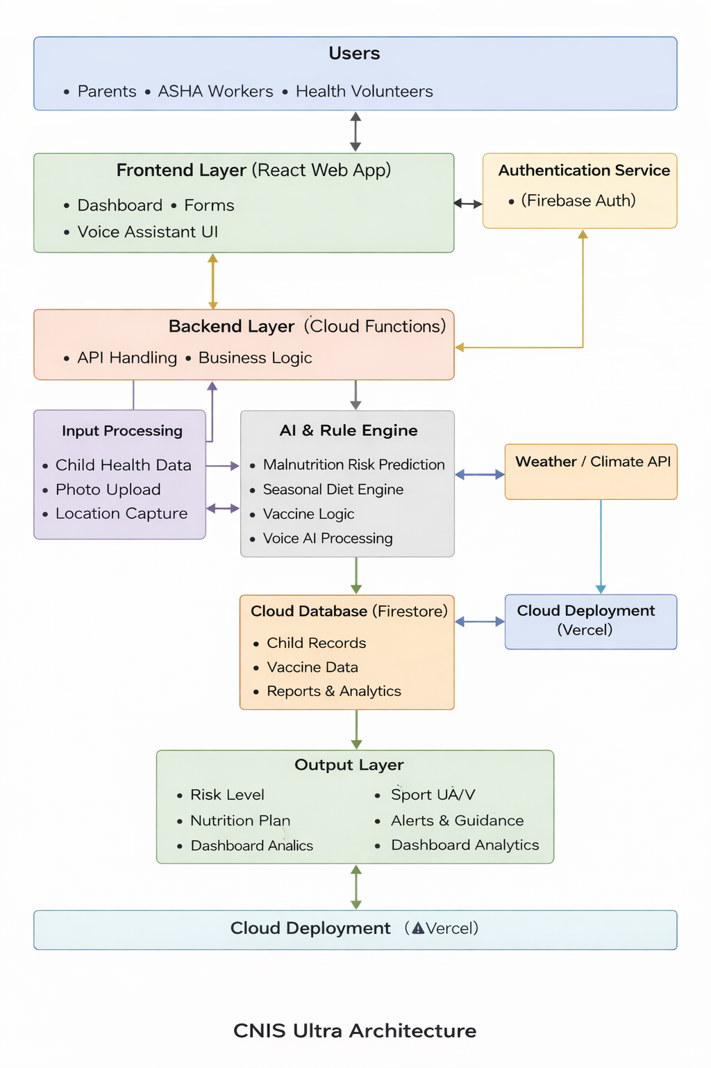

Declaration

We declare that the project CNIS (Climate Nutrition Intelligence System) is an original idea developed specifically for the CODEKSHETRA 2026 Hackathon. The concept, system design, implementation approach, and features have been created by our team for this competition. Any external tools, frameworks, APIs, or reusable components used in the project have been properly acknowledged and integrated only for development support. We confirm that this submission is our own work and does not violate any intellectual property or copyright policies.

