**Module 3 – ServiceNow Development Modules**

**1.ServiceNow Tutorial | ServiceNow Tutorial for Beginners | Introduction to ServiceNow**

* **What is ServiceNow?**
* It is a cloud based platform, mainly developed for workflow and process automation as per the ITIL principles.
* Highly customisable, can be used for other purposes.
* **Services of ServiceNow**
* IT Service Management
* HR Management
* GRC
* Integrations
* IT asset management
* Finance operation management
* IT business management
* **How to get free SNOW instances?**

1. develop.servicenow.com
2. Sign up/ login
3. Request/create an instance
4. Select Servicenow Developer Instance Version
5. Instance credentials info
6. Login into SN Developer instance

* If instance is inactive for
* 10 days- instance is released
* >24 hrs- instance may go to hibernation state
* **How to become a SNOW developer?**

1. Get a Bachelor’s degree
2. Learn Js & ITIL basics(recommended)
3. Get ServiceNow Course

* **Career and growth in ServiceNow**
* Exponential Growth
* Hype of Cloud platforms , SN is currently very popular
* Among cloud platforms, Servicenow is best tool to use because of its simplicity and ease of use
* Low coding
* ServiceNow fits best in industries like:

IT and Services

Healthcare

Insurance(ITBM)

Computer Software

Governance(GRC)

* **ServiceNow certification training**
* Learn and practice through Nowlearning platform
* After completing prerequisite courses, voucher will be provided
* Apply Voucher code and schedule for the certification exam
* **ServiceNow UI Overview**
* We interact with the application and modules of ServiceNow platform through the UI using web browser
* Every 6 months ,version changes(new release)

Banner frame:Instance Logo, name of instance,pickers, global search, connect chat, settings are displayed

Content frame: Where content is displayed

Navigation frame: Search or navigation is done here(All applications, Favourites, Watch History)

* **ServiceNow Modules**
* Modules are the elements that make up the ServiceNow application navigator
* Some of the modules in ServiceNow are:

Incident management

Problem management

Change and release management

Request management

Asset and cost management

Walk-up experience

Agent Workshop

Now Mobile,etc

* **Incident module**
* Interruption,Disruption or degradation to service is an incident
* The process of managing the incident lifecycle is called as Incident management
* Steps:

1. Incident->Create New->fill the form
2. Ticket is opened
3. Assigned to a group
4. Incident is resolved
5. Ticket is closed

At all steps notifications are sent to ticket raiser

* **Problem module**
* A problem is a cause of one or more incidents.
* The process of managing the lifecycle of all the problems that arise or could arise in an IT service is called problem management.
* **Change module**
* A change request contains detailed information regarding the change , like the reason for the change, the risk, the priority, the change type, and the change category.
* A systematic approach for controlling the life cycle of all changes, making it easier to make beneficial changes with less disruption to the IT services is called ServiceNow Change Management.
* Types:

Emergency changes

Normal changes

Standard changes

* **List**
* A list displays a set of records from a table.
* Users have the ability to search, sort, filter and edit data in lists.
* Users can search, sort, filter, and edit data in lists. Lists can be integrated into forms and can have sublists.
* The list interface includes a title bar, breadcrumbs and filters, columns of data, and a footer. Every column in a list represents a field in the table.
* **Form**
* A form is a content page that displays the fields and values of a single record in a database table
* Forms have a 1-column layout, a 2-column layout, or a blend of both.
* Forms are opened from

1. Modules in the application navigator (or)
2. By clicking a record number in a list

* **Filters**
* Funnel icon
* Displays desired records that meet the conditions set
* Condition includes:

Field

Operator

Value

**2. What is ServiceNow | ServiceNow Administration & Developer Overview**

* **Major customers**
* Netflix
* Facebook
* Intel
* Citi bank
* Dell
* Capgemini
* **ServiceNow Growth**

Servicenow has exponential growth

* **ServiceNow Architecture**

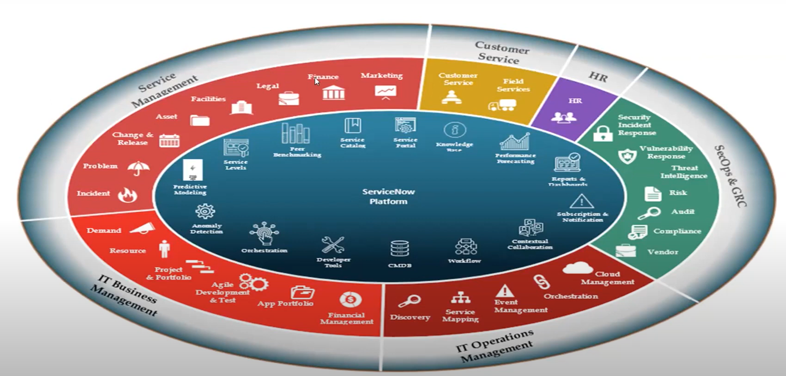

* **Who use ServiceNow?**
* Employees
* IT Support Team
* Administrators
* Implementers
* Developers
* A Service Catalog is a consumer-like user interface (UI) for requesting services or products.
* Dashboards are a drag and drop canvas for gathering visualizations used regularly into a single location.