Experiments with Digital Security Processes over SDN-based Cloud-native 5G Core Networks

In propose paper author providing security to cloud based 5G networks using SDN (software defined networks) algorithm. 5G network provides high speed using various sub-algorithms like Micro-services, Network Function Virtualization and SDN processing which leads to new threats and security vulnerabilities, that could affect both communication providers and users of 5G infrastructures.

To combat against above vulnerabilities author of this paper employing many algorithms such as Monitoring, AI & Simple algorithms based attack detection and Decision making. Each algorithm description given below

1. Monitoring: SDN responsible to collect network data and then process and input collected data to AI detection models. In this module author using simulator to generate data and this data is not available on internet so we downloaded available SDN 5G network attack dataset from below KAGGLE repository https://www.kaggle.com/datasets/iagobs/dosddos-attacks-on-5g-networks
2. AI Models: in propose paper author compare performance many models like EMA, ARIMA, MLP and AI based CNN1D algorithms. EMA and ARIMA is simple algorithms whose detection time is very less but prediction accuracy is low. MLP and CNN1D AI algorithms execution time is high and prediction accuracy also high. So author suggesting to use AI based model for attack detection
3. Decision Making: this module will take decision of accepting or rejecting packets if DDOS attack detected. If detected attack has high ratio of vulnerability then decision will be taken to drop packets which can leads to providing high security to 5G networks.

Extension Concept

For detection in propose work author has used existing CNN1D algorithm whose performance can be further improve by modifying with CNN2D algorithm so as extension work we have used CNN2D which is giving high accuracy compare to CNN1D. CNN2D generally outperform 1D CNNs (CNN1) in tasks involving spatial information like attack recognition. CNN2D excels at capturing spatial relationships within dataset features which may help algorithm in gaining accuracy over CNN1D.

In below screen showing SDN network 5G dataset details

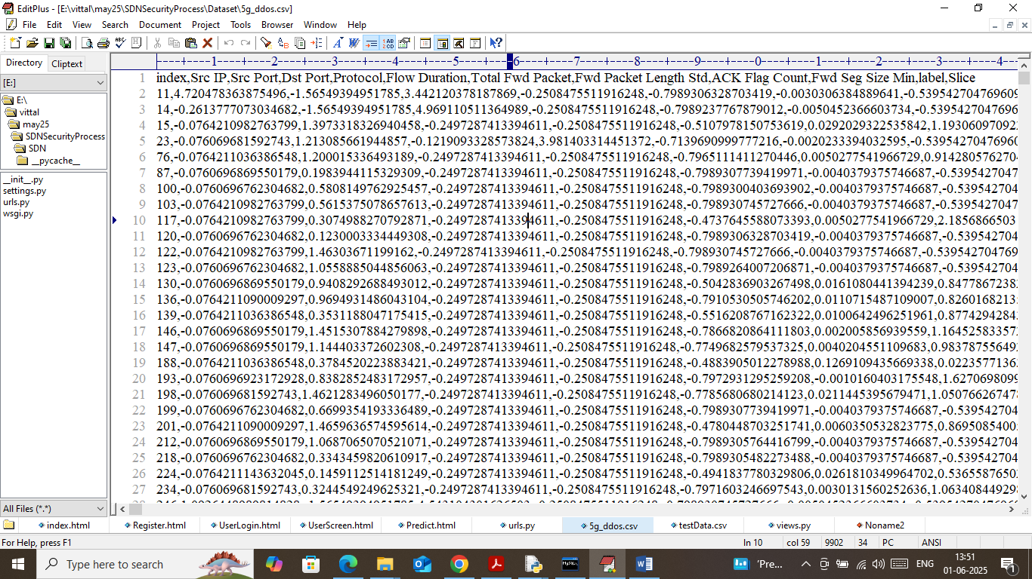

In above dataset screen first row contains dataset column names and remaining rows contains dataset values and this dataset contains all network information such as protocol type, port no, packet length etc.

Note: we don’t have real cloud servers and SDN hardware to gather network data so we are using above dataset.

So by using above dataset will perform monitoring, analysis and AI based detection process. To implement this project we have designed following modules

1. Registration Here: using this module user can register with the application
2. User Login: using this module user can login to system
3. SDN 5G Attack Data Generation: after login user can run this module to load SDN 5G network data and then process and split data into train and test where application using 80% dataset for training and 20% for AI testing.
4. EMA & AI Attack Identification: 80% training data will be input simple EMA (exponential moving average), MLP, CNN1D and CNN2d to train models and this models will be applied on 20% test data to calculate prediction accuracy.
5. Monitor & Detect Attack: using this module user can upload SDN 5G test data and then best performing AI model will be applied on test data to detect attacks and then make decision of dropping or accepting packets.

SCREEN SHOTS

To run project install python 3.7.2 and then install all packages given in requirements.txt file. Install MYSQL database and then copy content from ‘database.txt’ file and paste in MYSQL console to create database.

Now double click on ‘runWebServer.bat’ file to start python server and then will get below page

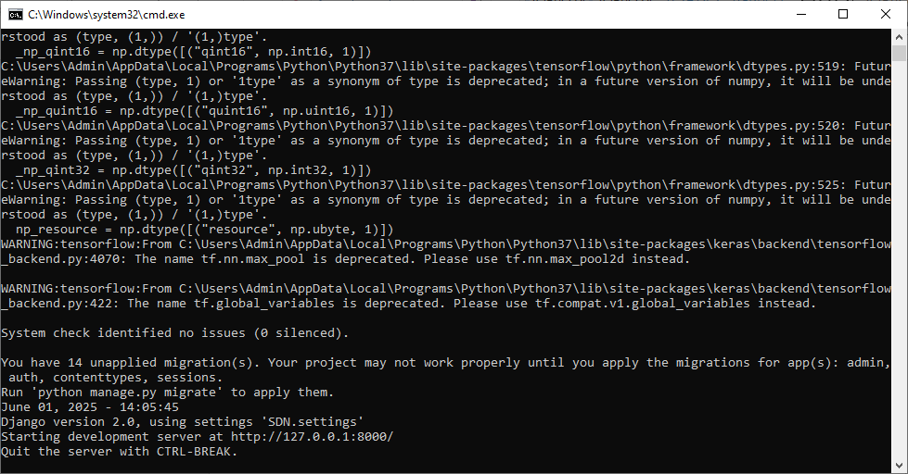

In above screen python server started and now open browser and enter URL as <http://127.0.0.1:8000/index.html> and then press enter key to get below page

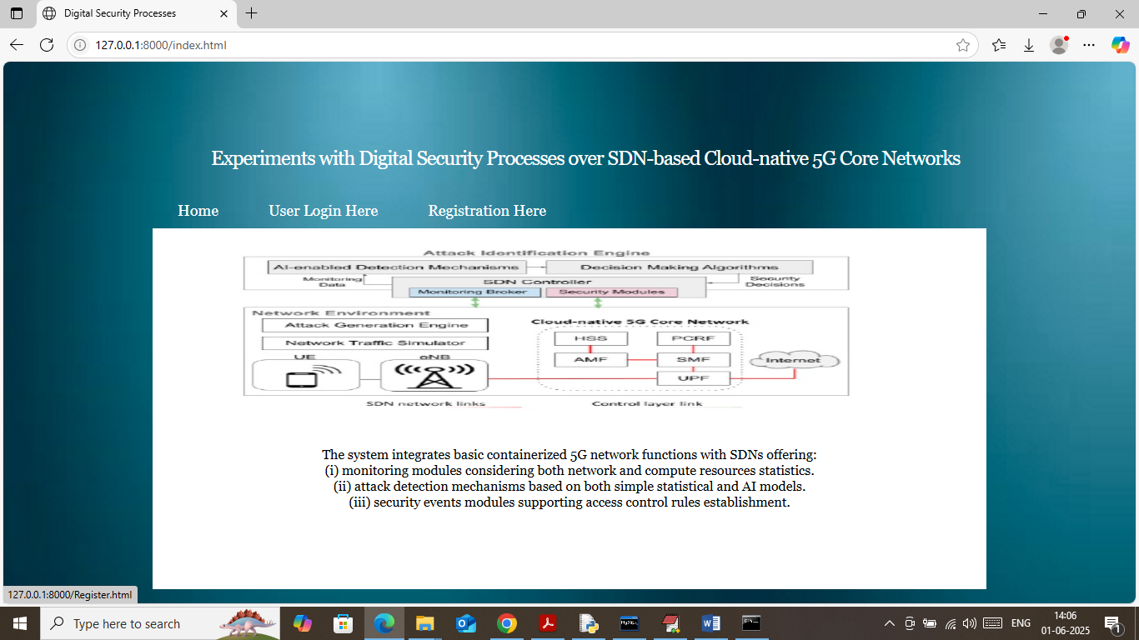

In above screen click on ‘Registration Here’ link to get below page

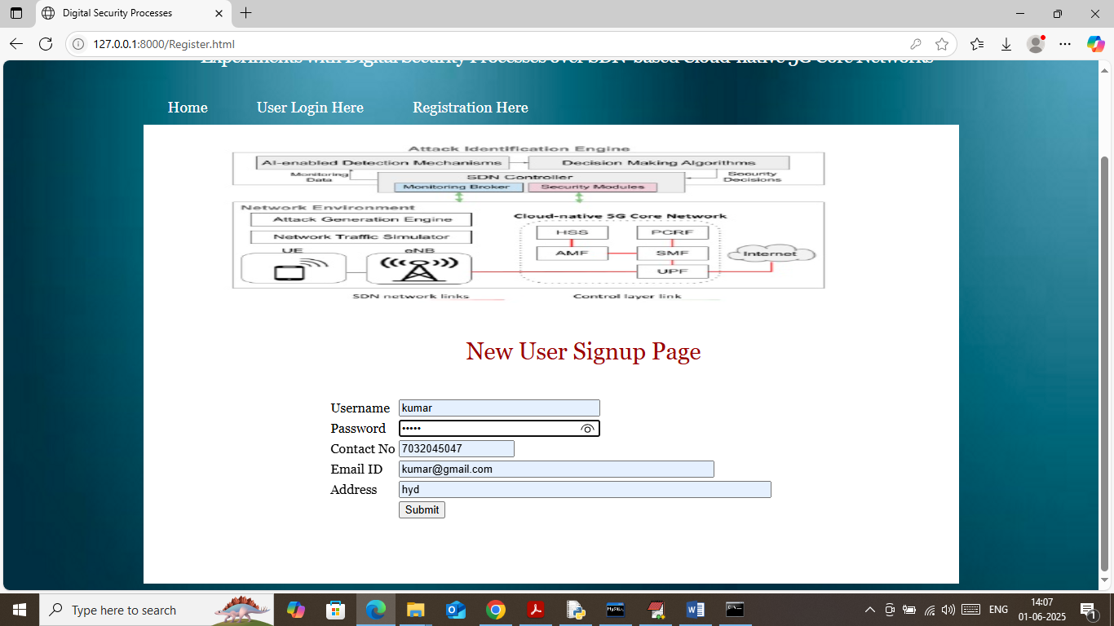

In above screen user is entering sign up details and then press button to get below page

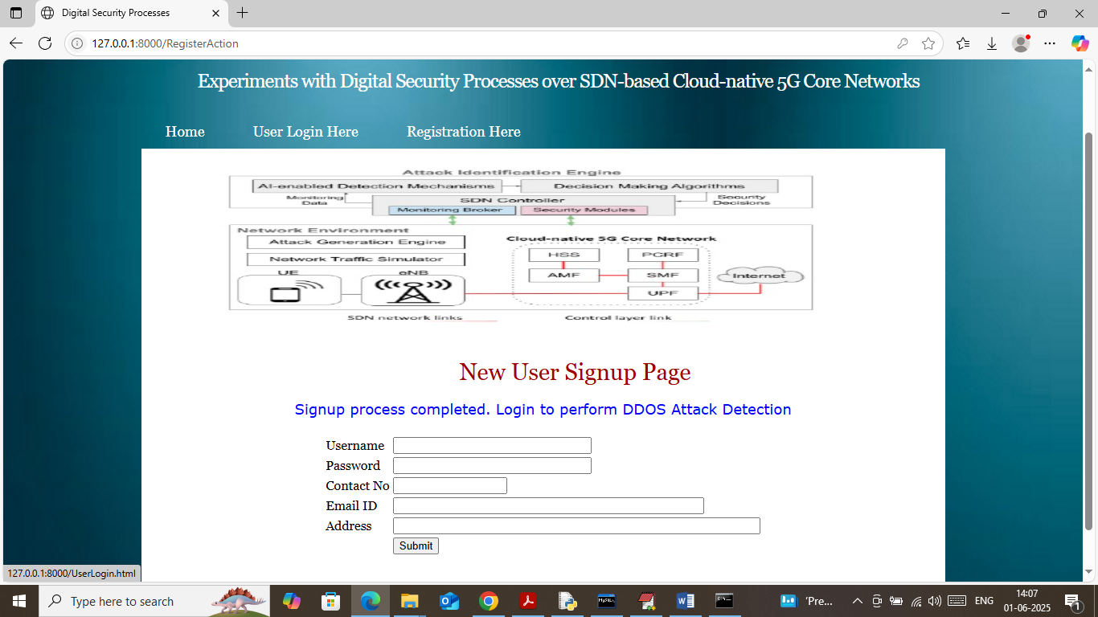

In above screen user sign up completed and now click on ‘User Login’ link to get below page

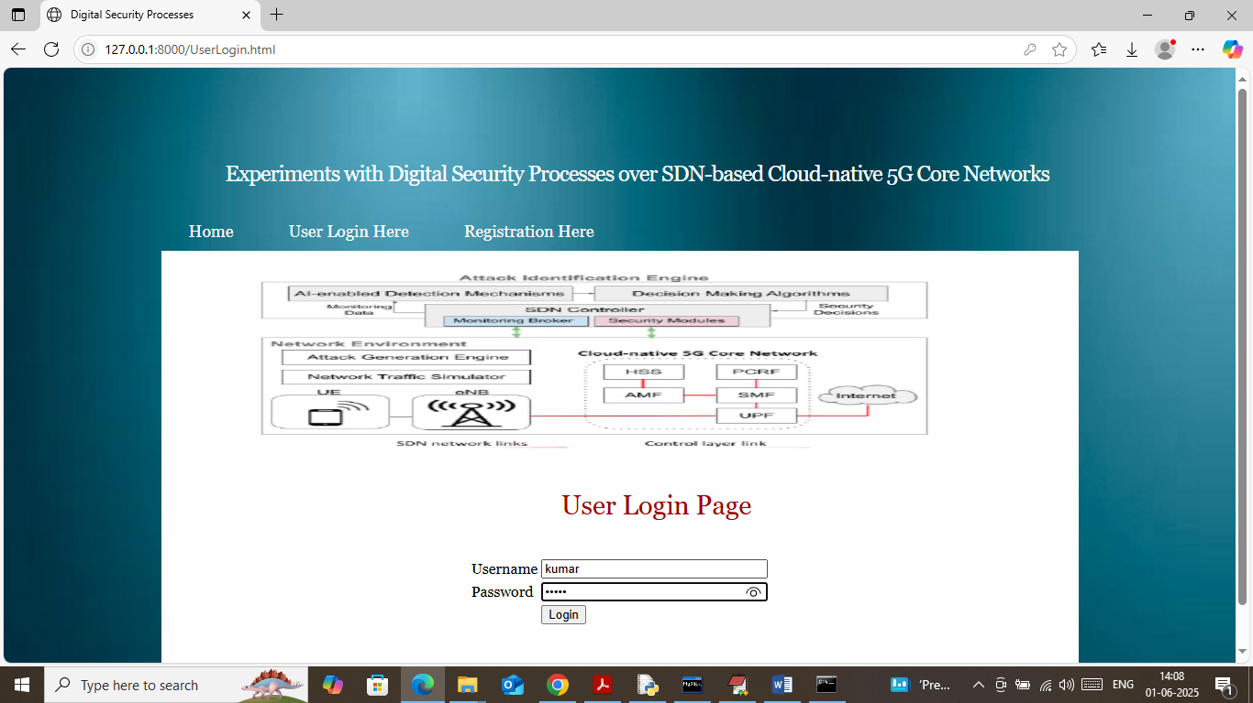

In above screen user is login and after login will get below page

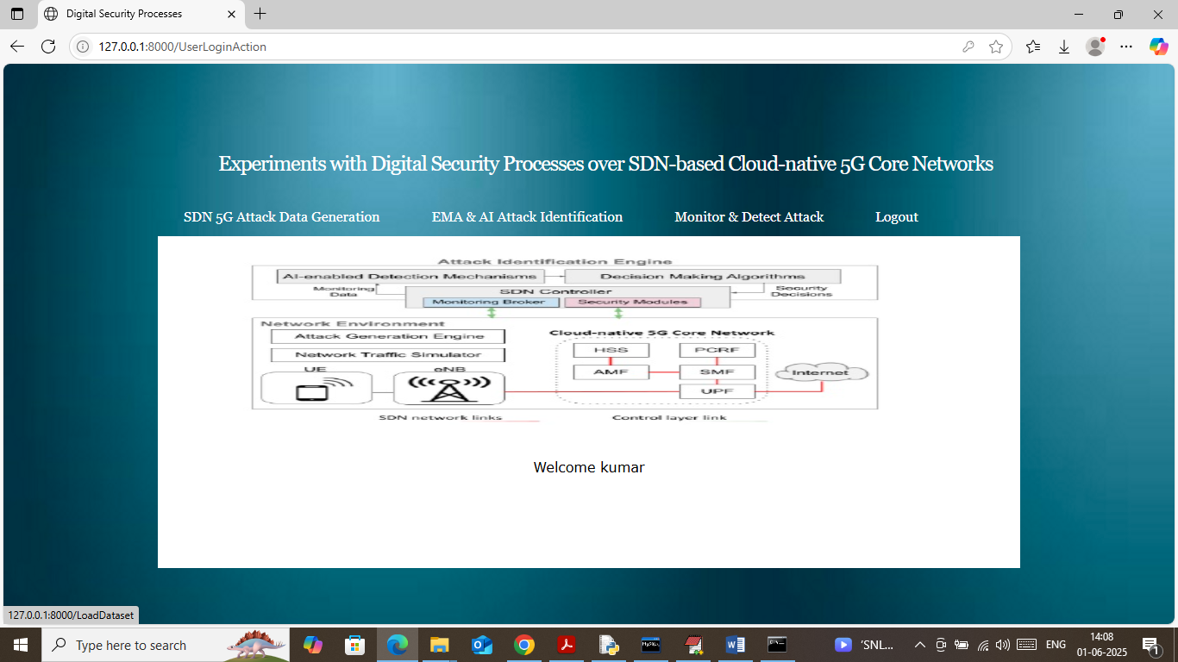

In above screen user can click on ‘SDN 5G Attack Data Generation’ link to generate, load and process dataset and then will get below page

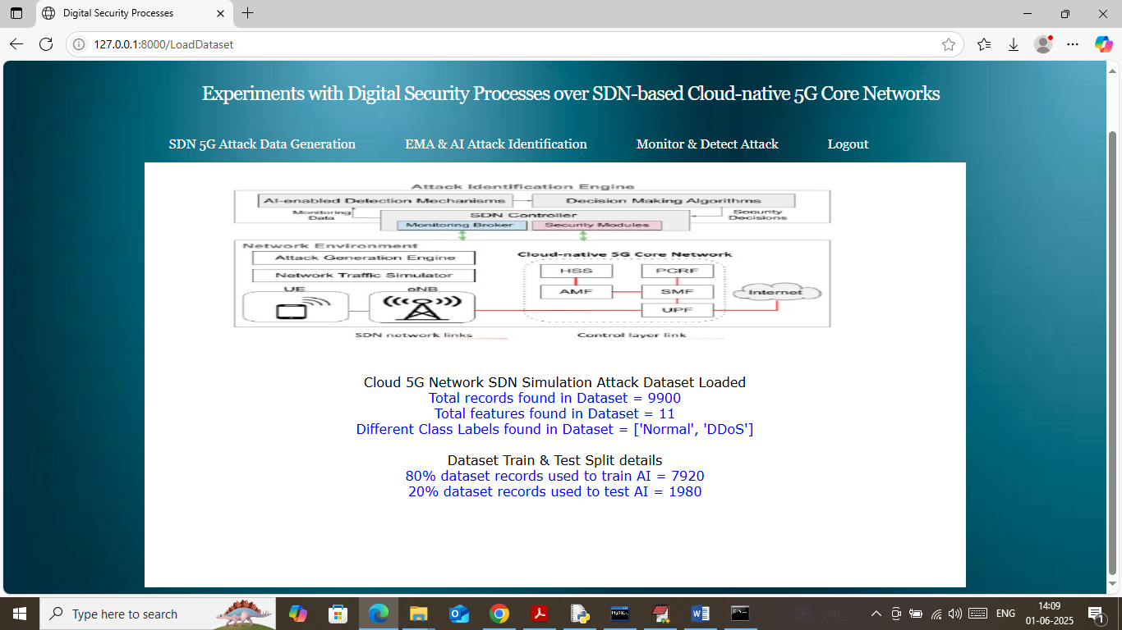

In above screen can see number of records and features loaded from dataset along with class labels. In next line can see train and test sizes and now click on ‘EMA & AI Attack Identification’ link to train simple and AI algorithms and then will get below page

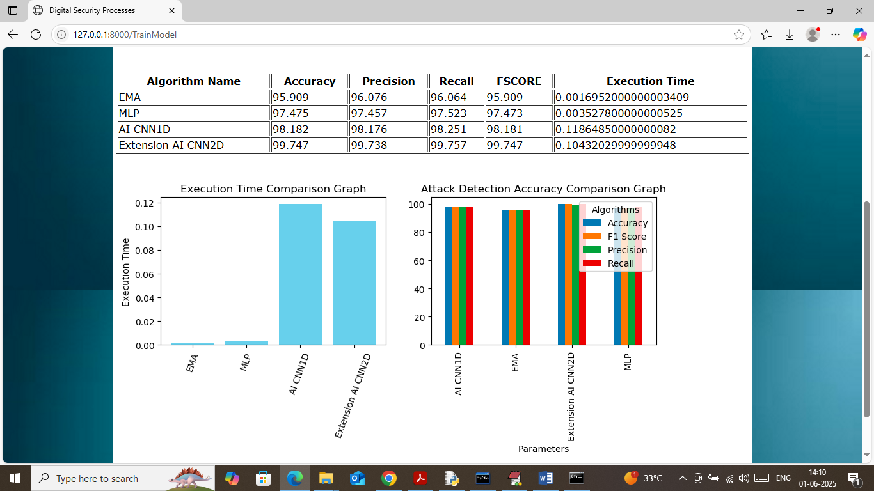

In above screen in table format can see accuracy and other metrics of different algorithms like EMA, MLP, CNN1D and CNN2D. In above table can see propose CNN1D and extension CNN2D got high accuracy. In above screen in first graph showing execution time comparison where x-axis represents algorithm names and y-axis represents execution time and in above graph can see EMA and MLP took less execution time but detection accuracy is high. In other scenario AI models got high accuracy and its execution time also high. In second graph showing all algorithms performance graph where x-axis represents algorithm names and y-axis represents accuracy and other metrics in different colour bars. In above second graph can see extension CNN2D got high performance. Now click on ‘Monitor & Detect Attack’ link to upload test data and then will get below page

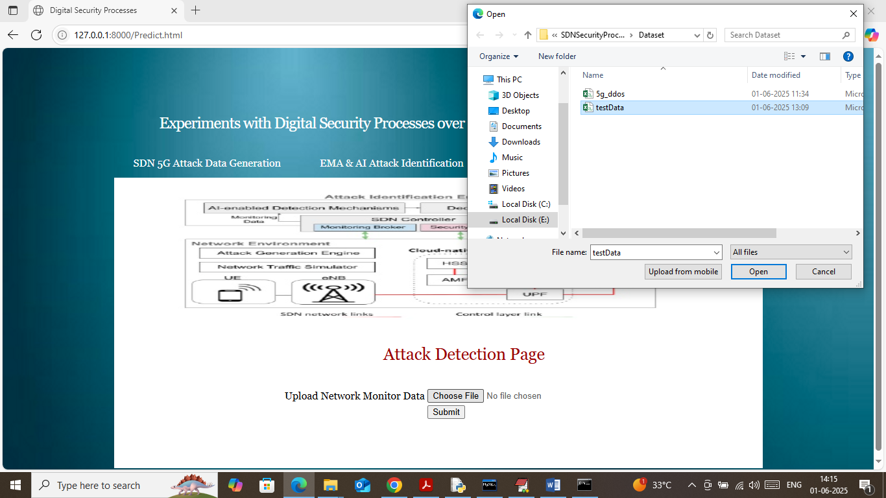

In above screen selecting and uploading test data file and then click on buttons to get below page

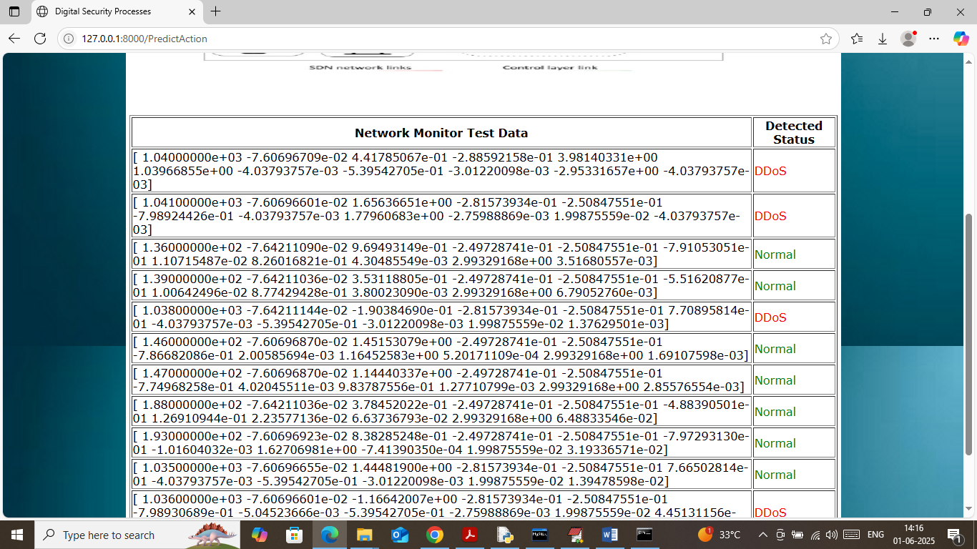

In above screen first column contains SDN test data values and in second column extension AI CNN2D detected those test data as Normal or DDOS.

So by using above algorithms we can detect attack from 5G networks to provide more security.