
Project Report On

Design and UVM based Verification of SPI protocol with BIST

Integration



Submitted in Partial Fulfillment for the award of
Post Graduate Certificate Program in VLSI Design (PGCP-VLSI)
from
C-DAC, ACTS (Pune)
Guided by:
Mr. Suyash Jain

Presented by:
Mr. MO Ijhar | PRN:260240133017
Ms. Shivani Maurya | PRN:260240133031
Mr. Sukuri Harish | PRN:260240133035
Mr. Kushagra Guptha | PRN:260240133039
Mr. Sarthak Pandey | PRN:260240133040

Centre for Development of Advanced Computing (C-DAC), Pune

This project “Design and UVM Verification of SPI Protocol with BIST Integration” was a great learning experience for us and we are submitting this work to Advanced Computing Training School (CDAC ACTS).
We are very glad to mention the name of Mr.Suyash Jain for their valuable guidance to work on this project. Their guidance and support helped us to overcome various obstacles and intricacies during the course of project work.
Our heartfelt thanks goes to Ms. Jubera Khan (Course Coordinator, PGCP-VLSI) who gave all the required support and kind coordination to provide all the necessities like required hardware, internet facility, and extra Lab hours to complete the project and throughout the course up to the last day here in C-DAC ACTS, Pune.

Introduction
- Introduction
- Literature Survey
- Aim of Project
- Scope and Objective

- THEORETICAL DESCRIPTION OF PROJECT
- Introduction to SPI Protocol
- SPI Master and Slave Architecture
- SPI Modes – CPOL / CPHA and Clock Division
- Register File and Host Address Map
- Built-In Self-Test (BIST) Controller
- LFSR Pattern Generator and MISR Signature Analyzer

- SYSTEM DESIGN AND OPTIMIZATION
- Design Information
- Basic Block Diagram 3.Implementation Considerations
- RESULTS AND TOOLS USED
- Simulation Result
- Synthesis Result
- Xilinx Vivado and Questa Sim

- VERIFICATION
  - Verification Technology – UVM

- CONCLUSION

- FUTURE SCOPE

- REFERENCES

Abstract
The Serial Peripheral Interface (SPI) is one of the most widely used synchronous serial protocols for short-distance, chip-to-chip communication in embedded and System-on-Chip (SoC) designs, valued for its simplicity, full-duplex operation, and low pin count. As SoC designs grow in complexity, ensuring the correctness and in-field reliability of such communication blocks becomes critical, which motivates the integration of a Built-In Self-Test (BIST) engine directly alongside the SPI datapath. This report presents the design and UVM-based verification of an SPI Master/Slave subsystem with an integrated BIST engine capable of exercising the SPI datapath through an internal loopback path.
The design phase covers the SPI master and slave finite state machines, a host-accessible register file (control, status, transmit, receive and signature registers), a BIST controller FSM, an 8-bit maximal-length Linear Feedback Shift Register (LFSR) pattern generator, a Multiple Input Signature Register (MISR) signature analyzer, and a loopback multiplexer that internally routes the SPI bus between the master and slave during self-test.
Verification of the design was carried out using a UVM-based testbench built around a transaction class, layered sequences, a driver, a monitor, a scoreboard, an agent, an environment and a top-level test, exercising basic register transfers, boundary/edge data values, all three BIST modes (fixed pattern, walking-1s and pseudo-random/LFSR), fault injection, sub-state abort, back-to-back BIST runs, BIST-while-busy handling, and a constrained-random regression.
The proposed design and verification methodology results in a compact, self-checking SPI subsystem that can validate its own datapath internally without external test equipment, improving testability and field diagnosability while remaining fully compliant with standard SPI host-register access.
Keywords: SPI, BIST, LFSR, MISR, Register File, Design, Verification, UVM.

INTRODUCTION
In modern embedded systems and Systems-on-Chip, numerous peripherals — sensors, ADC/DACs, flash memories, displays and companion controllers — communicate with a host processor over a small number of low-speed serial links. The Serial Peripheral Interface (SPI) protocol has become a de-facto standard for such communication because of its simple four-wire signalling (SCLK, MOSI, MISO and SS_N), full-duplex operation, and the absence of a complex arbitration or addressing scheme.
As the number of SPI-connected peripherals on a board or die increases, so does the cost of an undetected fault in the SPI datapath itself. Built-In Self-Test (BIST) addresses this by allowing the SPI block to verify its own transmit and receive path using an internally generated test pattern and an internally computed signature, without requiring an external SPI device or external test vectors.
This project documents the design of an SPI Master/Slave subsystem with an integrated BIST engine, and its verification using the Universal Verification Methodology (UVM). The BIST engine generates test patterns using an 8-bit maximal-length Linear Feedback Shift Register (LFSR), loops them back internally through a multiplexer to a companion SPI slave, and accumulates the received bytes into a Multiple-Input Signature Register (MISR). The final signature is compared against a golden/expected value held in the register file to declare a PASS or FAIL, along with a diagnostic error code.
Fundamentals of the SPI Protocol: this report first covers the SPI protocol basics — its signal set, master/slave roles, and clocking — which forms the foundation for the design that follows.
Design Considerations: the report then covers the internal FSMs of the SPI master, SPI slave and BIST controller, the register-file address map used to configure and monitor the block, and the loopback architecture that allows the BIST engine to test the SPI datapath without external stimulus.
Verification Methodology: finally, the report describes the UVM-based verification environment built to validate both normal SPI transfers and all BIST operating modes, including fault injection and abort handling.

LITERATURE SURVEY
The Serial Peripheral Interface was originally introduced by Motorola and has since been adopted, in various forms, across practically every microcontroller and SoC vendor. It remains widely used for connecting sensors, memories, displays and configuration EEPROMs because it needs only four signals and no addressing overhead, unlike bus protocols such as I2C or CAN.

SPI Protocol Variants and Timing Modes:
Literature on SPI implementations commonly discusses the four clock-phase/polarity (CPOL/CPHA) combinations that define when data is sampled and shifted, and how a design chooses a fixed mode or supports all four for interoperability with different peripherals.

Built-In Self-Test (BIST) Techniques:
BIST is a well-established technique in digital design for reducing dependency on external Automatic Test Equipment (ATE). Structural and functional BIST approaches typically pair a pseudo-random pattern generator with a signature analyzer, compressing a long test sequence into a compact signature that can be compared against a golden value in a single check.

LFSR-based Pattern Generation:
Linear Feedback Shift Registers are a common choice for generating pseudo-random test patterns because a maximal-length LFSR of width n cycles through 2^n − 1 non-zero states with minimal hardware — a small XOR feedback network and a shift register.

Signature Analysis using MISR:
A Multiple-Input Signature Register compresses a stream of response bits into a fixed-width signature, trading a small (but non-zero) probability of aliasing for a large reduction in the amount of data that must be stored or compared, making it a practical choice for on-chip self-test.

UVM-based Verification Methodology:
The Universal Verification Methodology (UVM), standardized by Accellera, provides a layered, reusable testbench architecture (sequence, driver, monitor, agent, environment, scoreboard) that is widely used in industry to verify protocol-based designs such as SPI, I2C and AXI, and is well suited to constrained-random and directed test generation alike.

Application in Automotive and Industrial Electronics:
In safety-relevant domains such as automotive electronics, periodic or power-on BIST of communication peripherals is often cited as a way to meet diagnostic-coverage requirements without adding external test hardware, reinforcing the practical motivation for integrating BIST directly into the SPI block studied in this project.

AIM OF PROJECT
The project aims to design and verify an SPI Master/Slave subsystem with an integrated Built-In Self-Test engine, accessible through a simple host register interface, and capable of validating its own SPI datapath internally using an LFSR-based pattern generator and an MISR-based signature analyzer.
The top module, spi_bist_top, instantiates a register file, an SPI master, a loopback multiplexer, an internal SPI slave, a BIST controller, an LFSR and an MISR, all written in Verilog HDL. The design supports normal host-driven SPI transfers as well as self-triggered BIST runs across three distinct test modes.
The primary aim of implementing this design is to understand SPI protocol fundamentals and BIST design techniques in the context of a realistic SoC peripheral block, and to build confidence in the design through a structured, UVM-based verification environment with a scoreboard that independently checks both register-access correctness and BIST pass/fail outcomes.

SCOPE AND OBJECTIVE
- RTL design of the SPI Master (spi_master.v) with a programmable clock divider for SCLK generation.
- RTL design of the SPI Slave (spi_slave.v) with a 3-flip-flop synchronizer on SCLK/SS_N to guard against metastability.
- RTL design of the host-accessible Register File (spi_regfile.v) covering control, status, transmit, receive and signature registers.
- RTL design of the BIST Controller (bist_ctrl.v) supporting three test modes — fixed pattern, walking-1s, and pseudo-random (LFSR).
- RTL design of the LFSR pattern generator (lfsr.v) and the MISR signature analyzer (misr.v), and the loopback multiplexer (loopback_mux.v) that routes the SPI bus internally during BIST.
- Integration of all sub-blocks into the top-level spi_bist_top design.
- Verification of the design using UVM, involving a scoreboard-based checker for register transfers and BIST signature outcomes, covering basic transfers, edge-case data, all BIST modes, fault injection, sub-state abort, busy-state handling, back-to-back BIST runs and constrained-random regression.
The scope of this SPI/BIST subsystem is broad, encompassing register-level host access, protocol-compliant SPI signalling, and self-contained diagnostic capability, making it representative of peripheral blocks used across consumer, industrial and automotive SoC designs.

Host Register Interface:
The block exposes a simple 4-bit address / 16-bit data write port and a 4-bit address / 16-bit data read port, making it easy to integrate behind any simple host bus or CPU-facing register bridge.

Configurability:
The SCLK frequency is programmable via an 8-bit clock-divider field in the control register (clk_div = ctrl_reg[15:8]), and the BIST mode is selected via a 2-bit field (bist_mode = ctrl_reg[4:3]), giving flexibility without requiring RTL changes.

Self-Diagnosis:
On a BIST failure, the controller reports a 4-bit diagnostic error code distinguishing a signature mismatch, a transfer timeout, and an invalid mode selection, which is useful for field debug and for driving verification checks.

Application in Automotive and Industrial Electronics:
Because the BIST engine can run entirely on-chip without external stimulus, the design is well suited to power-on self-test and periodic health-check use cases in automotive and industrial electronics, where diagnostic coverage of communication peripherals is often required.
Therefore, the scope of this project spans RTL design, register-level integration, self-test architecture and UVM-based functional verification of the complete SPI/BIST subsystem.

THEORETICAL DESCRIPTION OF PROJECT

Introduction to SPI Protocol
SPI is a synchronous, full-duplex serial protocol that uses four signals: SCLK (serial clock, driven by the master), MOSI (Master Out Slave In), MISO (Master In Slave Out), and SS_N (active-low slave select). The master generates the clock and drives SS_N low to select a slave; data is then shifted out on MOSI and shifted in on MISO simultaneously, one bit per clock edge, most-significant bit first in this design.
- Simple, low pin-count interface suitable for point-to-point or single-master, multi-slave topologies.
- Full-duplex transfer — transmit and receive happen in the same clock cycle.
- No built-in addressing scheme; slave selection is done entirely through the SS_N line.
- Clock frequency and edge polarity are set by the master, giving it full control over transfer timing.

SPI Master and Slave Architecture
The SPI master (spi_master.v) is implemented as a 4-state FSM: S_IDLE waits for a one-cycle spi_en pulse from the register file; S_LOAD latches the byte to transmit (tx_data) and asserts SS_N; S_SHIFT toggles SCLK at a rate set by an 8-bit clk_div value (SCLK frequency = clk / (2 × clk_div)) while shifting MOSI out and MISO in, one bit per SCLK edge; and S_DONE pulses a one-cycle done flag, deasserts SS_N and returns to idle. The received byte is only updated in rx_data once the full 8-bit transfer has completed, so a host reading rx_data always sees a complete byte.
The SPI slave (spi_slave.v) mirrors this with a 3-state FSM (S_IDLE, S_ACTIVE, S_DONE). Because SCLK and SS_N arrive from a different clock domain, the slave first passes both through a 3-flip-flop synchronizer to reduce the probability of metastable sampling before using them internally. The slave shifts data MSB-first and raises a one-cycle rx_done pulse once a complete byte has been received.

SPI Modes – CPOL / CPHA and Clock Division
The design carries cpol and cpha ports through the master and slave interfaces for future extensibility, but in the current implementation both are tied to a fixed value (mode 0 behaviour) by the register file. SCLK frequency, however, is fully programmable at run time through the clk_div field of the control register, allowing the host to trade off transfer speed against signal integrity or power without any RTL change.

Register File and Host Address Map
spi_regfile.v exposes a simple write port (wr_en, wr_addr[3:0], wr_data[15:0]) and read port (rd_addr[3:0], rd_data[15:0]) to the host, decoding a 4-bit address into six logical registers:
- 0x0 – CTRL: bit[1] = bist_en, bits[4:3] = bist_mode (00 = fixed pattern, 01 = walking-1s, 10 = PRBS/LFSR), bits[15:8] = clk_div for the SPI master's SCLK generator.
- 0x1 – STATUS: sticky done / bist_pass / bist_fail flags along with the current diagnostic error code, giving the host a single place to poll transfer and BIST outcomes.
- 0x2 – TX_DATA: the byte the SPI master will transmit on the next spi_en pulse.
- 0x3 – RX_DATA: the last byte received by the SPI master.
- 0x4 – SIG_EXP: the golden/expected signature the BIST controller compares against at the end of a run.
- 0x5 – SIG_ACT: the actual signature accumulated by the MISR during the most recent BIST run.
On reset, the control register defaults to 16'h0400 (clk_div = 4), giving a sensible default SCLK rate without requiring an initial configuration write.

Built-In Self-Test (BIST) Controller
bist_ctrl.v implements a 10-state FSM that generates test patterns, drives them through the SPI master, captures the looped-back response into the MISR, and compares the resulting signature against the expected value:
- S_IDLE – waits for a one-cycle bist_start pulse from the register file.
- S_CONFIG – asserts loopback_en, synchronously resets the MISR, loads the LFSR seed, latches the expected signature, clears the diagnostic error code from any previous run, and initializes the word counter to WORD_COUNT (8 words).
- S_GEN – produces the next test byte according to bist_mode: a fixed pattern (8'hA5) for mode 0, a walking-1 pattern for mode 1, or the current LFSR value (advancing the LFSR) for mode 2; an unrecognized mode sets err_code = 4'h3 and jumps directly to S_FAIL.
- S_SHIFT – pulses spi_en for one cycle to start an SPI transfer of the generated byte.
- S_WAIT – waits for the SPI transfer to complete (spi_done); if it does not complete within TIMEOUT_VAL (512) cycles, err_code = 4'h2 (timeout) is set and the FSM moves to S_FAIL.
- S_CAPTURE – enables the MISR for one cycle to fold the received byte into the running signature and decrements the word counter; control returns to S_GEN until all 8 words have been processed.
- S_MISR_WAIT – a one-cycle settle state after the final MISR capture.
- S_COMPARE – compares the accumulated MISR signature against the latched expected signature; a match proceeds to S_PASS, a mismatch sets err_code = 4'h1 and proceeds to S_FAIL.
- S_PASS / S_FAIL – assert a one-cycle bist_pass or bist_fail pulse respectively, release the loopback path, and return to S_IDLE.

LFSR Pattern Generator and MISR Signature Analyzer
The LFSR (lfsr.v) is an 8-bit maximal-length pseudo-random sequence generator built around the polynomial x⁸+x⁶+x⁵+x⁴+1, using feedback taps at bit positions {7,5,4,3}. It supports a synchronous seed load (seed_load / seed_in, default seed 8'h01) and a one-step advance enable (en), and is used to generate the pseudo-random test pattern in BIST mode 2.
The MISR (misr.v) accumulates the byte stream received during a BIST run into a single 8-bit running signature. On every enabled cycle it rotates its current signature left by one bit and XORs in the newly captured data byte (sig_reg ← rotate_left(sig_reg,1) ⊕ data_in); a synchronous misr_rst clears it to zero at the start of each BIST run. This rotate-and-XOR structure gives good coverage of bit errors while remaining inexpensive in hardware.
The loopback multiplexer (loopback_mux.v) is what makes internal, stimulus-free self-test possible: when loopback_en is asserted by the BIST controller, it disconnects the SPI master's SCLK/MOSI/SS_N/MISO pins from the external package pins and instead routes them directly to an internal SPI slave instance, so every byte the BIST engine transmits is looped straight back for the MISR to capture — no external SPI device is required to run BIST.

SYSTEM DESIGN AND OPTIMIZATION

Design Information
The top-level module spi_bist_top integrates the register file, SPI master, loopback multiplexer, internal SPI slave, BIST controller, LFSR and MISR into a single design that exposes only a host register interface (wr_en/wr_addr/wr_data, rd_addr/rd_data), the external SPI pins (spi_sclk, spi_mosi, spi_ss_n, spi_miso) and two debug pulses (bist_pass_pulse, bist_fail_pulse) at its boundary, keeping the internal FSMs and signature logic fully encapsulated.

BIST Controller FSM – Timing Behaviour
IDLE state: all BIST outputs are deasserted and the controller simply waits for bist_start; the diagnostic error code from a previous run is preserved on the STATUS register until the next run begins.
CONFIG / GEN / SHIFT / WAIT / CAPTURE loop: this sequence repeats once per word (8 words total) generating a pattern byte, shifting it out over SPI, waiting for completion, and capturing the looped-back byte into the MISR.
MISR_WAIT / COMPARE: after the last capture, a one-cycle settle state is inserted before the final signature comparison to avoid comparing against a signature that has not yet propagated.
PASS / FAIL: exactly one of bist_pass or bist_fail is pulsed high for a single cycle to mark completion, after which the controller returns to IDLE and is ready to accept the next bist_start.
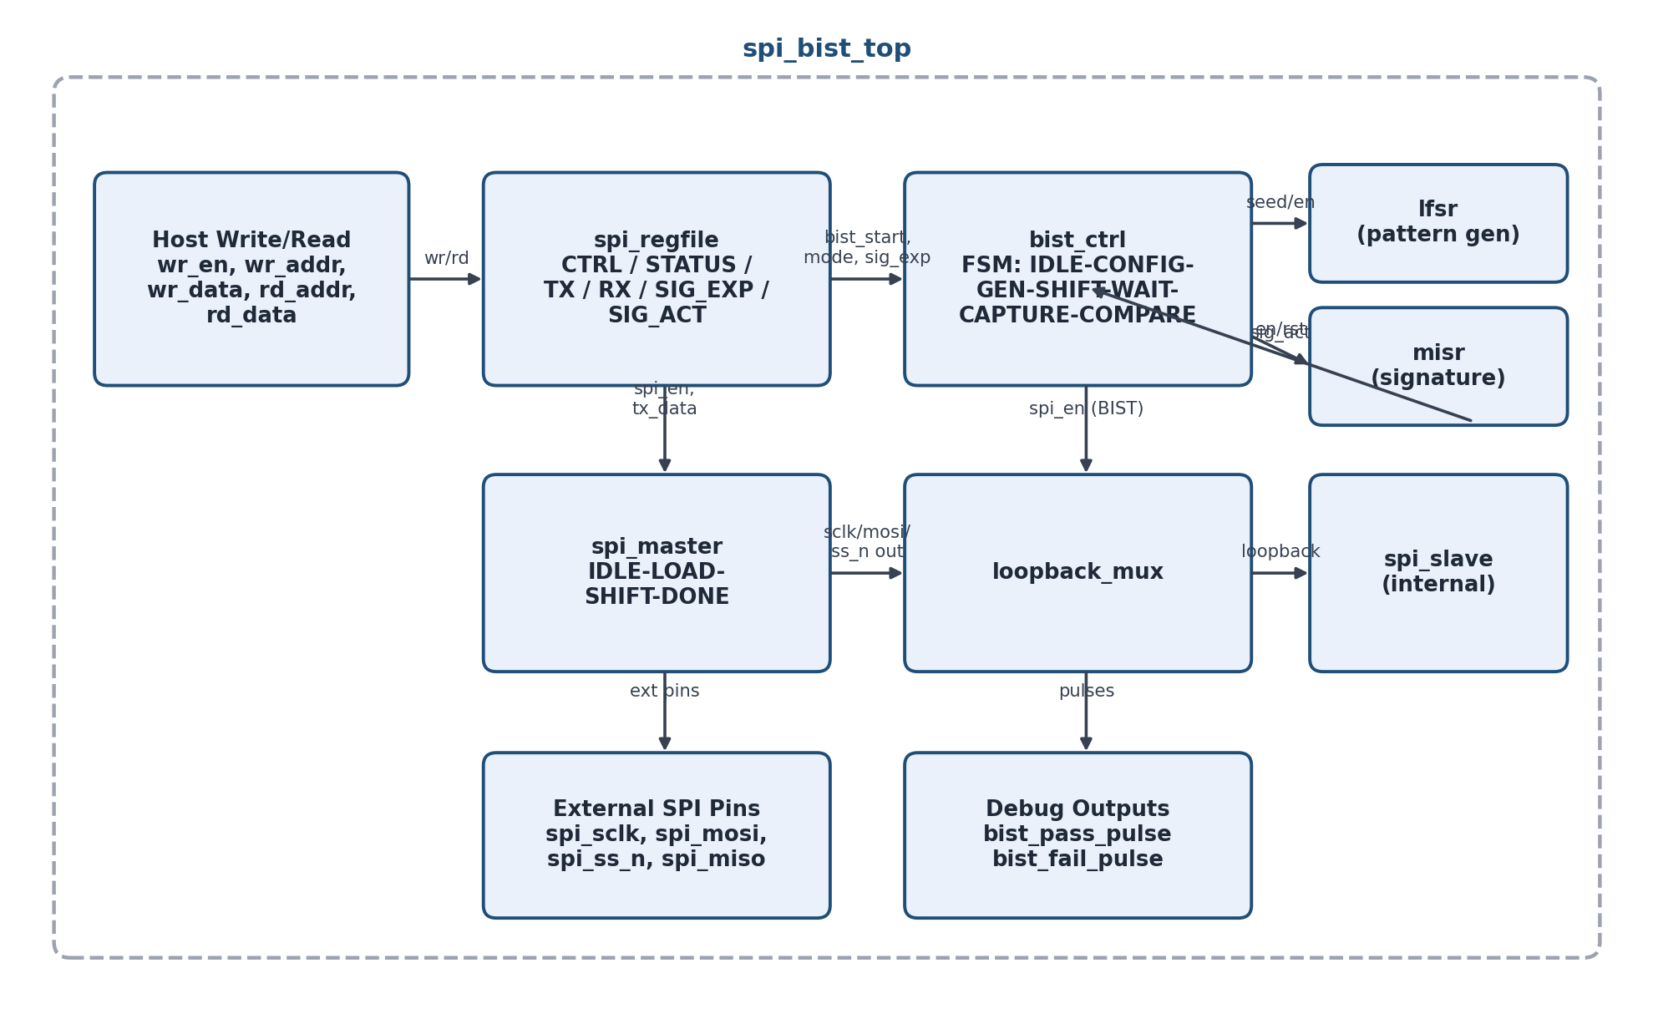
Fig: Basic Block Diagram of the SPI/BIST Subsystem

Write Operation
The host drives wr_addr/wr_data and pulses wr_en for one cycle. Writing to CTRL configures clk_div / bist_mode / bist_en; writing to TX_DATA loads the byte the SPI master will send on the next transfer; and writing bist_en / a BIST-start encoding to CTRL triggers the BIST controller via a one-cycle bist_start_out pulse from the register file.

Read Operation
The host drives rd_addr and reads rd_data combinationally/registered from the selected logical register. Reading STATUS reports done / bist_pass / bist_fail / err_code, reading RX_DATA returns the last byte received over SPI, and reading SIG_ACT returns the signature accumulated during the most recent BIST run for comparison against SIG_EXP.

Implementation Considerations

Signals Specification
clk, rst_n – system clock and active-low synchronous reset.
wr_en, wr_addr[3:0], wr_data[15:0] – host write port.
rd_addr[3:0], rd_data[15:0] – host read port.
spi_sclk, spi_mosi, spi_ss_n, spi_miso – external SPI pins.
bist_pass_pulse, bist_fail_pulse – one-cycle debug/status pulses indicating BIST completion outcome.

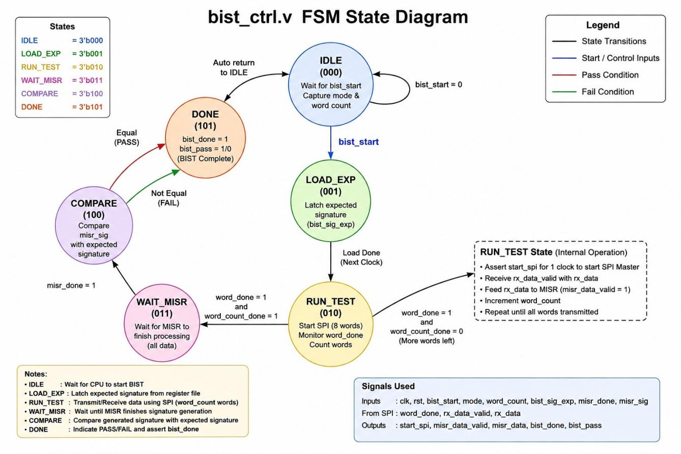

Fig: BIST control FSM

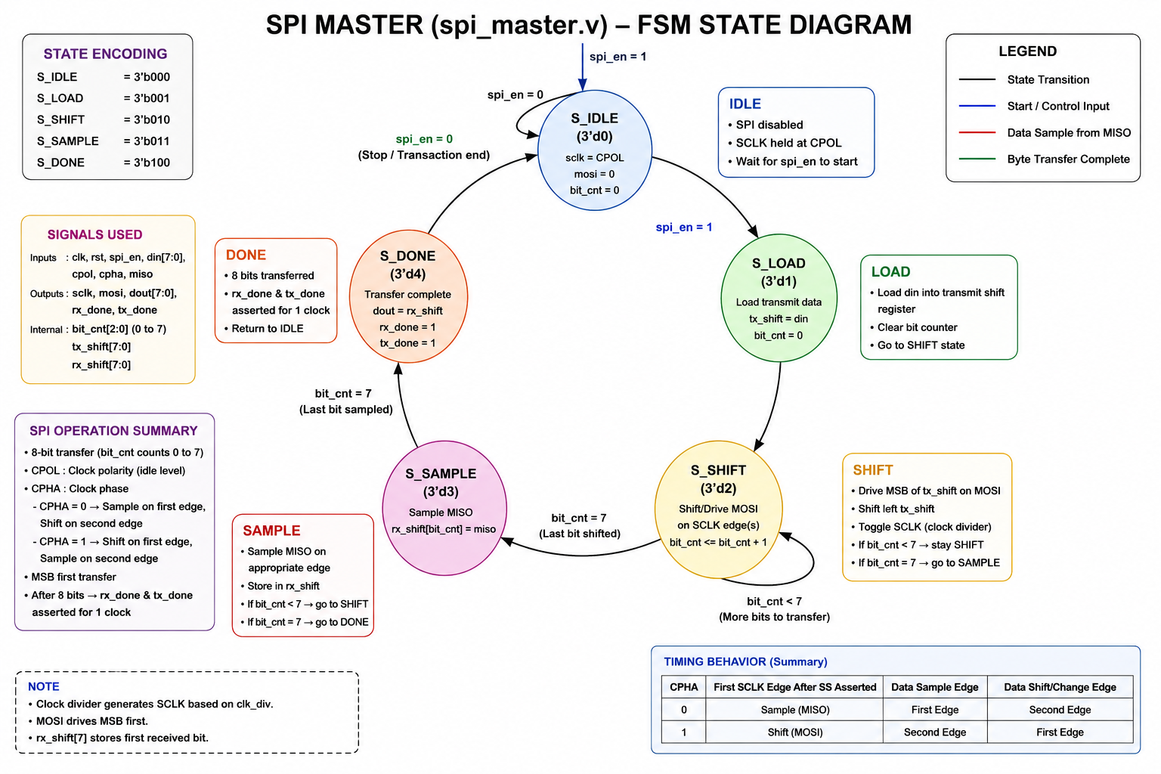

Fig: Master control FSM

TOOL USED AND RESULT
The following tools are used –
- Xilinx Vivado 2025
- QuestaSim

ELABORATED DESIGN
Elaborated design of the SPI/BIST subsystem is as follows:

Fig: Schematic of spi_bist_top

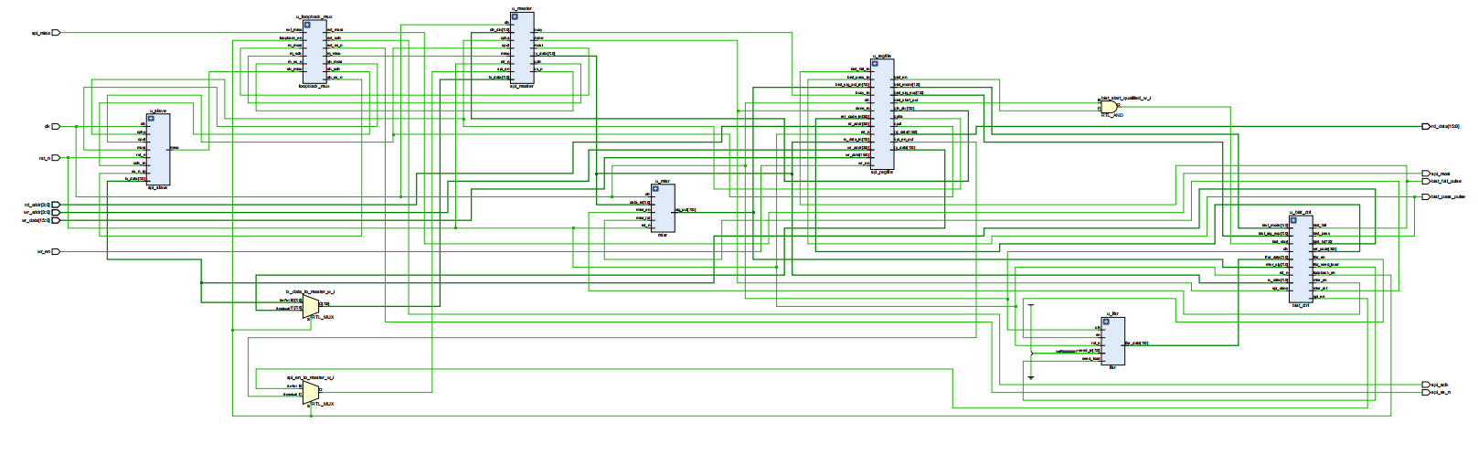

Fig: Elaborated design

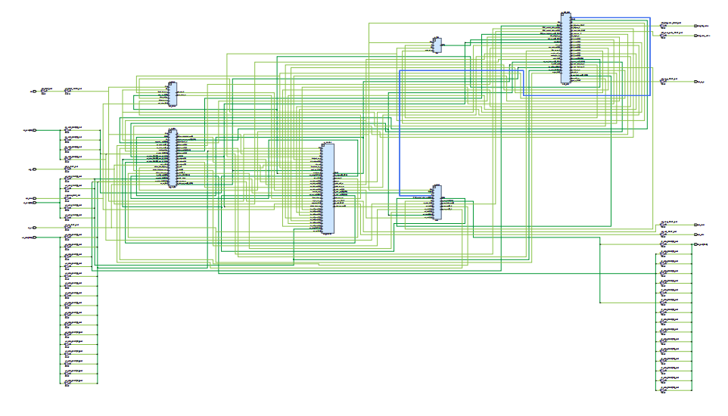

Fig: Synthesized Design

SPI/BIST Testcases
The following UVM tests were implemented and executed against the spi_bist_top DUT to cover normal register access, edge-case data, all three BIST modes, fault handling and regression:
test_tc01_basic_xfer – basic host write / SPI transfer / read-back cycle.
test_tc02_ss_abort – sub-state abort of an in-progress transfer/BIST run.
test_tc03_edge_data – boundary data patterns (all-zeros, all-ones, alternating bits) and address edges.
test_tc4_bist_mode0 – BIST fixed-pattern mode.
test_tc5_bist_mode1 – BIST walking-1s mode.
test_tc6_bist_mode2 – BIST pseudo-random (LFSR) mode.
test_tc7_bist_fault_inject – BIST run with an injected fault, verifying a correct FAIL and error code.
test_random_regression – constrained-random regression across all of the above scenarios.

SIMULATION RESULTS

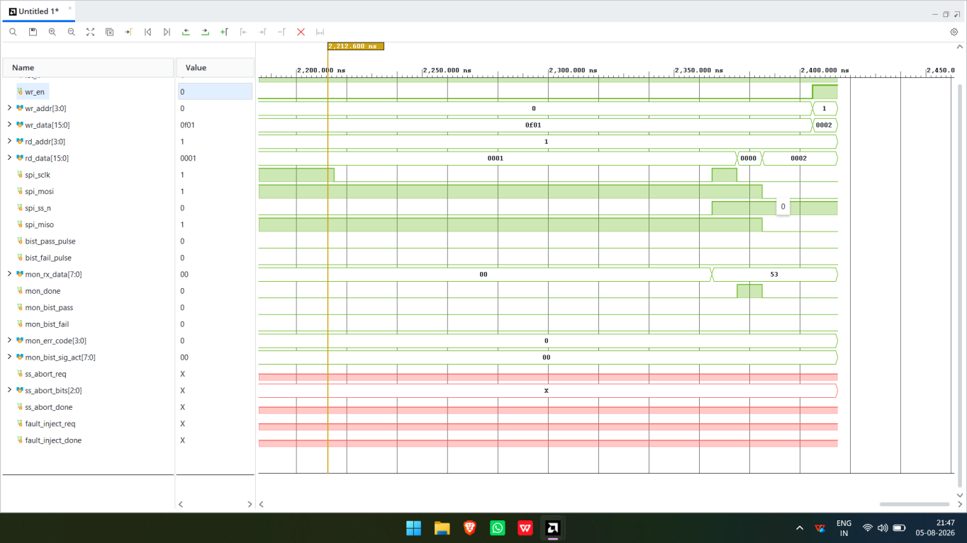

Fig: Normal SPI Register Transfer

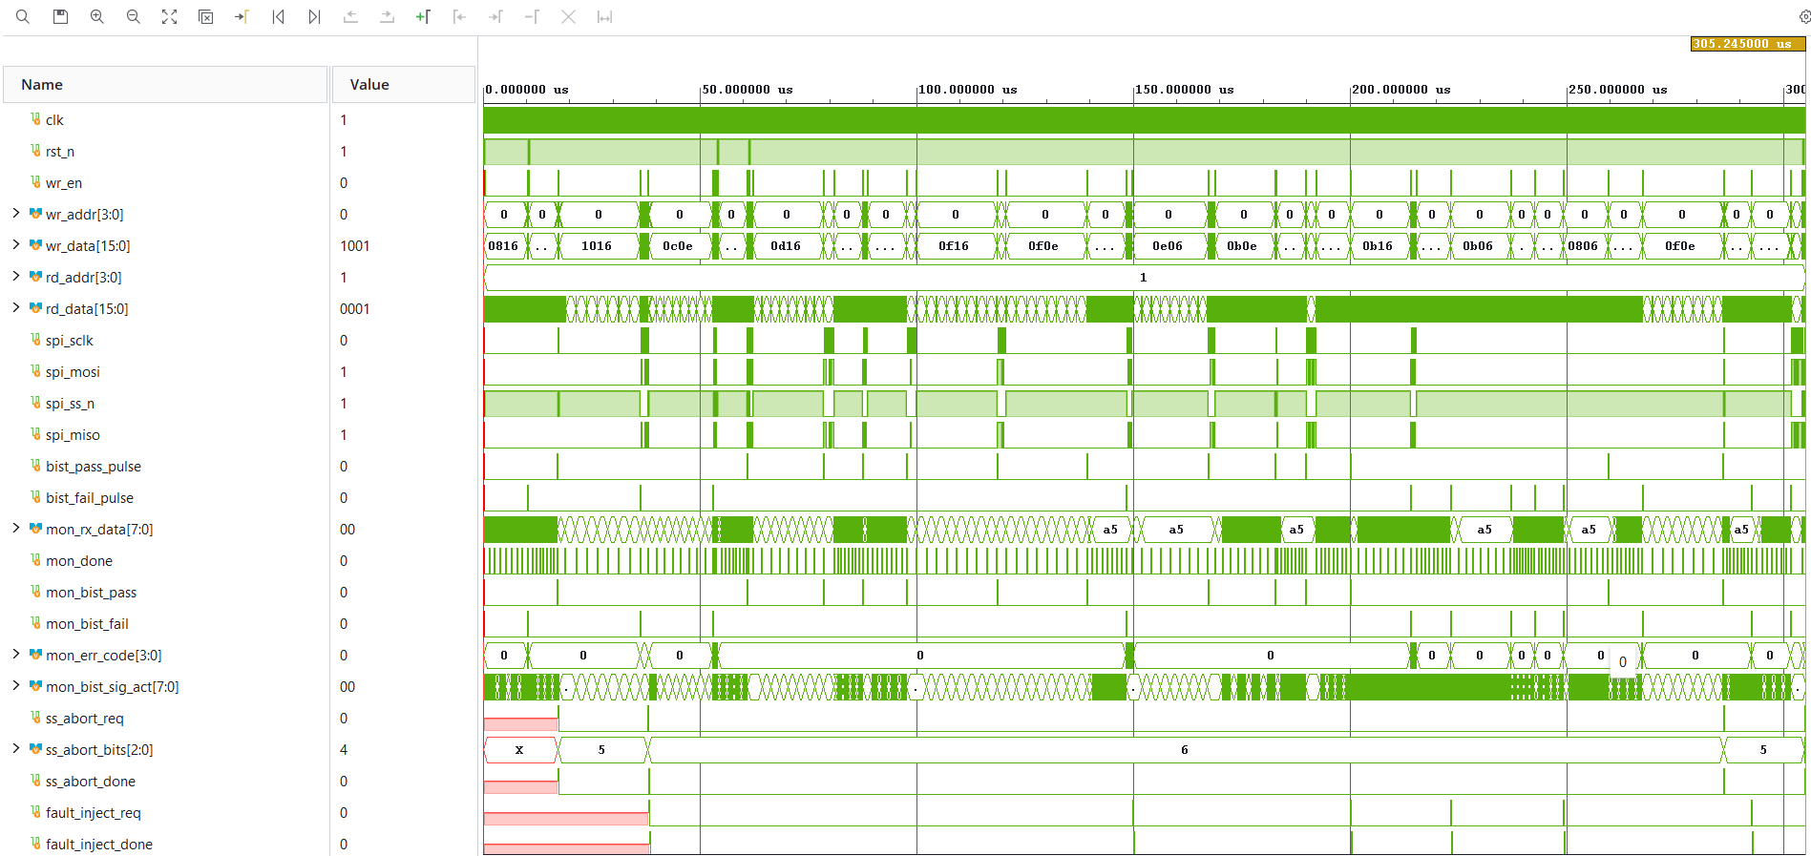

Fig: Random regression

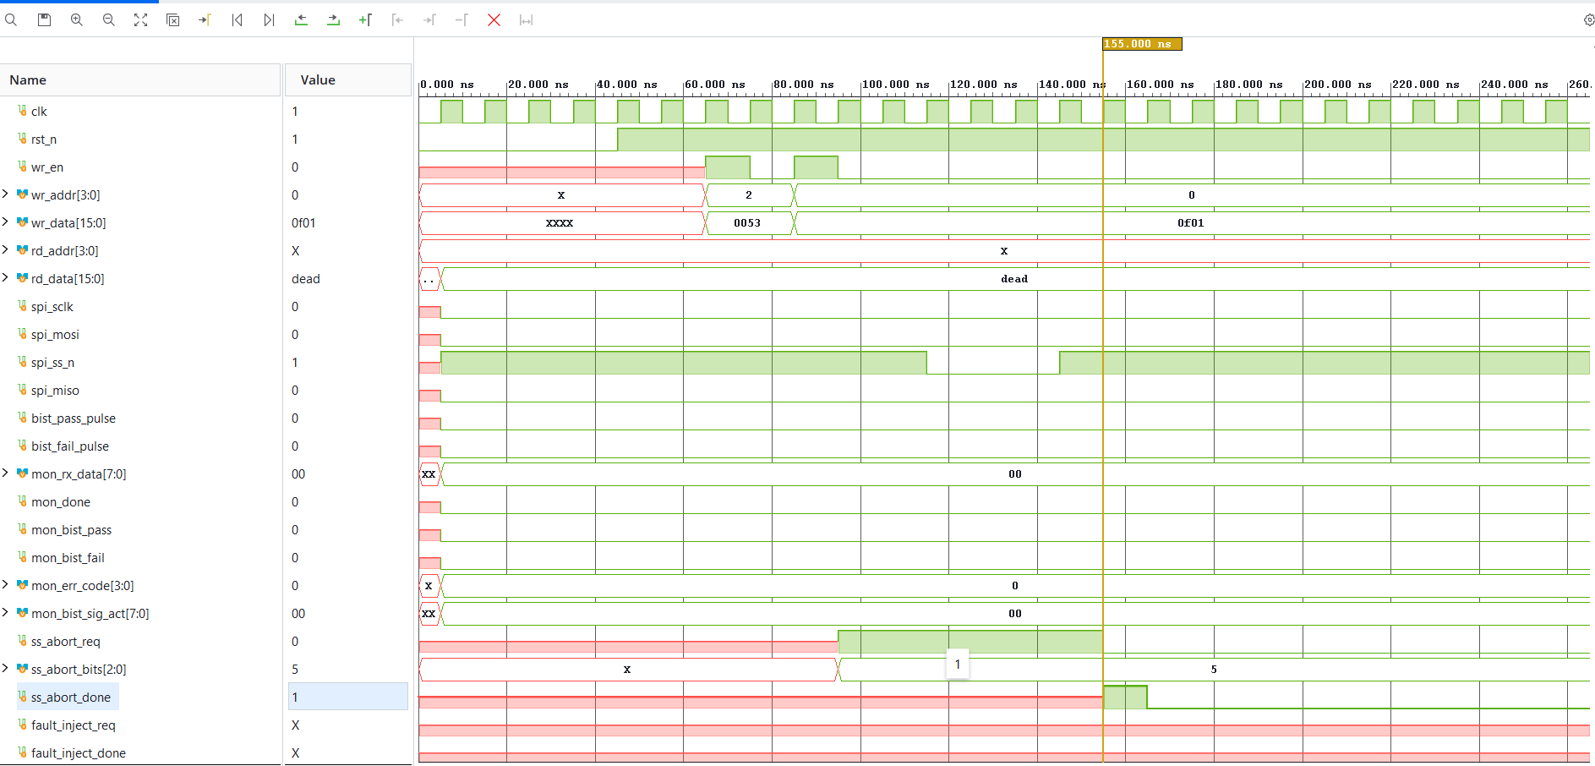

Fig:test TC02 SS abort mid transfer

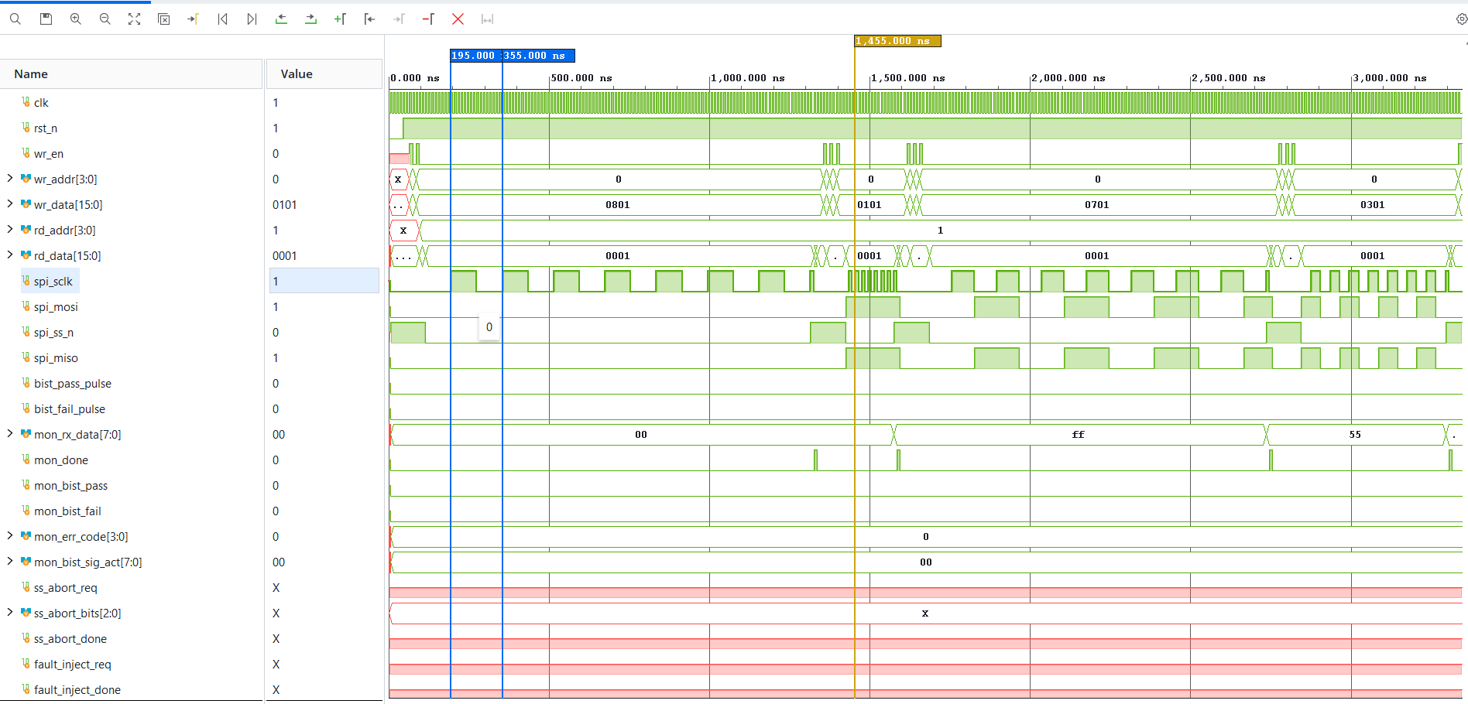

Fig:test TC03 Edge cases

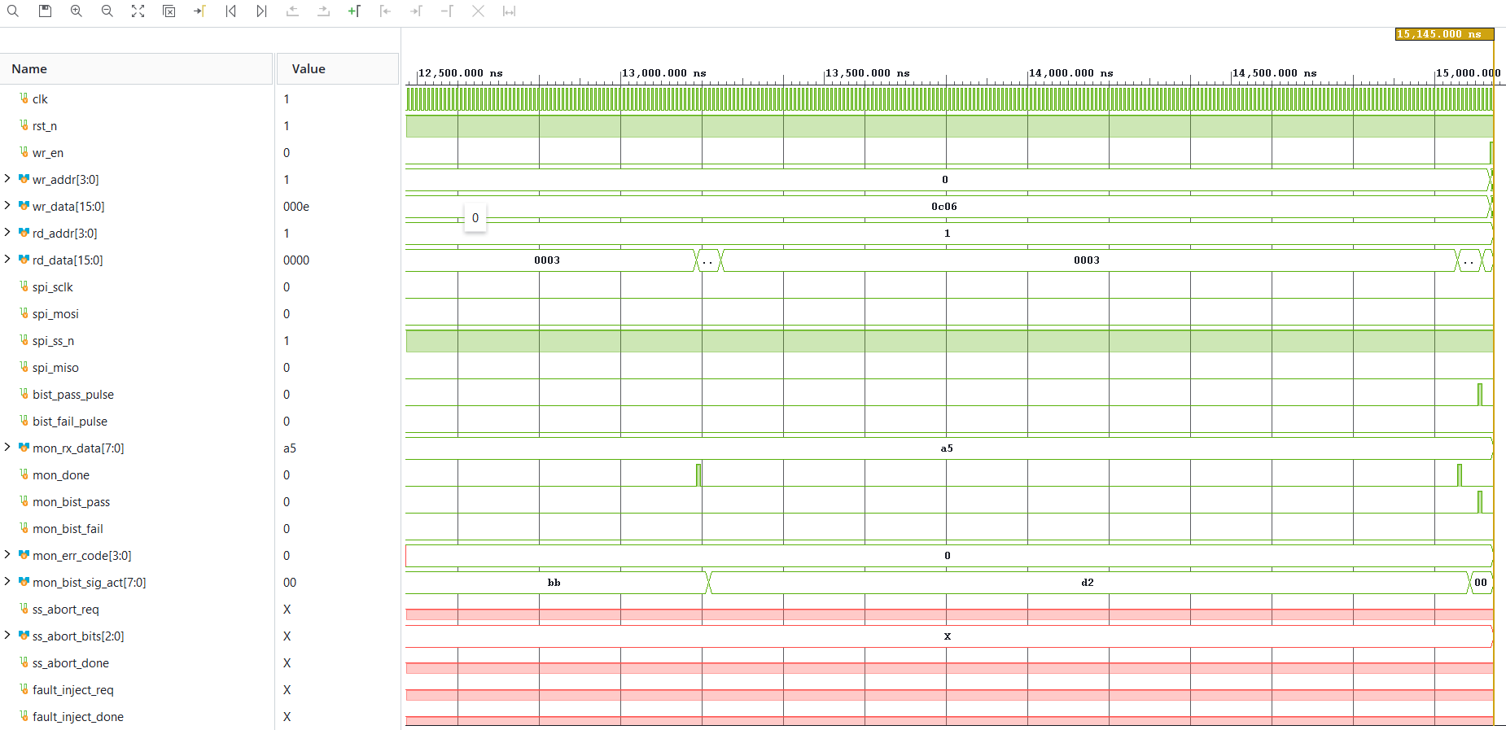

Fig:test TC04 BIST mode 0

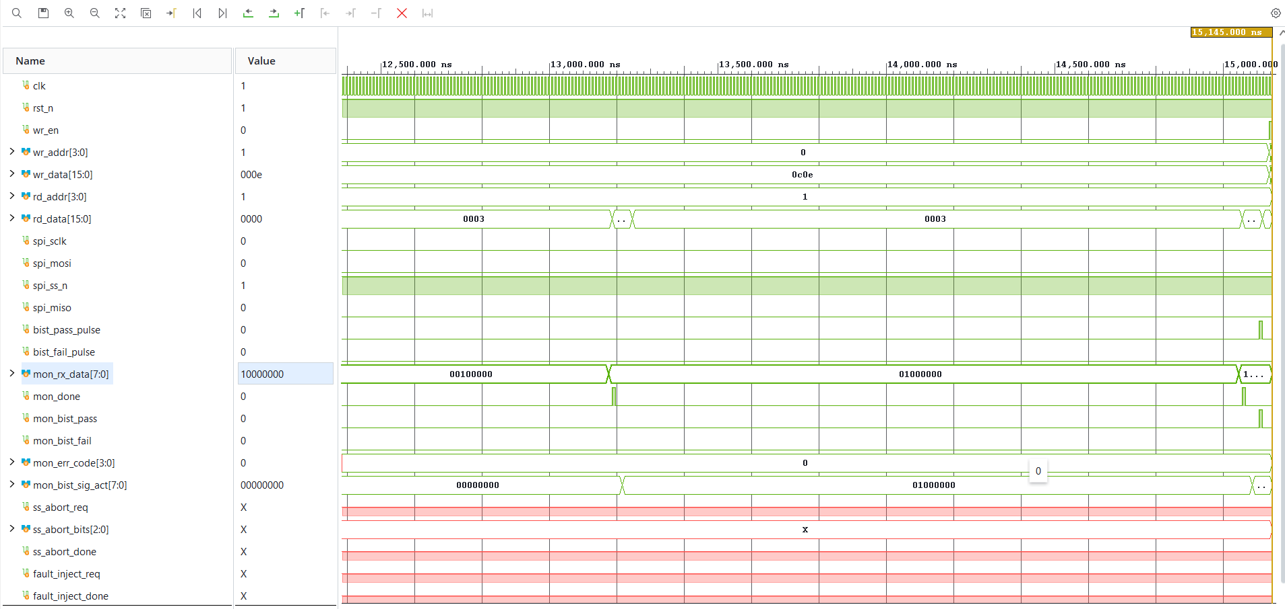

Fig:test TC05 BIST mode 1

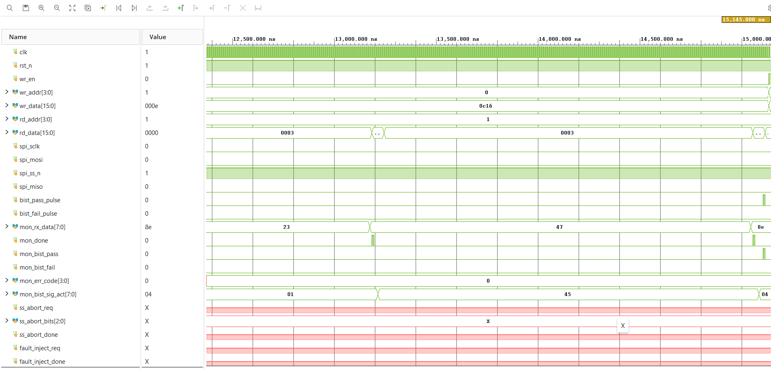

Fig:test TC06 BIST mode 2

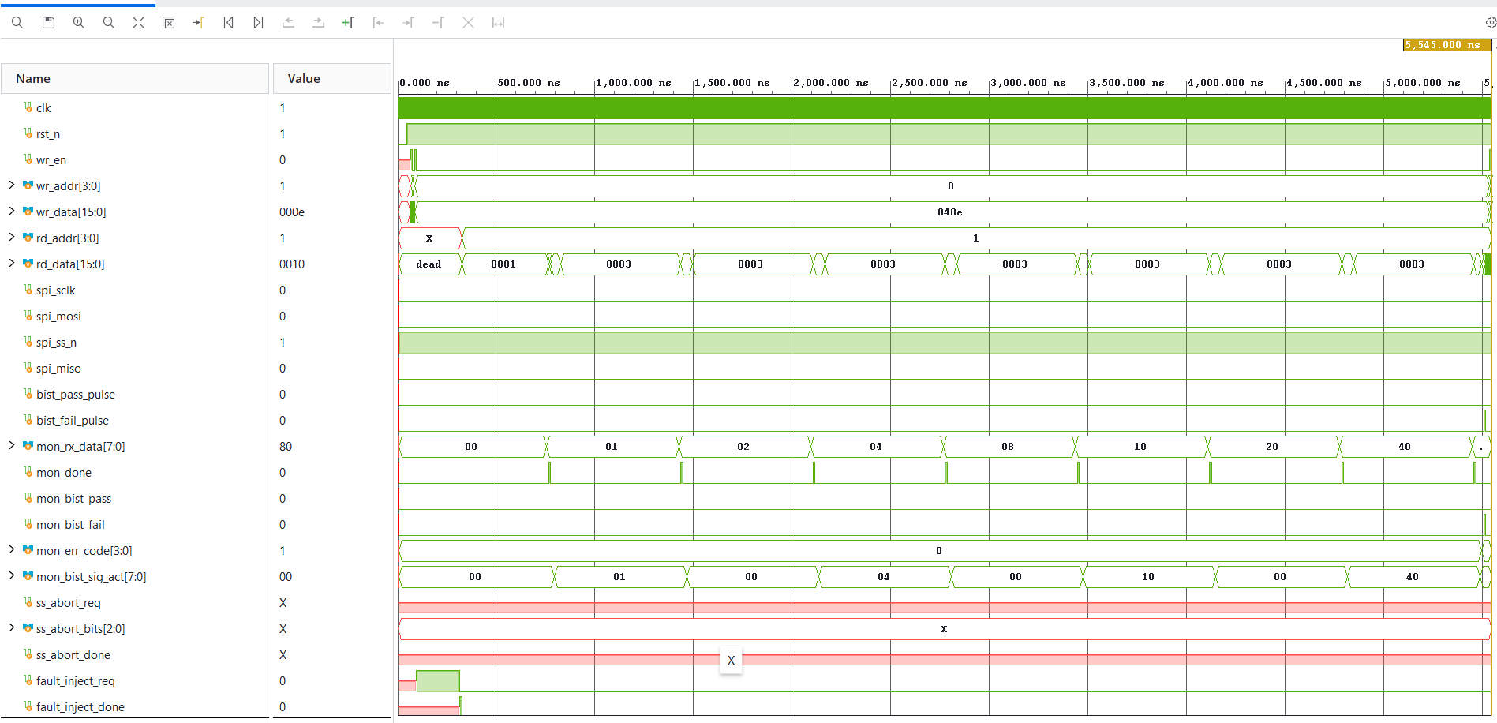

Fig:test TC07 fault injection

SYNTHESIS RESULT

TIMING SUMMARY

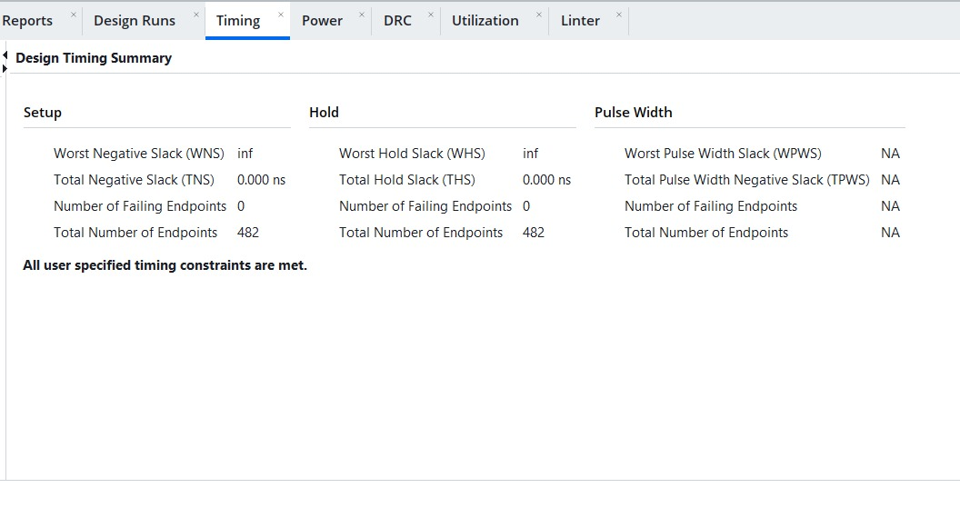
Fig: Timing report

POWER

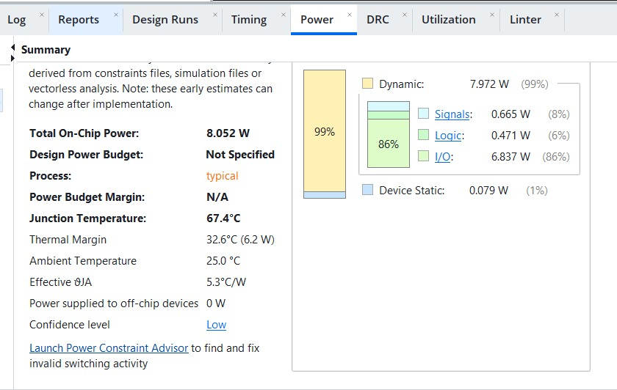
Fig: Power report

UTILIZATION REPORT

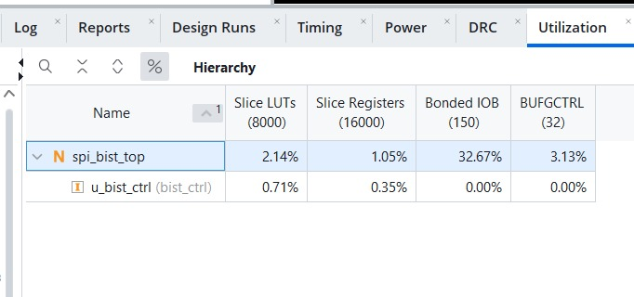

Fig: Utilization report

VERIFICATION USING UVM
This section provides an overview of the verification environment built for the SPI/BIST subsystem, utilizing a layered UVM architecture comprising:
- TEST
- SEQUENCES
- TRANSACTION
- DRIVER
- MONITOR
- AGENT
- ENVIRONMENT
- SCOREBOARD
Transaction Class:
The transaction class encapsulates the input stimulus applied to the DUT — write address/data, read address, BIST mode selection, fault-injection vectors and abort codes — so that each sequence can generate organized, reusable and randomizable stimulus.
- wr_addr / wr_data – randomized to exercise every register in the address map, including boundary values.
- bist_mode – randomized (constrained to 0/1/2) to exercise all three BIST test-pattern modes.
- fault vector / abort code – randomized for the fault-injection and sub-state-abort tests.
Non-Randomized Variables:
- wr_en, rd_addr – sequenced deterministically per test scenario rather than randomized.
- clk_div – typically held at a known value so timing checks in the monitor remain predictable.
- Sequences:
- basic_xfer_seq – drives test_tc01_basic_xfer: a single write, SPI transfer and read-back.
- edge_data_seq – drives test_tc09_edge_data with boundary data patterns.
- bist_mode0_seq / bist_mode1_seq / bist_mode2_seq – drive test_tc10/11/12_bist_mode{0,1,2} respectively.
- fault_inject_seq – drives test_tc13_bist_fault_inject.
- start_while_busy_seq – drives test_tc14_bist_start_while_busy.
- back_to_back_seq – drives test_tc15_bist_back_to_back.
- ss_abort_seq – drives test_tc06_ss_abort.
- random_regression_seq – layers the above sequences under constrained-random control for test_random_regression.
- Driver – drives stimulus from the sequencer onto the DUT through the virtual interface.

Transaction Generation:

The driver receives transactions from the active sequence, representing register writes, BIST-start commands, fault injections and abort requests.

Signal Translation and Driving:
Each transaction's fields are mapped onto the DUT's wr_en / wr_addr / wr_data / rd_addr signals (and, where applicable, fault_inject_req / ss_abort_req) with the correct cycle timing.

Interface Communication:
The driver communicates with the DUT through the virtual interface bound in tb_top via uvm_config_db, decoupling the testbench from the DUT's exact pin-out.
Monitor – a critical component responsible for passively observing DUT activity on the register and SPI interfaces.

Passive Monitoring of Data:
The monitor samples mon_rx_data, mon_done, mon_bist_pass, mon_bist_fail, mon_err_code and mon_bist_sig_act every clock cycle without driving any DUT input.

Protocol / Behaviour Checks:
- SPI framing – SCLK toggling is only expected while spi_ss_n is asserted.
- Signal stability – no monitored signal should carry an 'X' value during active operation.
- Pulse-width checking – bist_pass_pulse / bist_fail_pulse / mon_done must each be exactly one clock cycle wide.
- Mutual exclusivity – bist_pass and bist_fail must never assert in the same BIST run.
- If a violation is detected, the monitor raises the corresponding flag / log message so the environment can report it as a failure.
- Scoreboard – plays a critical role in verifying the correctness of both register transfers and BIST outcomes.

Storage of Expected Data:
- The scoreboard maintains a model of the register file, storing each write's data indexed by address.
- For BIST runs, it also computes/records the expected signature per mode so it can be compared against the DUT's reported signature.

Verification of Read Data / BIST Outcome:
As read transactions are issued to the DUT, the scoreboard compares rd_data against the value it has stored for that address.
- If the DUT's rd_data matches the scoreboard's stored value, the check passes.
- If the DUT's BIST result (mon_bist_pass / mon_bist_fail / mon_bist_sig_act) matches the scoreboard's expectation for the selected mode and any injected fault, the check passes; a mismatch is flagged as a scoreboard error.
- Agent – harmonizes the driver, sequencer and monitor for the register/SPI interface, coordinating stimulus generation and response monitoring for every test.
- Environment – the env class, extending uvm_env, instantiates the agent and the scoreboard during the build phase and connects the monitor's analysis port to the scoreboard, overseeing the entire verification process.
- Test – the top-level test class extends uvm_test, builds the environment, selects and starts the appropriate sequence (basic_xfer, one of the BIST-mode sequences, fault-injection, abort, back-to-back, or the random regression), raises an objection during the run phase, and drops it once the sequence completes.
- Tb_Top – the SystemVerilog/Verilog testbench top instantiates the spi_bist_top DUT, generates the system clock and reset, binds the virtual interface via uvm_config_db, and calls run_test() to start UVM execution.

Key Components:
- DUT: spi_bist_top instance connected to the register and SPI interfaces.
- Interface: a single virtual interface carrying wr_en/wr_addr/wr_data, rd_addr/rd_data, the SPI pins, and the debug/monitor signals.
- UVM Environment: agent (driver, sequencer, monitor), scoreboard, and the sequence library described above.

Benefits:
- Structured, reusable UVM-based verification for comprehensive coverage of both SPI transfers and all BIST modes.
- A single scoreboard checks both data-path correctness and self-test correctness.
- Easy extension — new fault or abort scenarios can be added as new sequences without changing the driver, monitor or scoreboard.

CONCLUSION
In this project, an SPI Master/Slave subsystem with an integrated Built-In Self-Test engine was designed in Verilog HDL, combining a register-file host interface, SPI master/slave FSMs, an LFSR-based pattern generator, an MISR-based signature analyzer, and a loopback multiplexer that allows the BIST engine to exercise the SPI datapath entirely on-chip.
The design was exercised across normal host-driven SPI transfers and all three BIST modes — fixed pattern, walking-1s and pseudo-random — as well as fault-injection and sub-state-abort scenarios, and correctly reported PASS/FAIL outcomes with the appropriate diagnostic error codes.
Verification of the design was carried out using a UVM-based environment built around a scoreboard that independently checks register read/write correctness and BIST signature outcomes. Across the executed test suite (basic transfer, edge-case data, all BIST modes, fault injection, busy-state handling, back-to-back BIST runs and constrained-random regression), the DUT produced correct, error-free results with no protocol or signature violations observed.

FUTURE SCOPE
The future scope of this project can be strategically expanded to include the following key areas:
Extend the design to support all four CPOL/CPHA timing modes at run time, rather than the fixed mode-0 behaviour currently wired into the register file, improving interoperability with a wider range of SPI peripherals.
Generalize the data width beyond the current 8-bit SPI byte and 16-bit register width to support wider transfers where required by a target application.
Add additional BIST algorithms and multiple independent signatures to increase fault coverage and reduce aliasing probability.
Apply formal verification to the BIST controller FSM to exhaustively prove state-reachability and absence of deadlock, complementing the simulation-based UVM results.
Explore power-aware BIST scheduling (e.g., clock-gating the BIST logic when idle) to minimize the energy cost of periodic self-test in battery-powered or automotive applications.
Extend functional and code coverage closure with automated coverage-driven constrained-random regression, and integrate the test suite into a continuous-integration regression flow.
Investigate extending the design toward multi-slave and Quad-SPI configurations while retaining the existing BIST architecture.

References
- Motorola SPI Block Guide – Serial Peripheral Interface (SPI) protocol reference.
- 1800-2017 – IEEE Standard for SystemVerilog — Unified Hardware Design, Specification, and Verification Language.
- Accellera UVM 1800.2 – Universal Verification Methodology Reference Manual.
- Cookbook by Verification Academy – UVM reference.
- P. H. Bardell, W. H. McAnney and J. Savir, "Built-In Test for VLSI: Pseudorandom Techniques", Wiley — LFSR/MISR BIST reference.

