**AQLI -TEST**

1. **Basic wrangling tasks and questions**
   1. How many GADM2 regions are present in India?

Ans - Number of GADM2 regions in India: **684**

* 1. Calculate population weighted pollution average of all years at country (GADM0)

level ?

● Save the country level file as a CSV.

● What are the 10 most polluted countries in 2021?

|  |  |
| --- | --- |
| **Country** | **Pm2.5 (2021)** |
| Bangladesh | 71.800781 |
| India | 51.091826 |
| Nepal | 42.204416 |
| Pakistan | 34.554938 |
| Myanmar | 34.553250 |
| Democratic Republic of the Congo | 33.831088 |
| Cameroon | 33.579828 |
| Republic of the Congo | 32.617917 |
| Rwanda | 32.372000 |
| Burundi | 32.155038 |

* 1. What was the most polluted GADM2 region in the world in 1998, 2005 and 2021?

|  |  |  |  |  |  |
| --- | --- | --- | --- | --- | --- |
| **Most Polluted GADM2 Region in 1998:** | | **Most Polluted GADM2 Region in 2005:** | | **Most Polluted GADM2**  **Region in 2021:** | |
| Country | India | Country | India | Country | India |
| State/Province | Uttar Pradesh | State/Province | NCT of Delhi | State/Province | NCT of Delhi |
| District | Unnao | District | NCT of Delhi | District | NCT of Delhi |
| pm1998 | 78.55 | pm2005 | 98.75 | pm2021 | 126.51 |

* 1. Plot a population weighted pollution average trendline plot for Uttar Pradesh from

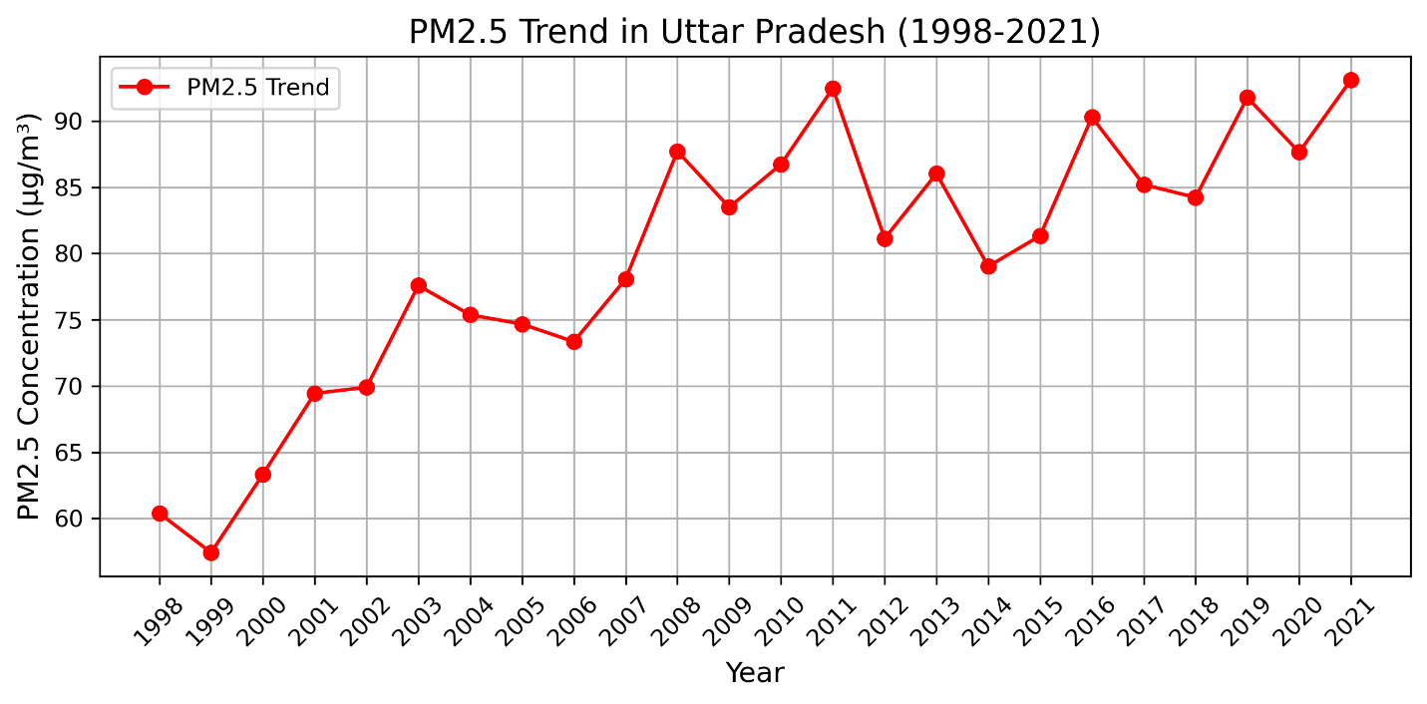1998 to 2021. Save this plot as a high quality PNG file.

**2**

2.1 Plot a bar graph for the life years lost relative to the WHO guideline in the 10 most polluted countries in the world and also plot them on a global country level map. For the map, the 10 most polluted country boundaries should be filled in with “dark red” and the rest of the map should be grayed out. Save both the bar graph and the map as high quality PNG files.

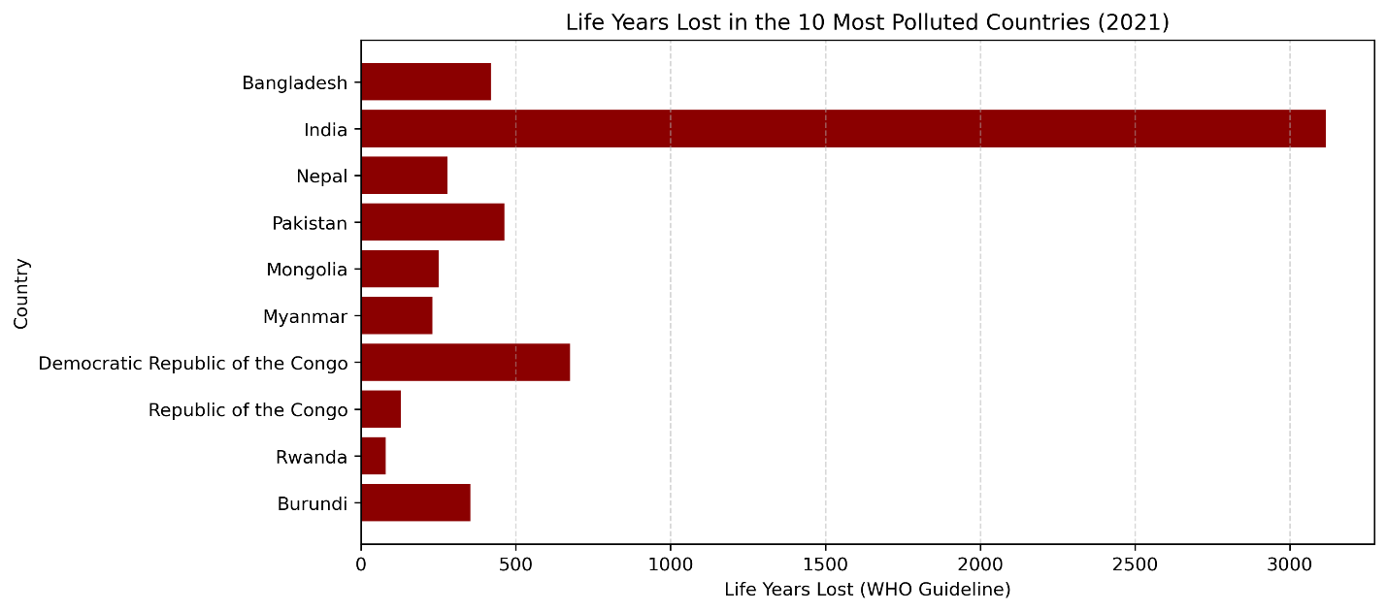

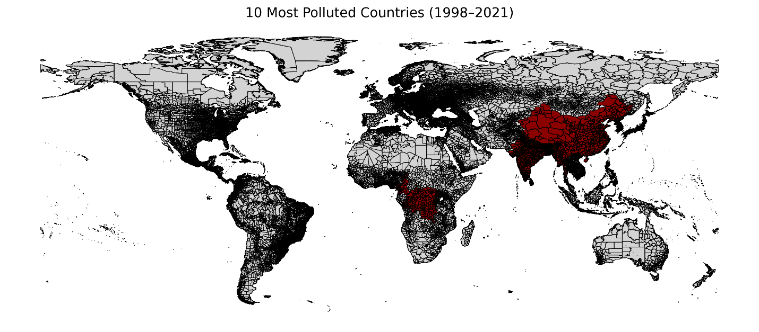

**4 Important Key findings**

* The air in the most polluted locations is six times dirtier than that in the cleanest ones, which reduces life expectancy by over three years.
* Despite the fact that many nations have air quality regulations, a third of the world's population continues to breathe air that is beyond national limits due to lax enforcement.
* It is challenging to regulate pollution and safeguard public health in some of the most polluted nations because they lack air quality standards and monitoring infrastructure.