Normally all classifier will predict only one class as 0 or 1 and True or False and if dataset contains multiple classes then this classifiers may not work and to implement multiclass classification task we need to use multiclass label classifier and SVM is one such algorithm which can handle single or multiple class labels. Our plant disease dataset contains 15 different type of diseases and this multiclass SVM can be trained on all such diseases. In below dataset screen you can see we have images from 15 different disease types and each type will consider as one class.

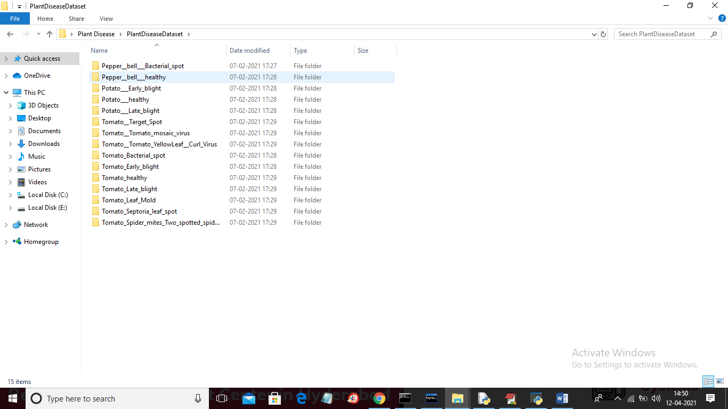

In above screen we can see we have 15 different folders for each disease so we will have 15 class labels and in below CODE screen you can read red colour comments to know how we are building SVM with above multi class labels dataset

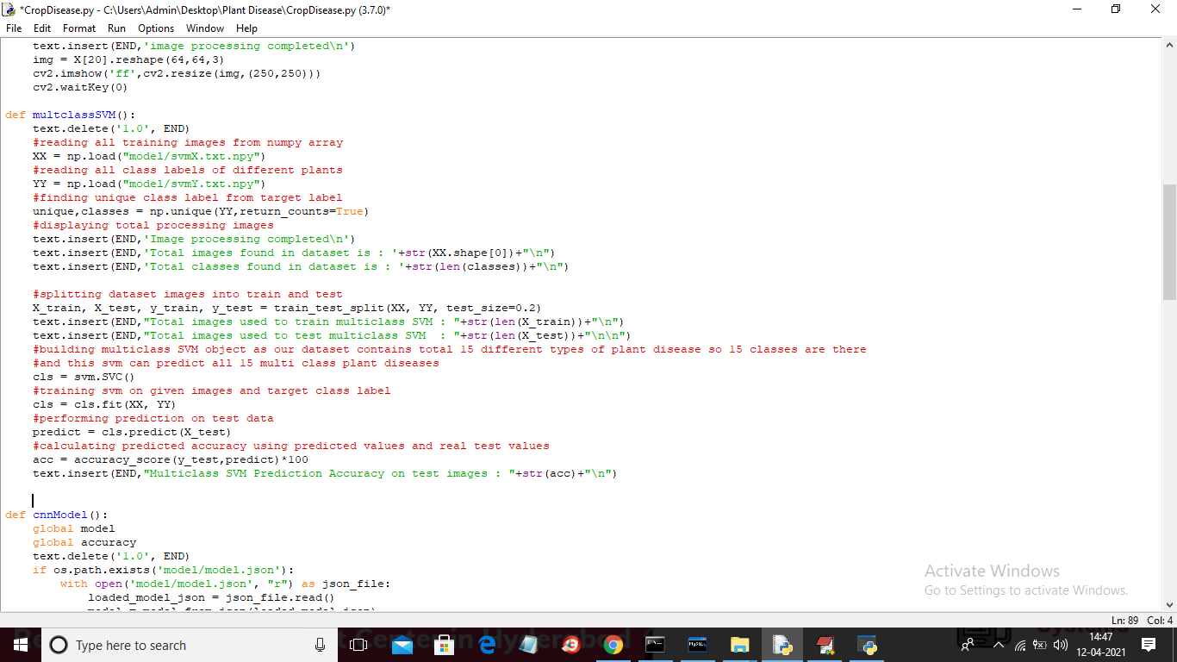

When you run code you will get ‘Run Multiclass SVM Algorithm’ button and you click on this button to train SVM and to get its prediction accuracy on test data.

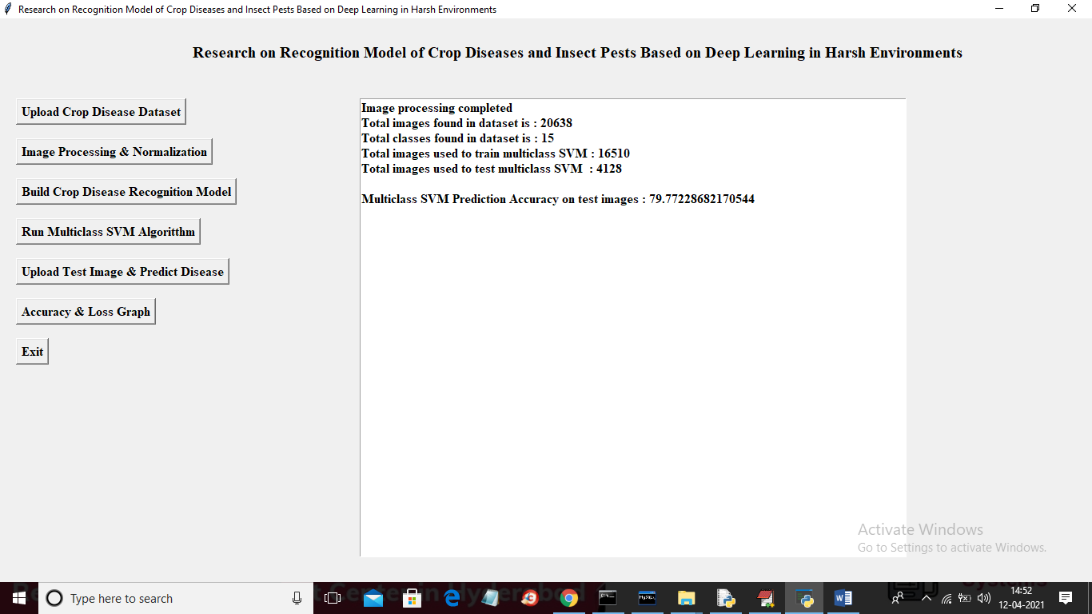

In above screen we can see total images found in dataset is 20638 which belongs to 15 different disease classes and for training application using 16510 images and to test SVM application using 4128 images. After predicting all test image we are getting SVM prediction accuracy as 79%.

Note: there are more than 20000 images so SVM will take 5 to 10 minutes time to give output