In this project after adding fertilizers we will get disease prediction name as well as fertilizers details

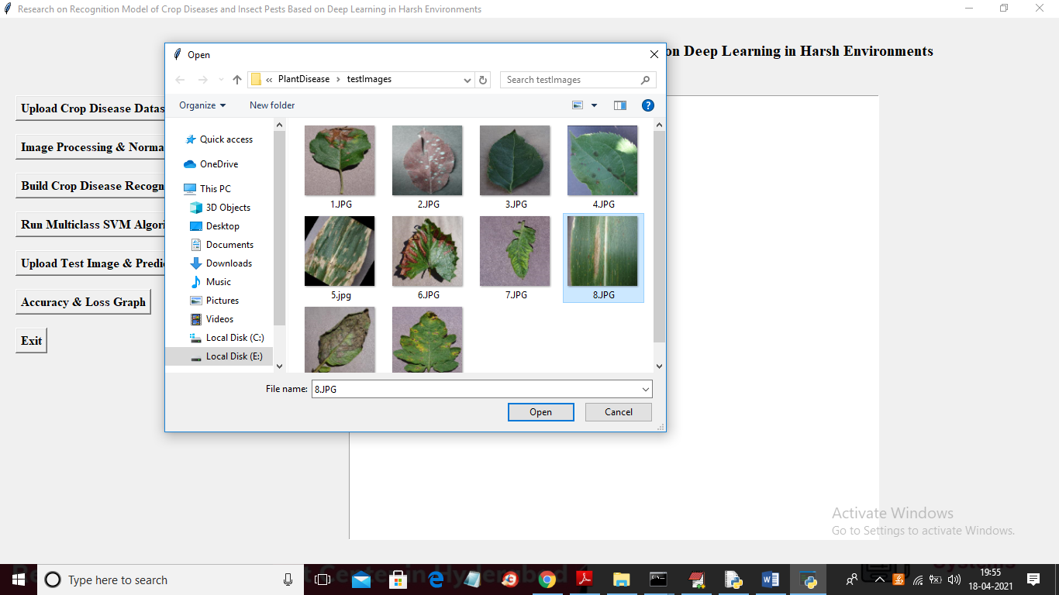

In above screen I am selecting and uploading ‘8.jpg’ and then click on ‘Open’ button to get below result

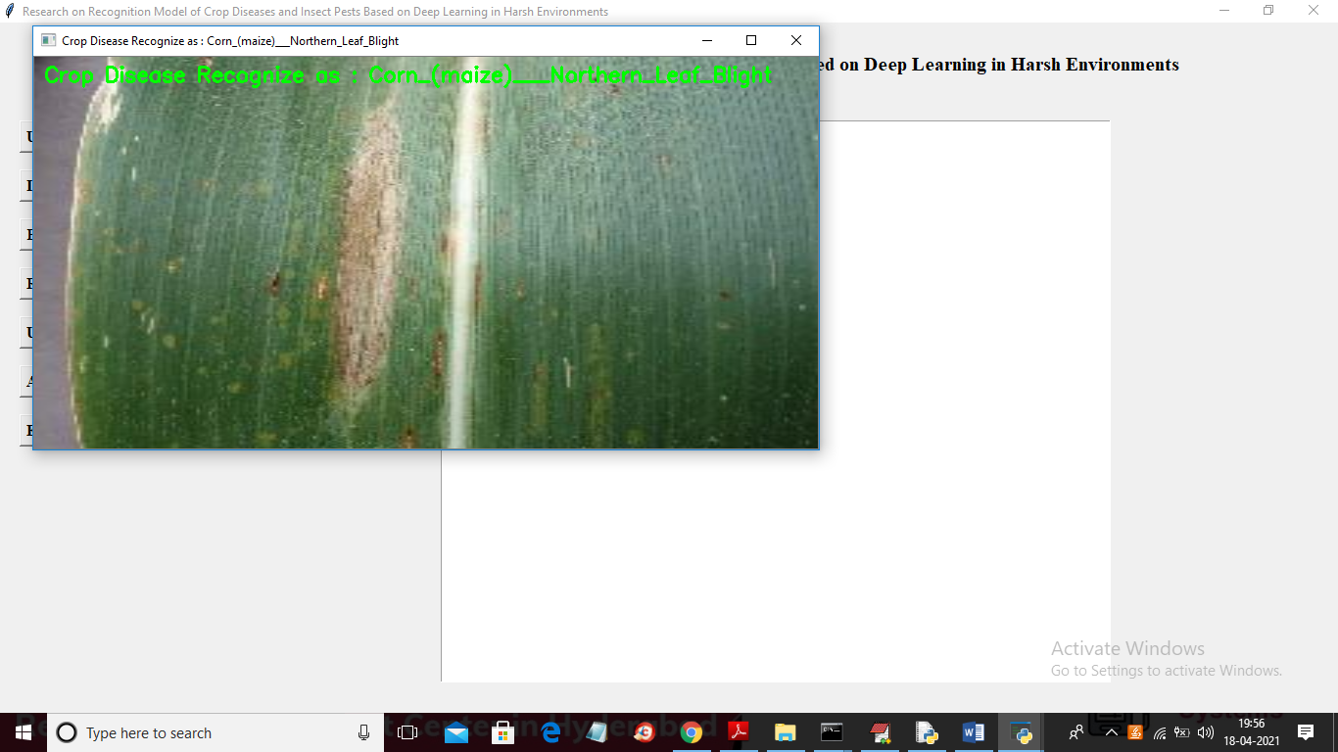

In above screen in green text we can see predicted disease and now close above image to get below fertilizers details

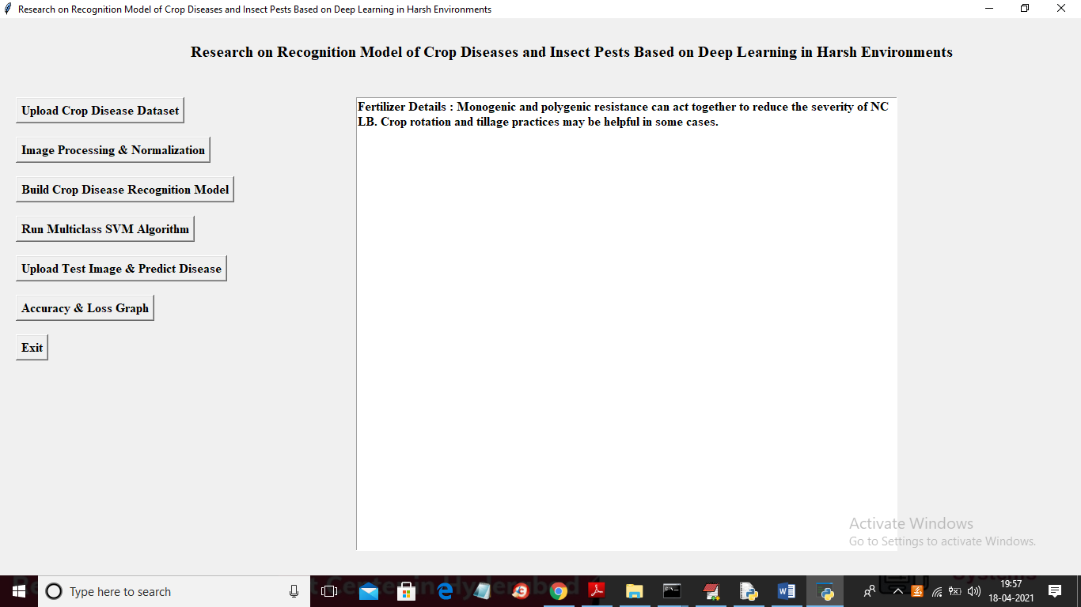

In above screen in text area you can see fertilizer details for predicted disease. Similarly you can upload other images and test